**Employee Appreciation App**

**Objective - :** To Build a web application of coin distribution system to appreciate someone for his/her performance.

**Overview**

* **Softwares/tools -**

**Frontend –** React (Semantic UI)

**Backend –** Node (Express Framework)

**Database –** Mongo DB (MLab)

**For UI, there will be four pages**

**Login Page –**

To Login into the application if account already exists

**Registration Page –**

To sign up in the application if user is not registered

**Home Page –**

To see coin information and user information and this page will also show summary which shows top 20 peoples having maximum coins and you can search a user with search button.

**Coin Transfer Page-**

To transfer coins to appreciate his/her work with some comment.

**User Profile Page-**

To show profile details of any user including his coin transfer history.

**Functionalities -**

1. **Sign Up**
2. **Sign In**
3. **Search**
4. **Transfer Coin**
5. **Sign Out**

**Flow Diagram**

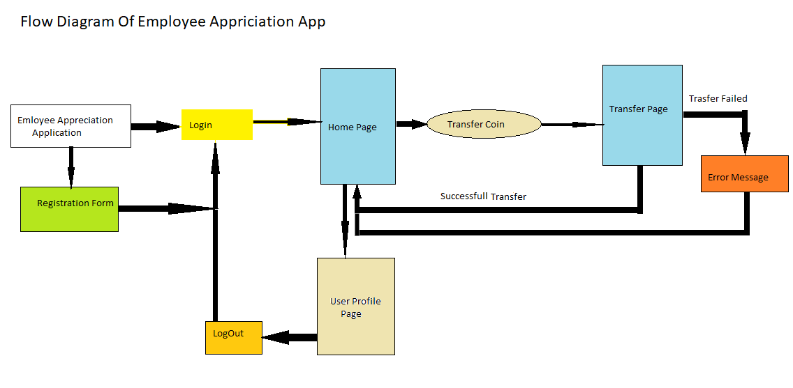

**User Interface**

**Sign In**

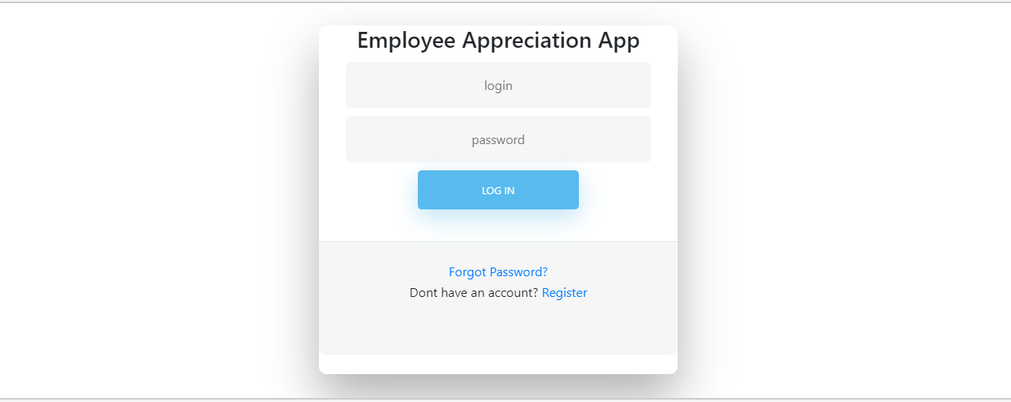

**Sign Up**

