GENERATIVE AI
REPORT
On

Text-to-Image Generation on CIFAR-10 Using Conditional GANs and Large Language Models
Submitted in Partial Fulfillment of Award of
BACHELOR OF TECHNOLOGY
In
Computer Science and Engineering
By
Akshita Singh (2022BCSE07AED832)

Under the Supervision of

Dr. K. Madheswari
Professor, Department of ASAC


ALLIANCE SCHOOL OF ADVANCED COMPUTING

ALLIANCE UNIVERSITY BENGALURU
APRIL 2025

Table of Contents
- Problem Statement
- Abstract
- Introduction
- Project Implementation
  - Write up( Proposed system module detail with proper explanation)
  - Proposed system architecture with explanation.
  - Proposed Algorithm
- Tech Stack
- Code Snaps (Paste the Code snippets / screenshots of code)
- Future Improvements
- Conclusion
- References

PROBLEM STATEMENT

In the domain of computer vision and generative modelling, synthesizing realistic images from textual descriptions is a challenging task that requires deep understanding of both natural language and visual data. The CIFAR-10 dataset consists of small, low-resolution images from 10 object categories, such as airplane, automobile, bird, cat, etc., and serves as a compact benchmark for generative models.

This project aims to explore text-to-image generation by leveraging Conditional Generative Adversarial Networks (cGANs) in conjunction with Large Language Models (LLMs) to generate realistic images conditioned on textual input derived from the corresponding CIFAR-10 class labels or more descriptive prompts. The problem involves converting class labels or extended textual descriptions into a form that guides the GAN to generate images matching the text's semantics.

The key challenges include:

- Designing a text encoder capable of capturing the semantic meaning of the text input.
- Conditioning the GAN architecture effectively on this encoded text.
- Generating high-quality, visually coherent images at the resolution and class variety of CIFAR-10.
- Evaluating the visual realism and semantic alignment between generated images and the input text

ABSTRACT

Text-to-image generation is an emerging task in the intersection of computer vision and natural language processing, where the objective is to synthesize realistic images that correspond to given textual descriptions. This project explores a hybrid approach that combines Conditional Generative Adversarial Networks (cGANs) with Large Language Models (LLMs) to perform text-to-image generation on the CIFAR-10 dataset. The CIFAR-10 dataset consists of 60,000 low-resolution images categorized into 10 object classes, providing a compact but challenging environment for generative tasks.

In this work, we utilize class labels and extended descriptions generated by LLMs to serve as textual conditions for image generation. The LLM encodes the semantic features of the text, which are then used to condition the image synthesis process in the GAN. By integrating LLMs for robust text representation and cGANs for high-quality image generation, the proposed method aims to produce images that are both visually realistic and semantically aligned with the input text. Evaluation metrics such as Inception Score (IS) and Fréchet Inception Distance (FID) are used to assess the quality and fidelity of the generated images.

The results demonstrate the potential of combining language models and generative adversarial networks for text-driven image synthesis, even on small and complex datasets like CIFAR-10.

INTRODUCTION

The task of generating realistic images from natural language descriptions has gained significant attention in recent years, driven by advancements in deep learning, computer vision, and natural language processing. Known as text-to-image synthesis, this area of research explores how machines can understand textual input and convert it into coherent and meaningful visual output. This challenging problem requires a deep semantic understanding of the input text and the ability to generate diverse, high-quality images that align with the given description.

One powerful approach for tackling this task is through Conditional Generative Adversarial Networks (cGANs), which extend traditional GANs by incorporating external information—such as text—as a conditioning variable. By conditioning both the generator and the discriminator on a textual input, cGANs can learn to generate images that are not only realistic but also contextually relevant to the text.

In parallel, Large Language Models (LLMs) such as GPT and BERT have shown exceptional capability in capturing the nuances of human language. These models can transform raw text or even simple class labels into semantically rich embeddings, which are more effective as inputs for conditional generation tasks. Integrating LLMs into the text-to-image pipeline enhances the model’s ability to understand and translate language into visual representations.
This project focuses on combining these two powerful technologies—cGANs and LLMs—to perform text- to-image generation on the CIFAR-10 dataset. CIFAR-10 is a benchmark dataset composed of 60,000 low- resolution (32x32) images across 10 object classes, such as airplane, automobile, bird, cat, and dog. While the images are relatively small and simple, generating them from textual descriptions is a non-trivial task due to their limited resolution and detailed class diversity.

The goal of this work is to build a system that takes a class label or a generated descriptive sentence as input and produces an image that matches the semantics of the text. By utilizing LLMs to generate or enrich textual input, and cGANs to learn the mapping from text to image, we aim to explore and evaluate the feasibility and quality of text-conditioned image generation on a small-scale dataset.

This research contributes to the ongoing efforts in multimodal AI, demonstrating how textual and visual modalities can be effectively combined for creative and generative applications, even within constrained data environments like CIFAR-10.

PROJECT IMPLEMETATION

Dataset:
  - Used CIFAR-10 with 60,000 images across 10 categories (32x32 pixels).

  - Normalized and one-hot encoded the data for training.

Text Embedding with LLMs:
  - Converted class labels into descriptive sentences using a Large Language Model (e.g., GPT-2).
  - Generated semantic embeddings using BERT or CLIP to represent text meaning.

Model Architecture:
  - Generator: Takes random noise + text embedding to generate 32x32 images.
  - Discriminator: Evaluates if the image is real and if it matches the text condition.

Training:
  - Used cGAN framework with adversarial and conditional loss.
  - Optimizer: Adam, trained over multiple epochs with a batch size of 64–128.

Evaluation:
  - Assessed using Inception Score (IS) and Fréchet Inception Distance (FID) to measure image quality and text-image alignment.

PROPOSED SYSTEM ARCHITECTURE

The proposed system uses Conditional Generative Adversarial Networks (cGANs) and Large Language Models (LLMs) to generate images from text descriptions.

Text Input (LLM-Based Module):
Class labels from CIFAR-10 (e.g., "dog") are expanded into detailed textual descriptions using an LLM like GPT-2 (e.g., "A small dog running in a field").

Text Embedding Module:
The text descriptions are transformed into numerical embeddings using models like BERT or CLIP, capturing the semantic meaning.

cGAN Architecture:
  - Generator: Takes random noise and text embeddings to generate images.
  - Discriminator: Evaluates if the image is real or fake and if it matches the text.

Training:
The model is trained using adversarial loss (real/fake) and conditional loss (text-image match) to
improve the generator’s performance.

Evaluation:
The generated images are evaluated using metrics like Inception Score (IS), Fréchet Inception Distance (FID), and CLIPScore

PROPOSED ALGORITHM

- Text Description Generation:

  - Convert CIFAR-10 class labels (e.g., "cat") into detailed text descriptions using a Large Language Model (LLM) like GPT-2.

- Text Embedding:

  - Use a text encoder (e.g., BERT or CLIP) to convert the descriptive text into a numerical vector that captures its meaning.
- Conditional GAN Training:

  - Generator: Takes random noise and text embedding to generate an image.
  - Discriminator: Evaluates if the image is real or fake and if it matches the text.

- Adversarial Training:

  - Train the generator to make fake images look real and the discriminator to distinguish between real and fake images using adversarial loss.

- Evaluation:

  - Evaluate generated images using metrics like Inception Score (IS) and Fréchet Inception Distance (FID), or CLIPScore to check the alignment with the text.
- Output:

  - The generated image that corresponds to the input text description.

TECH STACK
- Programming Language:

Python

- Deep Learning Framework:

PyTorch

- Generative Model:

Conditional GAN (cGAN)

- Text Generation & Embedding:

  - GPT-2/GPT-3 (for text generation)
  - BERT/Sentence-BERT/CLIP (for text embeddings)

- Data Processing:

NumPy, Pandas

- Image Processing:

OpenCV, Pillow (PIL)

- Model Training:

  - CUDA (GPU support)
  - TensorBoard/Matplotlib (for visualization)

- Evaluation Metrics:

Inception Score (IS), FID, CLIPScore

- Version Control:

Git

- Cloud Platforms (optional):

  - Google Colab, AWS, GCP

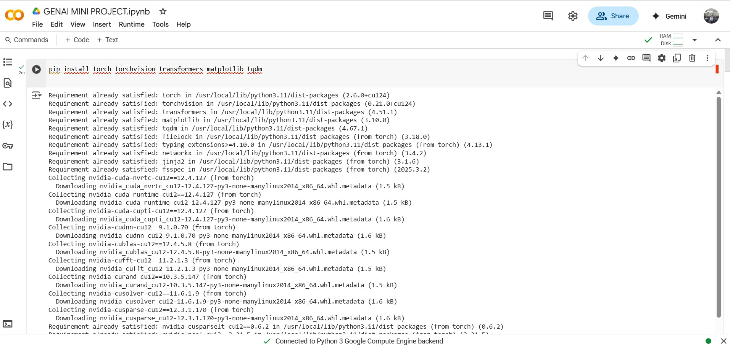
CODE SNAPS

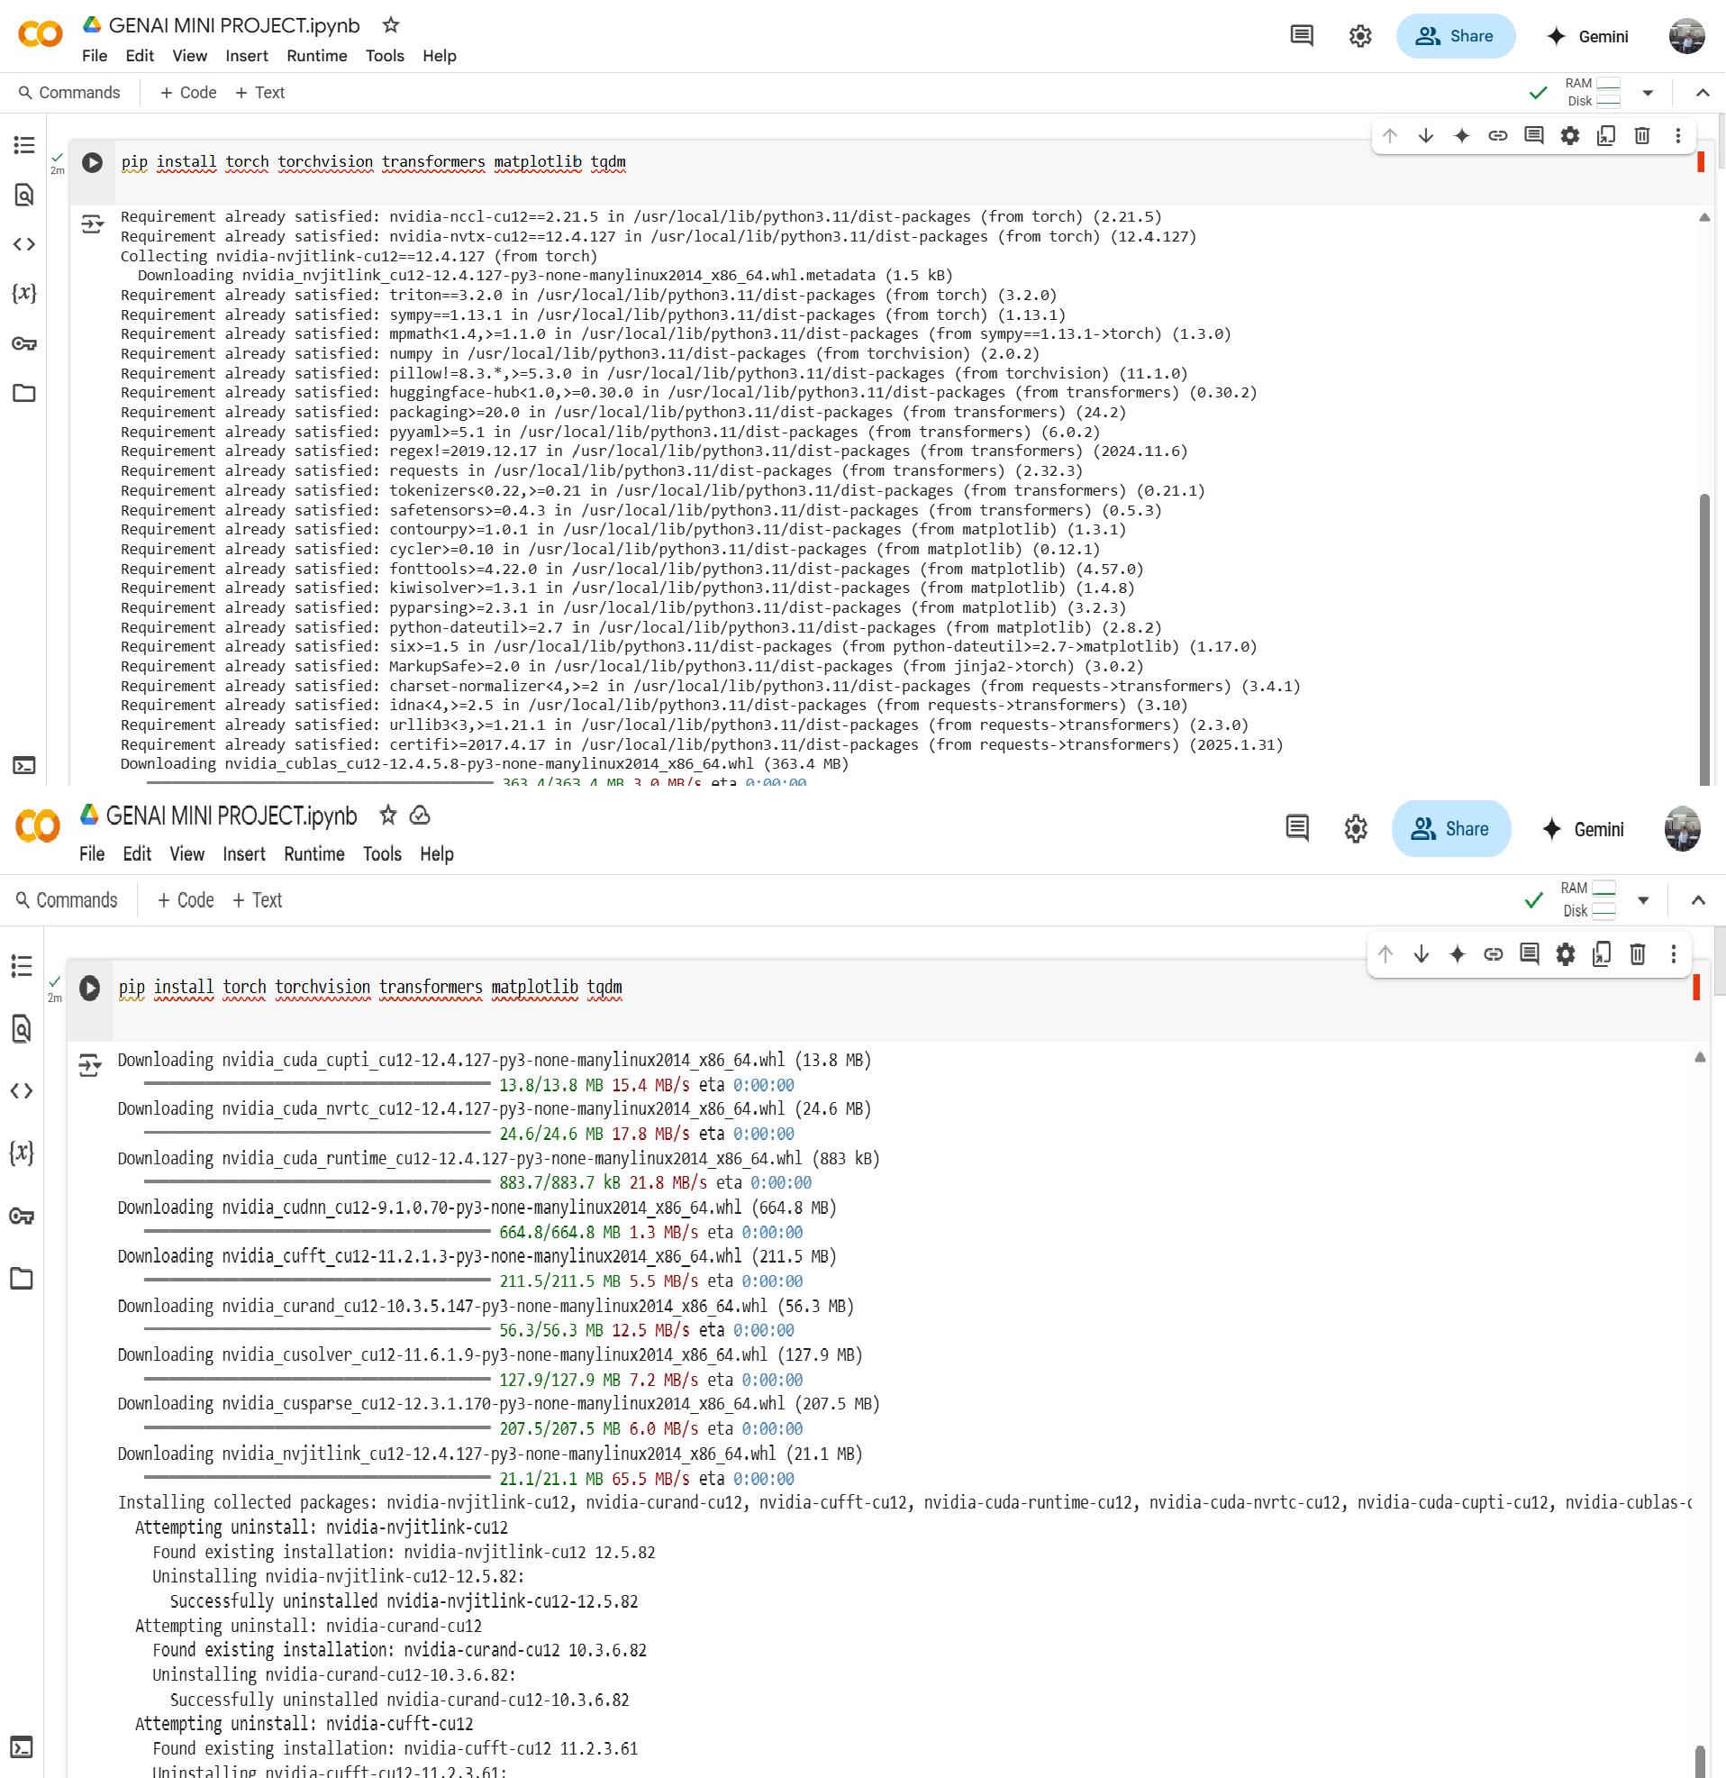
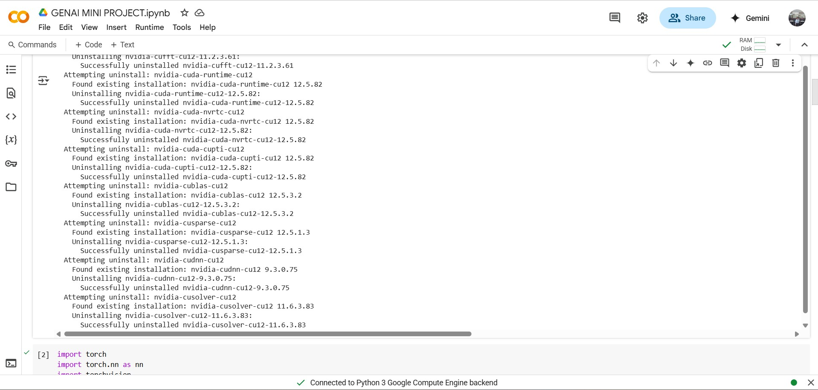

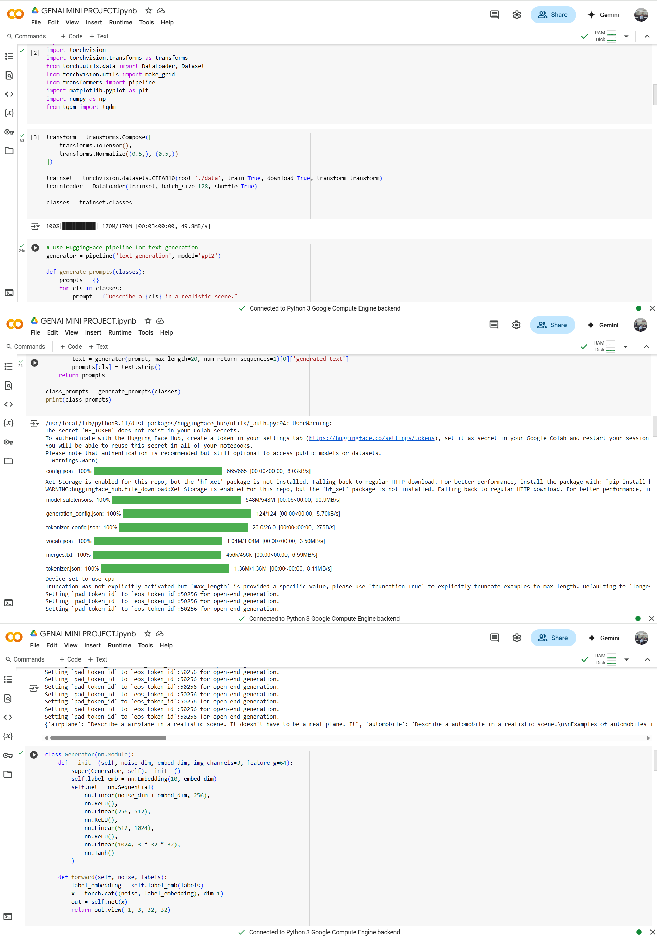

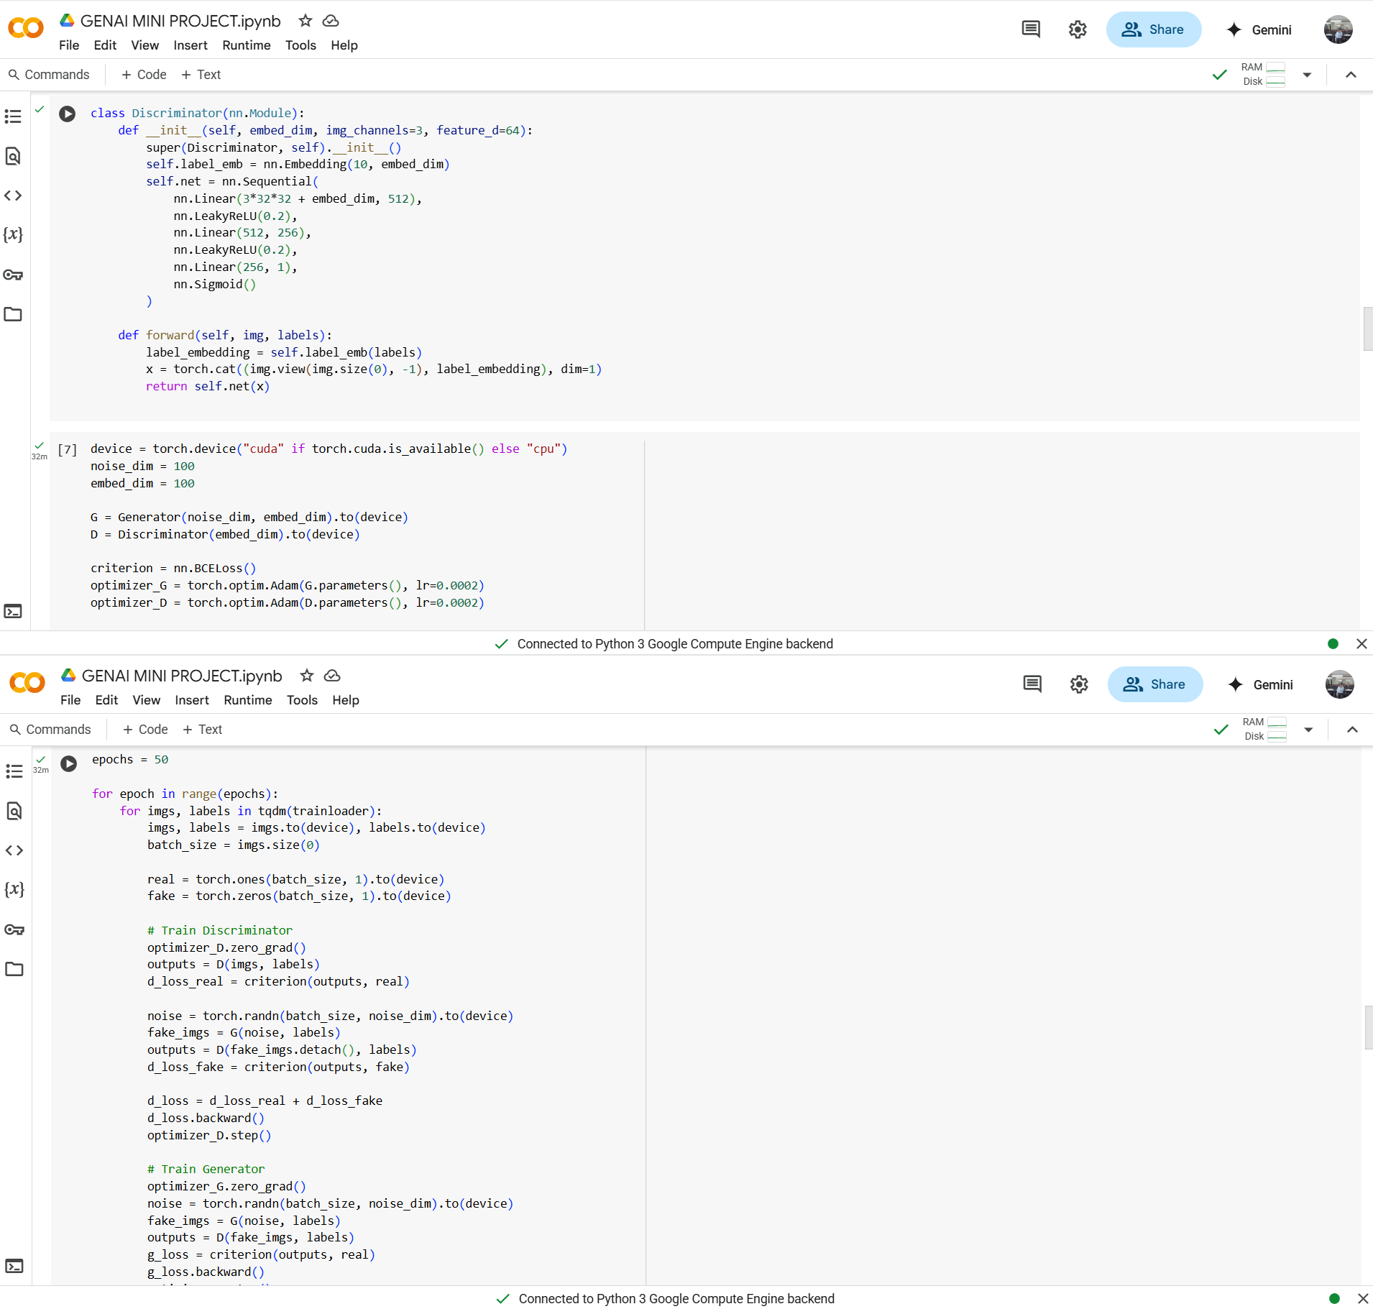
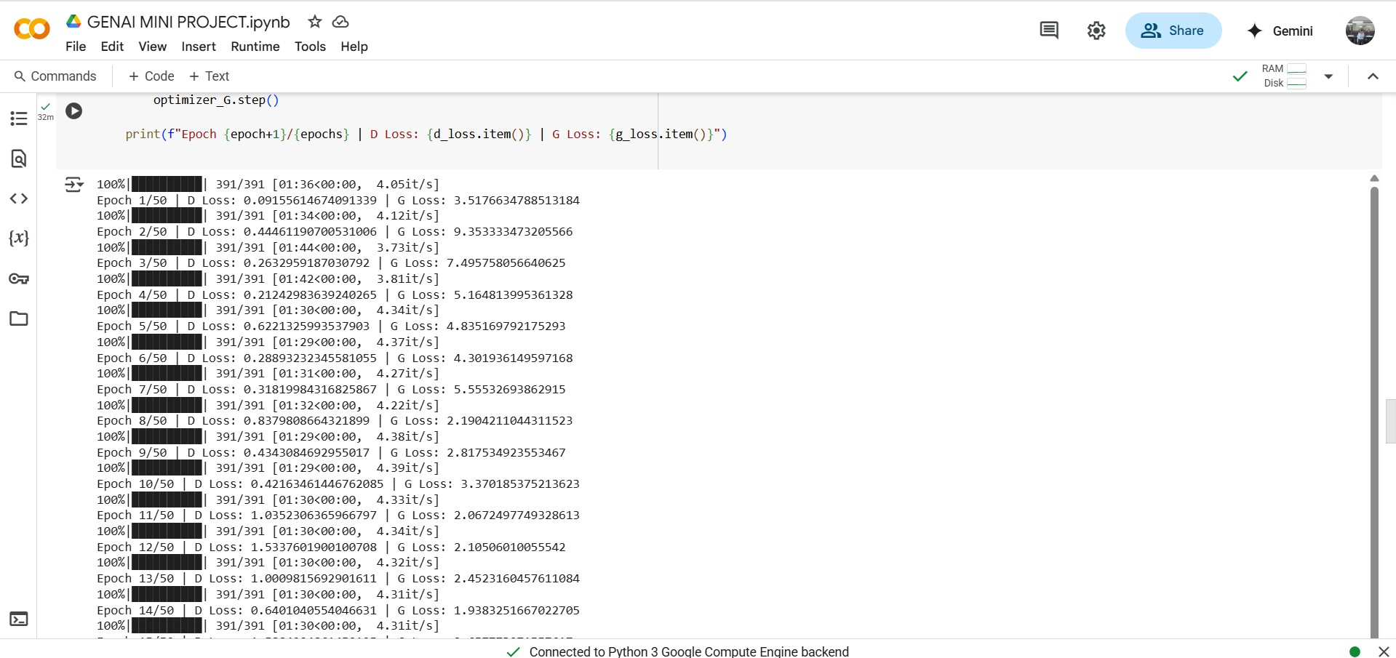

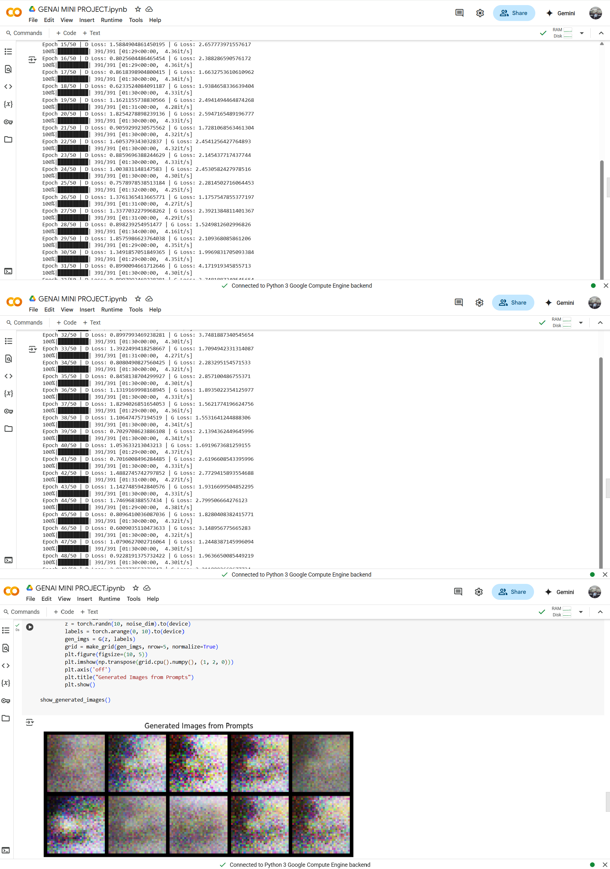

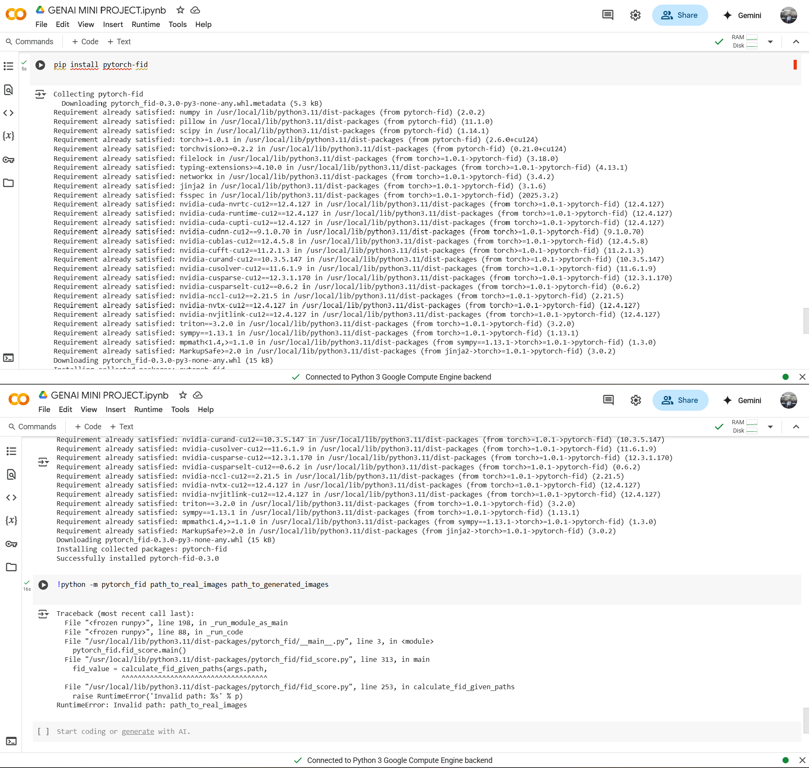

FUTURE IMPROVEMENTS

Although the current project successfully demonstrates how Conditional GANs and Large Language Models can work together to generate images from text on the CIFAR-10 dataset, there is still a lot of room for improvement and future development. One of the main limitations is the low resolution of the CIFAR-10 images. In the future, this project can be extended to larger and more detailed datasets like CIFAR-100 or ImageNet, which will allow the model to learn and generate more realistic and visually rich images.

Another important improvement would be to use more advanced and powerful generative models such as StyleGAN2 or diffusion-based models. These models have shown great success in producing high-quality images and could significantly enhance the output of this project..

Currently, the text input is based mostly on predefined class labels or simple generated sentences. In the future, the system could allow users to input their own custom text prompts. This would make the model more interactive and useful in real-world applications. Integrating attention mechanisms within the GAN architecture could also help the model focus better on the important parts of the text when generating images.

Finally, the way we evaluate the generated images can also be improved. Instead of relying only on automated scores like Inception Score or FID, we can include more advanced techniques such as CLIP Score, which compares text and images directly, or even use human evaluation to get more accurate feedback on the image quality and relevance.

CONCLUSION

This project successfully demonstrates the integration of Conditional Generative Adversarial Networks (cGANs) and Large Language Models (LLMs) for the task of text-to-image generation using the CIFAR-10 dataset. By transforming simple class labels into rich text descriptions and using them to condition the image generation process, we have shown that it is possible to generate images that are not only realistic but also semantically aligned with the input text.

Although CIFAR-10 is a small and low-resolution dataset, the project highlights how even basic textual descriptions can guide a GAN to produce meaningful visual content. The use of LLMs helps bridge the gap between natural language and visual data, making the system more intelligent and adaptable to human-like input. While the results are promising, there is still significant room for improvement in terms of image quality, text-image alignment, and system flexibility.

In conclusion, this work lays the foundation for more advanced research in multimodal AI, where text and image generation can be combined for creative, educational, and practical applications. With future enhancements such as better models, higher-resolution datasets, and more interactive inputs, text-to-image synthesis can become an even more powerful tool in the field of artificial intelligence.

REFERENCES

- Conditional Generative Adversarial Networks (cGANs)

  - Mirza, M., & Osindero, S. (2014). Conditional Generative Adversarial Nets. arXiv preprint arXiv:1411.1784.
  - Link: Conditional GANs

Large Language Models for Text Generation

  - Radford, A., Narasimhan, K., Salimans, T., & Sutskever, I. (2018). Improving Language Understanding by Generative Pre-Training. OpenAI Blog.
  - Link: GPT-2

Text-to-Image Generation

  - Reed, S., Akata, Z., Yan, Z., et al. (2016). Generative Adversarial Text to Image Synthesis.
Proceedings of the 33rd International Conference on Machine Learning (ICML 2016).
  - Link: Text-to-Image GAN

CLIP (Contrastive Language-Image Pretraining)

  - Radford, A., et al. (2021). Learning Transferable Visual Models From Natural Language Supervision. Proceedings of the International Conference on Machine Learning (ICML 2021).
  - Link: CLIP

- Fréchet Inception Distance (FID)

  - Heusel, M., Ramsauer, H., Unterthiner, T., et al. (2017). GANs Trained by a Two Time-Scale Update Rule Converge to a Local Nash Equilibrium. Advances in Neural Information Processing Systems (NeurIPS 2017).
  - Link: FID

- Inception Score (IS)

  - Salimans, T., Goodfellow, I., Zaremba, W., et al. (2016). Improved Techniques for Training GANs. Advances in Neural Information Processing Systems (NeurIPS 2016).
  - Link: Inception Score

- PyTorch Documentation

  - PyTorch: The primary framework used for implementing cGANs and training models.
  - Link: PyTorch

- CIFAR-10 Dataset

  - Krizhevsky, A. (2009). Learning Multiple Layers of Features from Tiny Images. Technical Report.
  - Link: CIFAR-10

