PROJECT REPORT
on
INTELLIGENT CHATBOT FOR CSE DEPARTMENT
(CSE III Semester Mini project )
2023-2024

Submitted to: Submitted by:
MR. DIVESH KUMAR Mr. Akshit Garg
(CC-CSE-B2-III-Sem) Roll. No:2218293
CSE-B2-III-Sem
Session: 2023-2024
DEPARTMENT OF COMPUTER SCIENCE AND ENGINEERING
GRAPHIC ERA HILL UNVERSITY, DEHRADUN

CERTIFICATE

Certified that Mr. Akshit Garg (Roll No.- 2218293) has developed mini project on “Intelligent Chatbot for CSE Department” for the CSE III Semester Mini Project Lab in Graphic Era Hill University, Dehradun. The project carried out by Students is their own work as best of my knowledge.

Date:20-01-2024

Mr. Divesh kumar
Class Co-ordinator
CSE-B2-III-Sem
(CSE Department)
GEHU Dehradun

ACKNOWLEDGMENT

We would like to express our gratitude to The Almighty Shiva Baba, the most Beneficent and the most Merciful, for completion of project.
We wish to thank our parents for their continuing support and encouragement. We also wish to thank them for providing us with the opportunity to reach this far in our studies.
We would like to thank particularly our project Co-ordinator Mr Divesh Kumar for his patience, support and encouragement throughout the completion of this project and having faith in us.
At last but not the least We greatly indebted to all other persons who directly or indirectly helped us during this work.

Mr. Akshit Garg
Roll No.- 2218293
CSE-B2-III-Sem
Session: 2023-2024
GEHU, Dehradun
TABLE OF CONTENTS

CHAPTER NO. TITLE PAGE NO.
1. INTRODUCTION 5 1.1 Key Features and Functionalities 6
1.2 Benefits 8
2. LITERATURE REVIEW
2.1 Overview of Existing Chatbot Technologies 9
2.2 Chatbots in Educational Institutions 9
2.3 Analysis of Similar Projects 10
2.4 Challenges and Opportunities 10
2.5 Ethical Considerations 10
3.SYSTEM ARCHITECTURE 11
3.1 Frontend 11
3.2 Chatbot Logic 11
3.3 Scalability and Flexibility 12
4. FEATURES 14
5.IMPLEMENTATION 17
5.1 Frontend Development 17
5.2 Chatbot Integration 17
5.3 System Functionality 18
6. Evolving the Demo CSE Department Website 20
6.1 Advancement in Chatbot Capabilities 20
6.2 Integration of Multimedia Elements 20
6.3 Alumni and Student Connectivity 20
6.4 Seamlessness with Social Media 20
6.5 Enhancements for Accessibility 20
7. Conclusion: Charting the Future of Intelligent 22
8. REFERENCES 23
9. SOURCE CODE 24
10. POWERPOINT PRESENTATION 24
11. SAMPLES 26

- INTRODUCTION :
The Intelligent Chatbot project was born out of the growing need for advanced chatbot systems in today's digital landscape. With the prevalence of social media, messaging platforms, and virtual assistants, users have become accustomed to interacting with technology to seek assistance, information, and entertainment.

“ AN INTERACTIVE SOLUTION FOR INFORMATION RETRIEVAL”
In our rapidly advancing technological landscape, where instant access to information is crucial, the Computer Science and Engineering (CSE) department stands at the forefront of innovation. Recognizing the need for efficient communication and information retrieval, our project introduces an intelligent chatbot tailored specifically for the CSE department.

1.1 Key Features and Functionalities:
1.Information Retrieval: The chatbot is equipped to retrieve information related to courses, curriculum, schedules, faculty details, and any other relevant data within the CSE department. Users can inquire about specific subjects, class timings, or upcoming events.

2.Academic Support: It can offer assistance with academic queries, such as clarification on course content, assignment deadlines, and exam schedules. The chatbot may also provide study resources, references, and learning materials.

3.Faculty Interaction: The chatbot can facilitate communication between students and faculty members. Users might inquire about a professor's office hours, research interests, or seek guidance on academic matters.

4.Event Information: Users can obtain information about departmental events, workshops, seminars, and conferences. The chatbot may also assist in event registration and provide details on guest speakers or topics.

5.Administrative Processes: The chatbot can guide users through administrative processes such as course registration, fee payment, and other departmental procedures. It can provide step-by-step instructions and clarification on common administrative queries.

6.Technical Support: For technical issues related to departmental resources, the chatbot can offer guidance. This includes assistance with computer labs, software installations, and troubleshooting common technical problems.

7.News and Updates: Users can receive updates on departmental news, announcements, and any relevant information through the chatbot. This ensures that stakeholders stay informed about the latest developments within the CSE department.

8.Feedback and Improvement: The chatbot may collect feedback from users to continuously improve its performance and identify areas for enhancement. Regular updates and improvements can be implemented based on user interactions and feedback.

  - Benefits:

- 24/7 Accessibility: The chatbot provides around-the-clock accessibility, allowing users to seek information and assistance at any time.
- Efficiency: It streamlines communication processes, reducing the need for manual intervention in answering routine queries, thus saving time for both users and administrative staff.
- Consistent Responses: The chatbot ensures consistent and accurate information delivery, eliminating the possibility of human errors in providing routine information.
- Enhanced User Experience: Users benefit from a user-friendly and interactive interface, creating a positive and efficient experience when interacting with the CSE department.
- Resource Optimization: By automating routine tasks, the chatbot allows departmental staff to focus on more complex and specialized activities, optimizing overall resource utilization.
2.Literature Review:
This literature review section provides a broad overview of the chatbot landscape, highlights its relevance in educational settings, explores similar projects, discusses challenges and opportunities, and emphasizes the importance of ethical considerations. Depending on the specific focus of your project, you may want to expand on certain aspects or include additional subsections.
  - Overview of Existing Chatbot Technologies:
Chatbots have evolved as powerful tools for automating conversational interactions between humans and computers. In recent years, various chatbot technologies have emerged, ranging from rule-based systems to more advanced artificial intelligence (AI) and natural language processing (NLP) models.
2.2 Chatbots in Educational Institutions:
The integration of chatbots in educational institutions has gained momentum due to their potential to enhance communication, streamline administrative processes, and provide personalized support. Additionally, chatbots contribute to positive user experience by providing instant and consistent information.

2.3 Analysis of Similar Projects:
Several educational institutions have implemented chatbots to cater to the specific needs of their departments. A notable example is the implementation of a chatbot in the Computer Science department at XYZ University.

2.4 Challenges and Opportunities:
While chatbots offer numerous advantages, challenges exist in terms of user acceptance, data privacy, and the need for continuous improvement. Addressing these challenges requires a thorough understanding of user expectations and the integration of robust security measures. Opportunities lie in the potential for chatbots to evolve into personalized virtual assistants that support not only administrative tasks but also educational and career guidance.
2.5 Ethical Considerations:
As with any AI-based system, ethical considerations play a crucial role in the development and deployment of chatbots. Ensuring transparency in the chatbot's decision-making processes, safeguarding user privacy, and mitigating biases are essential aspects that need to be addressed during the design phase.

3.SYSTEM ARCHITECTURE:
The system architecture of this demo website is designed with a focus on user-friendly interaction, intelligent chatbot integration, and scalability.
3.1 FRONTEND:
The frontend architecture lays the foundation for a visually appealing and intuitive user interface. Leveraging HTML for structure, CSS for styling, and basic JavaScript for interactivity, the website ensures a seamless and engaging user experience. Responsive design principles have been employed to optimize the display across various devices, guaranteeing accessibility to a broader audience.
  - CHATBOT LOGIC
The chatbot logic is a crucial component, enhancing user engagement and interaction. Powered by trained data, the chatbot employs basic conversational logic using JavaScript. The integration allows users to initiate dynamic conversations, extracting relevant information about the CSE Department. Additionally, exploration into external chatbot frameworks and APIs is encouraged to further enhance the chatbot's intelligence and responsiveness.

3.3 Scalability and Flexibility:

The architecture is designed to be scalable, allowing for easy integration of new features and functionalities. The modular design facilitates maintenance and updates without disrupting the overall functionality of the system.
4. FEATURES
The demo website showcasing the Computer Science and Engineering (CSE) Department incorporates a diverse set of functionalities carefully designed to deliver an engaging and informative experience for users:
1.Engaging User Interface: Meticulously crafted using HTML, CSS, and fundamental JavaScript, the frontend presents a visually captivating and user-friendly interface. Its responsiveness ensures an optimal viewing experience across various devices.
2.Insightful "About Us" Section: This comprehensive segment provides detailed information about the mission, vision, and core values of the demo CSE Department, offering users valuable insights into the department's identity.
3.Faculty Exhibition: An interactive showcase presents faculty members, their areas of expertise, and research interests, fostering transparency and strengthening the connection between faculty and users.
4.In-Depth Courses Overview: Users can explore detailed information about the array of programs offered, encompassing both undergraduate and postgraduate courses. Special emphasis is placed on specializations in cutting-edge fields.
5.Facilities Showcase: A dedicated section highlights the avant-garde facilities available, featuring specialized labs for Cloud Computing, High-Performance Computing, Big Data Analytics, and the Internet of Things.
6. Dynamic Chatbot: The website boasts an interactive chatbot, leveraging trained data and basic conversational logic through JavaScript. This empowers users to engage with the website dynamically, acquiring specific information about the CSE Department.
7. Scalable Architecture: The architecture is intentionally designed for scalability, laying the foundation for future expansion and enhancements. The modular code structure ensures flexibility in seamlessly accommodating additional features or improvements.
8.User-Friendly Contact Information: A convenient section furnishes users with contact details, facilitating inquiries and promoting communication between the demo CSE Department and its virtual visitors.

These features collaboratively contribute to a comprehensive and captivating exploration of the demo CSE Department, providing glimpses into its academic offerings, faculty expertise, and cutting-edge facilities. The incorporation of an intelligent chatbot adds an interactive dimension, significantly enhancing user engagement and satisfaction.

- IMPLEMENTATION :

The realization of the demo website for the Computer Science and Engineering (CSE) Department involves the execution of a strategic blueprint, encompassing frontend development, chatbot integration, and overall system functionality.

5.1 FRONTEND DEVELOPMENT
HTML, CSS, and JavaScript:
Organized Structure: HTML forms the backbone, establishing a well-structured layout for the website, defining content sections and their placement.
Visual Appeal: CSS is applied for aesthetic styling, ensuring a visually consistent and appealing design across diverse pages.
Interactivity: Basic JavaScript is woven in for interactive elements, fostering dynamic user experiences and responsive design.
5.2 CHATBOT INTEGRATION :
Chatbot Logic:
JavaScript Implementation: The implementation of basic conversational logic using JavaScript facilitates the creation of a responsive and interactive chatbot.
Trained Data: Empowered by trained data, the chatbot adeptly handles user queries, furnishing pertinent information about the CSE Department.
Integration with Frameworks/APIs: Encouragement is extended to explore the integration with existing chatbot frameworks or APIs, promising potential advancements in intelligence and functionality.

5.3 SYSTEM FUNCTIONALITY :
Scalability and User Interaction:
Modular Code Structure: The frontend code adopts a modular structure, fostering easy scalability and accommodating future updates seamlessly.
Responsive Design: The website is meticulously designed to be responsive, ensuring optimal user experiences on screens of varying sizes.
Contact Form Integration: A dedicated contact section is implemented, offering users a channel to inquire about the CSE Department, thereby enriching communication.

The implementation underscores a harmonious amalgamation of aesthetically pleasing design, interactive features, and a scalable architecture. The integration of an intelligent chatbot elevates user engagement, while the modular code structure ensures adaptability to future enhancements. The outcome is a functional and user-centric demo website that effectively portrays the dynamic nature of a Computer Science and Engineering Department.

6. Evolving the Demo CSE Department Website:
6.1 Advancement in Chatbot Capabilities:
Enhance chatbot comprehension by integrating Natural Language Processing (NLP) libraries.
Leverage machine learning techniques to enable adaptive and personalized responses, elevating user interactions.
6.2 Integration of Multimedia Elements:
Enrich the user experience with multimedia content, including videos, virtual tours, and 3D models.
Enable voice-assisted interaction, fostering a more intuitive and accessible way for users to engage with the chatbot.
6.3 Alumni and Student Connectivity:
Showcase inspirational alumni testimonials to provide real-world insights and motivation.
Establish a student forum for collaborative knowledge exchange, promoting a sense of community among users.
6.4 Seamlessness with Social Media:
Embed social media feeds and share buttons for effortless integration with external platforms.
Explore live social media updates directly within the website, creating a cohesive online presence.
6.5 Enhancements for Accessibility:
Optimize the website for accessibility by ensuring compatibility with screen readers and keyboard navigation.
Provide alternative text for images, making the content inclusive and accessible to a diverse audience.

7.Conclusion: Charting the Future of Intelligent Chatbot in CSE Department :
In the culmination of the "Intelligent Chatbot for CSE Department" mini project, we reflect on the journey undertaken to create a dynamic and engaging virtual experience for users exploring the Computer Science and Engineering domain. The project seamlessly blends frontend development, chatbot integration, and a strategic system functionality, resulting in a functional and user-centric demo website
Final Thoughts:
The "Intelligent Chatbot for CSE Department" mini project represents a crucial step towards a more interactive and user-centric online presence. As we embark on the journey of continuous improvement and innovation, the project serves as a testament to the dynamic nature of the Computer Science and Engineering domain. The integration of advanced technologies and thoughtful enhancements will pave the way for a cutting-edge virtual experience, ensuring the website remains at the forefront of technological advancements in the educational sector.

8. REFERENCES :
Codecademy: Codecademy is an American online interactive platform that offers free coding classes in 12 different programming languages including Python, Java, Go, JavaScript, Ruby, SQL, C++, C#, and Swift, as well as markup languages HTML and CSS.

Sololearn : Sololearn is a free learning platform that helps millions of people around the world to learn the hottest tech skills. We help you bridge the digital skills gap to a future life-changing career.

CodeMentor : Codementor is the largest community for developer mentorship and an on-demand marketplace for software developers

9. SOURCE CODE :
INTELLIGENT-CHATBOT-FOR-CSE-DEPARTMENT

10. POWERPOINT PRESENTATION :
akshit garg-TITLE-MINI PROJECT.pptx

11. SAMPLES :
1. Home Page:

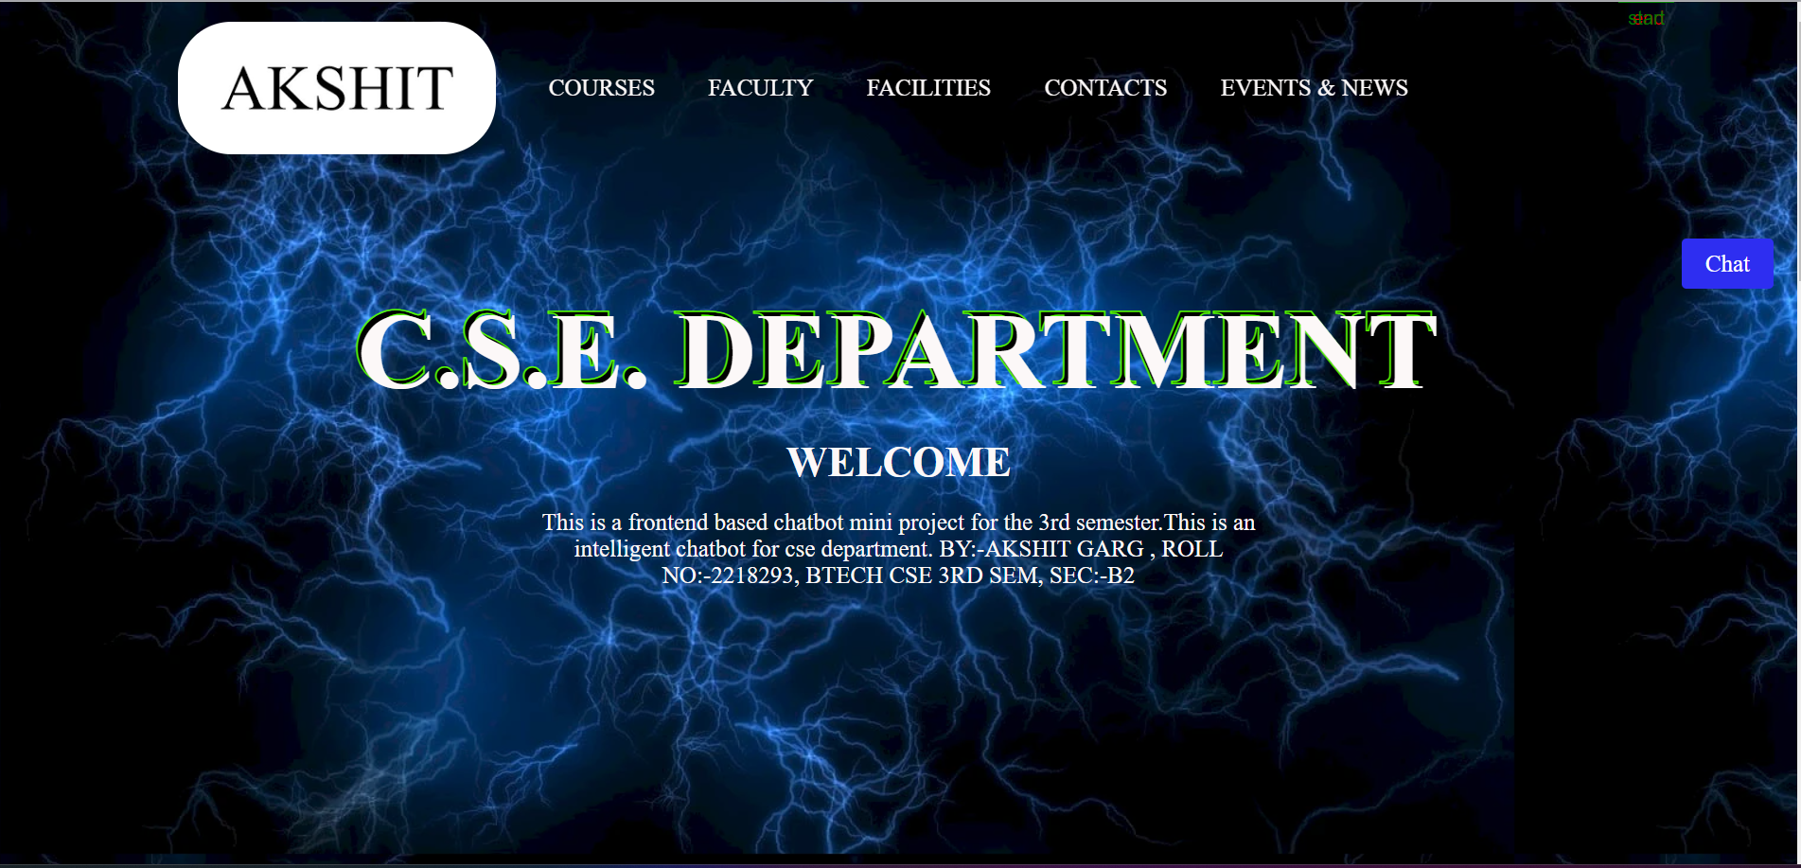
2.Insightful "About Us" Section :

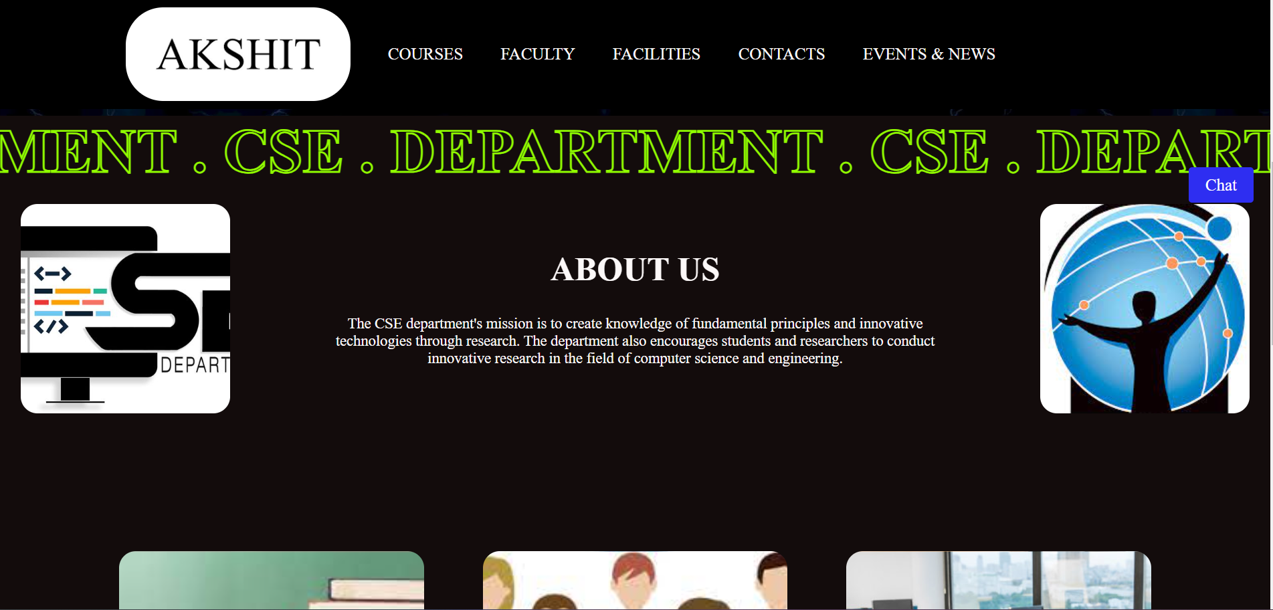

3.Dynamic Chatbot :
Test cases:

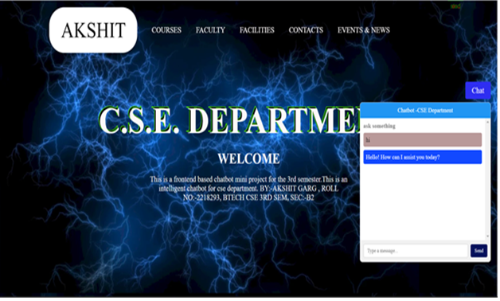

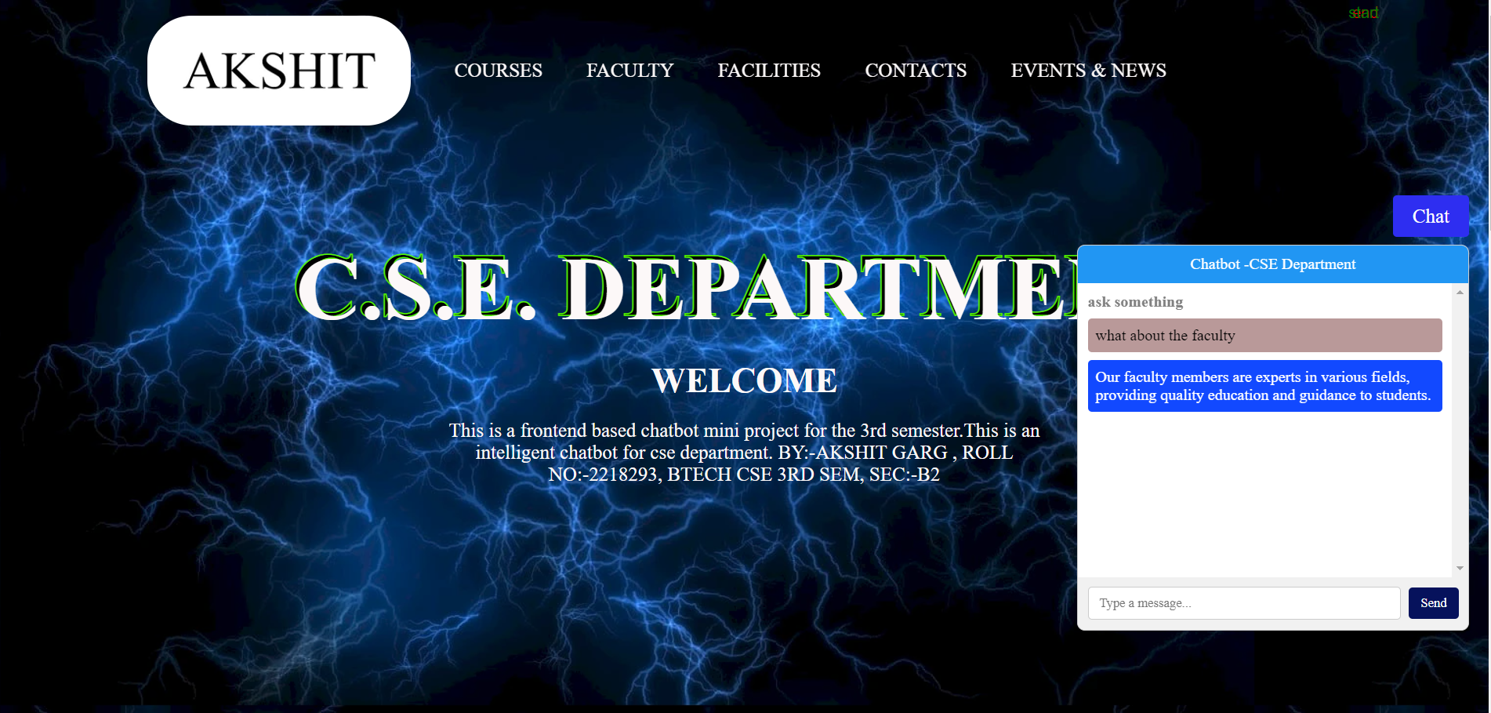

THANK YOU

