1.man
The man page contains documentation of every command available in linux or unix like OS.
The way to access is by typing out man followed by the command we need info about after that.

2.clear
The clear command just clears the entire screen.
3.history
This command gives a list of previously used commands
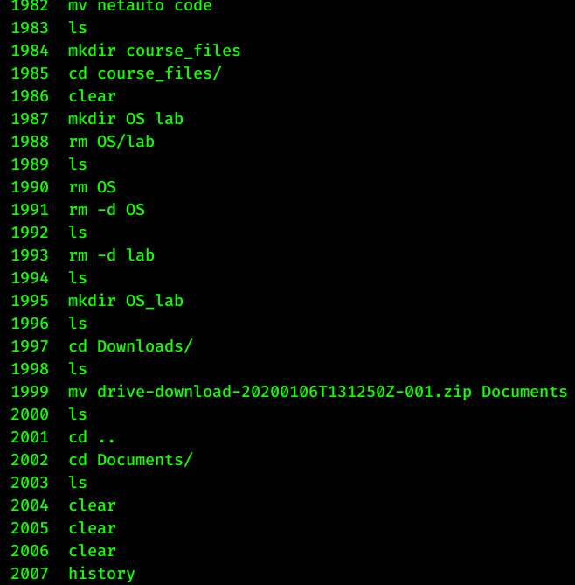

4.date
This can be used to obtain the present date and time on any given moment.
The command without any options gives date in the default options.
If required in a different format we can use date+”The format ”.
ex: date +”Year:%y, Month:%m, Day:%d”
5.Sleep
Sleep command is to be used in scripts.Havent executed it.
6.uptime

My system was up for 1 day and 22 hours when i ran the command.
It also gives the system load in terms of process running and not running.

7.whoami
shows the user currently logged in.
8.id
prints user and group information.It shows the different groups the user belongs to
9.groups
it shows all the different groups the user is part of.
10.passwd
This command can be used to change the password
11.who
this command shows the user logged in to the system and time of login.
12.last
Shows list of logins

13.ls
-Used to list directories and files.It comes with a variety of options to display all the files or display in specific format .
Some important arguments
ls -t : Sorts files based on time modifies
ls -1 : Displays one file per line
ls -l: displays all info including permissions and owner name etc

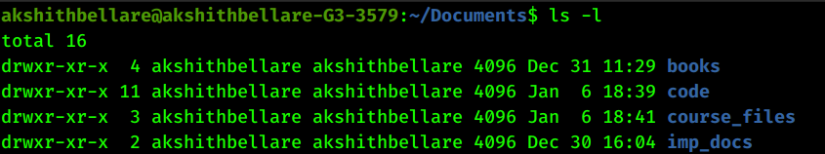

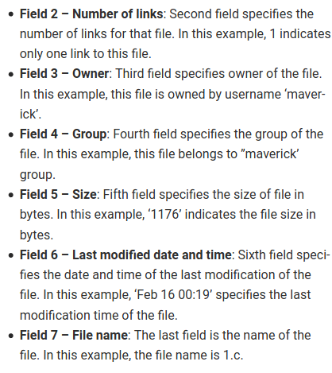

14.cp
Thid command copies files without modifying the original file.
It can also be used to create a new file with the same contents as the original file.

To copy a directory one has to use the -R tag.
.cp -R directory/ destination.

To prompt for confirmation use the -i tag

15.rm
Used to delete files and directories.
Use rm filename to delete the file.
Use rm -d directory_name to delete an empty directory
Use rm -r to recursively delete a nonempty directory.

16.mv
mv command is used to rename files as well as move files from one directory to another
17.chmod
--This command is used to change the permissions for a given file or directory.
18.chown
This is used to change the ownership of a file

19.cat
This command can be used to display the contents of the file in the terminal itself.

To create a file use cat > filename_to_be_created.
This will prompt the user to enter contents of the file

to view multiple files use cat followed by file names
20.more
Used to preview text files in the command prompt.
.more filename can be used to view the text file.
21.less
functions similar to more.
22.head
head displays the first ten lines of the file
23.tail
displays the last ten lines of the file.
24.grep
searches for specific patterns int text files.
Use -i to ignore case
Use -w to search for exact words

25.cd
-used to change directories
-cd~ goes to root directory
-cd.. use to go back one step into the home directory
26.pwd
-shows the present working directory
27.ln
-used to create links betwen files
use to create both hard links and soft links
28.mkdir
-makes a new directory
29.rmdir
-removes an existing directory

30.hostname
gives name of the system being used
31.w
shows who is logged in and what is being doneq
32.uname
prints system info

