EXERCISE 1

1) Create a file called hello.txt that contains the words "hello world". Can you use
"cp" using "terminal" as the source file to achieve the same effect?

Command: dev/stdin hello.txt
it prompts you to enter the text much like cat command.

2)How would you create and then delete a file called "$SHELL"? Try it.

Command: touch \$SHELL
rm \$SHELL

3)What is the output of the command: echo {con,pre}{sent,fer}{s,ed}? Now, from
your home directory, copy /etc/passwd and /etc/group into your home directory in
one command given that you can only type /etc once.

o/p: consents consented confers confered presents presented prefers prefered
Command: sudo / etc / {passwd,group} /home
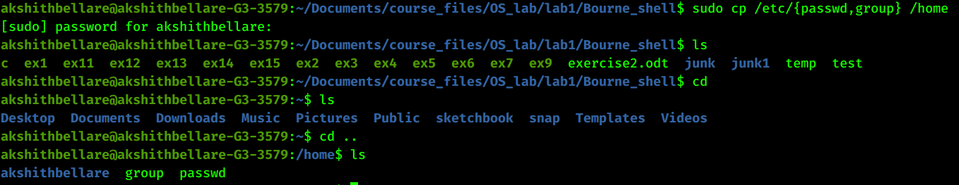

4) Use find and grep and sort to display a sorted list of all files in the /home
subdirectory tree that contain the word hello somewhere inside them.

Command: grep hello .* | sort
The .* indicates all files

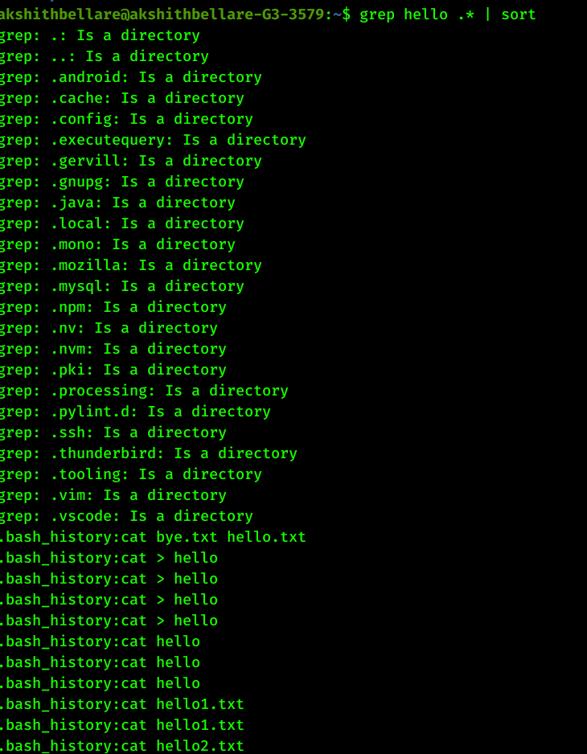

5) Type umask 000 and then create a file called world.txt containing the words
"hello world". Look at the permissions on the file. What's happened? Now type
umask 022 and create a file called world2.txt. When might this feature be useful?

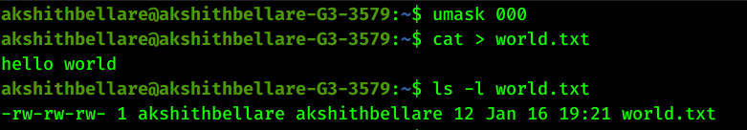
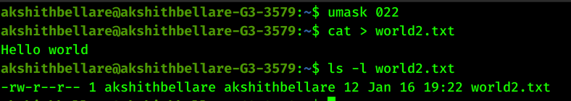
This might come in handy when only the owner of the file should be able to edit a file.

6) Describe three different ways of setting the permissions on a file or directory to
r--r--r--. Create a file and see if this works.

chmod 444 file_name
chmod a=r file_name
umask 222 //Then create your file

7) Run sleep 15 in the foreground, suspend it with Ctrl-z and then put it into the
background with bg. Type jobs. Type ps. Bring the job back into the foreground
with fg.

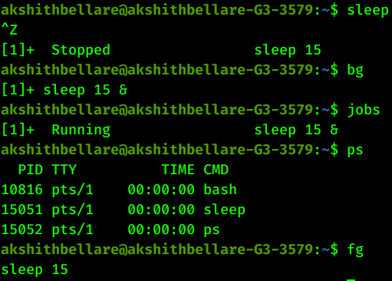

8) Run sleep 15 in the background using &, and then use kill to terminate the
process by its job number. Repeat, except this time kill the process by specifying
its PID.

To kill a process using its job number do
kill %job_number

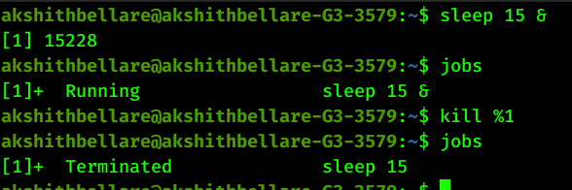

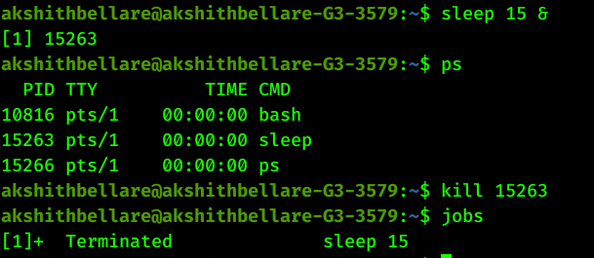
9) Run sleep 15 in the background using &, and then use kill to suspend the
process. Use bg to continue running the process.

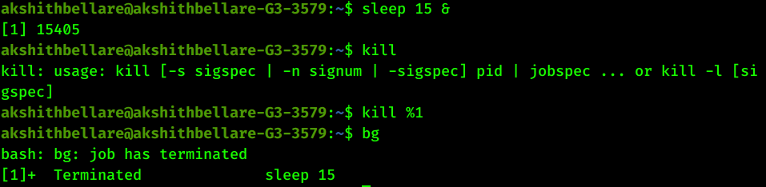

10) Use grep to isolate the line in /etc/passwd that contains your login details.

