EXERCISE 2

1) Write a shell script program to display “HELLO WORLD”.
#!/bin/bash
echo “Hello world”

o/p
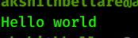

2)Write a shell script program to develop a scientific calculator.
echo "Enter the operation you want to perform"
echo "Enter 1 for addition, 2 for subtraction, 3 for multiplication, 4 for sine value"
read option
case "$option" in
1) echo "Enter the first numnber"
read num1
echo "Enter the second number"
read num2
result=`expr $num1 + $num2`
echo "result $num1 + $num2 : $result"
;;
2) echo "Enter the first number"
read num1
echo "Enter the second number"
read num2
result=`expr $num1 - $num2`
echo "result $num1 - $num2 : $result"
;;

3) echo "Enter the first number"
read num1
echo "Enter the second number"
read num2
result=`expr $num1 '*' $num2`
echo "result $num1 * $num2 : $result"
;;

4) echo "Enter the value"
read num1
result=`echo - | awk '{print cos('$num1')}'`
echo "result : $result"
;;

esac

o/p
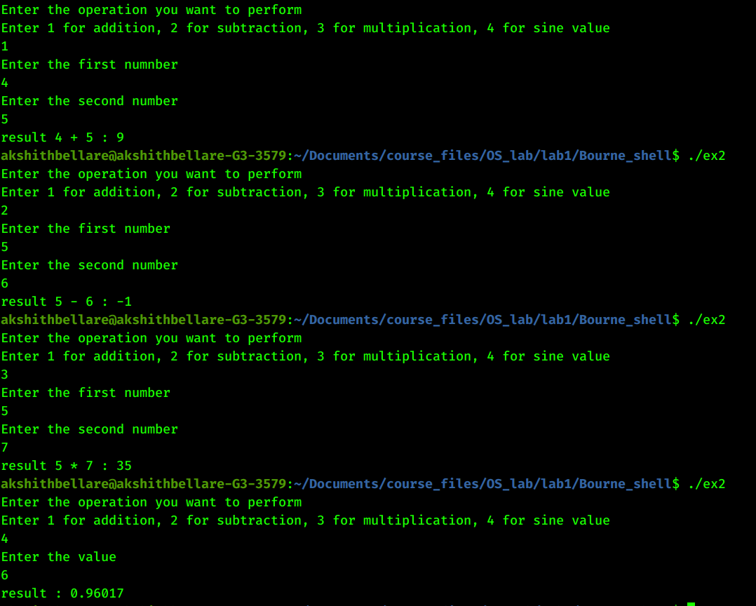

3) Write a shell script program to check whether the given number is even or odd.
echo "Enter number:"
read number
if [ `expr $number % 2` -eq 0 ]
then
echo "Even"
else
echo "Odd"
fi

o/p
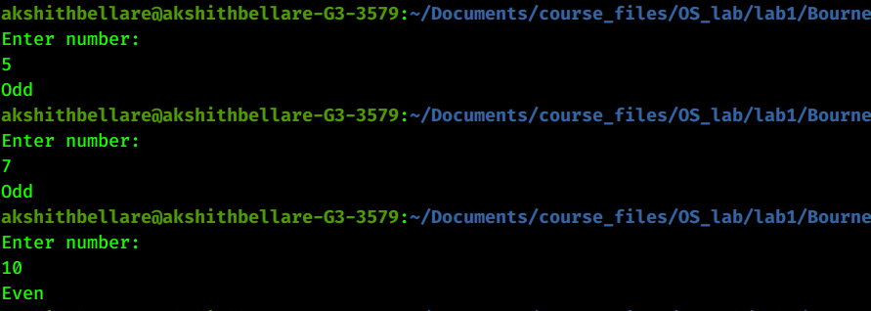

4) Write a shell script Program to search whether element is present in the list or
not.
read -p "How many numbers?" numOfValues

echo "Enter $numOfValues numbers."
arr=()
for (( i = 0; i < numOfValues; i++ ))
do
read n
arr+=( $n )
done

read -p "Enter the search element" num

eleExists=0
for(( i = 0; i < numOfValues; i++))
do
if [ $num -eq ${arr[i]} ]
then
echo "element exists"
eleExists=1
exit 0
fi
done

if [ $eleExists -eq 0 ]
then
echo "Element does'nt exist"
fi

echo "${arr[@]}"

o/p
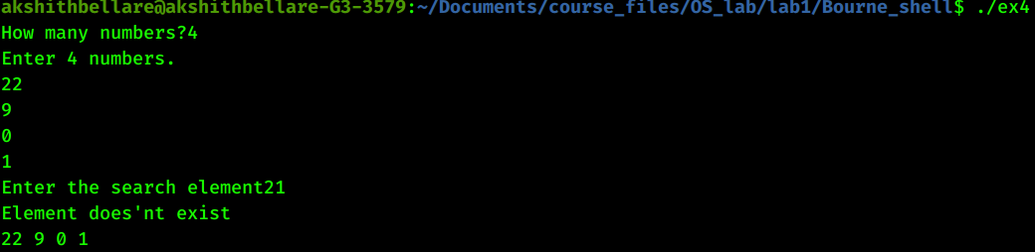

5) Write a shell script program to check whether given file is a directory or not.
echo "Enter filename:"
read filename

ls -l $filename
if [ "$?" -eq 0 ]
then
echo "File exists"
exit 0
else
echo "File doesn't exist"
exit 0
fi

o/p
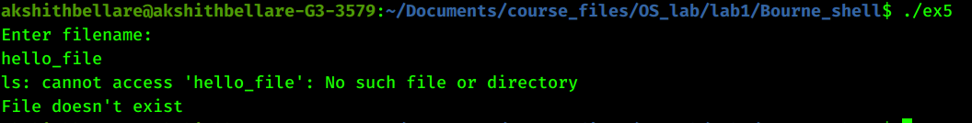

6) Write a shell script program to count the number of files in a Directory
#!/bin/sh
echo "The number of files in the directory: ` expr $(ls -l | wc -l) – 1`"

o/p
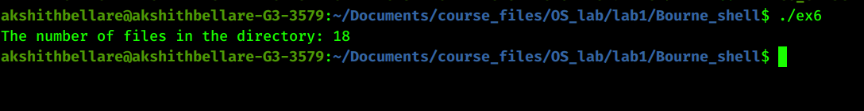

7)Write a shell script program to copy the contents of one file to another.
echo "Enter the first file:"
read file1
echo "Enter the second file:"
read file2
cp $file1 $file2
if [ "$?" -eq 0 ]
then
echo "Copying successful"
else
echo "Copying failed"
fi

o/p
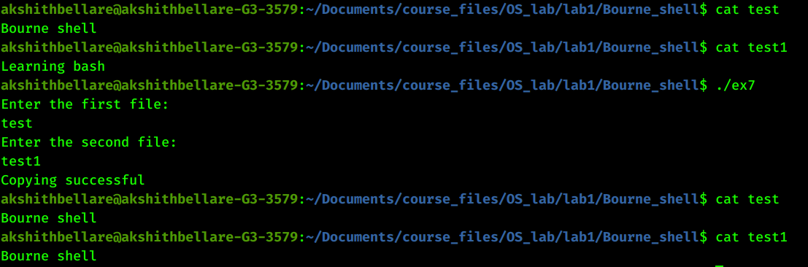

9) Write a shell script that accept a file name starting and ending line numbers as
arguments and display all the lines between given line no
echo "enter the filename"
read fname
echo "enter start"
read s
echo "enter end"
read n
sed -n $s,$n\p $fname | cat > newline
cat newline

o/p
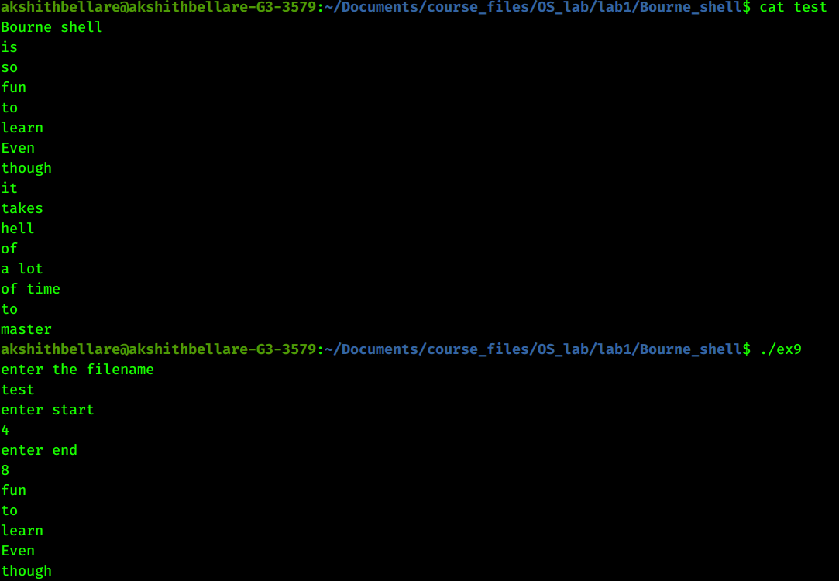

11)Write a shell script that displays a list of all the files in the current directory
ls -1

o/p
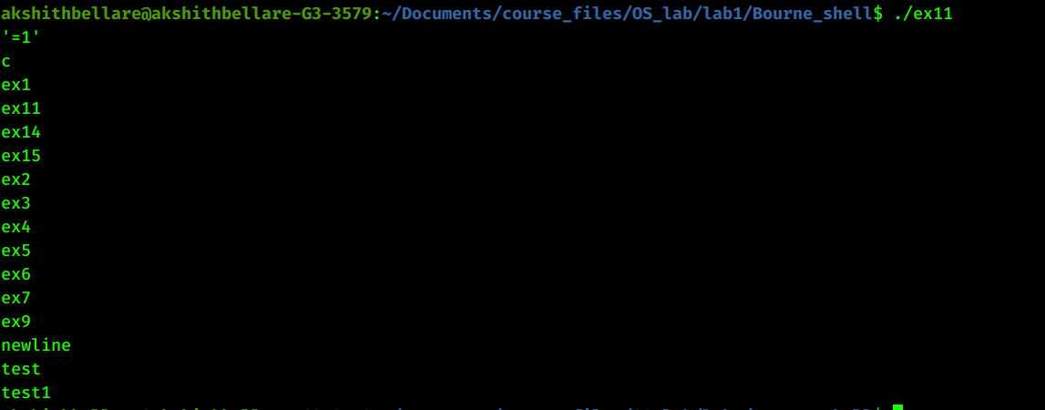

12)Write a shell script that receives any number of file names as arguments checks
if every argument supplied is a file or a directory and reports accordingly
whenever the argument is a file or directory.
for passed in "$@"
do
if [[ -d "$passed" ]]
then
echo "$passed is a directory"
else
if [[ -f "$passed" ]]
then
echo "$passed is a file"
else
echo "$passed is not valid"
exit 1
fi
fi
done
o/p
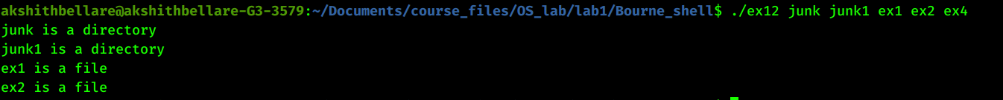
14) Write a shell script to find the factorial of a given integer
echo "Enter the integer:"
read number
factorial=1
while [ $number -ne 0 ]
do
factorial=`expr $factorial '*' $number`
number=`expr $number - 1`
done

echo "factorial is $factorial"

o/p

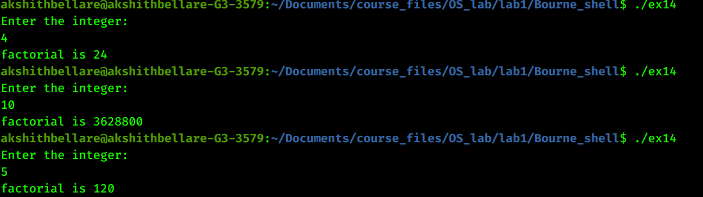

15)Write a shell script to guess the number. In a given range, your program chooses
a random number and allow the user to guess the number
echo "Enter a number between 0-9"
exit=0
while [ $exit -ne 1 ]
do
read a
if ((RANDOM % 10 == a))
then
echo "Right!"
exit=1
fi
done

o/p

