KONERU LAKSHMAIAH EDUCATION FOUNDATION
DEPARTMENT OF COMPUTER SCIENCE AND ENGINEERING
2026–2027 | ODD SEMESTER

INFORMATION ASSURANCE AND SECURITY
(24CS3105)

ALM – PROTOTYPE REVIEW
SENTINEL – INTRUSION DETECTION AND FIREWALL SIMULATOR

PROJECT REPORT SUBMITTED BY
V. AKSHITHA
Roll Number: 2420090105
Cluster: 4 Section: 11

UNDER THE GUIDANCE OF
Dr. Jagan Mohan Reddy Danda
Associate Professor


KONERU LAKSHMAIAH EDUCATION FOUNDATION
Bowrampet, Hyderabad – 500043
Telangana, India
2026–2027

ABSTRACT
SENTINEL is an Intrusion Detection and Firewall Simulator developed as part of the Information Assurance and Security course. The project provides a prototype environment for understanding how firewall policies, security-event monitoring, intrusion alerts and statistical anomaly analysis can be combined in a single security application.
The application contains a web-based interface and a backend service. The backend is implemented using FastAPI, while the frontend uses React with Vite. SQLite is used for persistent storage, and SQLAlchemy provides database interaction. The application exposes API endpoints for managing firewall rules, evaluating packet details, recording security events, retrieving alerts and analysing traffic values.
The firewall module evaluates submitted packet information against configured rules and applies a blocking default policy when no rule permits the packet. The intrusion-detection module processes submitted security events and identifies selected patterns, including repeated failed SSH attempts, Telnet activity and port scanning. The anomaly-detection module applies a statistical Z-score approach to compare a current value with a set of historical values.
The prototype demonstrates these concepts through controlled inputs and API responses. It is intended for educational simulation and testing; it does not claim to capture live network packets or configure the host operating system’s firewall. The report presents the project architecture, modules, implementation approach, observed tests, limitations and possible future enhancements.
Keywords: Information Security, Firewall Simulation, Intrusion Detection, Security Events, Anomaly Detection, FastAPI, React, SQLite.

TABLE OF CONTENTS
Abstract | 2
List of Figures | 4
Chapter 1 – Introduction | 5
1.1 Introduction | 5
1.2 Problem Statement | 5
1.3 Project Overview | 5
1.4 Objectives | 5
1.5 Scope | 5
1.6 Intended Users | 5
Chapter 2 – Technology Stack and Architecture | 6
2.1 Technology Stack | 6
2.2 Technology Description | 6
2.3 System Architecture | 6
2.4 Database Design | 6
Chapter 3 – Project Modules | 7
3.1 Security Overview Dashboard | 7
3.2 Firewall Management Module | 7
3.3 Firewall Rule Creation | 8
3.4 Intrusion Detection Module | 8
3.5 Anomaly Detection Module | 9
Chapter 4 – Implementation | 11
4.1 Backend and API Design | 11
4.2 Main API Endpoints | 11
4.3 Processing Workflow | 11
4.4 API Documentation and Execution | 11
4.5 Running the Application | 12
Chapter 5 – Testing and Results | 13
5.1 Functional Test Cases | 13
5.2 Results and Discussion | 13
Chapter 6 – Limitations, Conclusion and Future Enhancements | 15
6.1 Limitations | 15
6.2 Conclusion | 15
6.3 Future Enhancements | 15
GitHub Repository | 16
References | 16

LIST OF FIGURES
Figure 2.1 Logical architecture of SENTINEL 6
Figure 3.1 SENTINEL Security Overview dashboard 7
Figure 3.2 Firewall rules displayed in the SENTINEL interface 8
Figure 3.3 Successful addition of a TCP BLOCK rule for port 8080 8
Figure 3.4 Intrusion-detection alerts 9
Figure 3.5 Anomaly Detection interface showing an anomalous result for current value 115 9
Figure 3.6 Normal anomaly-detection result 10
Figure 4.1 FastAPI Swagger UI documentation 12
Figure 5.1 Recent security events recorded by the intrusion detection system 14

CHAPTER 1 – INTRODUCTION

1.1 Introduction
Information assurance focuses on protecting information systems and ensuring that information and services remain secure, reliable and available. Network security mechanisms such as firewalls and intrusion-detection systems help administrators observe traffic, apply access policies and identify suspicious activity.
SENTINEL is a software-based simulator designed to demonstrate selected network-security operations. It provides a common interface for viewing the system status, configuring firewall rules, submitting security events and analysing numerical traffic observations. The project combines a frontend interface with backend APIs and a relational database.

1.2 Problem Statement
For learners, firewall decisions and intrusion-detection processes can be difficult to understand when presented only as theoretical concepts. A controlled application is useful for demonstrating how rules affect packet decisions, how repeated or suspicious events can generate alerts, and how unusual numerical observations can be identified. SENTINEL addresses this learning need through a modular simulation that can be tested using predefined inputs.

1.3 Project Overview
The application is organised into four visible areas: Security Overview, Firewall Management, Intrusion Detection and Anomaly Detection. A Security Events area is also provided for viewing event information. Backend services expose endpoints for the operations and store relevant rules, events and alerts in SQLite.

1.4 Objectives
- To develop a web-based prototype that demonstrates selected information-security functions.
- To provide firewall-rule creation and packet-evaluation operations.
- To identify selected suspicious patterns from submitted security events.
- To analyse traffic-related numerical values using a statistical Z-score method.
- To persist firewall rules, security events and intrusion alerts using a database.
- To expose backend operations through REST API endpoints for testing and integration.

1.5 Scope
The scope of the current prototype is limited to simulated inputs and implemented detection rules. Packet evaluation is performed on packet details submitted to the application. Intrusion detection is based on event records submitted to the API, and anomaly detection analyses the numerical values supplied by the user.
The prototype is suitable for demonstrating and testing these mechanisms in a controlled academic environment. Live packet capture, deployment of operating-system firewall rules, enterprise-scale monitoring and production-grade authentication are outside the scope of the current implementation.

1.6 Intended Users
The application is intended primarily for students and evaluators who need to observe basic firewall and intrusion-detection behaviour through a working prototype.

CHAPTER 2 – TECHNOLOGY STACK AND ARCHITECTURE

2.1 Technology Stack
Layer | Technology | Purpose
Frontend | React with Vite | Provides the browser-based user interface and module navigation.
Backend | Python with FastAPI | Provides application logic and REST API endpoints.
Server | Uvicorn | Runs the FastAPI application during development.
Database | SQLite | Stores firewall rules, security events and IDS alerts.
ORM | SQLAlchemy | Maps application models to relational database tables.
API testing | FastAPI Swagger UI | Provides interactive API documentation at /docs.

2.2 Technology Description
React is used to build the interactive frontend. Vite supports the frontend development workflow. FastAPI defines the backend routes and request/response handling. Uvicorn serves the API application locally. SQLite provides lightweight relational persistence, while SQLAlchemy manages database models and sessions.
The Swagger interface generated by FastAPI allows the developer to inspect available routes, submit test requests and view response payloads. This is useful during implementation and functional verification.

2.3 System Architecture
SENTINEL follows a frontend–backend–database structure. A user interacts with the React interface. The interface sends requests to FastAPI endpoints. The backend applies the relevant module logic and reads or writes records through SQLAlchemy. SQLite stores the application data.
USER / SECURITY ANALYST
↓
React + Vite Frontend
Overview | Firewall Management | Intrusion Detection | Anomaly Detection
↓
FastAPI Backend
Firewall Router | IDS Router | Anomaly Router
↓
SQLAlchemy ORM / Database Session
↓
SQLite Database
firewall_rules | security_events | ids_alerts
Figure 2.1: Logical architecture of SENTINEL.

2.4 Database Design
The current database uses SQLite with SQLAlchemy models. The tables are firewall_rules, security_events and ids_alerts. FirewallRuleDB stores rule attributes such as name, protocol, port, action and enabled status. SecurityEventDB stores source IP, event type, port and timestamp. IDSAlertDB stores the source IP, alert type, severity, message and timestamp.

CHAPTER 3 – PROJECT MODULES

3.1 Security Overview Dashboard
The Security Overview page acts as the landing page of the SENTINEL application. It displays the backend connection status and summary cards for security alerts, high-severity alerts, medium-severity alerts and configured firewall rules. The navigation menu provides access to the main security modules.
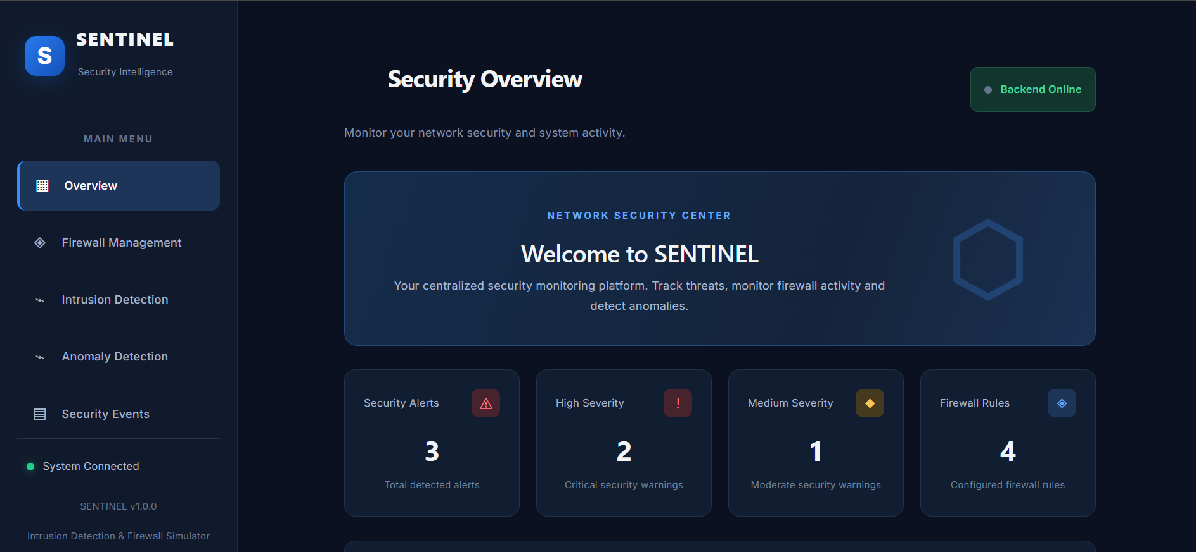
Figure 3.1: SENTINEL Security Overview dashboard.
Figure 3.1 shows the backend as online, together with the dashboard summary values at the time of capture. These values are a snapshot of the application state and change as rules and events are added.

3.2 Firewall Management Module
The Firewall Management module allows a user to create firewall rules and view rules retrieved from the backend database. A rule includes a name, protocol, optional port and action. The supported rule actions include ALLOW and BLOCK. The implementation also supports protocol selection such as TCP, UDP or ANY according to the backend rule model.
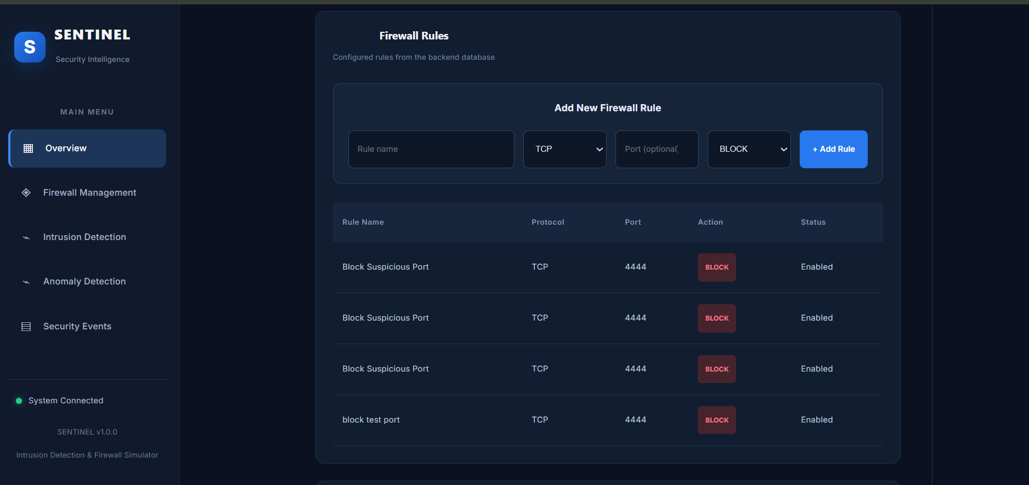
Figure 3.2: Firewall rules displayed in the SENTINEL interface.
Figure 3.2 shows four enabled TCP blocking rules for port 4444, reflecting the saved application state at the time of capture. The same rule appears in all four entries; duplicate rules can be consolidated without changing the packet decision.

3.3 Firewall Rule Creation
A user can submit a new rule through the Add New Firewall Rule form. The frontend sends the rule details to the backend, where the rule is stored for subsequent retrieval and packet evaluation.
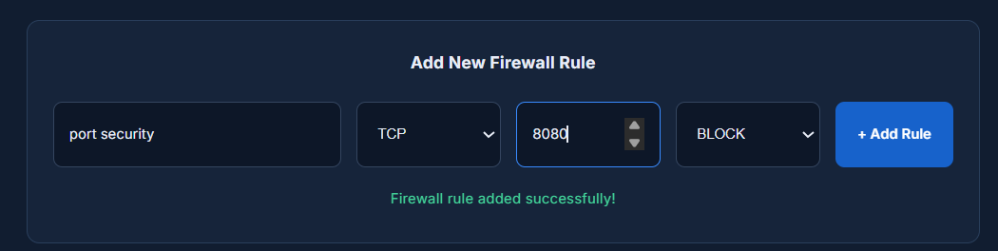
Figure 3.3: Successful addition of a TCP BLOCK rule for port 8080.

3.4 Intrusion Detection Module
The Intrusion Detection module processes security events submitted to the backend. The implemented event categories include failed SSH login attempts, Telnet activity and connection attempts. The detection logic identifies selected patterns: five failed SSH events from the same source IP generate a high-severity SSH brute-force alert; a Telnet event generates a medium-severity alert; and activity involving five different ports from one source IP generates a high-severity port-scan alert.
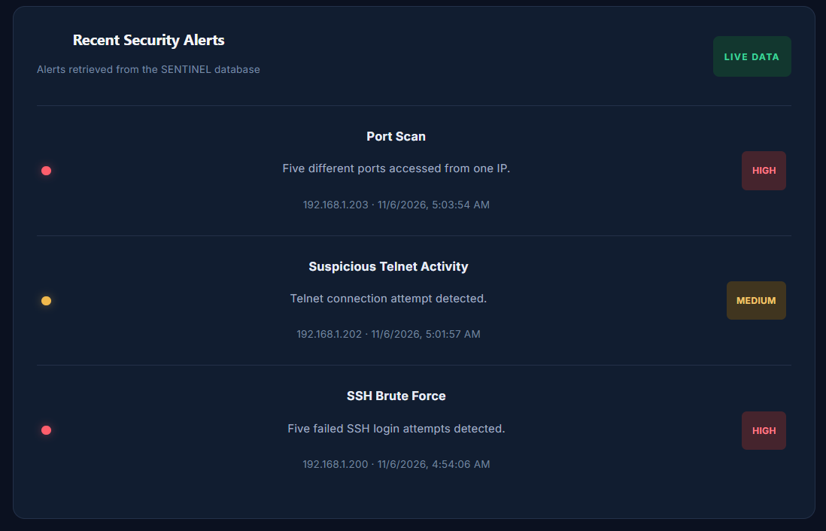
Figure 3.4: Intrusion-detection alerts.

3.5 Anomaly Detection Module
The Anomaly Detection module analyses a sequence of numerical observations and a current value. It calculates the mean and standard deviation of the supplied observations, then uses a Z-score to indicate how far the current value is from the mean in standard-deviation units. The result is classified as normal or anomalous according to the configured threshold in the implementation.
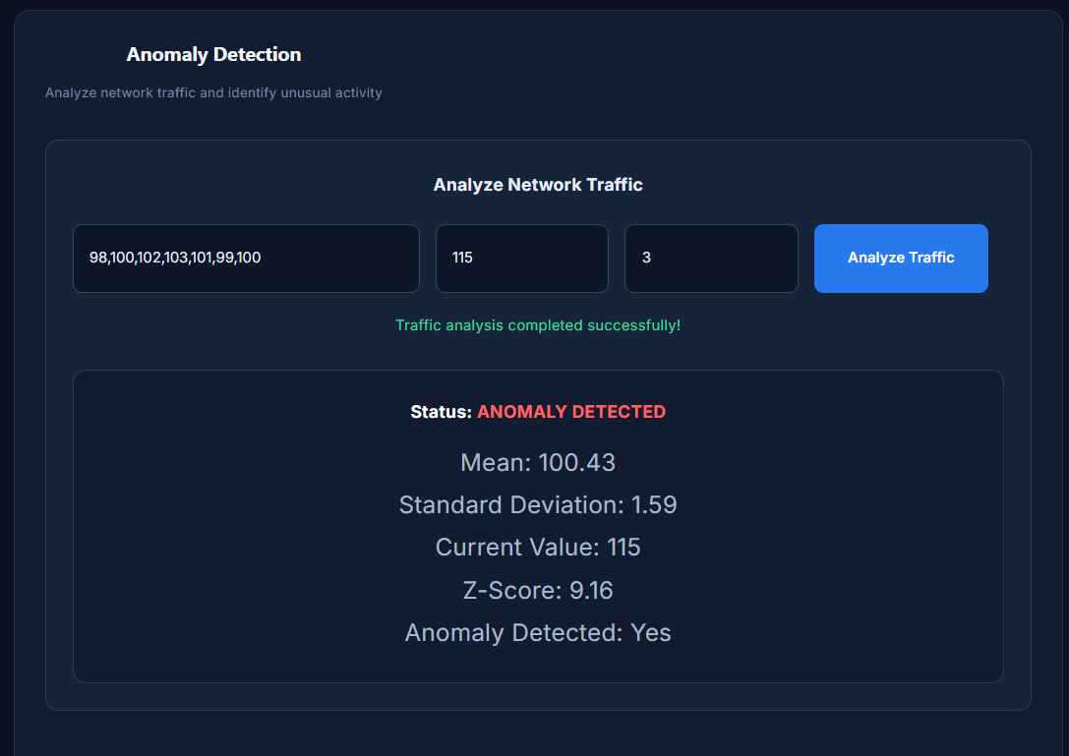
Figure 3.5: Anomaly Detection interface showing an anomalous result for current value 115.
Figure 3.5 reports a mean of 100.43, a standard deviation of 1.59, a current value of 115 and a Z-score of 9.16, with the status ANOMALY DETECTED. Figure 3.6 shows a normal result, in which the current value lies close to the mean and no anomaly is flagged.

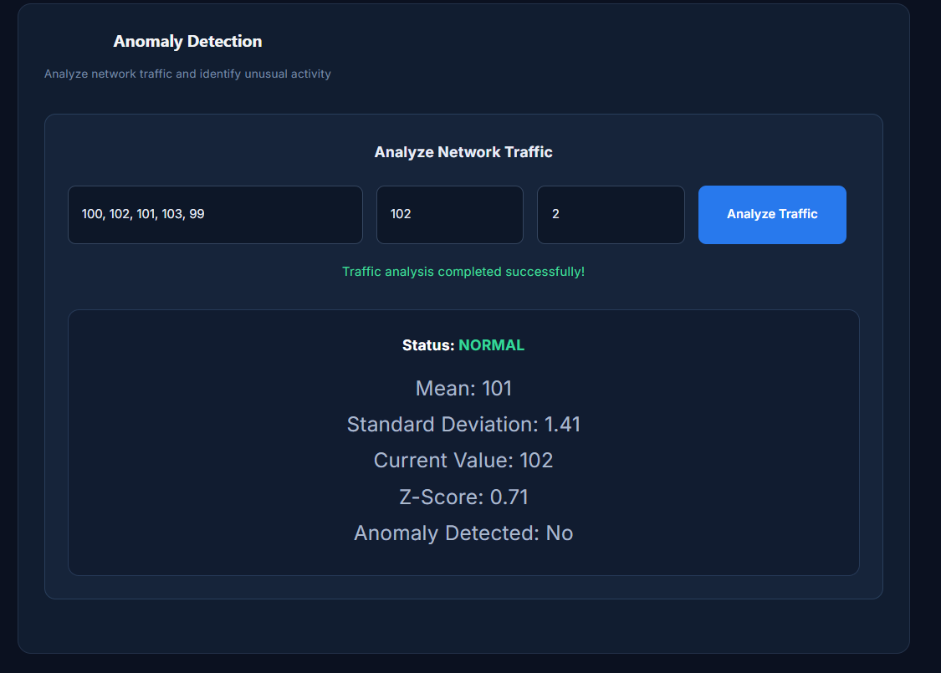
Figure 3.6: Normal anomaly-detection result.

CHAPTER 4 – IMPLEMENTATION

4.1 Backend and API Design
The backend is implemented as a FastAPI application with separate routers for firewall, intrusion-detection and anomaly-analysis operations. Database access is managed through SQLAlchemy sessions. The application includes a root status endpoint and a health endpoint used to confirm that the backend is responding.

4.2 Main API Endpoints
Method | Endpoint | Purpose
GET | /firewall/rules | Retrieve configured firewall rules.
POST | /firewall/rules | Create a firewall rule.
POST | /firewall/evaluate | Evaluate submitted packet information against firewall policy.
POST | /ids/events | Submit a security event for processing.
GET | /ids/events | Retrieve recorded security events.
GET | /ids/alerts | Retrieve generated intrusion-detection alerts.
POST | /anomaly/analyze | Analyse numerical observations and a current value.
GET | /health | Check backend health/status.

4.3 Processing Workflow
- The user selects a module and enters the required input through the frontend or API documentation.
- The frontend sends the request to the corresponding FastAPI endpoint.
- The backend validates the request and executes the module-specific logic.
- Where required, SQLAlchemy reads or updates the SQLite database.
- The backend returns a response that the frontend displays to the user.

4.4 API Documentation and Execution
FastAPI provides interactive API documentation through Swagger UI. During development, the documentation is available at http://127.0.0.1:8000/docs when the backend server is running locally. It lists the registered API routes and allows requests to be submitted for functional testing.
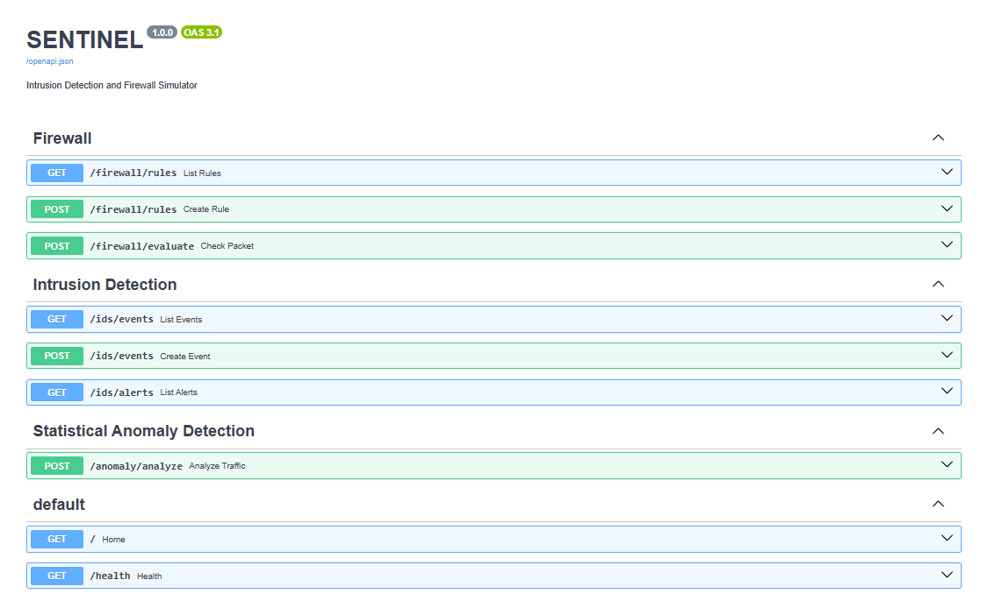
Figure 4.1: FastAPI Swagger UI documentation.

4.5 Running the Application
The backend is started from the backend project directory using the Uvicorn command configured for the application. The frontend is started from its frontend directory using the Vite development command. The local frontend is accessed at http://localhost:5173/ and the backend API at http://127.0.0.1:8000.
The application should be tested with the backend running before opening the frontend, so that API requests can reach the service.

CHAPTER 5 – TESTING AND RESULTS

5.1 Functional Test Cases
Test | Input / API | Expected behaviour | Observed status
Firewall rule retrieval | GET /firewall/rules | Configured firewall rules are returned. | Verified in application screenshot.
Firewall rule creation | POST /firewall/rules | A new rule is stored and returned. | Success message shown for TCP BLOCK port 8080.
HTTP packet evaluation | Port 80 | Configured HTTP rule permits the packet. | Previously observed ALLOW result.
Telnet packet evaluation | Port 23 | Telnet rule blocks the packet. | Previously observed BLOCK result.
Suspicious port evaluation | TCP port 4444 | Custom rule blocks the packet. | Previously observed BLOCK result.
Unmatched port evaluation | Port 8080 | Default policy blocks unmatched traffic. | Previously observed BLOCK result.
SSH brute-force detection | Five failed SSH events from one IP | High-severity SSH brute-force alert is generated. | Observed during API testing.
Telnet event detection | Telnet event | Medium-severity Telnet alert is generated. | Observed during API testing.
Port-scan detection | Five different ports from one IP | High-severity port-scan alert is generated. | Observed during API testing.
Anomaly analysis | Current value 104 | NORMAL result; Z-score 1.28. | Previously observed API response.
Anomaly analysis | Current value 200 | ANOMALY DETECTED; Z-score 44.3. | Previously observed API response.
Note: These are functional observations from manual API and interface testing, not results from an automated test suite.

5.2 Results and Discussion
The observed tests demonstrate that the prototype can create and retrieve firewall rules, evaluate submitted packet details, generate alerts for selected event patterns and classify numerical observations as normal or anomalous. The interface screenshots in Chapter 3 provide evidence of the dashboard, rule-management form, intrusion-detection alerts and anomaly-analysis results, and Figure 5.1 shows the security events recorded during testing.
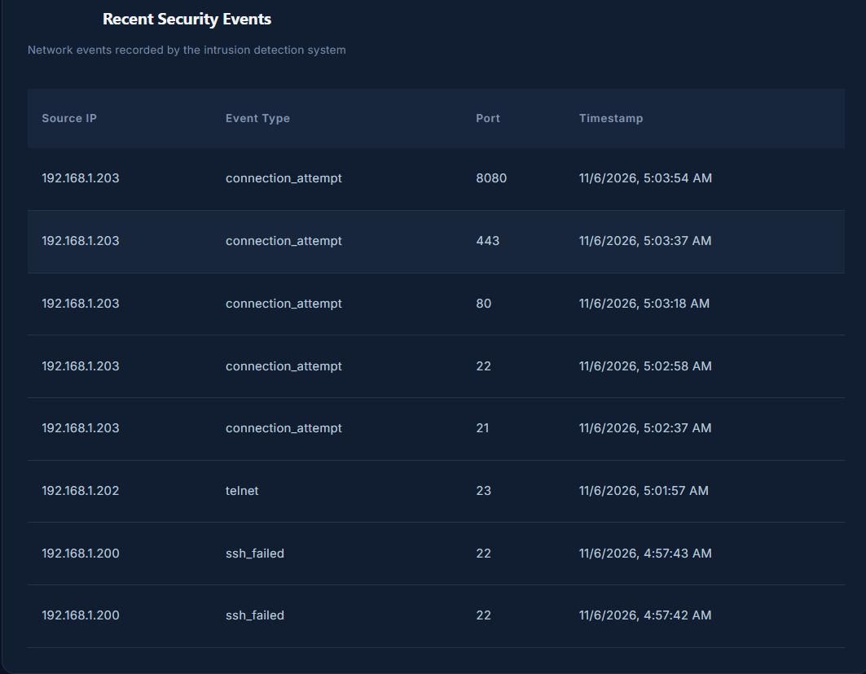
Figure 5.1: Recent security events recorded by the intrusion detection system.

CHAPTER 6 – LIMITATIONS, CONCLUSION AND FUTURE ENHANCEMENTS

6.1 Limitations
- The current project is a simulator and does not perform live network packet capture.
- Firewall decisions are made on submitted packet details; the application does not configure the host operating system firewall.
- Intrusion detection is based on the event types and pattern rules implemented in the prototype.
- The anomaly detector analyses supplied numerical values and is not a trained machine-learning model.
- The prototype is intended for academic demonstration and is not a production network-security platform.

6.2 Conclusion
SENTINEL demonstrates a modular approach to learning basic network-security concepts through a working web application. It combines firewall-rule management, packet evaluation, event-based intrusion detection and statistical anomaly analysis. The use of FastAPI, React, SQLite and SQLAlchemy provides a clear separation between the user interface, backend services and persistent data. Functional testing confirmed the expected behaviour for the implemented scenarios.

6.3 Future Enhancements
- Integrate live packet capture in a controlled and permission-based environment.
- Expand intrusion-detection rules and provide configurable thresholds.
- Add user authentication and role-based access control.
- Introduce exportable event and alert reports.
- Evaluate additional statistical or machine-learning approaches for anomaly detection.

GITHUB REPOSITORY
Project repository: https://github.com/Akshitha-90105/IAS-ALM
The repository holds the source code and project files for the SENTINEL prototype, including the frontend, backend and documentation.

REFERENCES
- FastAPI Documentation. https://fastapi.tiangolo.com/
- React Documentation. https://react.dev/
- Vite Documentation. https://vite.dev/guide/
- SQLAlchemy Documentation. https://docs.sqlalchemy.org/
- SQLite Documentation. https://www.sqlite.org/docs.html
- Uvicorn Documentation. https://www.uvicorn.org/
The implementation descriptions and test observations in this report are based on the project details, screenshots and manual testing carried out during development.

