
DEPARTMENT OF CSE
PROJECT ABSTRACT SUBMISSION
COURSE:ADAPATIVE SOFTWARE ENGINEERING PROJECT– 1
A.Y. 2026 - 2027
TITLE OF THE PROJECT | AI-Driven Requirements Prioritization and Change Impact Analysis System
S. No. | University ID | Name
1 | 2420090122 | M.Suchita
2 | 2420090105 | V.Akshitha(Team lead)
3 | 2420030601 | B.Niharika
4 | 2420030628 | P.Akshaya
Name of the Guide

Abstract
AI-Driven Requirements Prioritization and Change Impact Analysis System is a software engineering platform designed to assist development teams in managing software requirements and adapting to changes efficiently. In large software projects, requirements frequently change during development, making it difficult to determine their priority and understand which modules or components may be affected. The proposed system uses Natural Language Processing (NLP) and machine learning techniques to analyze requirements written in natural language, classify their importance, identify relationships between requirements, and detect potential conflicts.
The system allows users to add, modify, and manage software requirements through an interactive web interface. Based on requirement characteristics and their relationships with existing requirements, the system assigns priority levels and estimates the potential impact of proposed changes. It can identify related requirements and affected software modules, helping developers make informed decisions before implementing changes. The platform also maintains requirement history and provides visual insights into priorities, dependencies, and change risks.
The system is implemented using React.js, FastAPI, Python, NLP, Scikit-learn, Sentence Transformers, PostgreSQL, GitHub API, and Docker. By combining automated requirement analysis with change-impact prediction, the proposed solution aims to reduce manual effort, improve requirement traceability, minimize development risks, and support adaptive and efficient software development.
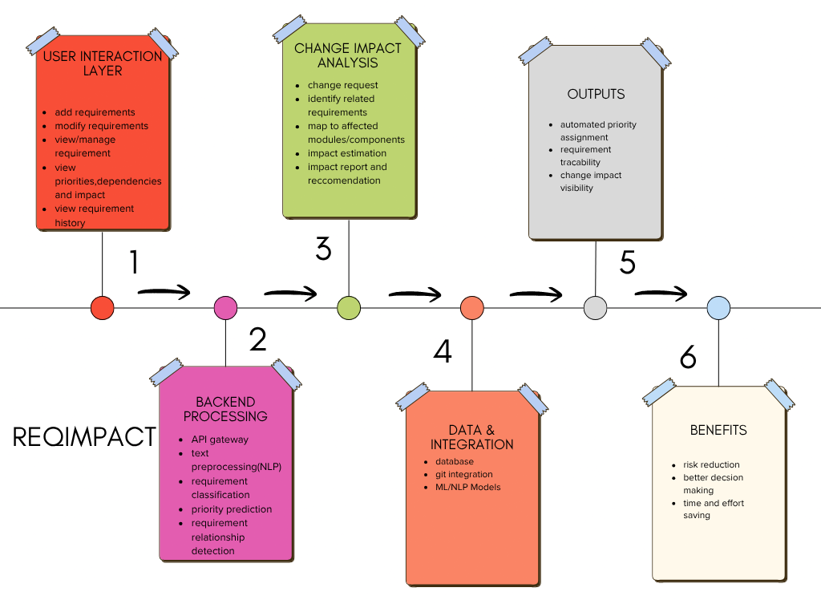

Signature of the Guide HOD

