Centralized Attendance

A Course Project Report
Submitted in the partial fulfillment of the completion of the course
23CS302PC303- High Performance Computing
In III-Year II-Semester B.Tech - CSE
Submitted by
ANYAM AKSHITHA
2303A52453

Under the supervision of the faculty
Dr. Sri Raman Kothuri
Associate Professor, SoCS&AI
Academic Year: 2025–2026



Department of Computer Science and Artificial Intelligence
SR University
Warangal, Telangana, India.

INDEX

- Introduction

- Problem Statement

- Methodology

- Procedure

- Implementation

- Output

- Result

- Conclusion

- References

1.INTRODUCTION:
Weather Modeling simulations are used to predict temperature and climate changes over different regions. These simulations divide a geographic area into grids, where each cell represents a specific region.
The temperature in each cell depends on neighboring cells. Traditional serial computation takes longer for large grids, as each cell is updated one by one. Parallel computing allows multiple grid cells to be updated simultaneously, reducing computation time and making large simulations feasible.
This project demonstrates a simple weather modeling simulation using serial and parallel processing, and compares their execution times.

2.PROBLEM STATEMENT:
Weather modeling simulations require the computation of temperature changes across a large geographic area. Updating each cell in a temperature grid sequentially can take a significant amount of time, especially for high-resolution grids. Traditional serial computation is inefficient for such large-scale simulations.
The problem addressed in this project is: how to efficiently simulate weather modeling by updating grid temperatures while reducing computation time.
By implementing parallel processing techniques, the simulation can process multiple regions of the grid simultaneously, thereby improving performance and demonstrating the practical application of High-Performance Computing (HPC) in weather modeling.

3. METHODOLOGY
The methodology describes how the Weather Modeling Simulation using Parallel Computing is implemented, from creating the temperature grid to measuring performance improvements.
3.1 Creating the Temperature Grid
- The simulation begins by creating a 2D temperature grid using Python’s NumPy library.
- Each cell in the grid represents a small geographic region and contains a temperature value.
- The temperature values are randomly generated within a realistic range (e.g., 20–35°C) to simulate initial weather conditions.
EXAMPLE:
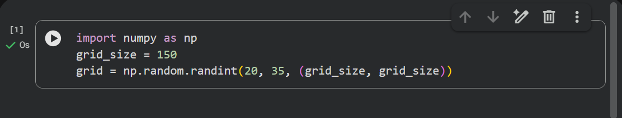
- Here, grid_size = 150 creates a 150×150 temperature grid.
- Each element represents the temperature of a region in degrees Celsius.

3.2 Updating Grid Cells (Simulation Step)
- Each cell’s temperature is updated based on the average of its four neighbors (top, bottom, left, right).
- This simulates the diffusion of temperature across regions, a basic principle used in weather modeling.
- Edge cells are excluded or handled separately to avoid index errors.
Formula:
$$\text{new_cell}=\frac{\text{top}+\text{bottom}+\text{left}+\text{right}}{4}$$
This step is repeated for all grid cells in each simulation iteration.

3.3 HPC Usage
Serial Execution
- In the serial approach, each cell is updated one by one, using nested loops over rows and columns.
- This approach is simple but can be time-consuming for large grids, as all calculations are done sequentially.

Parallel Execution Using Multiprocessing
- In the parallel approach, the grid is divided into chunks, and each chunk is assigned to a separate process.
- Python’s multiprocessing module is used to create multiple worker processes.
- Each process updates its assigned rows simultaneously, reducing overall execution time.
Key Steps:
- Divide grid into N chunks (N = number of processes).
- Assign each chunk to a process.
- Update cells in each chunk independently.
- Combine results from all processes to form the updated grid.
Advantages:
- Computation is done concurrently.
- Reduces execution time compared to serial computation.
- Demonstrates the efficiency of High-Performance Computing in simulations.

3.4 Measuring Performance
- Python’s time module is used to measure execution time for both serial and parallel implementations.
- Comparison shows how parallel execution reduces computation time.

3.5 Flow Diagram (Optional Visual)
You can insert a simple flowchart in Word using shapes or SmartArt:
Start → Create Temperature Grid → Update Grid Cells → Serial / Parallel Execution → Measure Execution Time → Output Results → End

3.6 Summary
The methodology demonstrates a step-by-step approach for simulating weather changes in a grid, comparing serial and parallel execution, and showcasing the advantages of parallel computing in reducing computation time.

4. PROCEDURE
1.Start the simulation program.
2. Create a temperature grid:
- Use Python’s NumPy library to generate a 2D array of size NxN (e.g., 150×150).
- Fill each cell with a random temperature value between 20°C and 35°C.
3. Update the grid cells:
- For each cell (excluding edges), calculate the new temperature as the average of its four neighbors (top, bottom, left, right).
4. Serial Execution:
- Update all cells sequentially using nested loops over rows and columns.
- Record the execution time using Python’s time module.
5. Parallel Execution:
- Divide the grid into chunks based on the number of processes (e.g., 4).
- Assign each chunk to a separate process using Python’s multiprocessing module.
- Each process updates its assigned rows simultaneously.
- Combine results from all processes to form the updated grid.
- Record the execution time.
6. Compare Execution Times:
- Compare the serial and parallel execution times to observe performance improvement.
7. Visualize the Temperature Grid (Optional):
- Use matplotlib to plot a heatmap of the grid for visual representation.
8. End the program.

5. IMPLEMENTATION
5.1 Import Required Libraries
import numpy as np
import time
from multiprocessing import Pool
import matplotlib.pyplot as plt
5.2 Create the Temperature Grid
grid_size = 150
grid = np.random.randint(20, 35, (grid_size, grid_size))
- Creates a 150×150 grid.
- Each cell contains a random temperature value between 20°C and 35°C, simulating initial weather conditions.
5.3 Serial Execution Function
Code
def update_serial(grid):
new_grid = grid.copy()
for i in range(1, grid.shape[0] - 1):
for j in range(1, grid.shape[1] - 1):
new_grid[i][j] = (
grid[i-1][j] +
grid[i+1][j] +
grid[i][j-1] +
grid[i][j+1]
) / 4
return new_grid

# Create temperature grid
grid_size = 300
grid = np.random.randint(20, 35, (grid_size, grid_size))

start = time.time()
updated_grid = update_serial(grid)
print("Serial execution time:", time.time() - start, "seconds")

Explanation:
- Each cell is updated sequentially, one by one.
- The new temperature is the average of its four neighbors.
- Execution time is recorded using time.time().
  - Parallel Execution Function
Code
def process_chunk(args):
grid, start, end = args
part = grid.copy()

for i in range(start, end):
for j in range(1, grid.shape[1] - 1):
part[i][j] = (
grid[i-1][j] +
grid[i+1][j] +
grid[i][j-1] +
grid[i][j+1]
) / 4

return part[start:end]

def update_parallel(grid, workers=4):
chunk_size = grid.shape[0] // workers
tasks = []

for i in range(workers):
start = max(1, i * chunk_size)
end = min(grid.shape[0] - 1, (i + 1) * chunk_size)
tasks.append((grid, start, end))

with mp.Pool(workers) as pool:
results = pool.map(process_chunk, tasks)

return np.vstack(results)

if __name__ == "__main__":
grid_size = 300
grid = np.random.randint(20, 35, (grid_size, grid_size))

start = time.time()
updated_grid = update_parallel(grid, workers=4)
print("Parallel execution time:", time.time() - start, "seconds")

Explanation:
- The grid is divided into chunks, one for each process.
- Each process updates its assigned rows simultaneously.
- The results are combined into a single updated grid.
- This demonstrates the performance advantage of parallel computing.
5.5 Visualizing the Temperature Grid
plt.imshow(grid, cmap='hot')
plt.colorbar()
plt.title("Temperature Grid Heatmap")
plt.show()
- Displays a heatmap of the temperature grid.
- Helps visualize temperature distribution across the regions.

6. OUTPUT
6.1 Serial Execution Function
Output
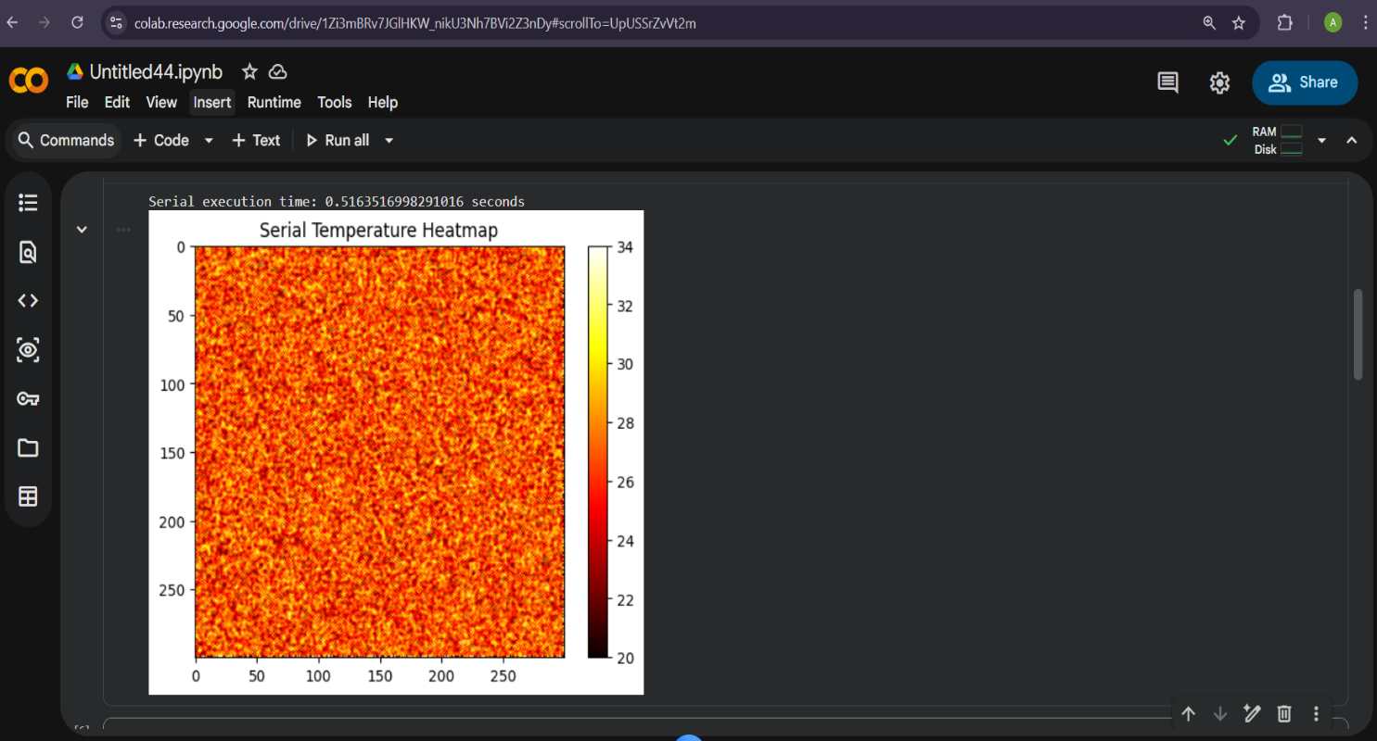

6.2 Parallel Execution Function
Output
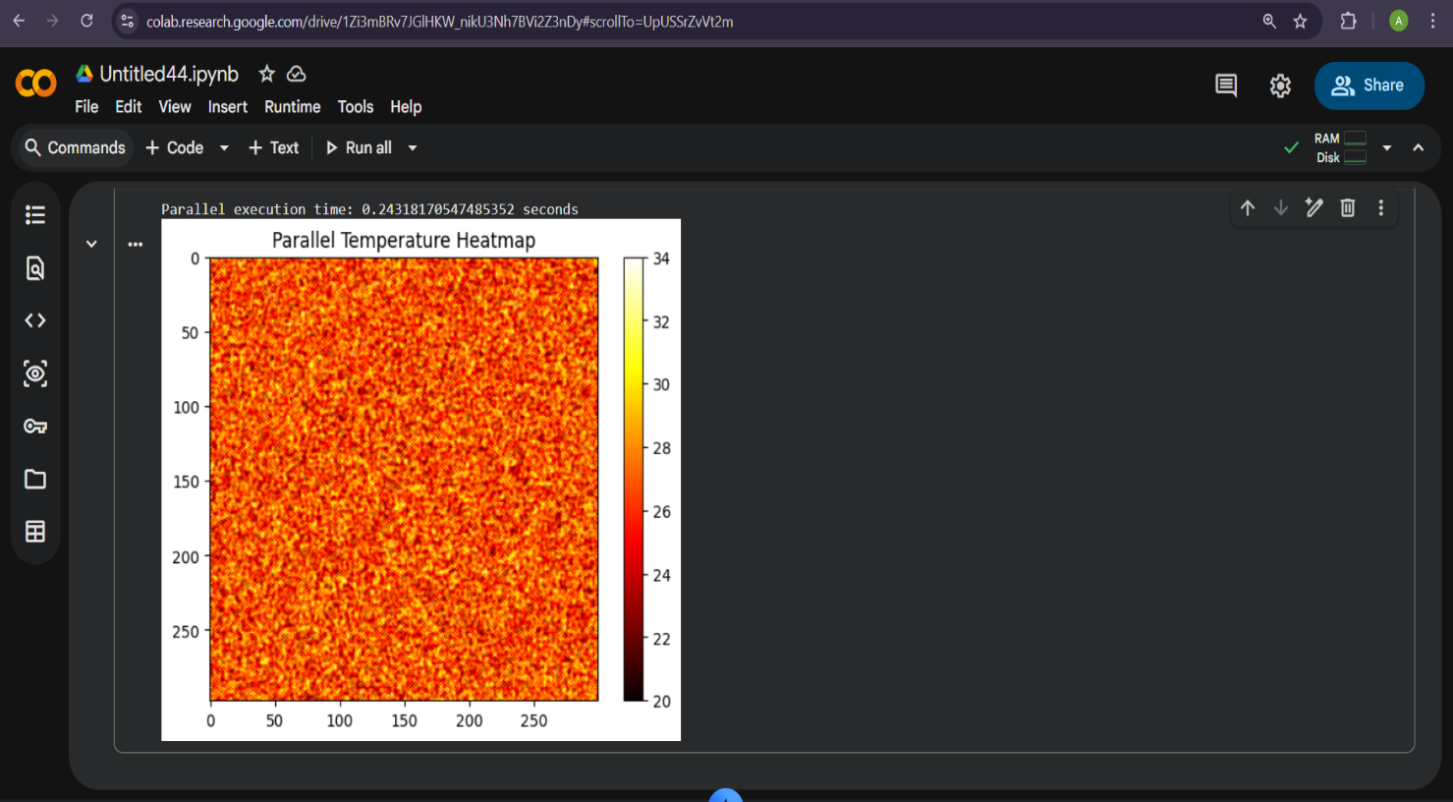

7. RESULT
The results show a performance difference between serial and parallel execution.
- Serial execution updates grid cells one by one.
- Parallel execution updates multiple rows simultaneously using multiprocessing.
- The execution time for parallel computation is generally lower than serial execution, especially for larger grid sizes.
This demonstrates that parallel computing improves computational efficiency in simulation-based applications like weather modeling.
The project successfully shows how grid-based numerical simulations can benefit from High-Performance Computing techniques.

8.CONCLUSION
This project implemented a weather modeling simulation using a temperature grid in Python.
Both serial and parallel approaches were developed to update grid cells using neighbor averaging.
The comparison of execution times shows that parallel processing reduces computation time by distributing the workload across multiple processes.
The project demonstrates:
- Grid-based simulation concepts
- Serial vs parallel computation
- Performance measurement using execution time
- Practical use of multiprocessing in Python
Overall, the project highlights the importance of parallel computing in scientific simulations and weather modeling applications.

9.REFERENCES
- Python Software Foundation. Python 3 Documentation. Available at: https://docs.python.org/3/

- NumPy Developers. NumPy User Guide and Documentation. Available at: https://numpy.org/doc/

- Grama, A., Gupta, A., Karypis, G., & Kumar, V. Introduction to Parallel Computing. Pearson Education.

