**Exp No:1**

**Analyze the problem and come with the entities in it . Identify what data has to be persisted in ithe databases(ER-MODEL)**

**The Following are the entities and relationships:**

**1 .Bus(Entity)**

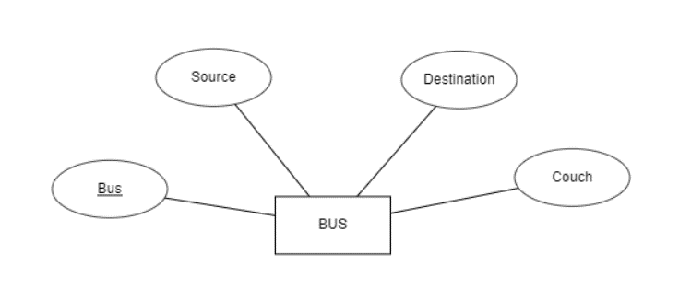

**2.Passenger(Entity)**

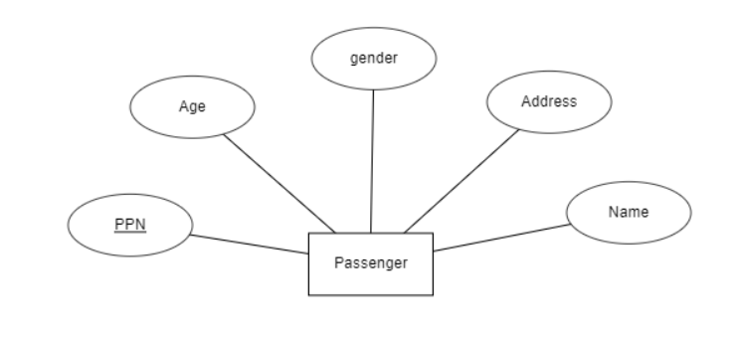

**3.Reservation(Relationship)**

