**Exp No: 10 Writing triggers Database Triggers:**

show databases;

use db;

show tables;

create table testdata(name varchar(20) primary key, sub varchar(10),marks int);

desc testdata;

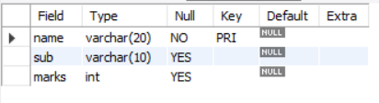



insert into testdata(name,sub, marks) values("akshitha", "Maths",24);

insert into testdata(name, sub,marks) values("soumya","Science",25);

insert into testdata(name,sub, marks) values("thulasi","English",23);

select * from testdata;

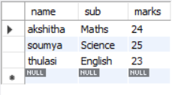

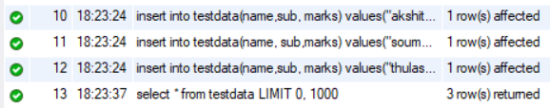

create table test_audit(name varchar(20),sub varchar(10), marks int);

desc test_audit;

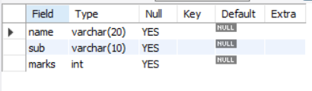



create trigger t

before insert on testdata

for each row

insert into test_audit set name = new.name, sub = new.sub, marks = new.marks + 10;

insert into testdata values ("sahithi", "Arts",12);



show triggers;

select * from testdata;

update testdata set name = "siri" where name = "sahithi";

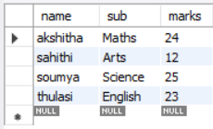

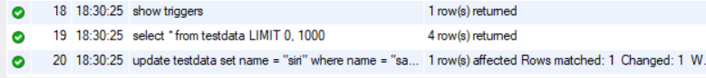

select * from test_audit;

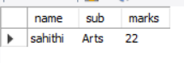



show triggers;



