**Ex 4 – 5 : Practicing DDL Commands (Data Definition Language)**

**• Create table command**

**• Alter table command**

**• Truncate table command**

**• Drop table command**

CREATE schema employee;

use employee;

CREATE TABLE employees

(emp_id numeric(10) primary key, DOB date, f_name varchar(20), l_name varchar(20),date_of_join date,salary numeric,gender varchar(10),age varchar(10));

desc employees;

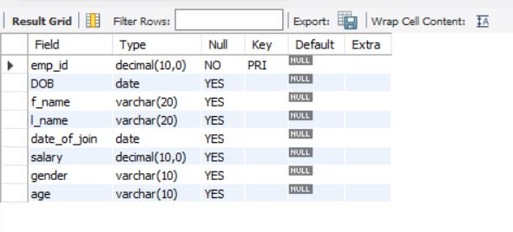



alter table employees add email varchar(20);

alter table employees add address varchar(50);

desc employees;

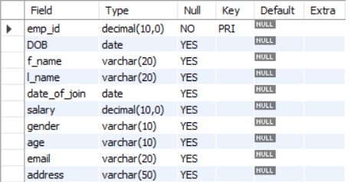



truncate employees;

desc employees;

drop table employees;

desc employees;

