**Exp No: 6 Applying DML commands on Road Way Travels Tables. Data Manipulation Command**

**• Insert**

**• Update**

**• Delete**

**• Select**

INSERT into employees values

(102,'2001-10-10','akshitha','bichala','2019-04-10',60000,'Female',19),

(115,'1999-03-15','abhilash','bichala','2018-02-01',75000,'Male',21),

(105,'1999-07-05','abhishek','bichala','2017-02-01',65000,'Male',22);

SELECT * FROM employees;

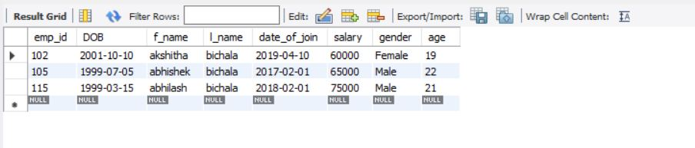

alter table employees add phoneno numeric;

update employees set phoneno = 9396485273 where emp_id=102;

update employees set phoneno = 9397519905 where emp_id=105;

update employees set phoneno = 8639001586 where emp_id=115;

alter table employees drop age;

SELECT * FROM employees;

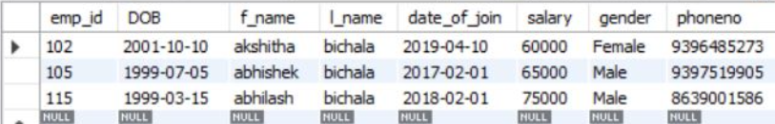

SELECT distinct gender from employees;

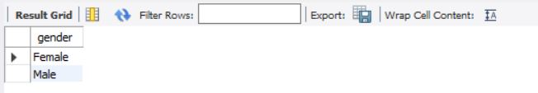

SELECT phoneno from employees where emp_id=115;

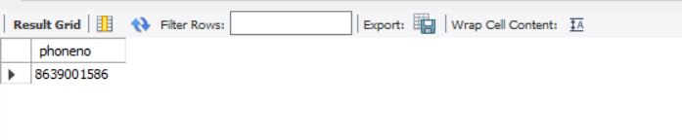

SELECT count(distinct gender) from employees;

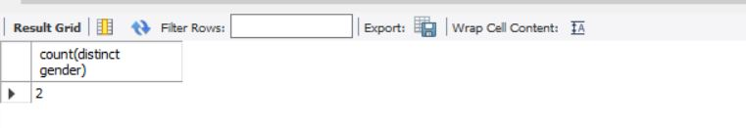

SELECT *FROM employees where salary>60000 ;

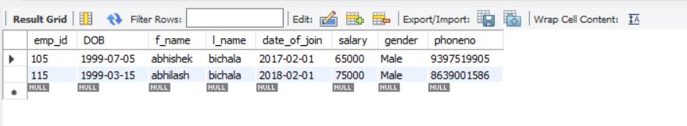

UPDATE employees set f_name='venkat' where emp_id = 105;

SELECT * FROM employees;

insert into employees values(100,'2000-01-10','sona','bichala','2019-04-10',55000,'Female',20);

SELECT * FROM employees;

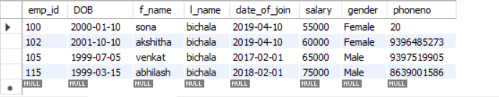

delete from employees where emp_id = 100;

SELECT * FROM employees;

