## Exp No:7 Practice Queries using ANY, ALL, IN, EXISTS, UNION, INTERSECT Set Operators

select * from sailors;

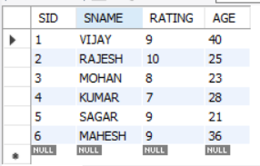

select * from boats;

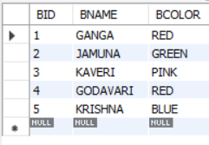

select * from reserves;

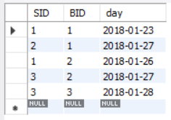

desc sailors;

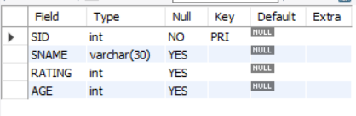

SELECT S.SID, S.SNAME, S.RATING, S.AGE FROM

SAILORS AS S WHERE S.RATING > 8;

desc boats;

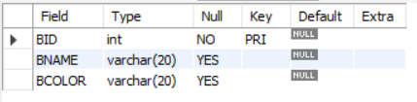

#Any

select * from boats;

select BCOLOR from boats

where BID = ANY (select BID from reserves where day='2018-01-27');

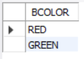

#All

select all BNAME from boats where true;

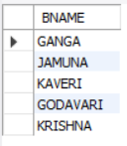

#Exists

select BNAME from boats

where Exists

(select RATING from sailors where sailors.SID = boats.BID and RATING >= 8);

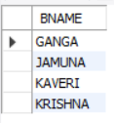

#in

select * from boats

where BCOLOR in ('PINK' , 'BLUE');

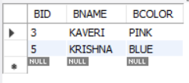

#union

select BNAME from boats union select SNAME from sailors;

