**Exp No 8_9:**

**Practice Queries using Aggregate functions, Group By, Having Clause and Order by Clause.**

use dbs;

# Find the sailors with the highest rating.

SELECT MAX(RATING), MIN(AGE), AVG(AGE), SUM(AGE) FROM SAILORS;

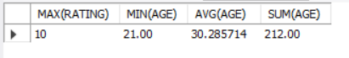

# Find the name and age of oldest sailor

SELECT SNAME,AGE FROM SAILORS WHERE AGE=(SELECT MAX(AGE) FROM SAILORS);



# Find the age of the youngest sailor for each rating level.

SELECT RATING, MIN(AGE) FROM SAILORS GROUP BY RATING;

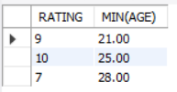

# Find the age of the youngest sailor who is eligible to vote (i.e, is at least 18 years old) for each rating level with at least two such sailors.

SELECT RATING, MIN(AGE) FROM SAILORS WHERE AGE>=18 GROUP BY RATING HAVING COUNT(SID)>1;

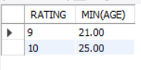

# Find all sailors name according to names

SELECT SNAME FROM SAILORS ORDER BY SNAME;

