**Exp No: 9 Views:**

use db;

create table Product(PID int, Pname varchar(10), cid int, price int);

insert into Product values(1,"fruits",1,18);

insert into Product values(2,"milk",1,19);

insert into Product values(3,"tofu",2,6);

insert into Product values(4,"bread",7,25);

insert into Product values(5,"butter",3,30);

insert into Product values(6,"oil",3,11);

select *from Product;

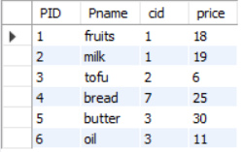

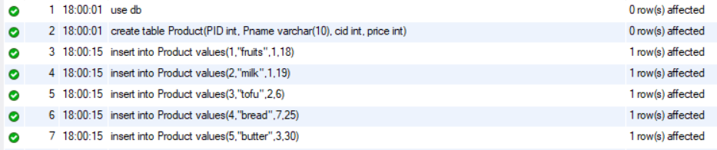

create view ProductAboveAveragePrice as select Pname, price from Product where price > (select AVG(price) from product);

select * from ProductAboveAveragePrice;

