# Phase 4: Process Automation (Admin)

This document captures all **automation configurations** in Phase 4 of the Salesforce Smart City Waste Management project.

## Validation Rules

**Object: Pickup Request**

1. **No Past Pickup Date**
   * Rule Name: No_Past_Pickup_Date
   * Formula:
   * Pickup_Date__c < TODAY()
   * Error: “Pickup Date cannot be in the past.”
   * Error Location: Pickup Date field.
2. **Address Required if Status = New**
   * Rule Name: Address_Required_New
   * Formula:
   * AND(  
      ISPICKVAL(Status__c, "New"),  
      ISBLANK(Address__c)  
     )
   * Error: “Address is required when creating a new request.”
   * Error Location: Address field.
   * 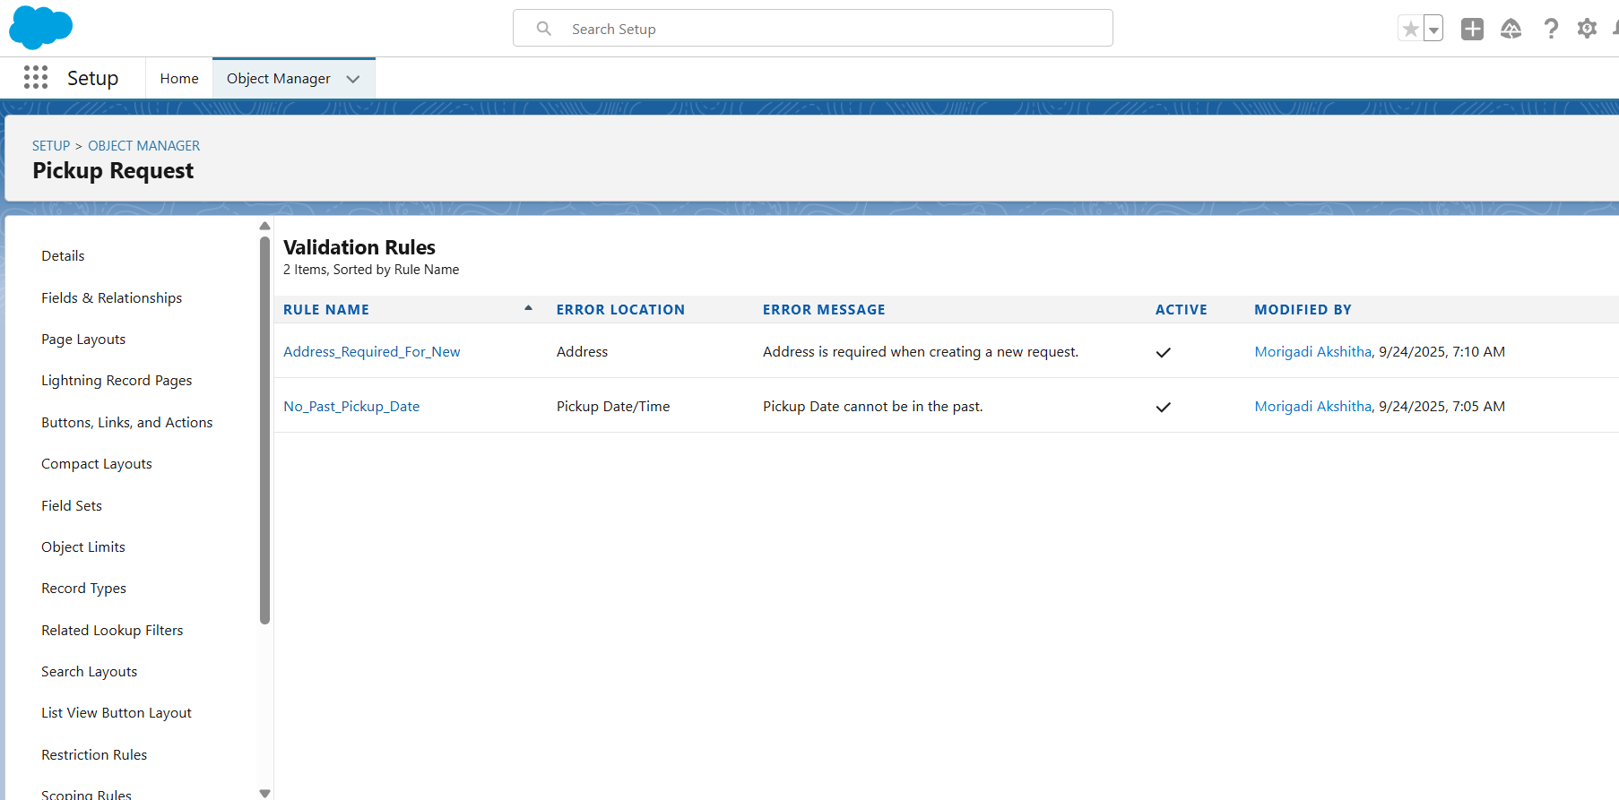

## Process Builder (Record-Triggered Automation)

**Process Name**: Pickup Request Completion → Update Truck Status

1. **Trigger**: When Pickup Request is updated.
2. **Criteria**: Status = Completed.
3. **Immediate Action**: Update Records → Related Truck (Assigned Truck Lookup).
   * Field: Status__c
   * Value: Available

## 

## Approval Process

**Example Approval:** - **Object**: Pickup Request - **Process Name**: City Official Approval - **Entry Criteria**: Status = New AND Priority = High - **Steps**: Submitter → Collector → City Official. - **Final Approval Action**: Change Status → Approved. - **Final Rejection Action**: Change Status → Rejected.

## Flow Builder

Flows replace Workflow & Process Builder. Create:

1. **Screen Flow** → Citizen submits Pickup Request.
2. **Record-Triggered Flow** → Auto-assign Collector when Status = New.
3. **Scheduled Flow** → Send reminder email 1 day before Pickup_Date__c.
4. **Auto-Launched Flow** → Reusable logic for truck status updates.

## Email Alerts

1. Create **Email Templates**:
   * Citizen Confirmation
   * Collector Assignment Notification
   * Request Completion Notice
2. Create **Email Alerts**:
   * Use templates above
   * Set recipients via related fields (e.g., Assigned Collector, Request Owner)

## Field Updates

**Example Field Update:** - **Object**: Pickup Request - **Name**: Auto-close Request - **Action**: Change Status to Closed when approved.

## Tasks & Notifications

* **Task Example**: Auto-create task for Collector → “Check assigned pickup.”
* **Custom Notification**: Send mobile notification to City Officials when a High Priority Request is submitted.