SCHOOL OF COMPUTER SCIENCE AND ARTIFICIAL INTELLIGENCE |  |  |  |  | DEPARTMENT OF COMPUTER SCIENCE ENGINEERING
Program Name: B. Tech |  |  |  | Assignment Type: Lab |  |  | Academic Year:2025-2026
Course Coordinator Name |  |  |  | Venkataramana Veeramsetty
Instructor(s) Name
  Dr. V. Venkataramana (Co-ordinator)
  Dr. T. Sampath Kumar
  Dr. Pramoda Patro
  Dr. Brij Kishor Tiwari
  Dr.J.Ravichander
  Dr. Mohammand Ali Shaik
  Dr. Anirodh Kumar
  Mr. S.Naresh Kumar
  Dr. RAJESH VELPULA
  Mr. Kundhan Kumar
  Ms. Ch.Rajitha
  Mr. M Prakash
  Mr. B.Raju
  Intern 1 (Dharma teja)
  Intern 2 (Sai Prasad)
  Intern 3 (Sowmya)
  NS_2 ( Mounika)
Course Code |  |  | 24CS002PC215 | Course Title |  | AI Assisted Coding
Year/Sem |  |  | II/I | Regulation |  | R24
Date and Day  of Assignment |  |  | Week9 - Thursday | Time(s)
Duration |  |  | 2 Hours | Applicable to  Batches
AssignmentNumber:18.4(Present assignment number)/24(Total number of assignments)
 | Q.No. | Question |  |  |  |  |  | Expected Time  to complete
 | 1 | Lab 18 – API Integration: Connecting to External Services with Error Handling  Lab Objectives:  - Learn how to integrate Python programs with external REST APIs.  - Understand API request/response handling using requests or similar libraries.  - Implement proper error handling for failed API calls (timeouts, invalid responses, rate limits).  - Practice extracting and displaying meaningful information from API responses.  Task 1: Connect to a Public API  - Instructions:  - Use Python (or Node.js/JavaScript) to connect to a public API (e.g., OpenWeatherMap or JSONPlaceholder).  - Send a simple GET request to retrieve data.  - Display the response in a readable format (pretty JSON).  - Expected Output:  - Program prints API response (e.g., weather data or posts from JSONPlaceholder).  - Output should be properly formatted JSON (not raw).  Prompts:  Basic API Request  Requests with Error Handling  Function with Parameter  Code:  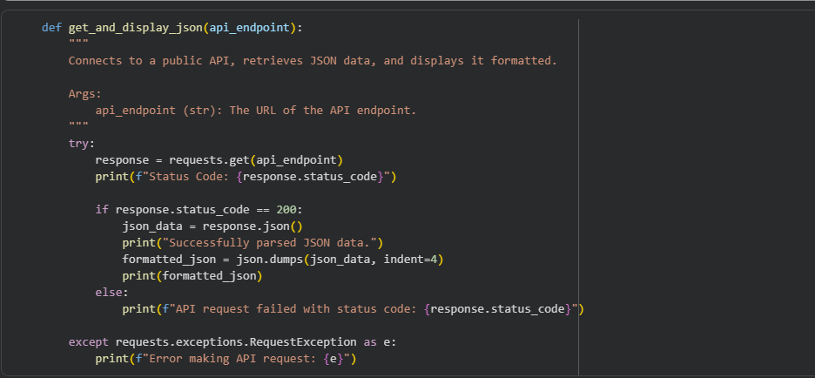  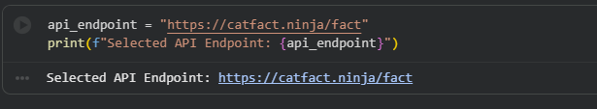  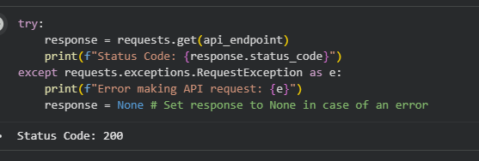  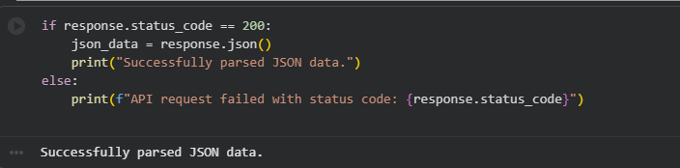  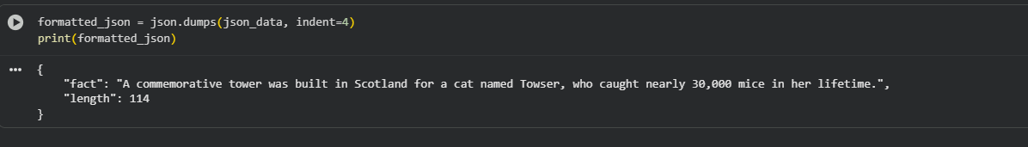  EXPLANATIONS:  - Identify a public API: We chose the "Cat Facts" API (https://catfact.ninja/fact) as an example of a publicly available API that returns data in JSON format.  - Import necessary libraries: We import the requests library to make HTTP requests to the API and the json library to work with JSON data.  - Make an API request: We use the requests.get() function to send a GET request to the specified API endpoint. A try...except block is included to handle potential errors during the request.  - Process the JSON response: We check if the API request was successful (status code 200). If it was, we use the .json() method from the requests library to parse the JSON data from the response.  - Display the formatted JSON: We use json.dumps() with an indent=4 to format the parsed JSON data with indentation, making it easier to read. Finally, we print the formatted JSON.  Task 2: Add Error Handling for Invalid API Calls  - Instructions:  - Modify your code from Task 1 to handle errors.  - Include try/except (Python) or try/catch (JavaScript) blocks.  - Handle cases like:  - Invalid URL  - Network timeout  - Wrong API key (if required)  - Print user-friendly error messages.  - Expected Output:  - If the API works, the result is shown as in Task 1.  - If there’s an error, output:  Error: Could not connect to API. Check your API key or network connection.  Prompt:  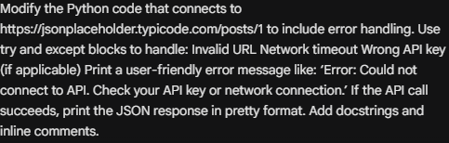  Code:  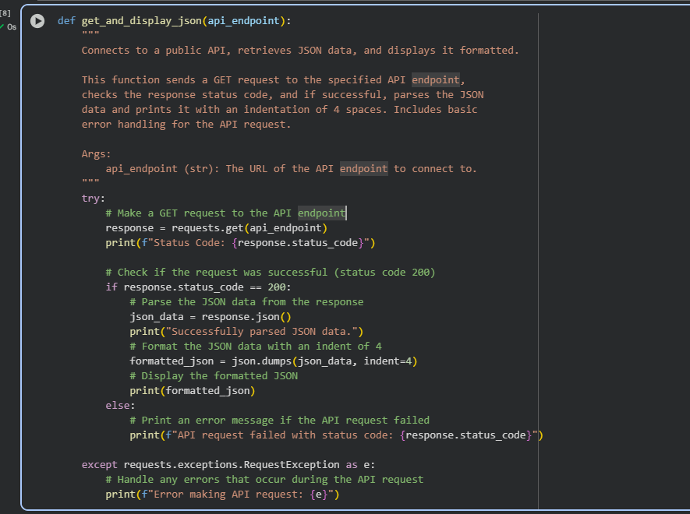  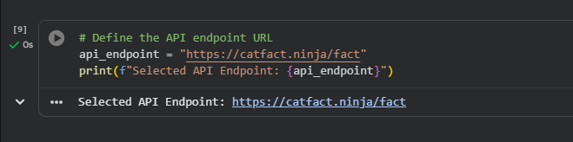  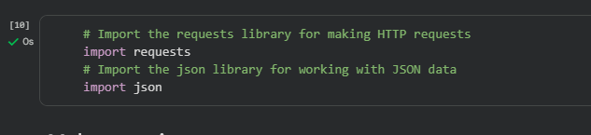  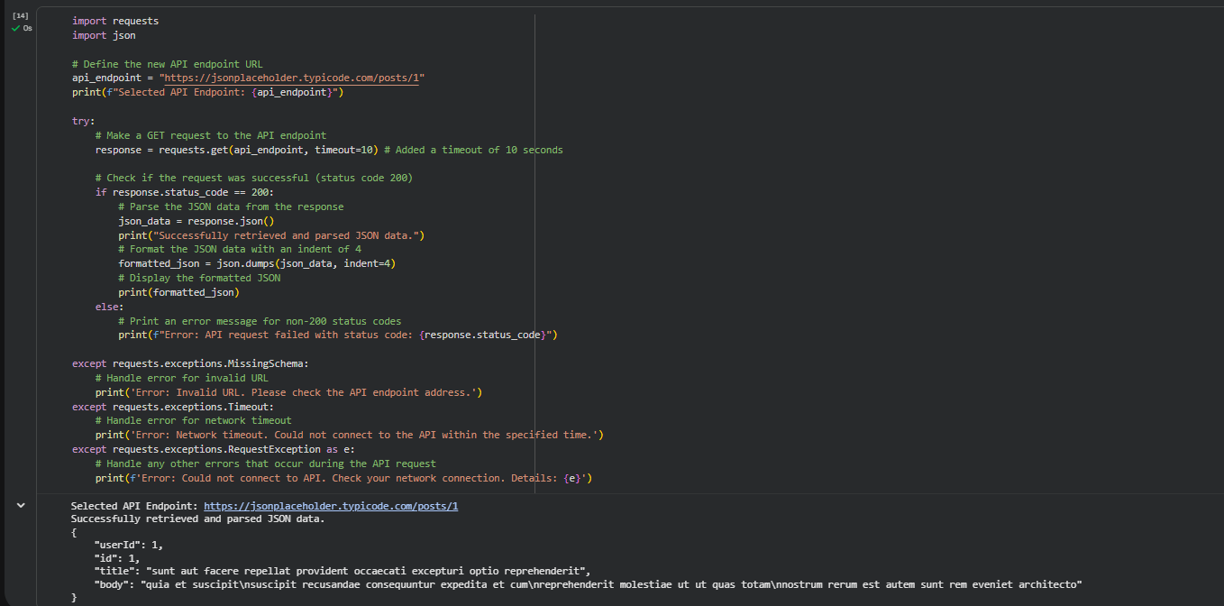  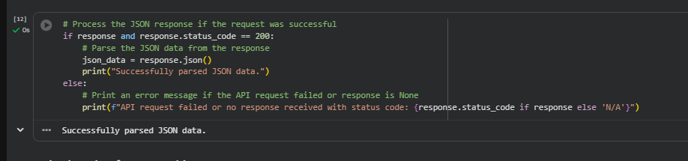  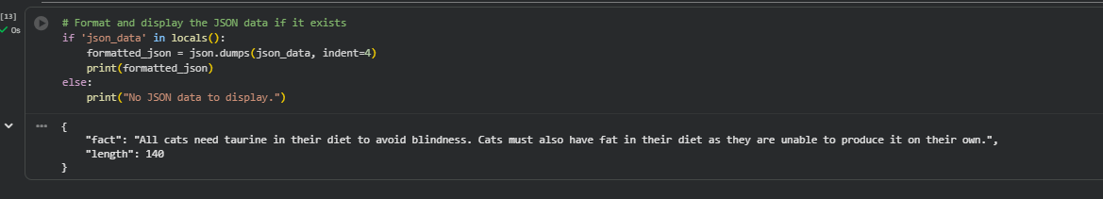  Task 3: Extract and Display Specific Data  - Instructions:  - From the API response (e.g., weather API), extract specific fields (temperature, humidity, description).  - Display them in a user-friendly format (not raw JSON).  - Expected Output:  - City: London  - Temperature: 18°C  - Humidity: 60%  Weather: Clear sky  Prompt:  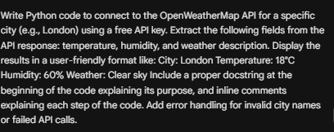  Code:  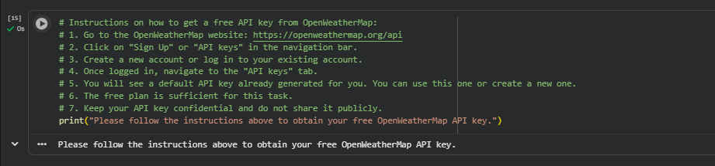  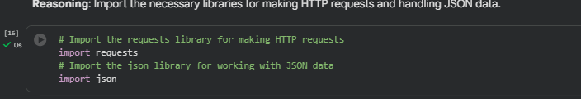  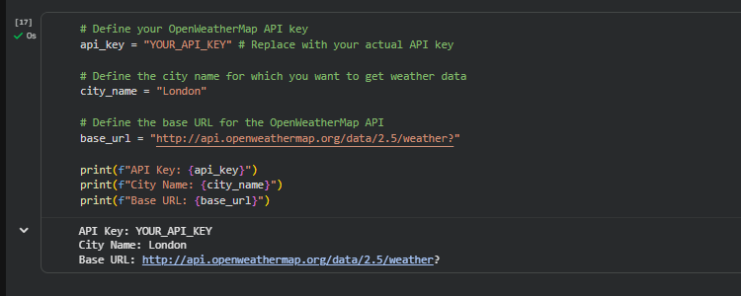  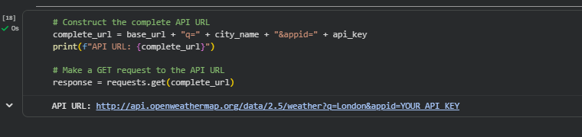  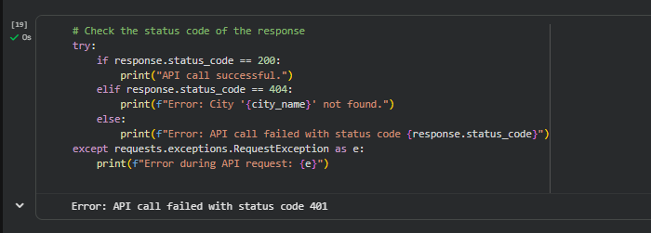  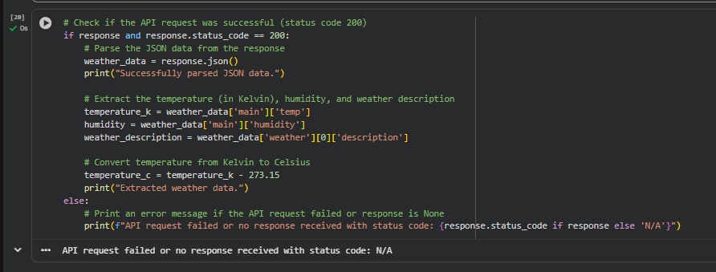  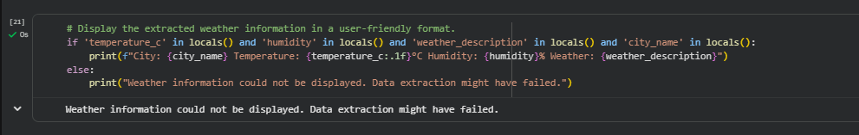  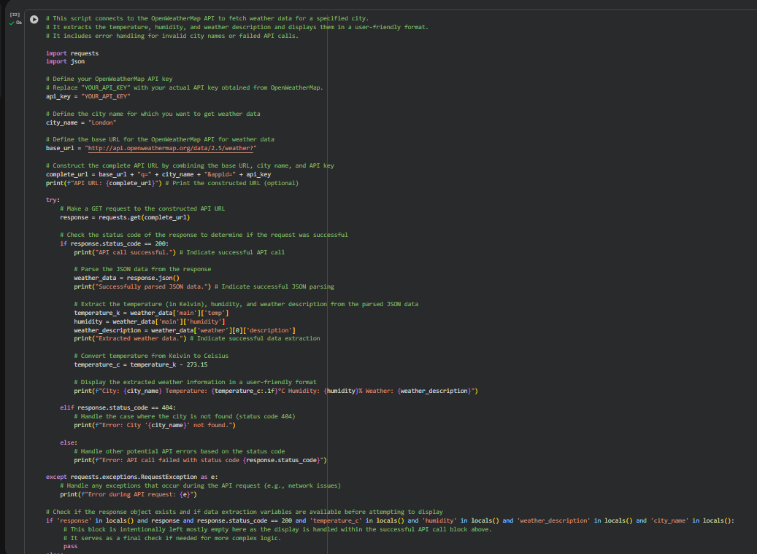  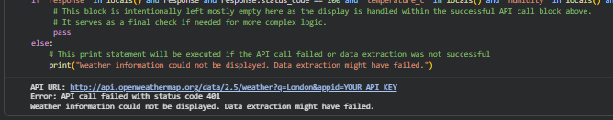  Task 4: Build a Function with Parameters  - Instructions:  - Write a function that accepts a parameter (e.g., city name for weather API).  - The function should call the API dynamically based on user input.  - Include error handling if the city is invalid.  - Expected Output:  - Input: "New York"  - Output:  - City: New York  - Temperature: 22°C  - Humidity: 55%  - Weather: Few clouds  - Input: "xyz123"  - Output:  Error: City not found. Please enter a valid city.  Prompt:  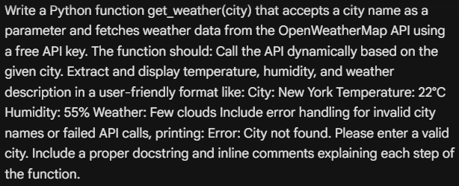  Code:  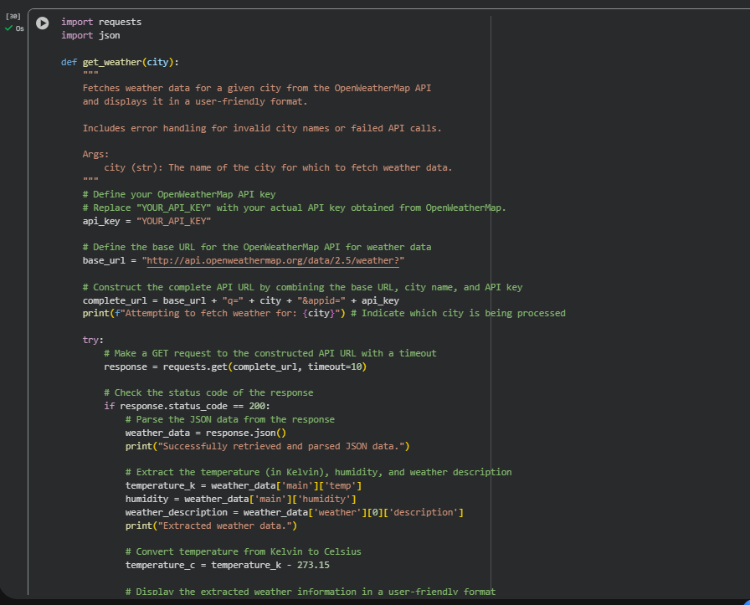  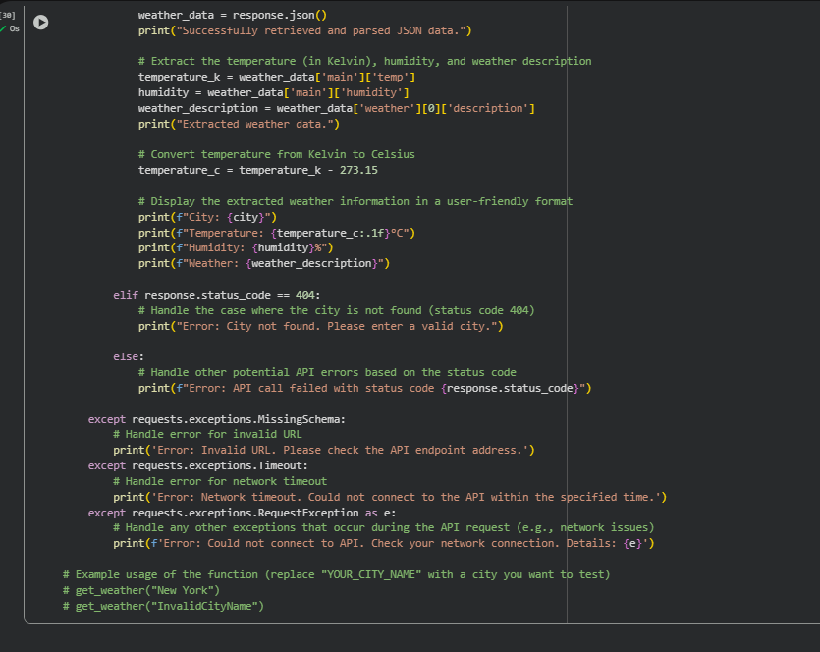  Task 5: Store API Results Locally  - Instructions:  - Extend your function from Task 4.  - Save the extracted API results into a local file (results.json or results.txt).  - Each new request should append results without overwriting old ones.  - Expected Output:  - Console still shows formatted output.  - A local file results.json is created/updated with stored responses like:  - [  - {"city": "London", "temp": 18, "humidity": 60, "weather": "Clear sky"},  - {"city": "New York", "temp": 22, "humidity": 55, "weather": "Few clouds"}  Prompt:  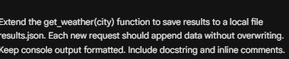  Code:  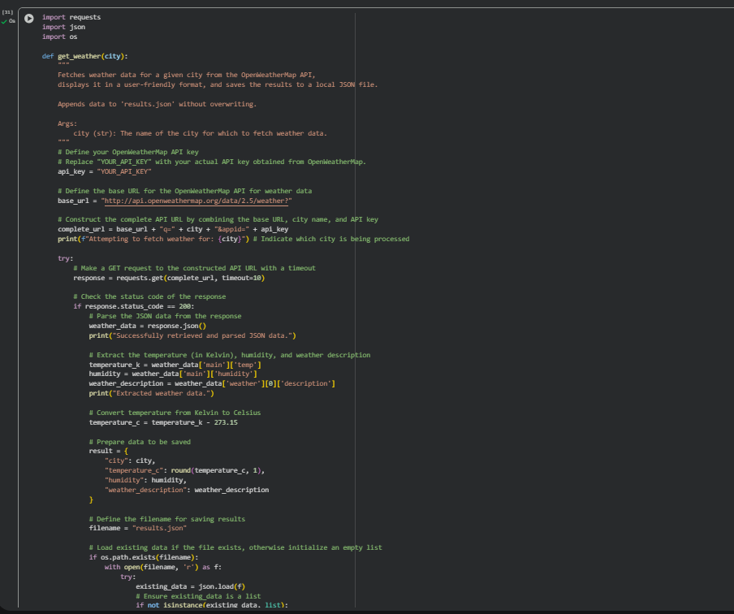  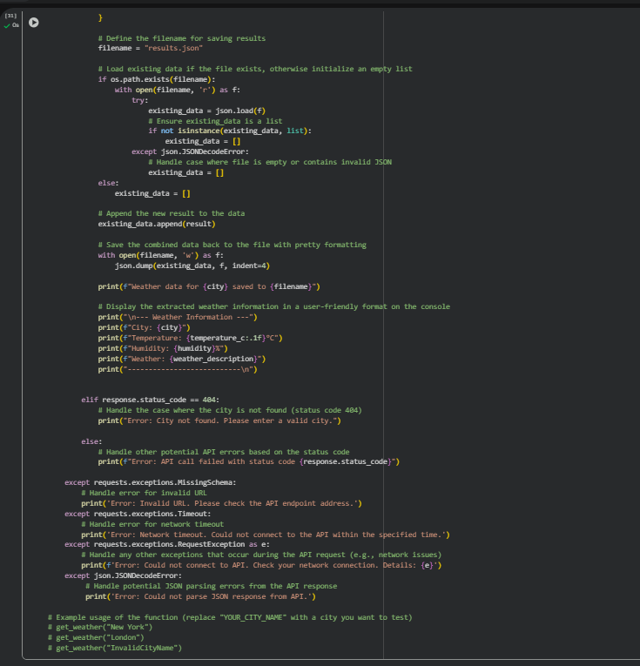  ✅ Deliverables (For All Tasks)  - AI-generated prompts for code and test case generation.  - At least 3 assert test cases for each task.  - AI-generated initial code and execution screenshots.  - Analysis of whether code passes all tests.  - Improved final version with inline comments and explanation.  - Compiled report (Word/PDF) with prompts, test cases, assertions, code, and output. |  |  |  |  |  | Week9 - Thursday

