INTRODUCTION TO PYTHON

What is python?

* Python is high level language. It is created by Gudio van Rossum and first released in 1991.
* Python is Interpreter (Code can be executed line by line) language.
* Python is Object-Oriented.
* Easy to learn (simple syntax that’s similar to English).

Why we need to learn/use python?

* Simple and Readable Syntax

Example: print("Hello, world!") is all it takes to display text.

* Versatile and Powerful.

You can use Python for:

* + Web Development
  + Data Science & AI
  + Automation/Scripting
  + Cybersecurity
  + Game Development
  + IoT and Robotics

Where I am using python in real technology app example?

* Python is used behind the scenes in many real-world technologies and apps.
* Examples:
* Instagram
* You Tube
* Netflix
* Google
* Dropbox
* Reddit
* Spotify

What is difference between python and other languages?

| Feature | Python | C/C++ | Java | JavaScript |
| --- | --- | --- | --- | --- |
| Syntax | Simple, readable | Verbose | Verbose | Lightweight |
| Speed | Slower | Very fast | Moderate | Fast |
| Easy of  Learning | Very easy | Harder | Moderate | Easy |
| Use Case | Data science, automation | OS, game engines, embedded | Enterprise apps, Android | Web front-end |
| Memory Management | Automatic | Manual | Automatic | Automatic |
|  |  |  |  |  |

What is Data?

Data is information—raw facts, figures, or symbols—collected, stored, and processed by computers or humans to gain insight or make decisions.

Data Types in python

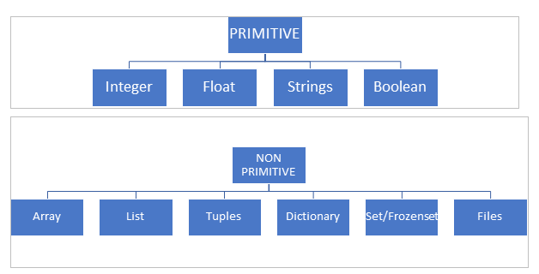

Primitive Data Types

* Primitive data types are the basic building blocks of data in Python.
* They can store only single values and used more complex structures.
* Primitive data types which can’t be changed.

1. Integers(int): numbers

Ex: print(4)

Output:4

1. String(str): characters

Ex: print(“akshitha”)

Output: akshitha

1. Float: decimal points

Ex: print(8.38)

Output:8.38

1. Boolean(bool): True or False

Ex: print(True)

Output: True

Non-Primitive Data Types:

* Non-Primitive data types are complex and which can hold multiple values.
* Non-Primitive data types which can be change.

1. List: []

* Collection of multiple values or multiple data types.
* It can be store heterogenous and homogenous values.
* Heterogenous values means different values or different data types.
* Homogenous values means same values or same data types.

Ex: [1, ”akhi”, False, 83.8] 🡪 Heterogenous values

[True, True, False, True] 🡪 Homogenous values

1. Dictionary: {}

* Dictionary is nothing but collection of data in the form of key: value pair.

{“id”:1, key: value pair}

Ex: {

“id”:1, “name”: “ap”, “Age”: 41

}

Variable in Python

* Variable is nothing but a container which can be some data and data can be anything.

Example:

* a=4

Print(a)

Output: 4

* For list

k =[1, “kkl”, True, True, 11.28]

#Assign

k is var and = list assign (equal to)

Print(k)

* For dict

K={ “id”:1, “name”: “ar”, “Age”: 41}

Print(“K”)