Lesson 1:

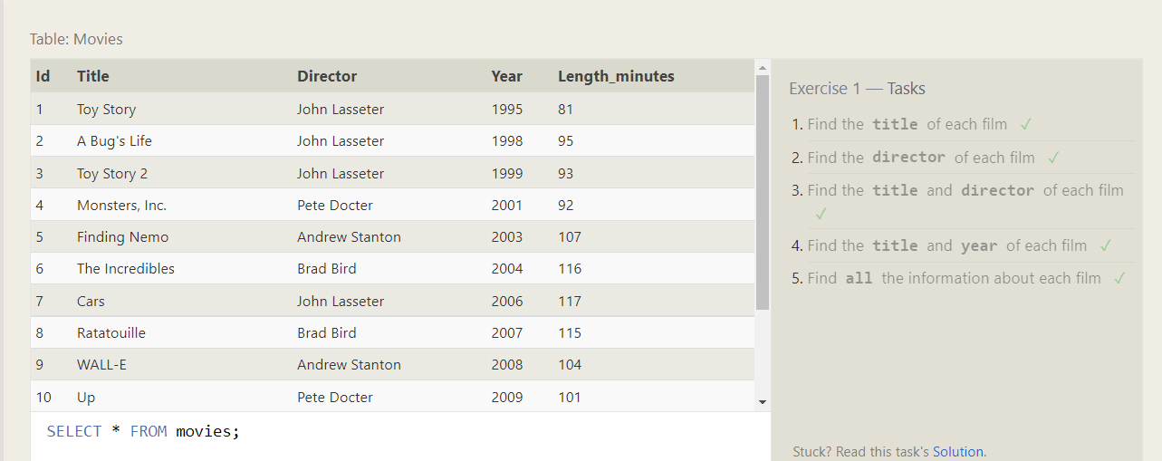

* SELECT title FROM movies;
* SELECT director FROM movies;
* SELECT title,director FROM movies;
* SELECT title,year FROM movies;
* SELECT * FROM movies;

Lesson 2:

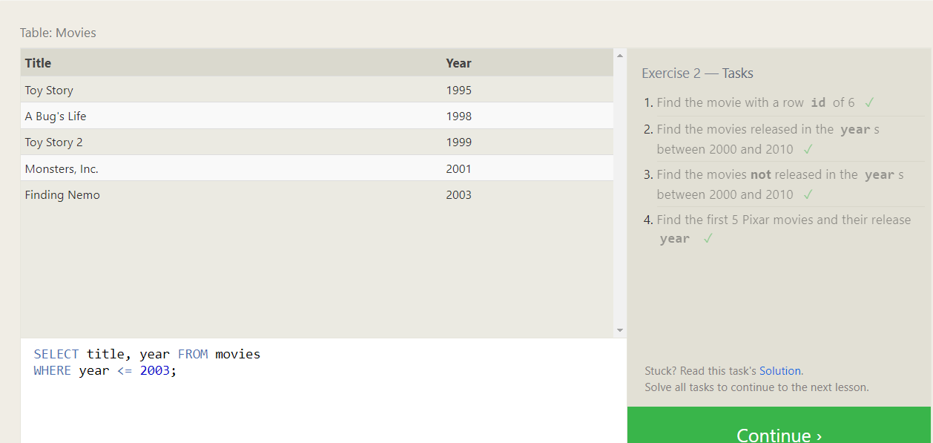

* SELECT * FROM movies where Id = 6;
* SELECT * FROM movies where year BETWEEN 2000 and 2010;
* SELECT * FROM movies where year NOT BETWEEN 2000 and 2010;
* SELECT title,year FROM movies where year <= 2003;

Lesson 3:

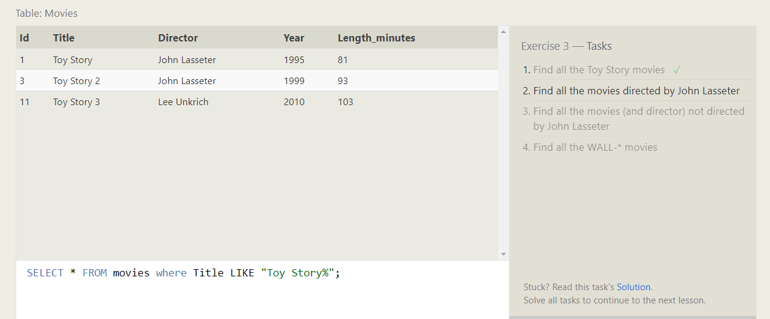

* SELECT * FROM movies where Title LIKE "Toy Story%";
* SELECT * FROM movies where Director = "John Lasseter";
* SELECT * FROM movies where Director != "John Lasseter";
* SELECT * FROM movies where Title LIKE "WALL-%";

Lesson 4:

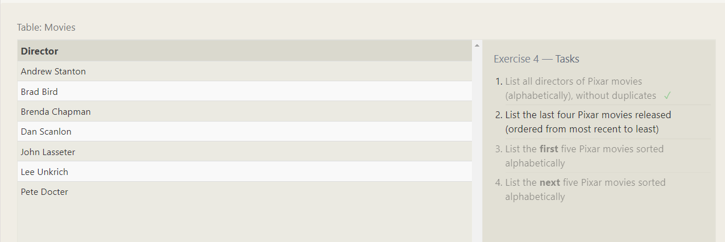

* SELECT DISTINCT director FROM movies ORDER BY director ASC;
* SELECT title, year FROM movies ORDER BY year DESC LIMIT 4;
* SELECT title, year FROM movies ORDER BY Title ASC LIMIT 5;
* SELECT title FROM movies ORDER BY title ASC LIMIT 5 OFFSET 5;

Lesson 5:

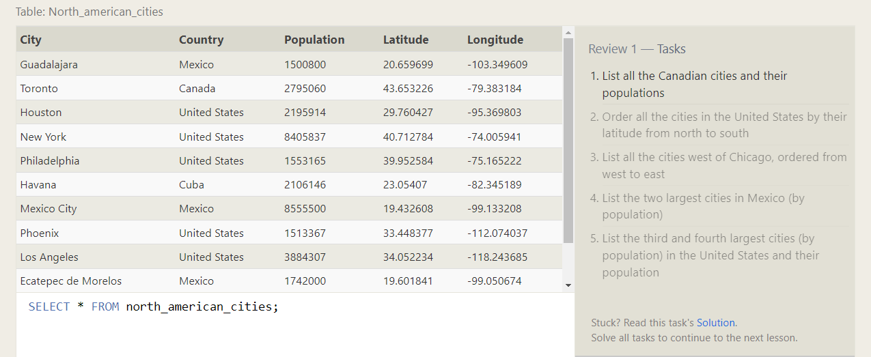

* SELECT * FROM north_american_cities Where Country = 'Canada';
* SELECT * FROM north_american_cities Where Country = 'United States' Order By Latitude DESC;
* SELECT city, longitude FROM north_american_cities WHERE longitude < -87.629798 ORDER BY longitude ASC;
* SELECT city, population FROM north_american_cities WHERE country LIKE "Mexico" ORDER BY population DESC LIMIT 2;
* Select * from North_american_cities where Country = 'United States' Order By Population DESC Limit 2 Offset 2;