Name: Kandukuri Akshitha
Branch: ECE (ES)
Mtech-1st year
HTNO: 2505B04202

Lab 14 – Web Frontend Development: AI-assisted HTML/CSS/JS with Python
Task Description-1 – AI-generated HTML Page
Task: Ask AI to generate a simple HTML homepage for a "Student Info Portal" with a header, navigation menu, and footer.
Expected Output:
- HTML code with <header>, <nav>, <footer>.
- Clean indentation, proper tags, and comments.

Code:

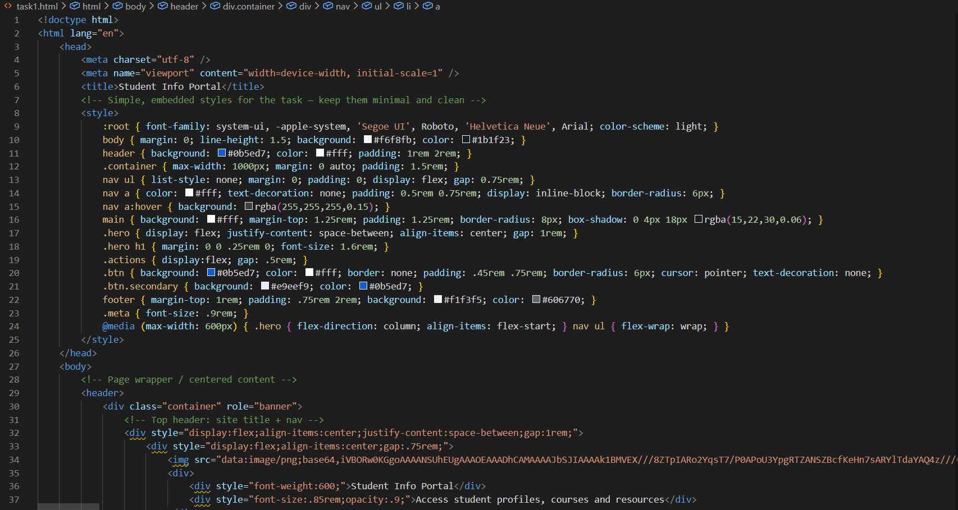
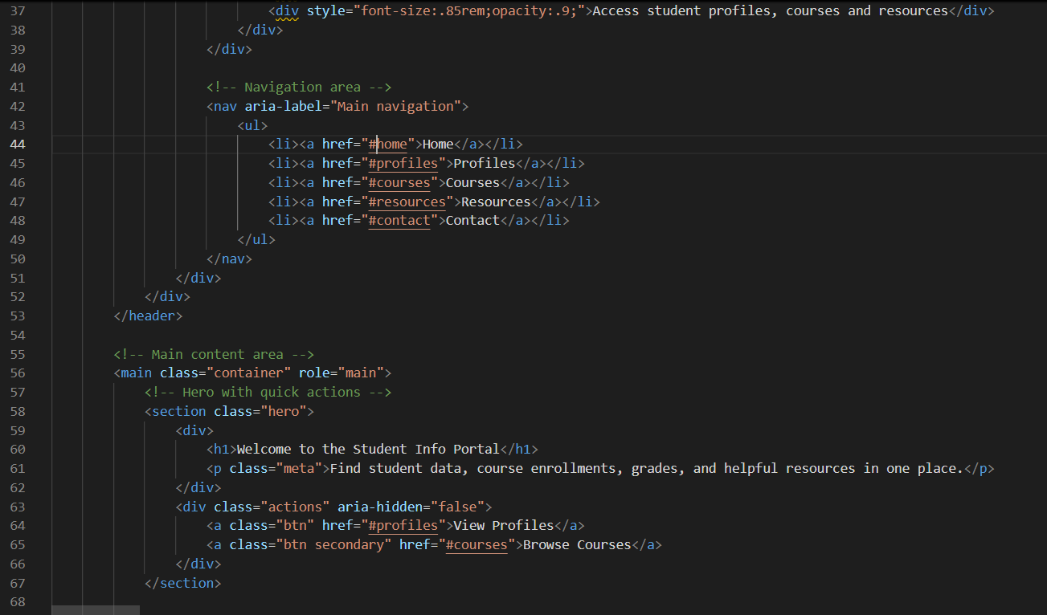

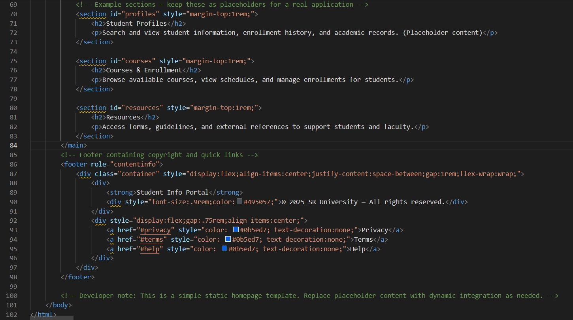

Output:
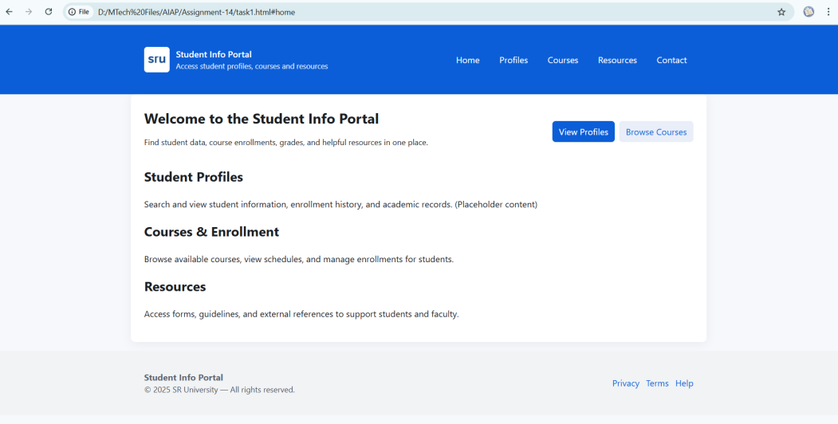

Task Description-2 – CSS Styling
Task:
Use AI to add CSS styling to Task #1 homepage for:
- Responsive navigation bar.
- Centered content section.
- Footer with light gray background.
Expected Output:
- HTML + CSS combined.
- AI explains how CSS classes apply.
Expected Output: AI refactors with withopen() and try-except:
Code:
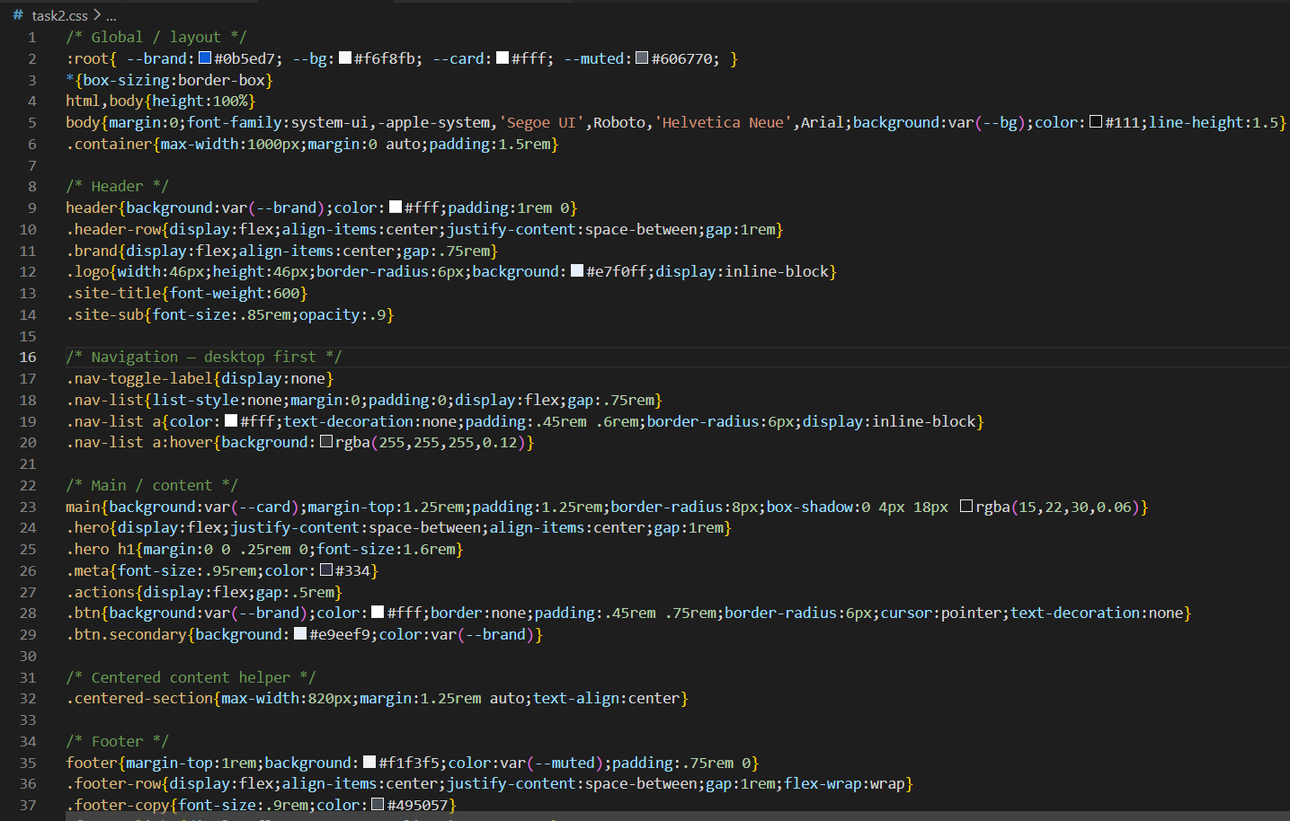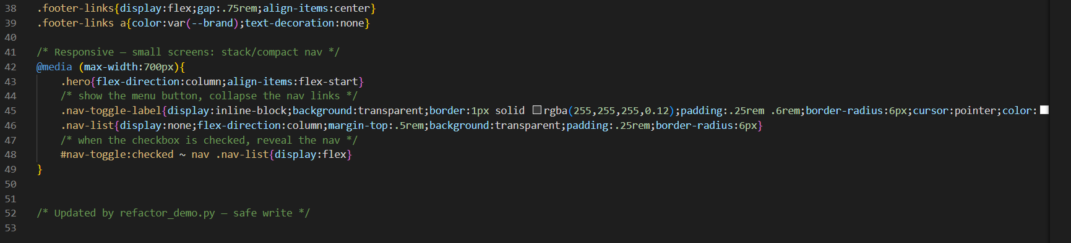

Output:
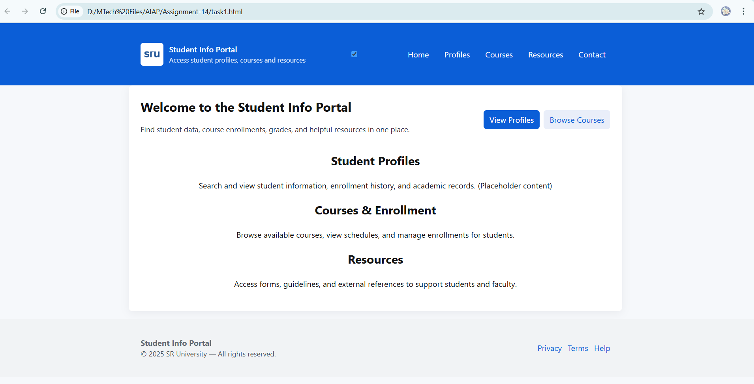

Task Description-3 – JavaScript Interactivity
Task: Prompt AI to generate a JS script that validates a simple login form (non-empty username/password).
Expected Output:
Working on submit JS validation.
Clear error messages if inputs are empty.
Code:
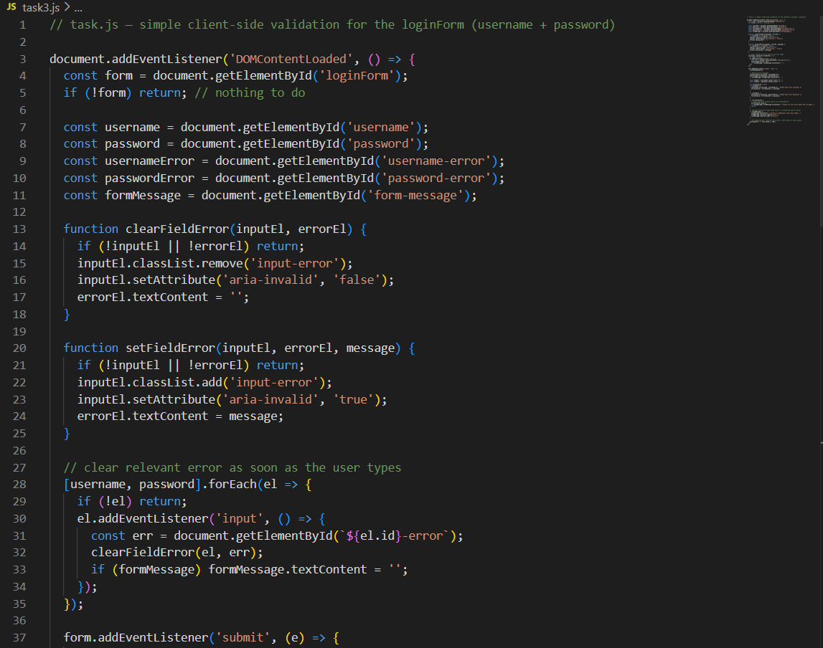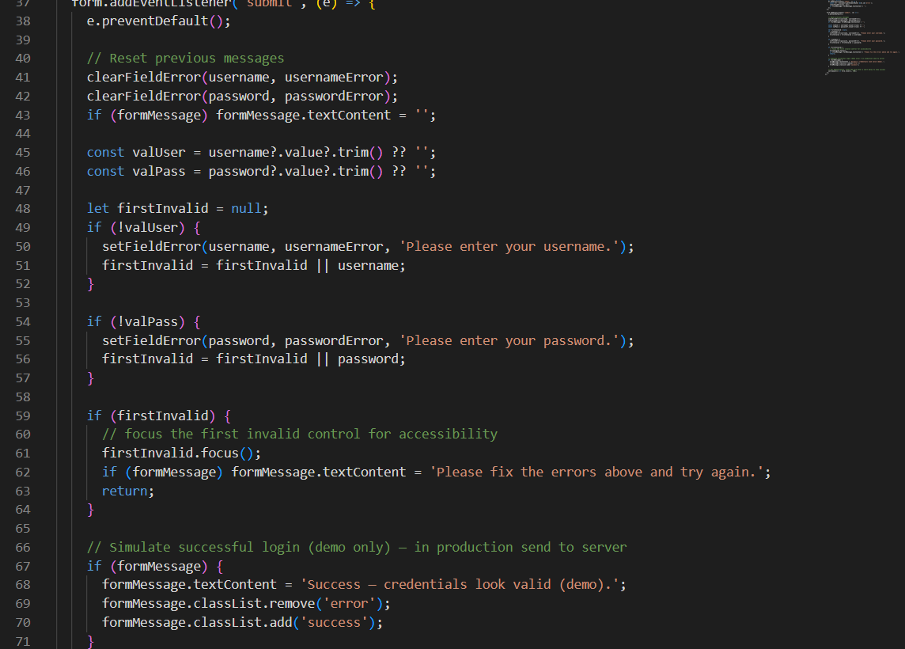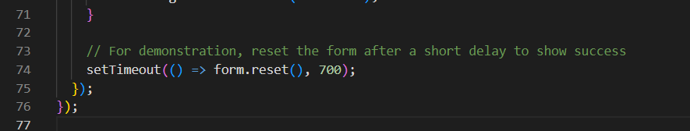
Output:
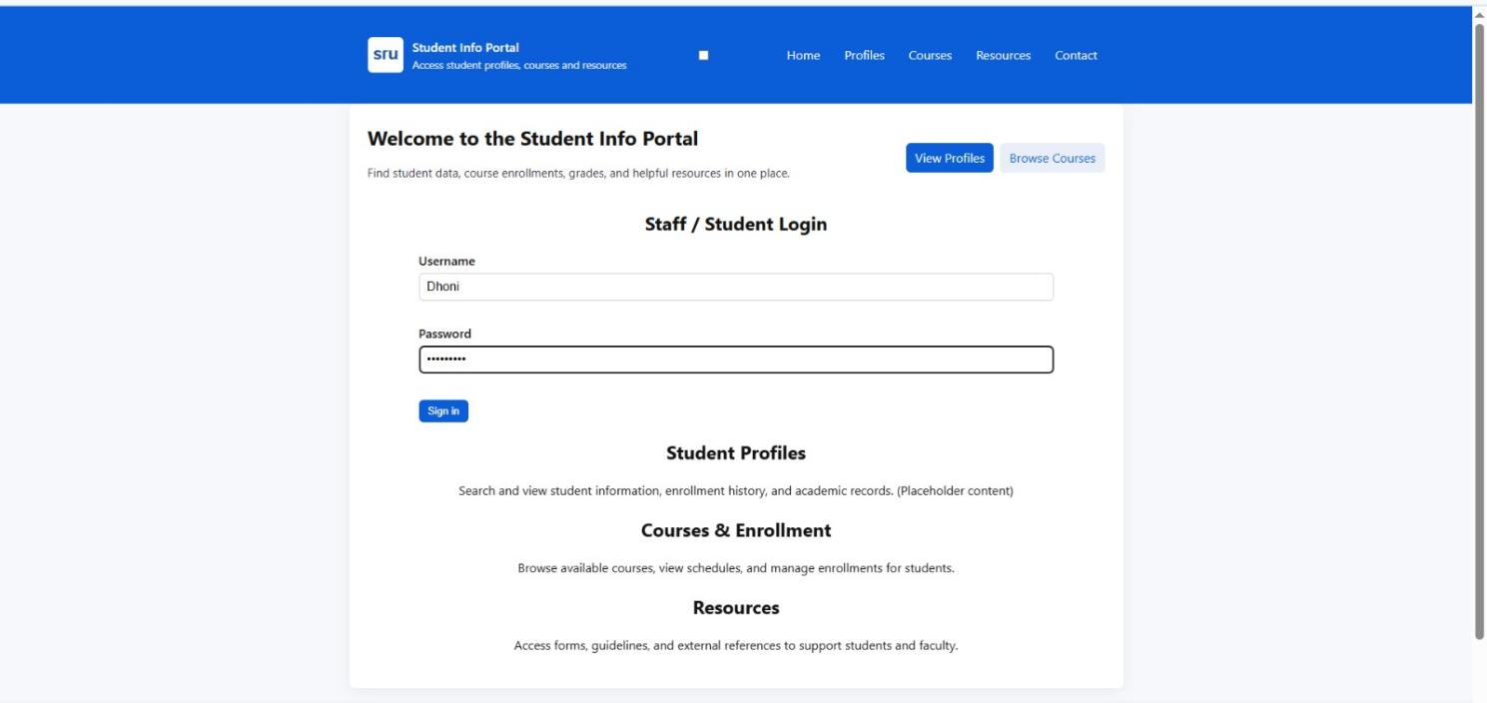

Task Description-4 – Python Backend Integration
Task: Ask AI to generate a Flask app that serves the HTML form (Task #3) and prints the username on successful login.
Code:
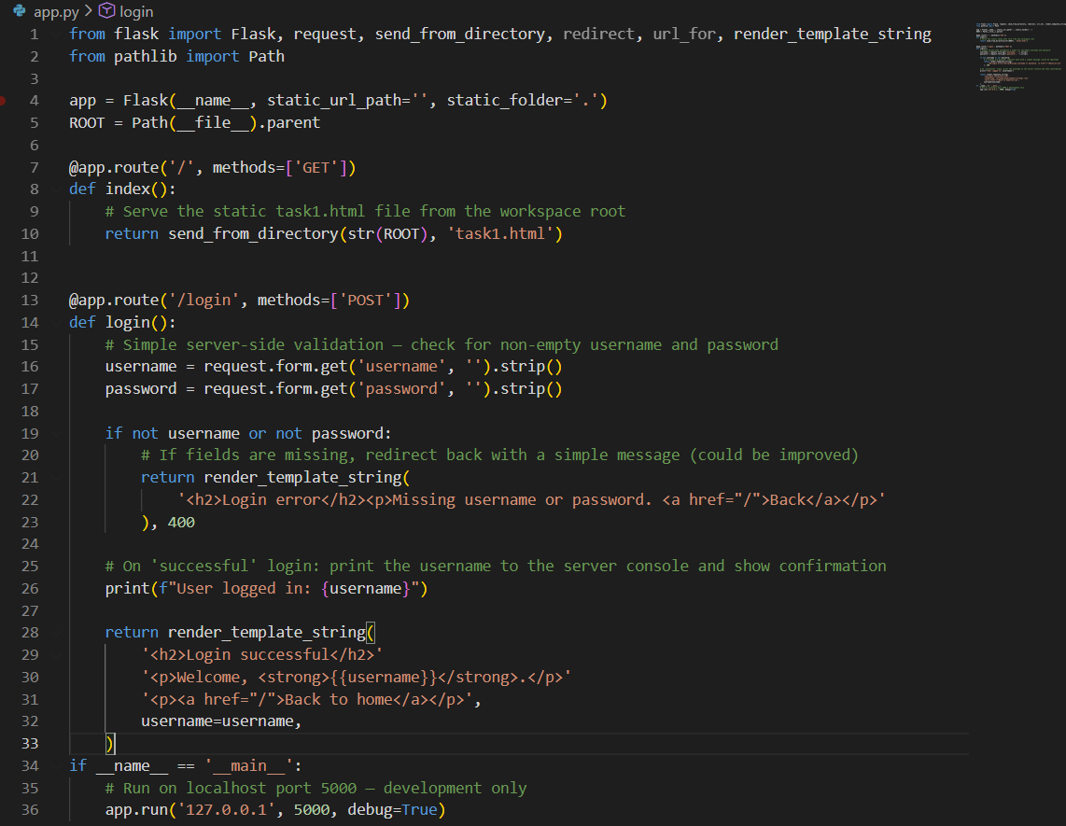
Terminal:
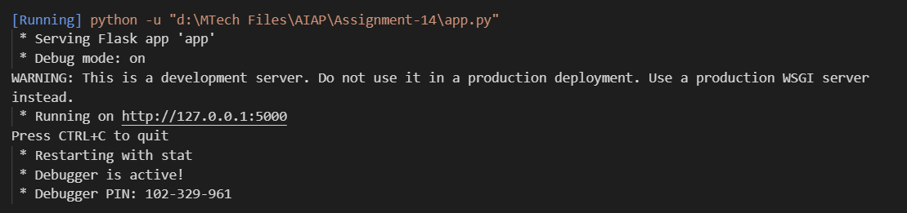
Output:
