Assignment-11
AI Assisted Problem Solving Using Python –AIAP

Student Name:- Kandukuri Akshitha
Hall ticket No:- 2505B04202
Branch :- Embedded System (ES)

Lab 11 – Data Structures with AI: Implementing Fundamental Structures
Lab Objectives
- To implement fundamental data structures with the assistance of AI tools.
- To understand how AI suggests different implementations and optimizations.
- To analyze the readability, correctness, and performance of AI-generated code.
- To reinforce problem-solving skills using AI-powered coding assistance.

Learning Outcomes
After completing this lab, students will be able to:
- Implement stack, queue, and linked list using Python with AI support.
- Use AI tools to optimize and refactor basic data structure operations.
- Compare multiple AI-suggested implementations for the same structure.
- Apply AI assistance to generate test cases for verifying data structure behavior.
- Demonstrate understanding of trade-offs in AI-generated solutions.

Task Description #1 – Stack class implementation
Task: Ask AI to implement a stack class with push(), pop(), peek() and is_empty() methods

Task Description #2 – Queue Implementation
Task: Use AI to generate a Queue class with enqueue(), dequeue(), and is_empty().

Task Description #3 – Linked List Implementation
Task: Ask AI to create a singly linked list with insert_at_end(), insert_at_beginning(), and display().

Task Description #4 – Binary Search Tree (BST)
Task: Ask AI to generate a simple BST with insert() and inorder_traversal().

Task1
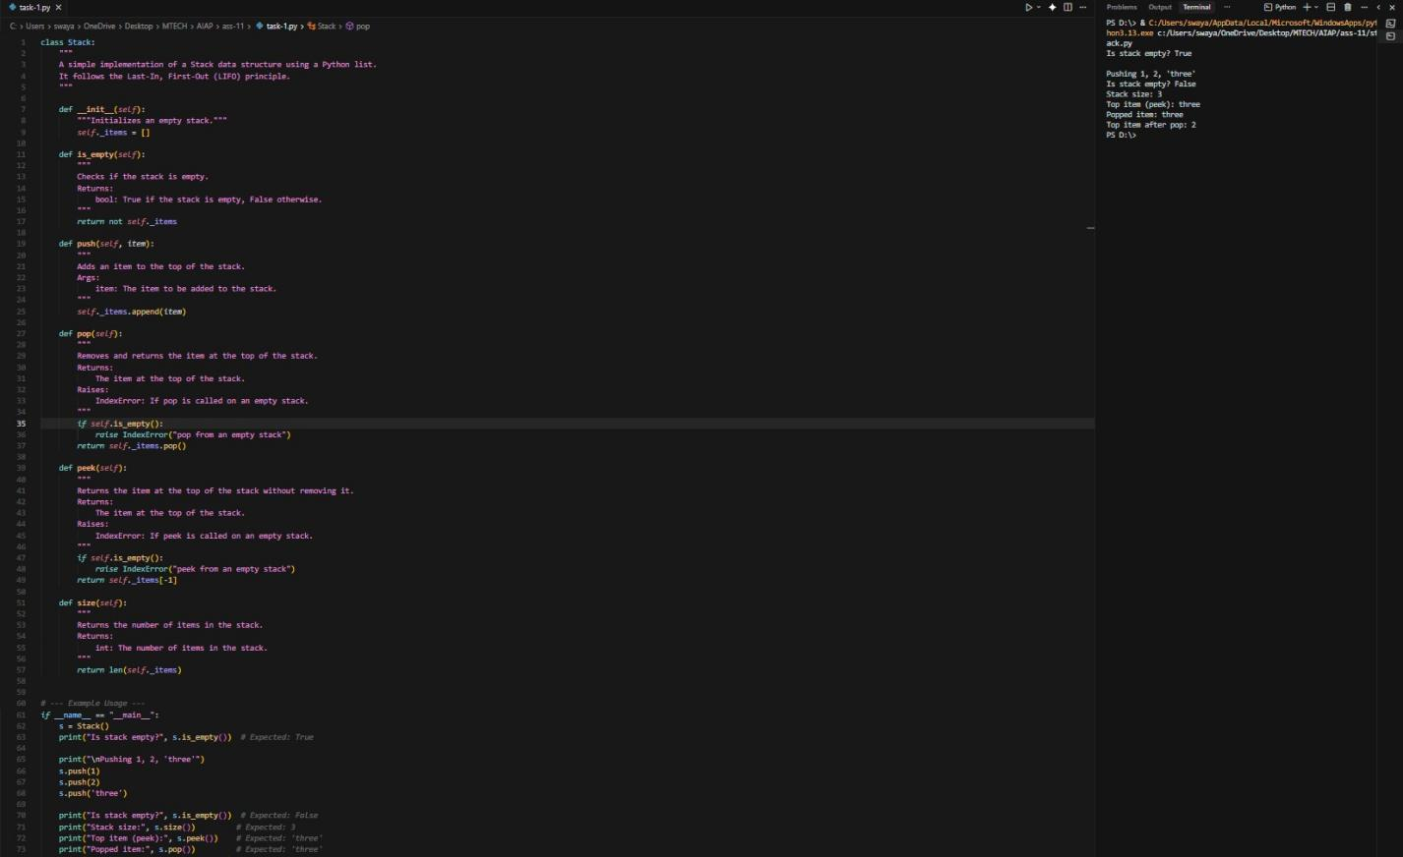

Task2

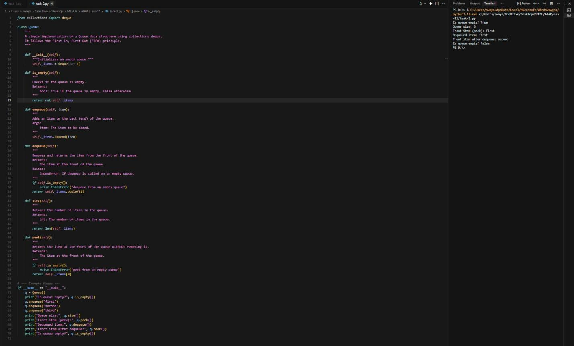

Task3

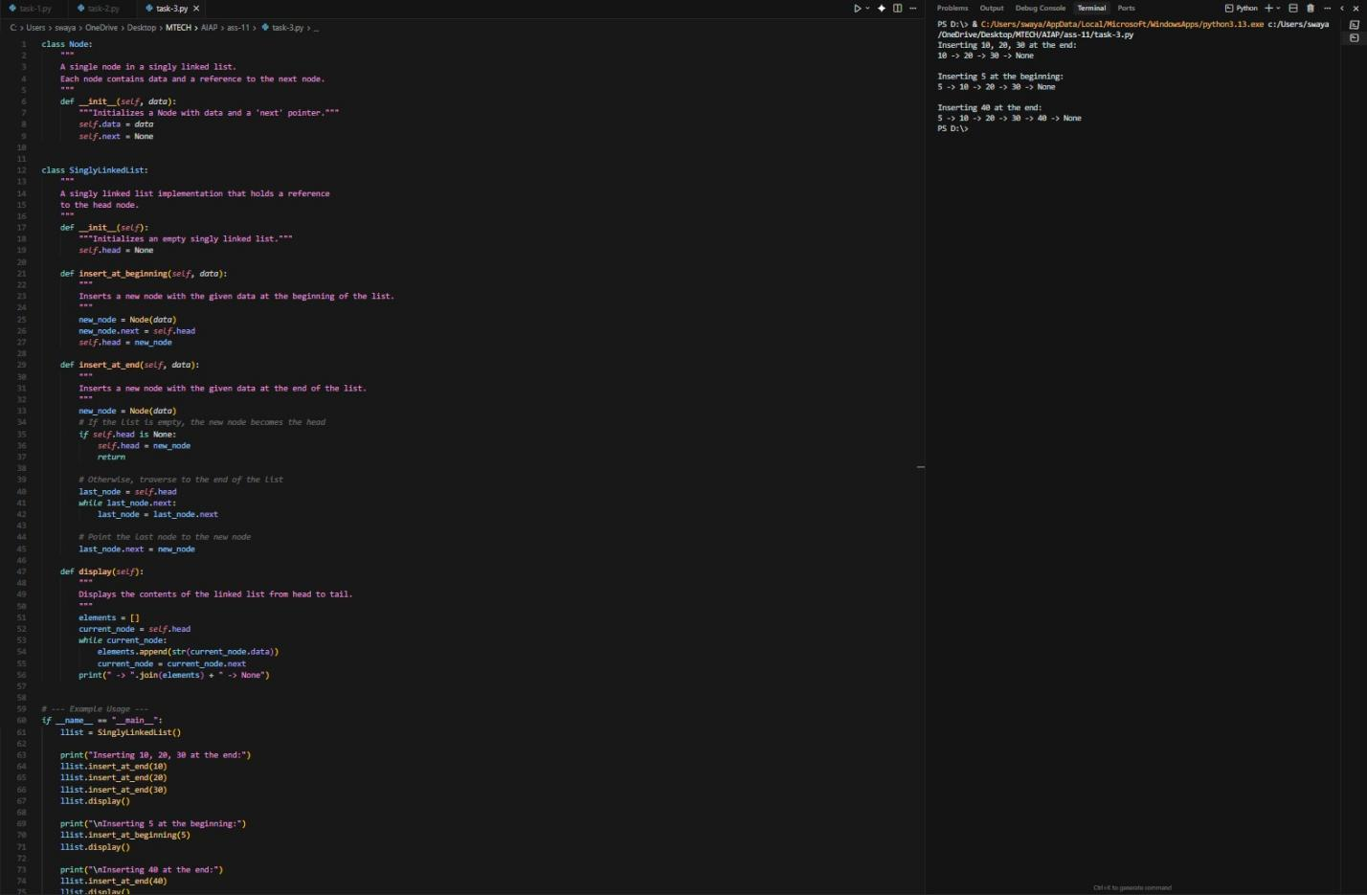

Task4

