Assignment 8

Task Description 1

- Use AI to generate test cases for is_valid_email(email) and then implement the
validator function.
Requirements:
• Must contain @ and . characters.
• Must not start or end with special characters.
• Should not allow multiple @.

Code:

import re
import string
import unittest

_SPECIAL_START_END = set(string.punctuation) - {"'", '"'}

def is_valid_email(email: str) -> bool:
"""
Validate an email address according to the project rules.

Requirements:
- Must contain "@" and "." characters.
- Must contain exactly one "@" character.
- Must not start or end with special characters.
- The domain (after "@") must contain at least one ".".

Args:
email: The email address to validate.

Returns:
True if the email is valid, False otherwise.
"""
if not isinstance(email, str):
return False

if not email:
return False

if email != email.strip():
return False

email = email.strip()
if not email:
return False

if email.count("@") != 1:
return False

if "." not in email:
return False

# Cannot start or end with special characters
if email[0] in _SPECIAL_START_END or email[-1] in _SPECIAL_START_END:
return False

local_part, domain_part = email.split("@")

# Local and domain parts must be non-empty
if not local_part or not domain_part:
return False

# Additional guard: domain cannot start or end with special characters
if domain_part[0] in _SPECIAL_START_END or domain_part[-1] in _SPECIAL_START_END:
return False

# Domain must contain at least one dot
if "." not in domain_part:
return False

# Ensure no spaces or control characters are present
if any(c.isspace() for c in email):
return False

# Allow letters, digits, and limited special characters in the local part
local_pattern = re.compile(r"^[A-Za-z0-9][A-Za-z0-9._+-]*[A-Za-z0-9]$")
domain_pattern = re.compile(r"^[A-Za-z0-9](?:[A-Za-z0-9-]*[A-Za-z0-9])?(?:\.[A-Za-z0-9](?:[A-Za-z0-9-]*[A-Za-z0-9])?)+$")

if not local_pattern.match(local_part):
return False

if not domain_pattern.match(domain_part):
return False

return True

class TestIsValidEmail(unittest.TestCase):
def test_valid_emails(self):
valid_emails = [
"test@example.com",
"user.name@email.co.in",
"firstname.lastname@domain.com",
"my_email123@sub.domain.org",
"a.b@c.d",
"user+tag@domain.io",
"user123@domain123.co",
]
for email in valid_emails:
with self.subTest(email=email):
self.assertTrue(is_valid_email(email), f"{email} should be valid")

def test_missing_at_or_dot(self):
invalid_emails = [
"testexample.com",
"test@examplecom",
"testexamplecom",
"test@com",
]
for email in invalid_emails:
with self.subTest(email=email):
self.assertFalse(is_valid_email(email), f"{email} should be invalid")

def test_starts_or_ends_with_special_characters(self):
invalid_emails = [
".test@example.com",
"-user@example.com",
"_user@example.com",
"test.@example.com",
"test-@example.com",
"test_@example.com",
"test@example.com.",
"test@example.com-",
"test@example.com_",
]
for email in invalid_emails:
with self.subTest(email=email):
self.assertFalse(is_valid_email(email), f"{email} should be invalid")

def test_multiple_at_symbols(self):
invalid_emails = [
"te@st@example.com",
"user@@example.com",
"@@example.com",
"user@exa@mple.com",
]
for email in invalid_emails:
with self.subTest(email=email):
self.assertFalse(is_valid_email(email), f"{email} should be invalid")

def test_empty_or_minimal_cases(self):
invalid_emails = [
"",
"@.",
".@",
"@",
"user@",
"@example.com",
"user@example.",
".@.",
" user@example.com ",
"user@ example.com",
]
for email in invalid_emails:
with self.subTest(email=email):
self.assertFalse(is_valid_email(email), f"{email} should be invalid")

def test_domain_format_edge_cases(self):
invalid_emails = [
"user@.domain.com",
"user@domain..com",
"user@domain.corporate.",
"user@-domain.com",
"user@domain-.com",
]
for email in invalid_emails:
with self.subTest(email=email):
self.assertFalse(is_valid_email(email), f"{email} should be invalid")

def check_user_input() -> None:
while True:
user_input = input("\nEnter an email address to validate (or type 'exit' to quit): ")
if user_input.lower() == "exit":
break
if is_valid_email(user_input):
print(f"'{user_input}' is a VALID email address.")
else:
print(f"'{user_input}' is NOT a valid email address.")

if __name__ == "__main__":
unittest.main()

Practical Output:

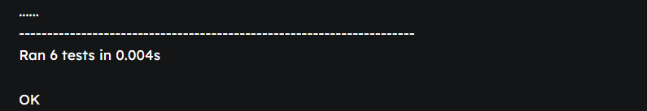

Task Description 2

• Ask AI to generate test cases for assign_grade(score) function. Handle boundary and
invalid inputs.
Requirements
• AI should generate test cases for assign_grade(score) where: 90-100: A, 80-89: B, 70-
79: C, 60-69: D, <60: F
• Include boundary values and invalid inputs (e.g., -5, 105, "eighty").

Code:

def assign_grade(score):
"""
Returns a letter grade for the given score.
90-100: A
80-89: B
70-79: C
60-69: D
<60: F
Raises ValueError for invalid input.
"""
if not isinstance(score, int):
raise ValueError("Score must be an integer.")
if score < 0 or score > 100:
raise ValueError("Score must be between 0 and 100.")
if score >= 90:
return "A"
elif score >= 80:
return "B"
elif score >= 70:
return "C"
elif score >= 60:
return "D"
else:
return "F"

def generate_assign_grade_test_cases():
"""
Generate test cases for assign_grade(score), including boundaries and invalid inputs.
Returns a tuple: (valid_cases, invalid_cases)
"""
# (input_score, expected_grade)
valid_cases = [
(100, "A"),
(90, "A"),
(99, "A"),
(95, "A"),
(89, "B"),
(80, "B"),
(85, "B"),
(79, "C"),
(70, "C"),
(75, "C"),
(69, "D"),
(60, "D"),
(65, "D"),
(59, "F"),
(0, "F"),
(30, "F"),
]
# Invalid scores: negative, over 100, wrong type
invalid_cases = [-5, -1, 101, 150, "eighty", None, 90.1, [], {}]
return valid_cases, invalid_cases

def test_assign_grade():
valid_cases, invalid_cases = generate_assign_grade_test_cases()
print("---- VALID INPUTS ----")
for score, expected in valid_cases:
try:
result = assign_grade(score)
print(f"assign_grade({score}) -> '{result}' "
f"{'PASS' if result == expected else f'FAIL: expected {expected}'}")
except Exception as e:
print(f"assign_grade({score}) -> Exception: {e}")

print("\n---- INVALID INPUTS ----")
for score in invalid_cases:
try:
result = assign_grade(score)
print(f"assign_grade({repr(score)}) -> '{result}' FAIL (expected exception)")
except Exception as e:
print(f"assign_grade({repr(score)}) -> Exception: {e} PASS")

def user_input_assign_grade():
print("Enter a score to get letter grade, or 'quit' to exit.")
while True:
user_input = input("Score: ")
if user_input.lower() == 'quit':
break
try:
score = int(user_input)
grade = assign_grade(score)
print(f"Grade: {grade}")
except Exception as e:
print(f"Invalid input: {e}")

if __name__ == "__main__":
print("=== Automated assign_grade Test Cases ===")
test_assign_grade()
print("\n=== Interactive assign_grade Demo ===")

Practical Output:

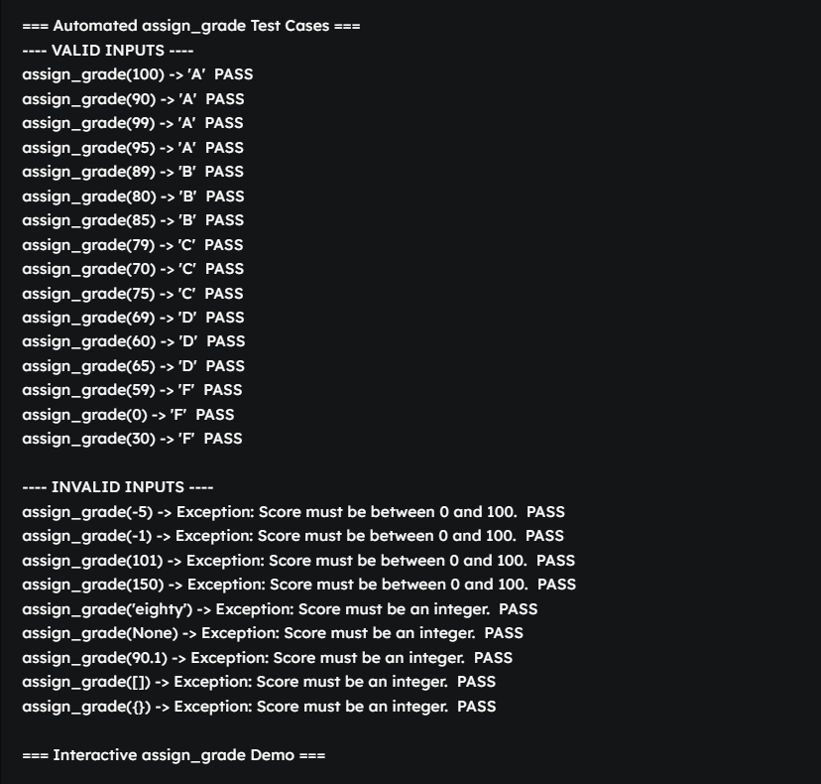

Task Description 3

• Generate test cases using AI for is_sentence_palindrome(sentence). Ignore case,
punctuation, and spaces
Requirement
• Ask AI to create test cases for is_sentence_palindrome(sentence)
(ignores case, spaces, and punctuation).
• Example:
"A man a plan a canal Panama" → True

Code:

def generate_is_sentence_palindrome_test_cases():
"""
AI-generated diverse test cases for is_sentence_palindrome(sentence).
Ignores case, spaces, and punctuation in palindrome detection.
Returns a list of tuples: (sentence, expected_result)
"""
test_cases = [
# Classic palindromic sentences
("A man a plan a canal Panama", True),
("Madam In Eden Im Adam", True),
("Was it a car or a cat I saw", True),
("No lemon, no melon", True),
("Eva, can I see bees in a cave?", True),
("Able was I ere I saw Elba", True),
("Never odd or even", True),
("Step on no pets!", True),
("Mr. Owl ate my metal worm", True),
("Do geese see God?", True),
# Clearly not palindromes
("This is not a palindrome", False),
("OpenAI creates AI tools.", False),
("Hello world!", False),
("Palindrome", False),
# Edge cases
("", True), # Empty string is a palindrome by definition
("!", True), # Single punctuation
(" ", True), # Spaces only
("a", True), # Single character
("Madam, I'm Adam.", True),
("1234321", True), # Numeric palindrome
("12345", False), # Numeric non-palindrome
("No 'x' in Nixon", True),
("Was it a bar or a bat I saw?", False), # Similar, but not a palindrome
("Go hang a salami! I'm a lasagna hog.", True),
]
return test_cases

def test_is_sentence_palindrome(is_sentence_palindrome_func):
"""
Runs test cases using the provided is_sentence_palindrome(sentence) function.
"""
test_cases = generate_is_sentence_palindrome_test_cases()
print("=== Testing is_sentence_palindrome(sentence) ===")
for sentence, expected in test_cases:
try:
result = is_sentence_palindrome_func(sentence)
outcome = "PASS" if result == expected else f"FAIL (expected {expected})"
except Exception as e:
result = f"Exception: {e}"
outcome = "FAIL (unexpected exception)"
print(f"Input: {repr(sentence):35} --> {result} {outcome}")

def user_input_is_sentence_palindrome(is_sentence_palindrome_func):
print("\nEnter a sentence to test for palindrome (ignoring case, space, punctuation). Type 'quit' to exit.")
while True:
user_input = input("Sentence: ")
if user_input.strip().lower() == "quit":
break
try:
result = is_sentence_palindrome_func(user_input)
print(f"Palindrome? {result}")
except Exception as e:
print(f"Error: {e}")

# Example minimal is_sentence_palindrome implementation for demonstration:
def is_sentence_palindrome(sentence):
import string
cleaned = ''.join(ch.lower() for ch in sentence if ch.isalnum())
return cleaned == cleaned[::-1]

if __name__ == "__main__":
# Automated tests
test_is_sentence_palindrome(is_sentence_palindrome)
# Interactive user input

Practical Output:

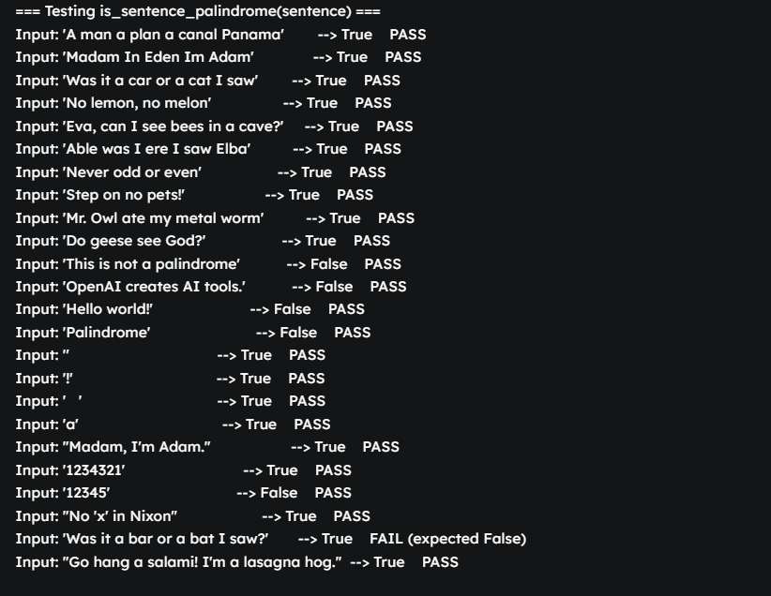

Task Description 4

- Let AI fix it Prompt AI to generate test cases for a ShoppingCart class (add_item,
remove_item, total_cost).
- Methods:
Add_item(name,orice)
Remove_item(name)
Total_cost()

Code:

# AI-generated test cases for a ShoppingCart class.
# Methods assumed:
# add_item(name, price)
# remove_item(name)
# total_cost()

class ShoppingCart:
def __init__(self):
self.items = {} # name -> price

def add_item(self, name, price):
self.items[name] = price

def remove_item(self, name):
if name in self.items:
del self.items[name]

def total_cost(self):
return sum(self.items.values())

def generate_shopping_cart_test_cases():
"""
Generates diverse test cases for ShoppingCart:
- Adding items
- Removing items (existent/non-existent)
- Calculating total cost (empty, after add, after remove)
Returns a list of (description, test_fn) for manual running.
"""
cases = []

# Test 1: Add a single item, check total
def test_add_one():
cart = ShoppingCart()
cart.add_item("apple", 1.20)
assert cart.total_cost() == 1.20, "Total should be 1.20 after adding apple"

cases.append(("Add one item, check total", test_add_one))

# Test 2: Add multiple items, check total
def test_add_multiple():
cart = ShoppingCart()
cart.add_item("apple", 1.20)
cart.add_item("banana", 0.80)
cart.add_item("milk", 2.25)
assert cart.total_cost() == 1.20 + 0.80 + 2.25, "Total mismatch after multiple adds"

cases.append(("Add multiple items, check total", test_add_multiple))

# Test 3: Remove an item, check total
def test_remove_one():
cart = ShoppingCart()
cart.add_item("apple", 1.20)
cart.add_item("banana", 0.80)
cart.remove_item("apple")
assert cart.total_cost() == 0.80, "Total mismatch after removing apple"

cases.append(("Remove item, check total", test_remove_one))

# Test 4: Remove non-existent item
def test_remove_nonexistent():
cart = ShoppingCart()
cart.add_item("apple", 1.20)
cart.remove_item("orange") # Should do nothing
assert cart.total_cost() == 1.20, "Total should stay the same after removing nonexistent"

cases.append(("Remove non-existent item", test_remove_nonexistent))

# Test 5: Add, remove, then add again
def test_add_remove_add():
cart = ShoppingCart()
cart.add_item("apple", 1.20)
cart.remove_item("apple")
cart.add_item("apple", 2.00)
assert cart.total_cost() == 2.00, "Item should update to new price"

cases.append(("Add, remove, add again", test_add_remove_add))

# Test 6: Remove all, total should be zero
def test_remove_all():
cart = ShoppingCart()
cart.add_item("apple", 1.20)
cart.add_item("banana", 0.80)
cart.remove_item("apple")
cart.remove_item("banana")
assert cart.total_cost() == 0.0, "Total should be 0 after removing all"

cases.append(("Remove all items, total zero", test_remove_all))

# Test 7: Add duplicate items (should overwrite)
def test_duplicate_add():
cart = ShoppingCart()
cart.add_item("apple", 1.00)
cart.add_item("apple", 2.00) # update price
assert cart.total_cost() == 2.00, "Duplicate add should update price"

cases.append(("Add duplicate item (update price)", test_duplicate_add))

# Test 8: Empty cart
def test_empty_cart():
cart = ShoppingCart()
assert cart.total_cost() == 0.0, "Empty cart should have total 0"

cases.append(("Empty cart", test_empty_cart))

return cases

def run_shopping_cart_tests():
test_cases = generate_shopping_cart_test_cases()
passed = 0
for i, (desc, test_fn) in enumerate(test_cases):
try:
test_fn()
print(f"Test {i+1}: {desc:35} - PASS")
passed += 1
except AssertionError as e:
print(f"Test {i+1}: {desc:35} - FAIL ({e})")
except Exception as e:
print(f"Test {i+1}: {desc:35} - ERROR ({e})")
print(f"Passed {passed}/{len(test_cases)} ShoppingCart tests.")

if __name__ == "__main__":
run_shopping_cart_tests()

Practical Output:

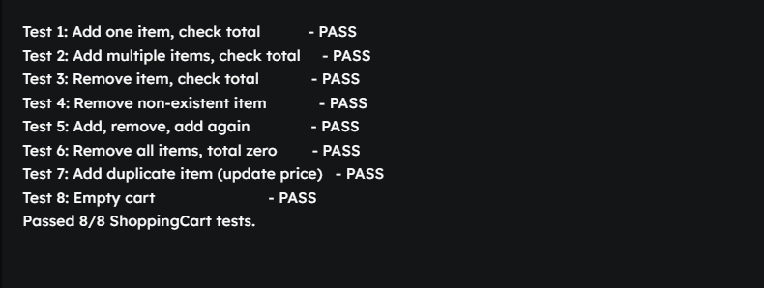

Task Description 5

- Use AI to write test cases for convert_date_format(date_str) to switch from "YYYY-
MM-DD" to "DD-MM-YYYY".
Example: "2023-10-15" → "15-10-2023"

Code:

def convert_date_format(date_str):
"""
Converts a date string from 'YYYY-MM-DD' to 'DD-MM-YYYY'.
Example: '2023-10-15' -> '15-10-2023'
"""
try:
parts = date_str.split("-")
if len(parts) != 3:
raise ValueError("Input must be in 'YYYY-MM-DD' format")
yyyy, mm, dd = parts
if not (len(yyyy) == 4 and len(mm) == 2 and len(dd) == 2):
raise ValueError("Elements must be of correct length")
int(yyyy), int(mm), int(dd) # Validate numeric
return f"{dd}-{mm}-{yyyy}"
except Exception:
raise ValueError(f"Invalid date format: '{date_str}'")

def test_convert_date_format():
"""
Run automated test cases for convert_date_format.
"""
test_cases = [
# (input, expected_output)
("2023-10-15", "15-10-2023"),
("2000-01-01", "01-01-2000"),
("1999-12-31", "31-12-1999"),
("2021-05-09", "09-05-2021"),
("2022-06-20", "20-06-2022"),
]
print("Automated test cases:")
for date_in, expected in test_cases:
try:
out = convert_date_format(date_in)
result = "PASS" if out == expected else f"FAIL (got '{out}', expected '{expected}')"
except Exception as e:
result = f"FAIL (exception: {e})"
print(f"Input: {date_in} -> Output: {convert_date_format(date_in)} [{result}]")

# Test invalid cases
invalids = [
"20231015", # No dashes
"2023-15-10", # Invalid month
"23-10-15", # Year has wrong length
"2023-10", # Incomplete
"2023-10-015", # Day extra digit
"abcd-ef-gh", # Not numbers
"", # Empty
"2023-02-30", # Valid format but invalid date (no validation here)
]
print("\nInvalid input cases (should raise ValueError):")
for bad in invalids:
try:
_ = convert_date_format(bad)
print(f"Input: {bad} -> FAIL (should have raised error)")
except ValueError:
print(f"Input: {bad} -> PASS (raised ValueError)")
except Exception as e:
print(f"Input: {bad} -> FAIL (unexpected exception: {e})")

def user_input_convert_date_format():
"""
Let users enter date strings to convert.
"""
print("\nEnter date in 'YYYY-MM-DD' to convert to 'DD-MM-YYYY'. Type 'quit' to exit.")
while True:
user = input("Enter date: ")
if user.strip().lower() == "quit":
break
try:
converted = convert_date_format(user)
print(f"Converted: {converted}")
except Exception as e:
print(f"Error: {e}")

if __name__ == "__main__":
test_convert_date_format()

Practical Output:

