Task Description-1: -
Basic Docstring Generation
• Write python function to return sum of even and odd numbers in the given list.
• Incorporate manual docstring in code with Google Style
• Use an AI-assisted tool (e.g., Copilot, Cursor AI) to generate a docstring describing
the function.
• Compare the AI-generated docstring with your manually written one.

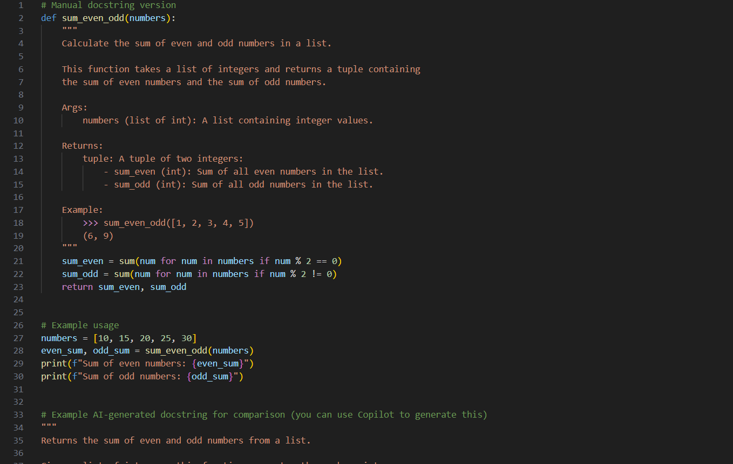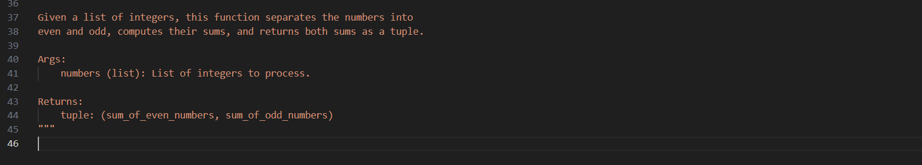
Practical Output: -

Explanation: -

Function Definition
def sum_even_odd(numbers):
This defines a function named sum_even_odd that takes one argument numbers.
numbers is expected to be a list of integers.

2. Manual Docstring (Google Style)
"""
Calculate the sum of even and odd numbers in a list.

This function takes a list of integers and returns a tuple containing
the sum of even numbers and the sum of odd numbers.

Args:
numbers (list of int): A list containing integer values.

Returns:
tuple: A tuple of two integers:
- sum_even (int): Sum of all even numbers in the list.
- sum_odd (int): Sum of all odd numbers in the list.

Example:
>>> sum_even_odd([1, 2, 3, 4, 5])
(6, 9)
"""
Explanation:
Purpose: The first line briefly explains what the function does.
Detailed Description: Explains that it sums even and odd numbers separately and returns them as a tuple.
Args: Specifies the function input type (list of int).
Returns: Explains the output: a tuple with the sum of evens and sum of odds.
Example: Shows how the function works with a real input and what output to expect.
This is very thorough and helpful for someone reading your code for the first time.

3. Logic of the Function
sum_even = sum(num for num in numbers if num % 2 == 0)
sum_odd = sum(num for num in numbers if num % 2 != 0)
return sum_even, sum_odd
num % 2 == 0 checks if a number is even.
num % 2 != 0 checks if a number is odd.
sum() adds all numbers that meet the condition.
The function returns a tuple (sum_even, sum_odd).
Example:
For numbers = [10, 15, 20, 25, 30]
Even numbers: 10 + 20 + 30 = 60
Odd numbers: 15 + 25 = 40
Returns: (60, 40)

4. Example Usage
numbers = [10, 15, 20, 25, 30]
even_sum, odd_sum = sum_even_odd(numbers)
print(f"Sum of even numbers: {even_sum}")
print(f"Sum of odd numbers: {odd_sum}")
Calls the function with a sample list.
Stores results in even_sum and odd_sum.
Prints the results in a readable format:
Output:
Sum of even numbers: 60
Sum of odd numbers: 40

5. AI-Generated Docstring
"""
Returns the sum of even and odd numbers from a list.

Given a list of integers, this function separates the numbers into
even and odd, computes their sums, and returns both sums as a tuple.

Args:
numbers (list): List of integers to process.

Returns:
tuple: (sum_of_even_numbers, sum_of_odd_numbers)
"""
Comparison with manual docstring:
Shorter and less detailed.
No example included.
Slightly more general and readable for quick understanding.
Great for speeding up documentation but may need refinement for teaching or detailed explanations.

Task Description-2: -
Automatic Inline Comments
• Write python program for sru_student class with attributes like name, roll no.,
hostel_status and fee_update method and display_details method.
• Write comments manually for each line/code block
• Ask an AI tool to add inline comments explaining each line/step.
• Compare the AI-generated comments with your manually written one.
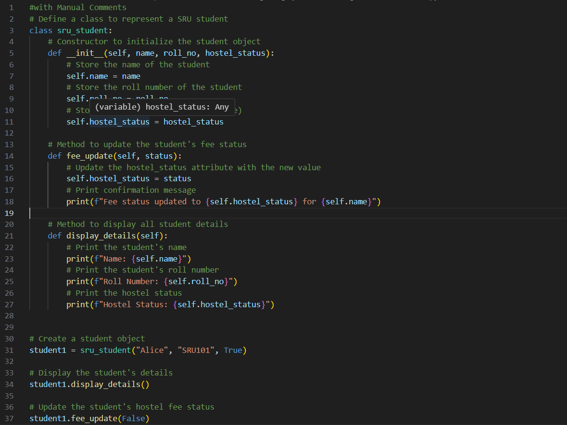
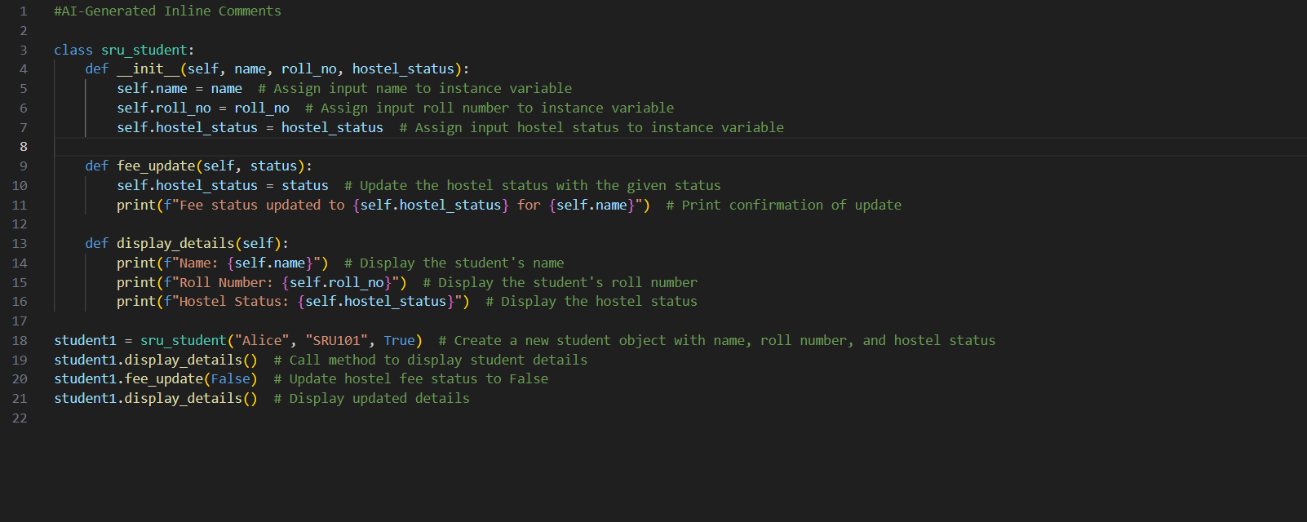
Practical Output: - 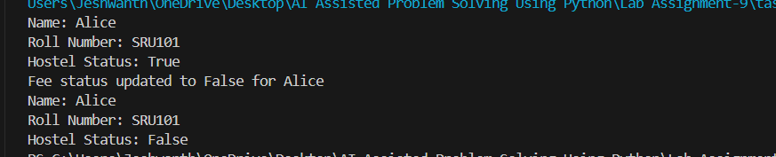

Explanation: -

Comparison
Aspect | Manual Comments | AI-Generated Comments
Detail | More descriptive, explains reasoning behind steps | More concise, explains what each line does
Readability | Easy for beginners to understand | Clear and straightforward, good for quick reading
Usefulness | Good for teaching or documentation purposes | Good for code review or quick understanding
Effort | Requires manual writing | Automatically generated by AI tool

Class Definition
class sru_student:
This line defines a new class called sru_student.
Classes are used to model objects—in this case, a student at SRU with attributes and methods.

2. Constructor Method (__init__)
def __init__(self, name, roll_no, hostel_status):
The __init__ method is called when a new student object is created.
It takes three arguments besides self: name, roll_no, and hostel_status.
self.name = name
self.roll_no = roll_no
self.hostel_status = hostel_status
These lines store the input values as attributes of the student object so they can be used later.
self refers to the instance of the object itself.
Manual comments: Explain the purpose of each line clearly.
AI-generated comments: Usually just say what is happening, e.g., “Assign input name to instance variable.”

3. Fee Update Method
def fee_update(self, status):
self.hostel_status = status
print(f"Fee status updated to {self.hostel_status} for {self.name}")
fee_update changes the student's hostel fee status.
status is the new fee status (True or False).
First line updates the hostel_status attribute.
Second line prints a confirmation message.
Manual comments: Explain why we do this (update the status and confirm).
AI-generated comments: Explain what is done, often very straightforward.

4. Display Details Method
def display_details(self):
print(f"Name: {self.name}")
print(f"Roll Number: {self.roll_no}")
print(f"Hostel Status: {self.hostel_status}")
This method prints all attributes of the student.
Easy way to check the current state of the object.
Manual comments: Can describe each attribute’s meaning.
AI-generated comments: Usually repeat the obvious, e.g., “Display the student's name.”

5. Creating and Using the Student Object
student1 = sru_student("Alice", "SRU101", True)
Creates a new student named “Alice” with roll number SRU101 and hostel_status = True.
student1.display_details()
student1.fee_update(False)
student1.display_details()
First call prints initial details.
Second call updates the fee status to False and prints confirmation.
Third call prints updated details.
Task Description-3: -
• Write a Python script with 3–4 functions (e.g., calculator: add, subtract, multiply,
divide).
• Incorporate manual docstring in code with NumPy Style
• Use AI assistance to generate a module-level docstring + individual function
docstrings.
• Compare the AI-generated docstring with your manually written one.

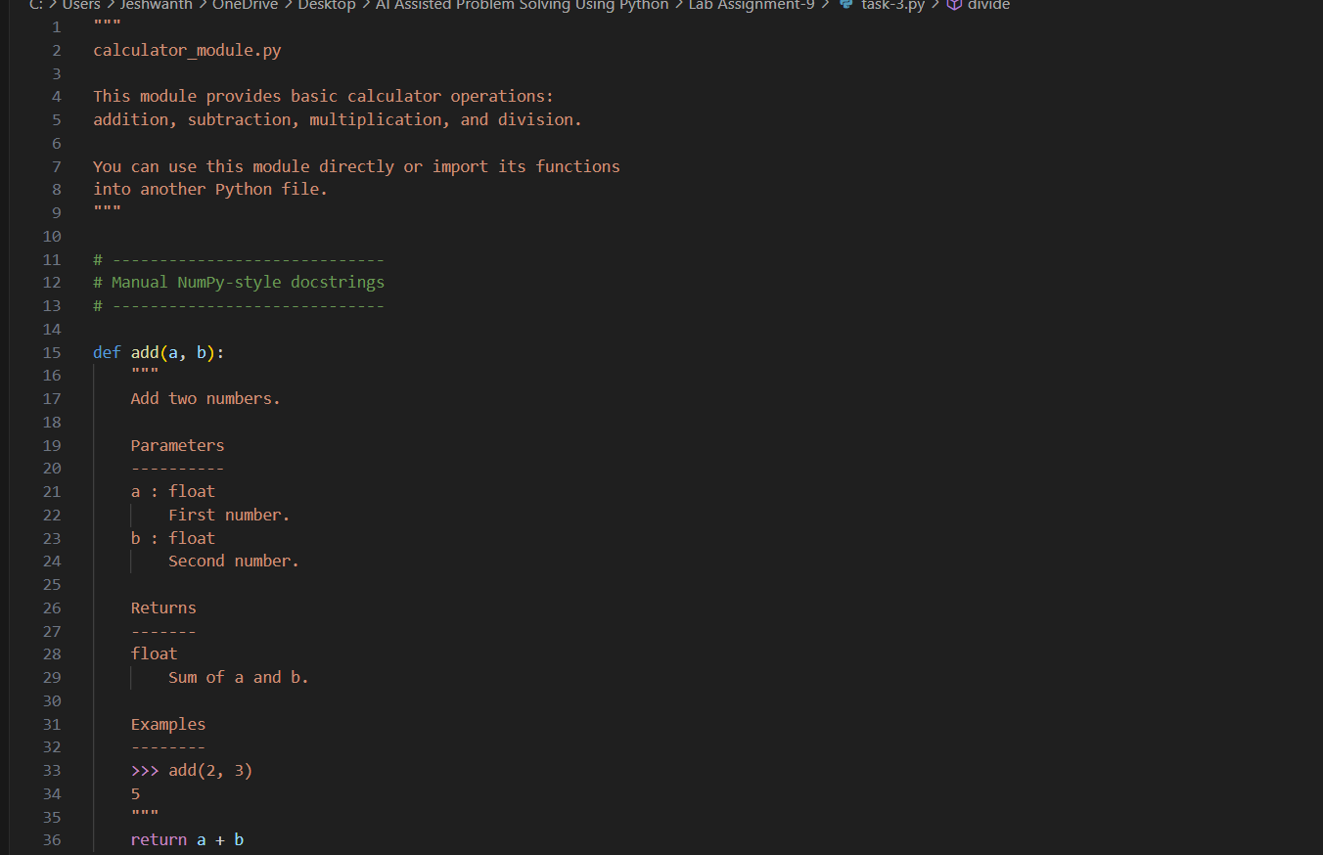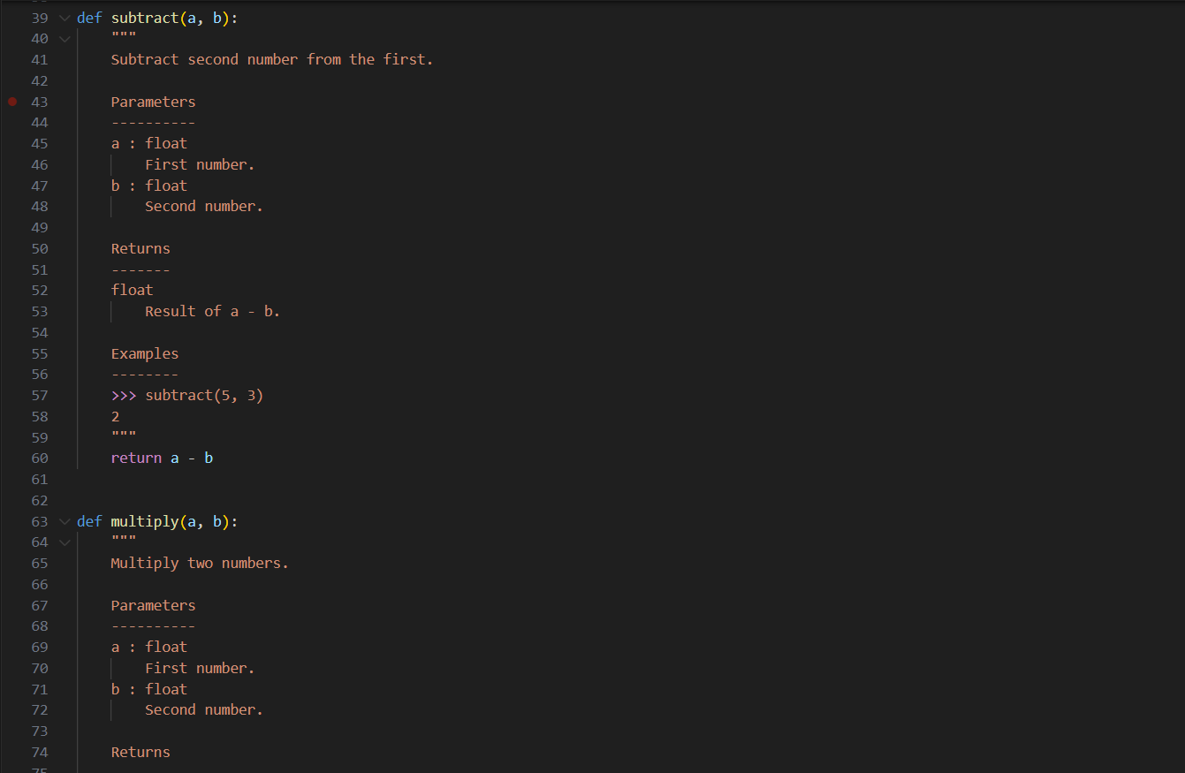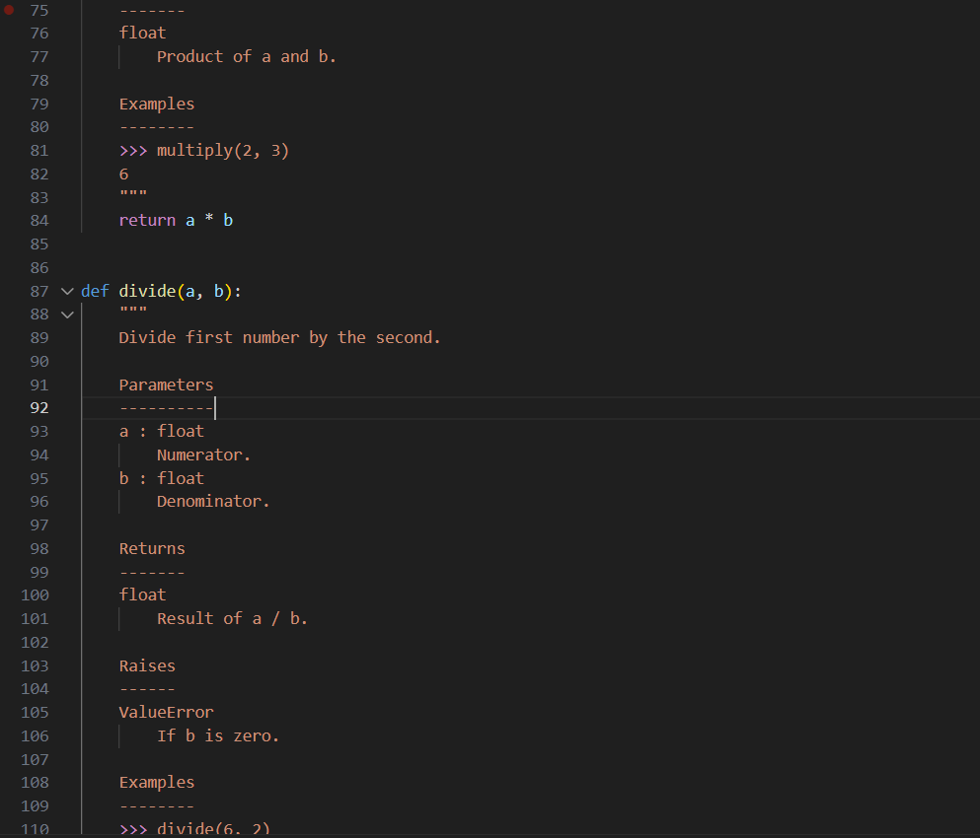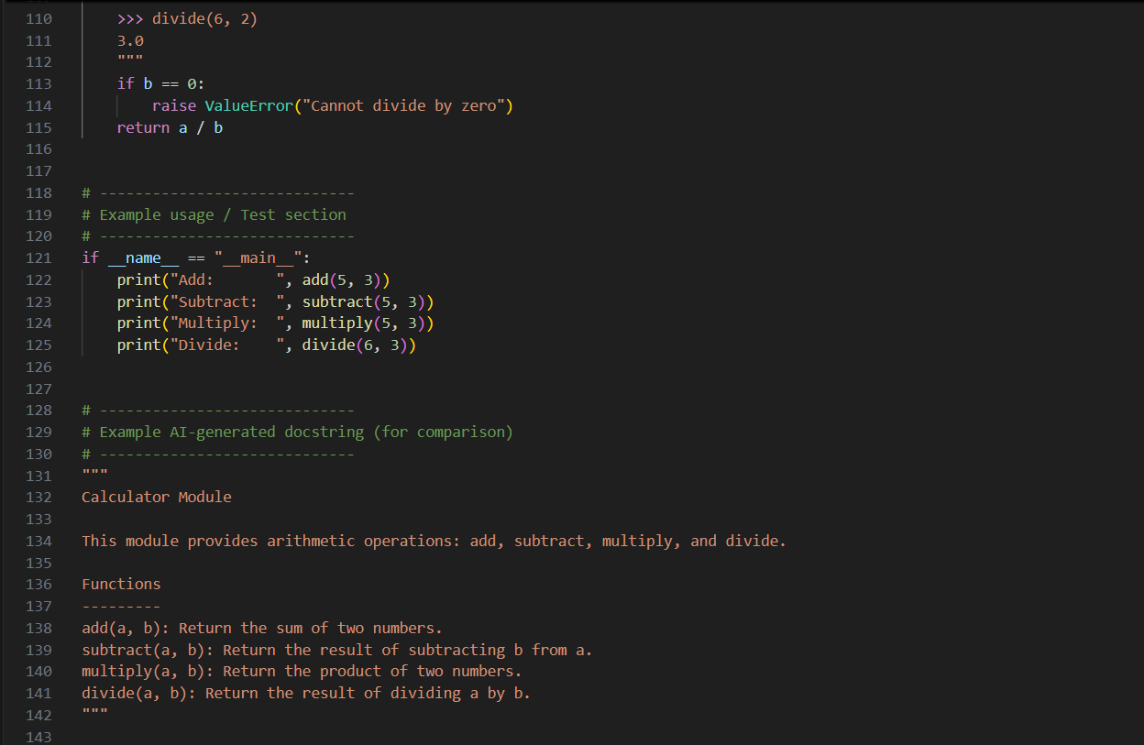
Practical Output: -

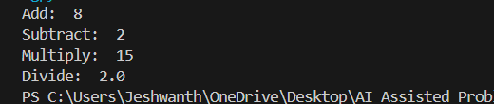
Push documentation whole workspace as .md file in GitHub Repository
Note: Report should be submitted a word document for all tasks in a single document with
Explanation: -

Module Overview
"""
calculator_module.py

This module provides basic calculator operations:
addition, subtraction, multiplication, and division.
"""
- This is a module-level docstring.
- Explains what the module does overall: it provides four basic arithmetic operations.
Manual Docstring: Structured, clear, educational.
AI-Generated: Similar, concise, may skip extra details.

2. Function Definitions
Add Function
def add(a, b):
"""
Add two numbers.

Parameters
----------
a : float
First number.
b : float
Second number.

Returns
-------
float
Sum of a and b.

Examples
--------
>>> add(2, 3)
5
"""
return a + b
Explanation:
- Parameters: Lists the inputs with type and description.
- Returns: Specifies the type and meaning of output.
- Examples: Shows usage.
AI-generated version might look like:
"""
Return the sum of two numbers.

Parameters:
a (float): First number.
b (float): Second number.

Returns:
float: Sum of a and b.
"""
Difference:
- Manual docstring includes Examples section.
- AI docstring is shorter, explains what it does but no usage example.

Subtract, Multiply, Divide Functions
- Same structure:
  - Manual: Parameters, Returns, Examples, and for divide a Raises section if dividing by zero.
  - AI: Mostly Parameters and Returns, sometimes includes Raises.
Divide Example with Error Handling:
def divide(a, b):
if b == 0:
raise ValueError("Cannot divide by zero")
return a / b
- Manual docstring explains why the ValueError is raised.
- AI docstring usually mentions the exception briefly.

3. Example Usage
if __name__ == "__main__":
print("Add: ", add(5, 3))
print("Subtract: ", subtract(5, 3))
print("Multiply: ", multiply(5, 3))
print("Divide: ", divide(6, 3))
- Tests all four functions.
- Demonstrates how the module works when run directly.
- Output will be:
Add: 8
Subtract: 2
Multiply: 15
Divide: 2.0

4. Comparison of Manual vs AI-Generated Docstrings
Feature | Manual Docstring (NumPy) | AI-Generated Docstring
Style | NumPy style: Parameters, Returns, Examples, Raises | Simple, generic documentation
Examples | Included for clarity | Usually missing
Detail | Describes reasoning, error handling, and output | Describes what function does only
Usefulness | Good for learning, teaching, or official docs | Quick, saves time, good for code review
Effort | Manual writing required | Auto-generated
Key Insight:
- Manual docstrings are more structured and educational, perfect for formal documentation.
- AI docstrings are faster to generate, enough for quick understanding but less detailed.

✅ Takeaway for Students:
- Structured documentation (NumPy style) makes multi-function scripts easy to read, maintain, and use.
- AI tools can help save time but may require manual refinement for full clarity and examples.

