Assignment-2

Task Description 1:
- Use Google Gemini in Colab to write a function that reads a CSV file and calculates mean, min, max.

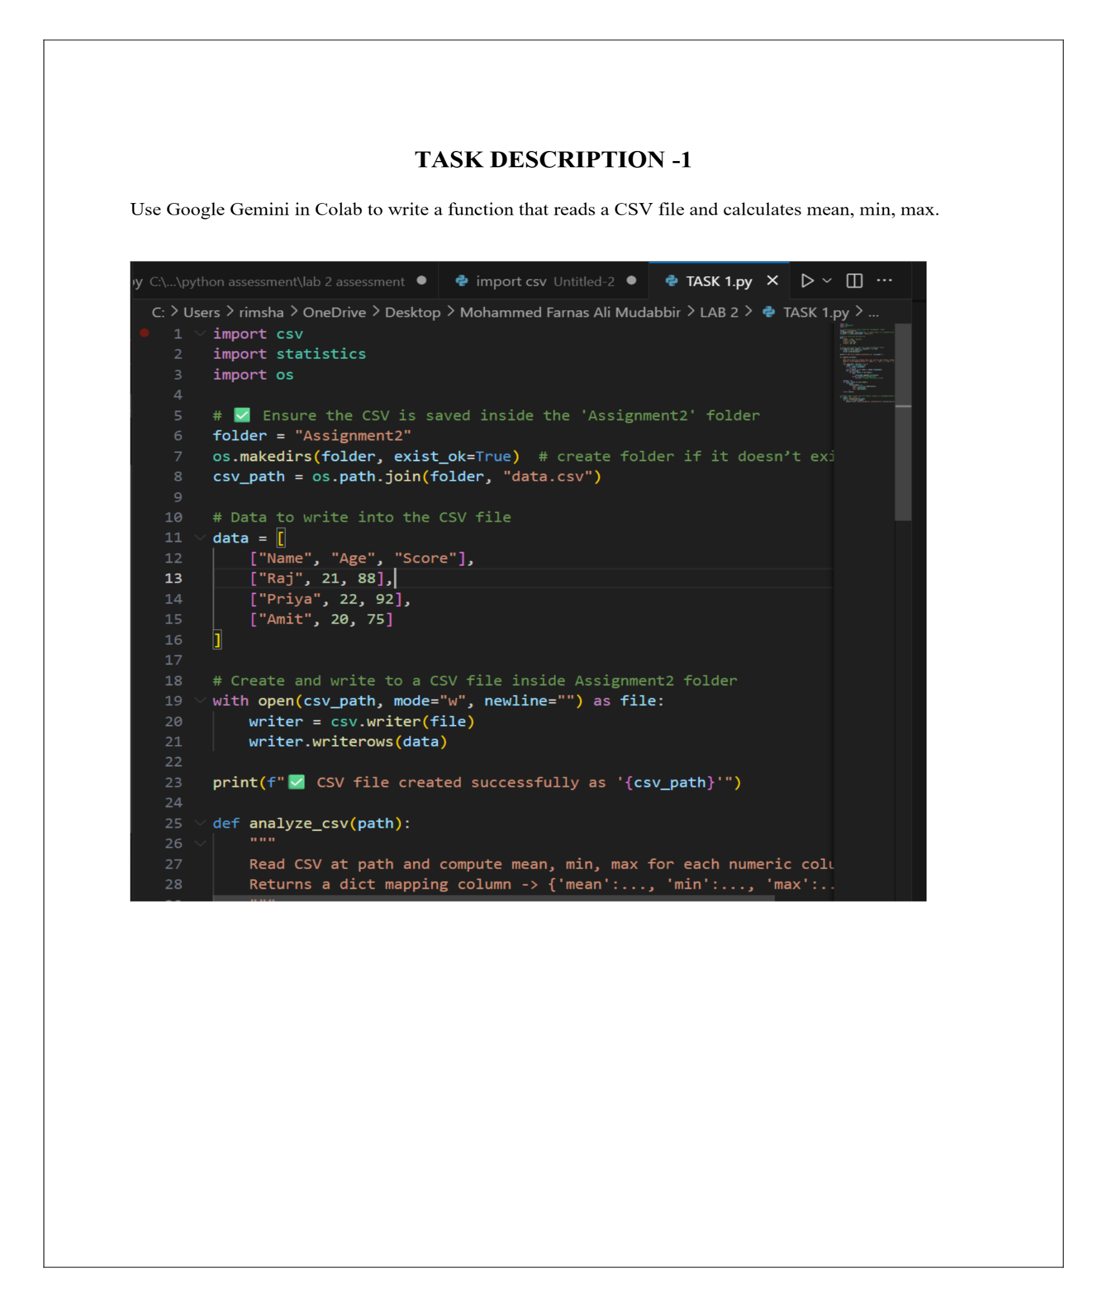
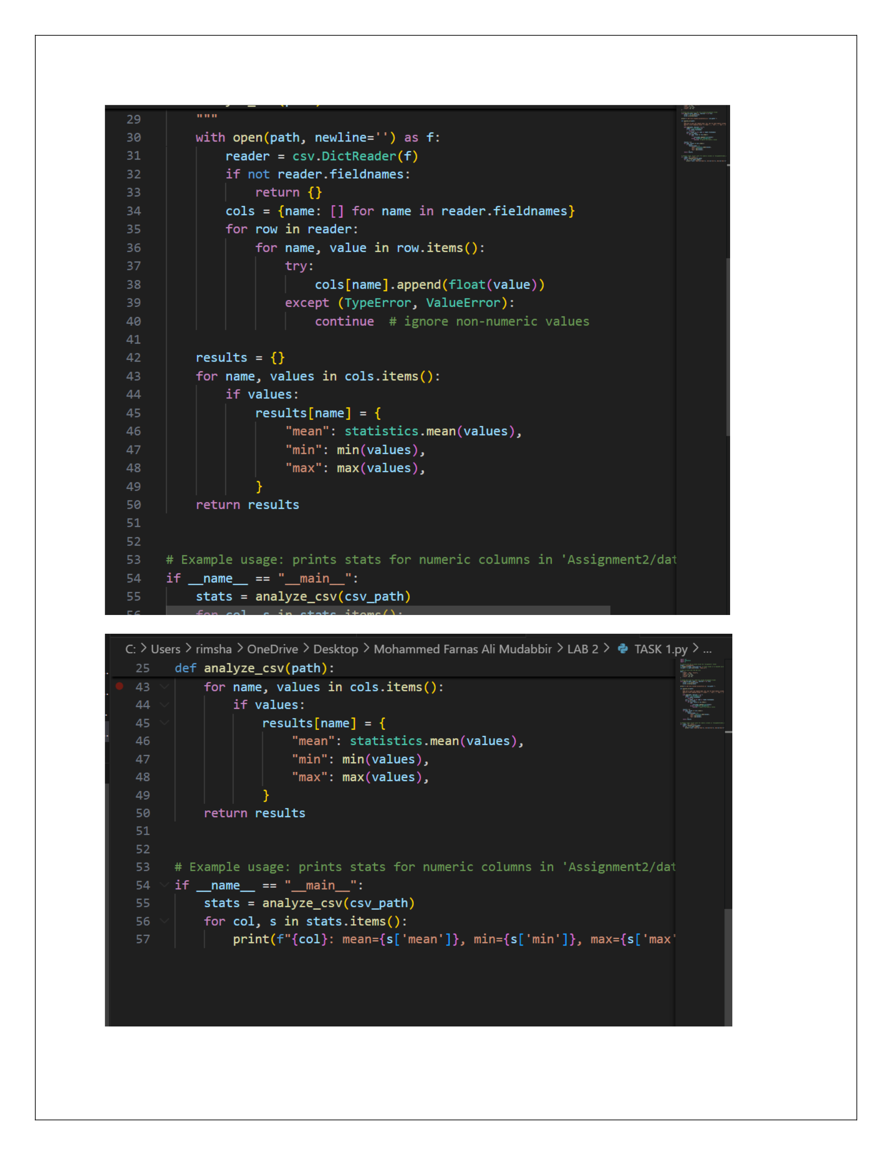


Practical output:
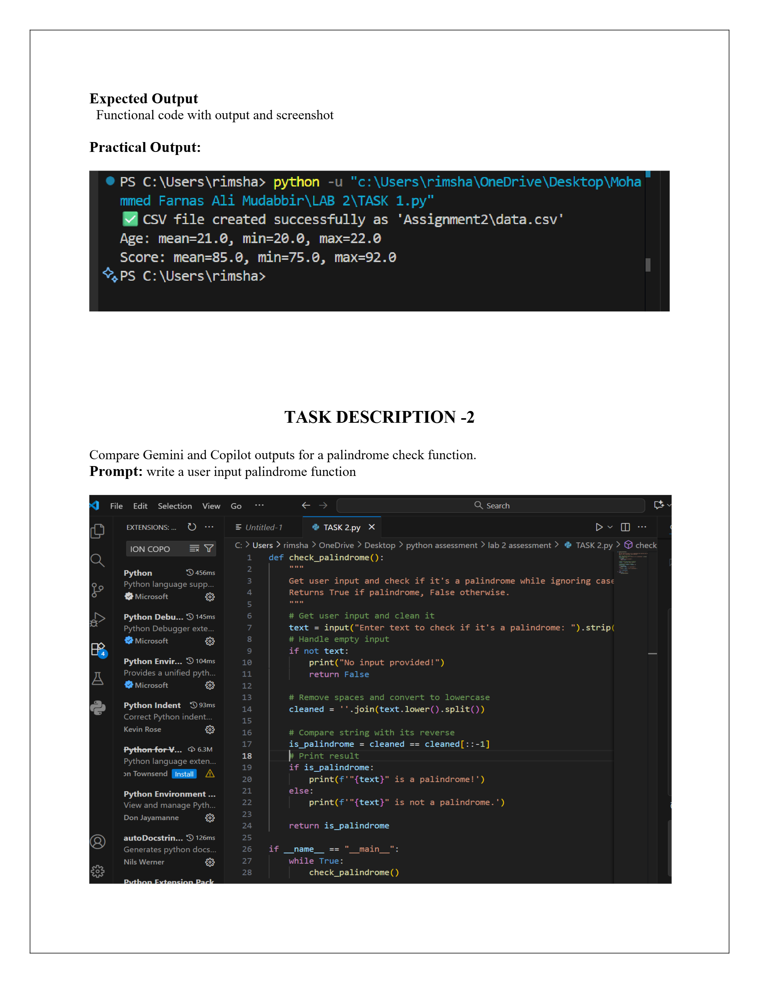

Task Description 2:
- Compare Gemini and Copilot outputs for a palindrome check function.

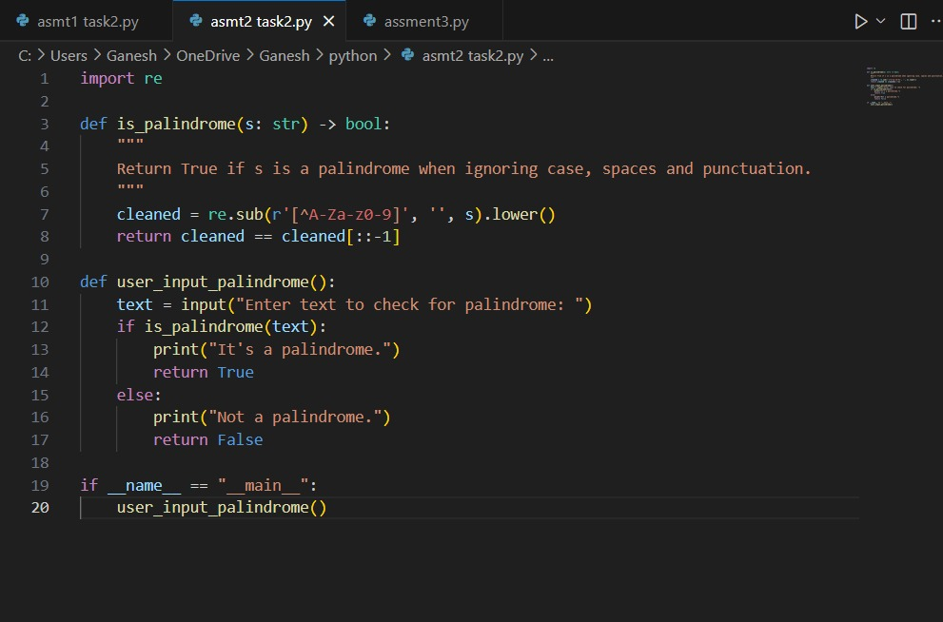
Practical output:
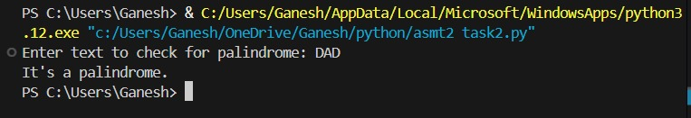

Task Description 3:
- Ask Gemini to explain a Python function (to calculate area of various shapes) line by line.

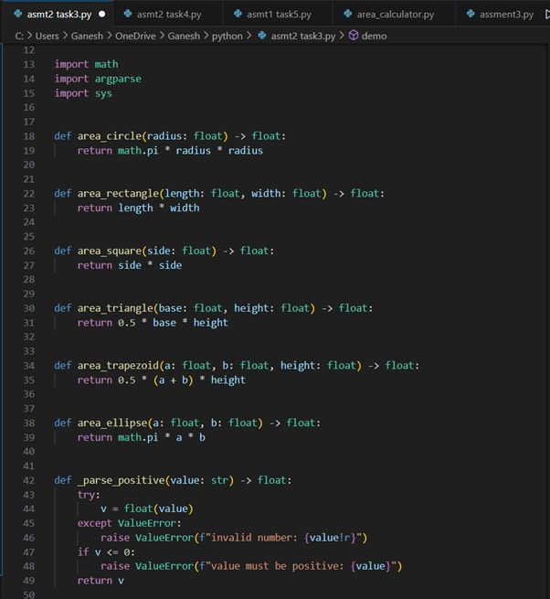
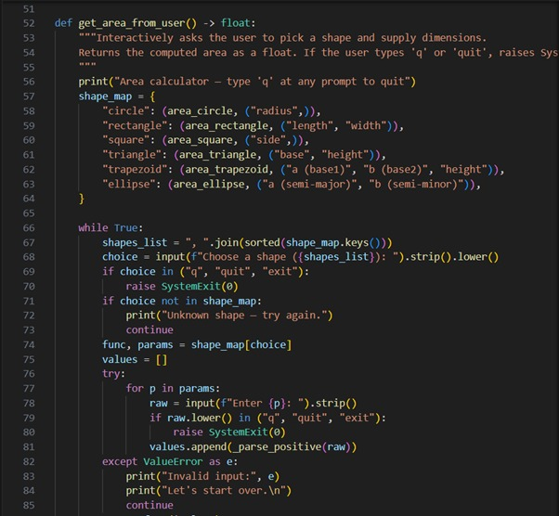
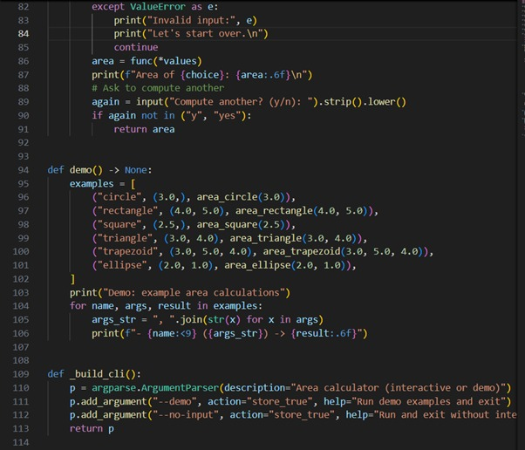
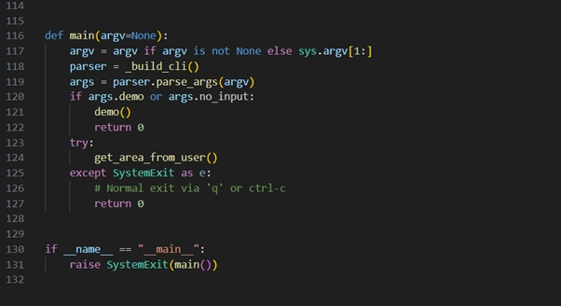

Practical output:
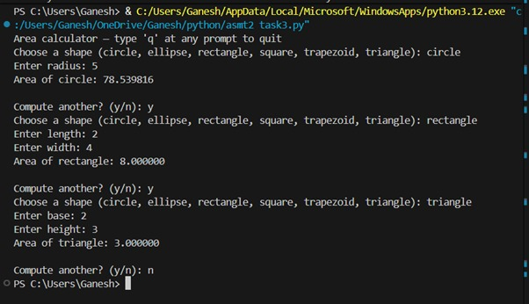

Task Description 4:
- Install and configure Cursor AI. Use it to generate a Python function (e.g., sum of squares).

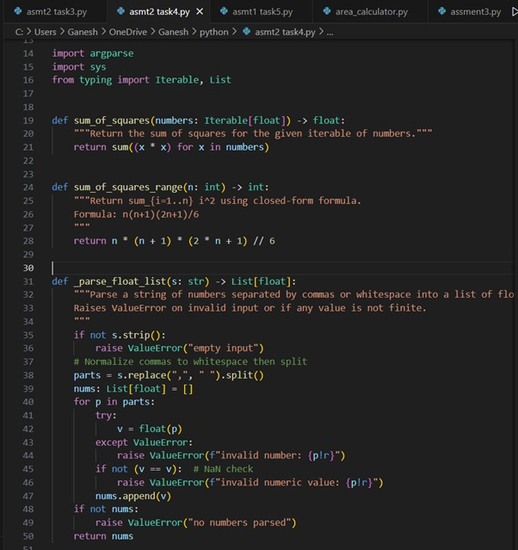
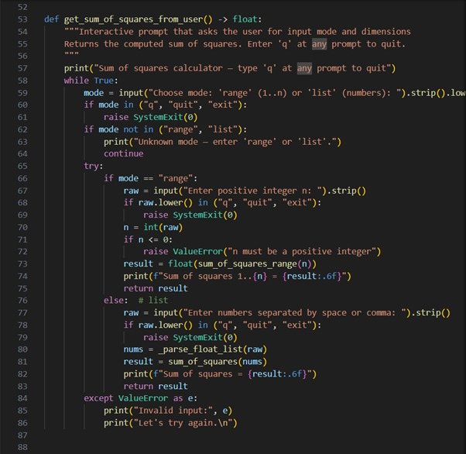
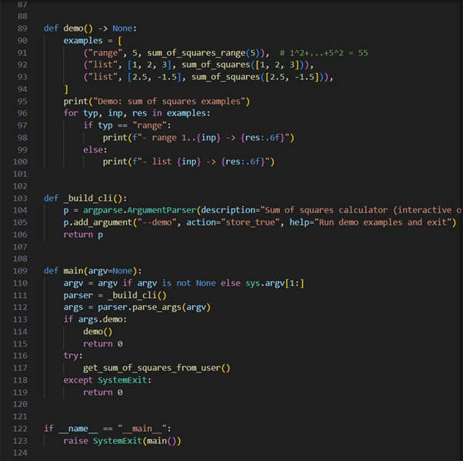
Practical output:

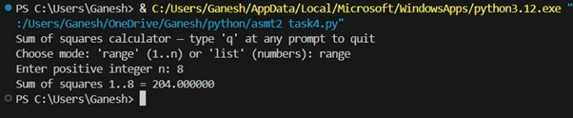

Task Description 5:
- Student need to write code to calculate sum of add number and even numbers in the list.

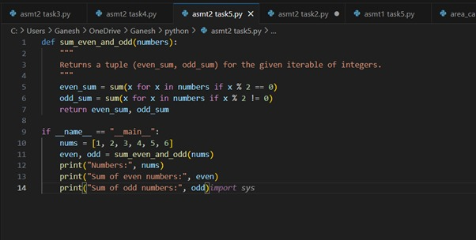
Practical output:

