Task 1
Description: Install and configure GitHub Copilot in VS Code. Take screenshots of each step.
Expected Output: Install and configure GitHub Copilot in VS Code. Take screenshots of each step.

Prerequisites: Latest version of VS Code is installed, GitHub Account, Internet Connection
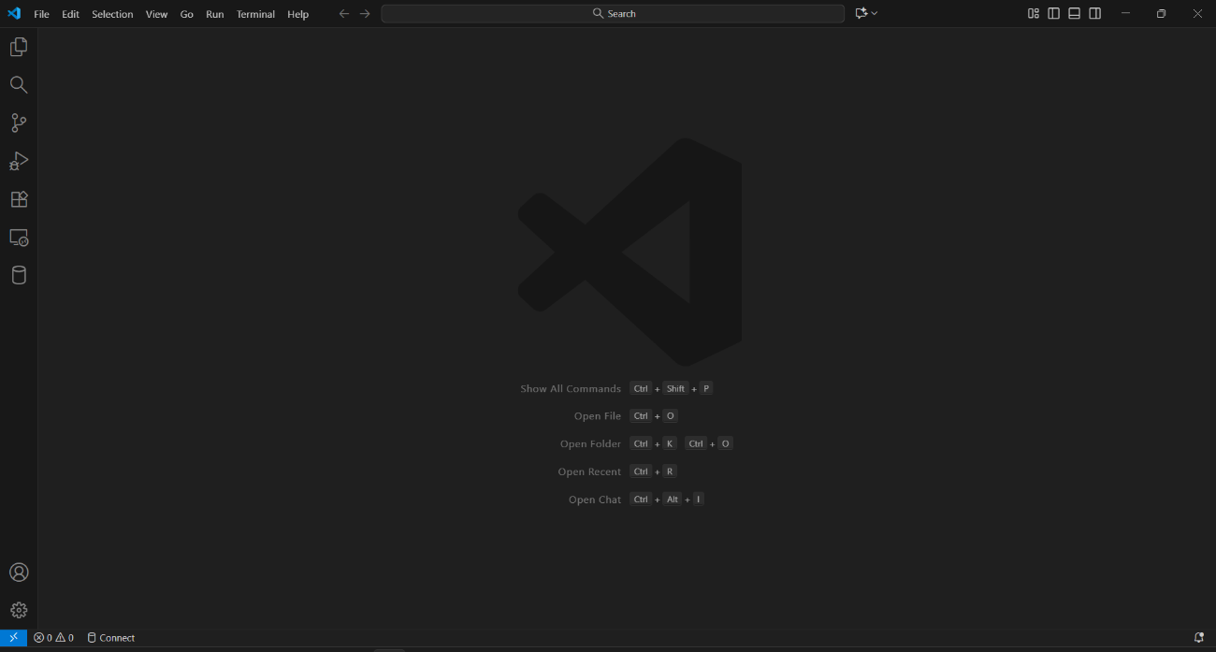
Step 1: Open VS Code

Step 2: Open the Extensions Tab
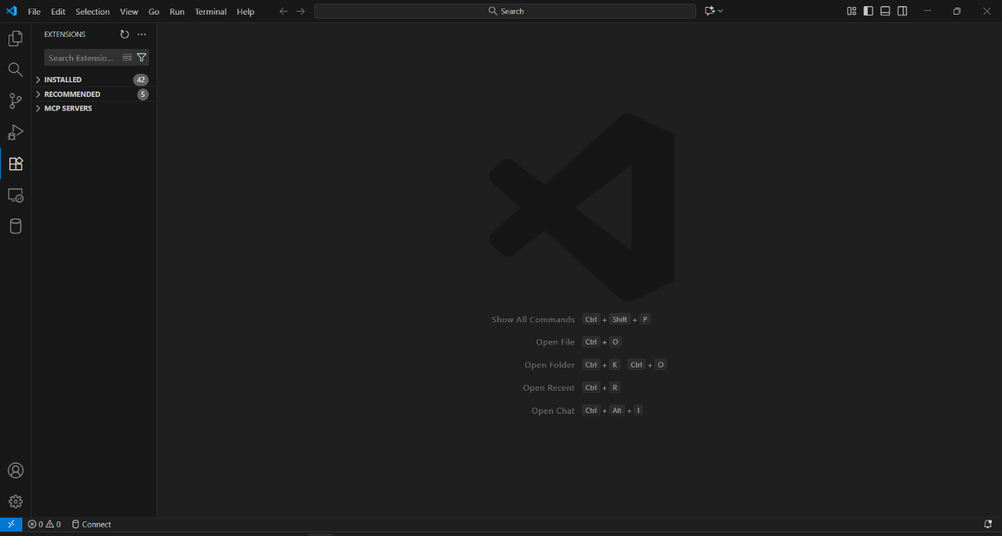

Step 3: Search for “GitHub Copilot”
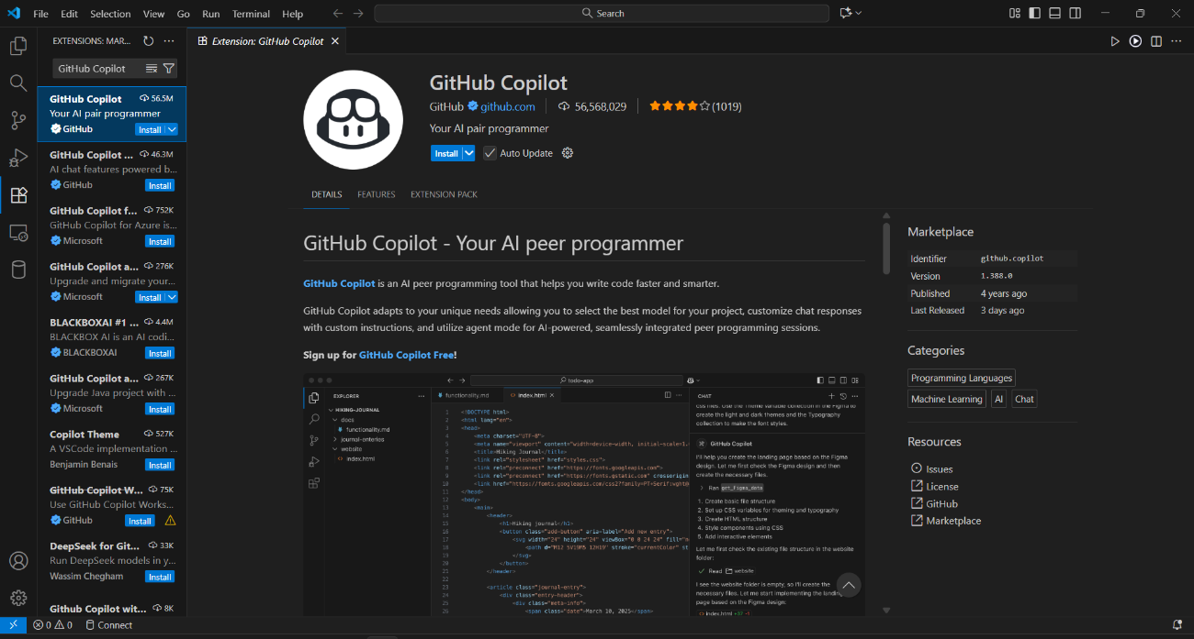
Step 4: Click on “Install” and wait for VS Code to install the GitHub Copilot Extension
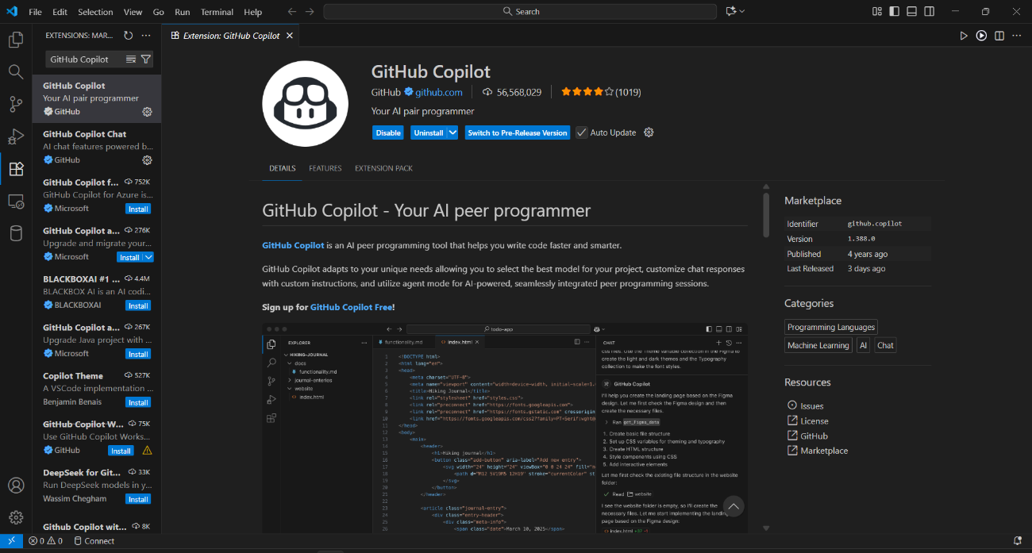

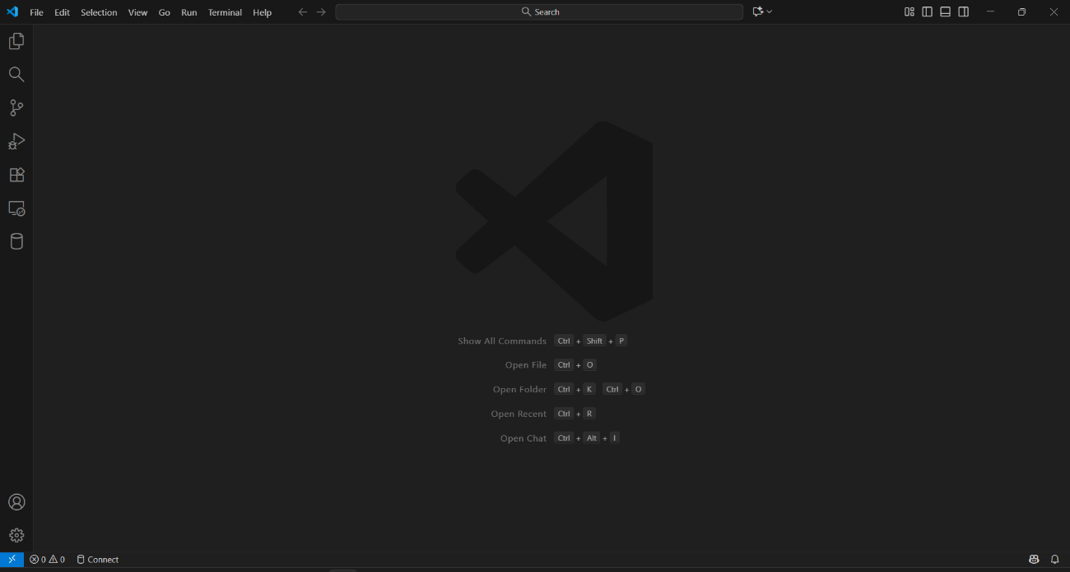
Step 5: Close and Reopen VS Code

Step 6: Sign-in and Authorize GitHub Copilot using the GitHub account


Step 7: GitHub Copilot is now Ready!
