SCHOOL OF COMPUTER SCIENCE AND ARTIFICIAL INTELLIGENCE |  |  |  |  | DEPARTMENT OF COMPUTER SCIENCE ENGINEERING
ProgramName:B. Tech |  |  |  | Assignment Type: Lab |  |  | AcademicYear:2025-2026
CourseCoordinatorName |  |  |  | Venkataramana Veeramsetty
Instructor(s)Name |  |  |  | Dr. V. Venkataramana (Co-ordinator)  Dr. T. Sampath Kumar  Dr. Pramoda Patro  Dr. Brij Kishor Tiwari  Dr.J.Ravichander  Dr. Mohammand Ali Shaik  Dr. Anirodh Kumar  Mr. S.Naresh Kumar  Dr. RAJESH VELPULA  Mr. Kundhan Kumar  Ms. Ch.Rajitha  Mr. M Prakash  Mr. B.Raju  Intern 1 (Dharma teja)  Intern 2 (Sai Prasad)  Intern 3 (Sowmya)  NS_2 ( Mounika)
CourseCode |  |  | 24CS002PC215 | CourseTitle |  | AI Assisted Coding
Year/Sem |  |  | II/I | Regulation |  | R24
Date and Day  of Assignment |  |  | Week4 - Wednesday | Time(s)
Duration |  |  | 2 Hours | Applicableto  Batches
AssignmentNumber:7.3(Present assignment number)/24(Total number of assignments)
 | Q.No. | Question |  |  |  |  |  | ExpectedTime  to complete
 | 1 | Lab 7: AI-Error Debugging with AI: Systematic approaches to finding and fixing bugs  Lab Objectives:  - To identify and correct syntax, logic, and runtime errors in Python programs using AI tools.  - To understand common programming bugs and AI-assisted debugging suggestions.  - To evaluate how AI explains, detects, and fixes different types of coding errors.  - To build confidence in using AI to perform structured debugging practices.  Lab Outcomes (LOs):  After completing this lab, students will be able to:  - Use AI tools to detect and correct syntax, logic, and runtime errors.  - Interpret AI-suggested bug fixes and explanations.  - Apply systematic debugging strategies supported by AI-generated insights.  - Refactor buggy code using responsible and reliable programming patterns.  Task Description#1  - Paste a function with a missing colon (add(a, b)), and let AI fix the syntax error.  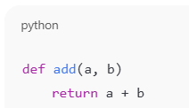  Expected Output#1  - Corrected function with syntax fix  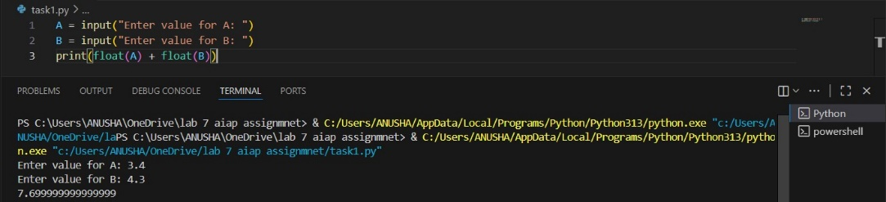  Task Description#2 (Loops)  - Identify and fix a logic error in a loop that causes infinite iteration.  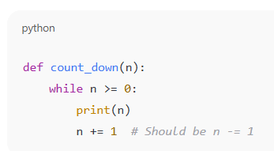  Expected Output#2  - AI fixes increment/decrement error  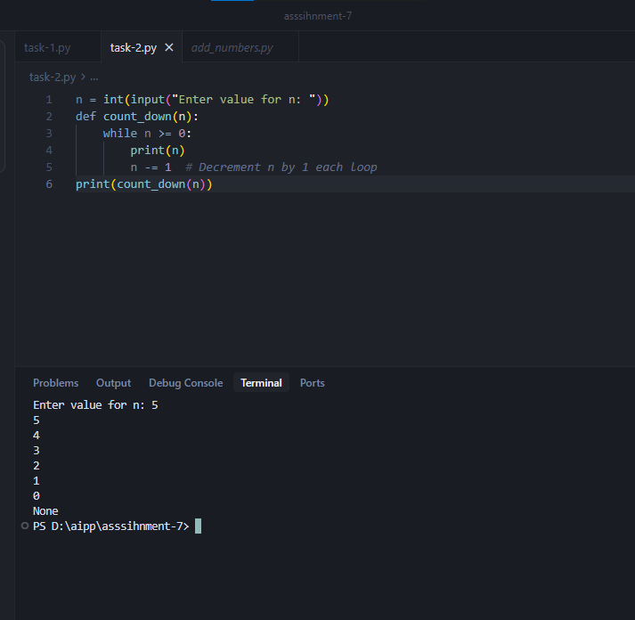  Task Description#3  - Debug a runtime error caused by division by zero. Let AI insert try-except.  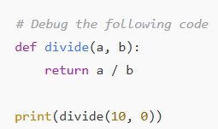  Expected Output#3  - Corrected function with safe error handling  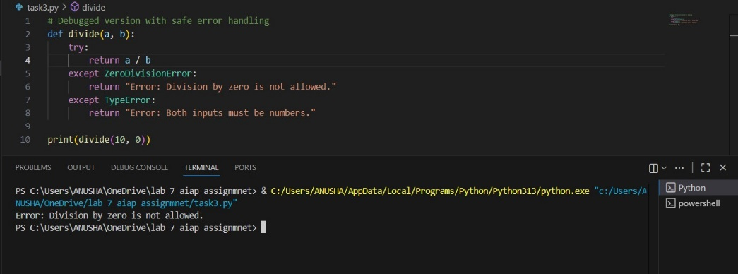  Task Description#4  - Provide a faulty class definition (missing self in parameters). Let AI fix it  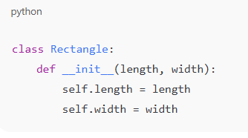  Expected Output#4  - Correct __init__() method and explanation  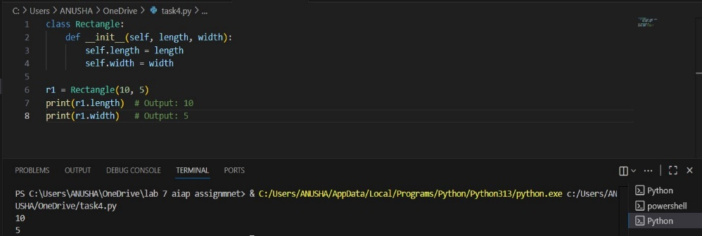  Explanation:  The first parameter of every instance method (including __init__) must be self.  self refers to the current instance of the class, allowing access to its attributes and methods.  Task Description#5  - Access an invalid list index and use AI to resolve the Index Error.  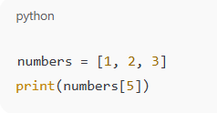  Expected Output#5  - AI suggests checking length or using safe access logic  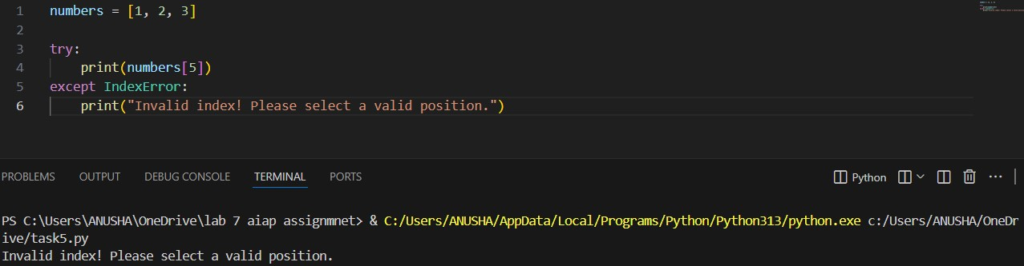  Note: Report should be submitted a word document for all tasks in a single document with prompts, comments & code explanation, and output and if required, screenshots  Evaluation Criteria:  Criteria Max Marks  Identification of bugs 0.5  Application of AI-suggested fixes 0.5  Explanation and understanding of errors 0.5  Corrected code functionality 0.5  Report structure and reflection 0.5  Total 2.5 Marks |  |  |  |  |  | Week4 - Wednesday

