SET-3
Q1. Implement a Python class for a stack data structure (`push`, `pop`, `peek`). Use GitHub Copilot to generate code, test its handling of edge cases, and explain any improvements made.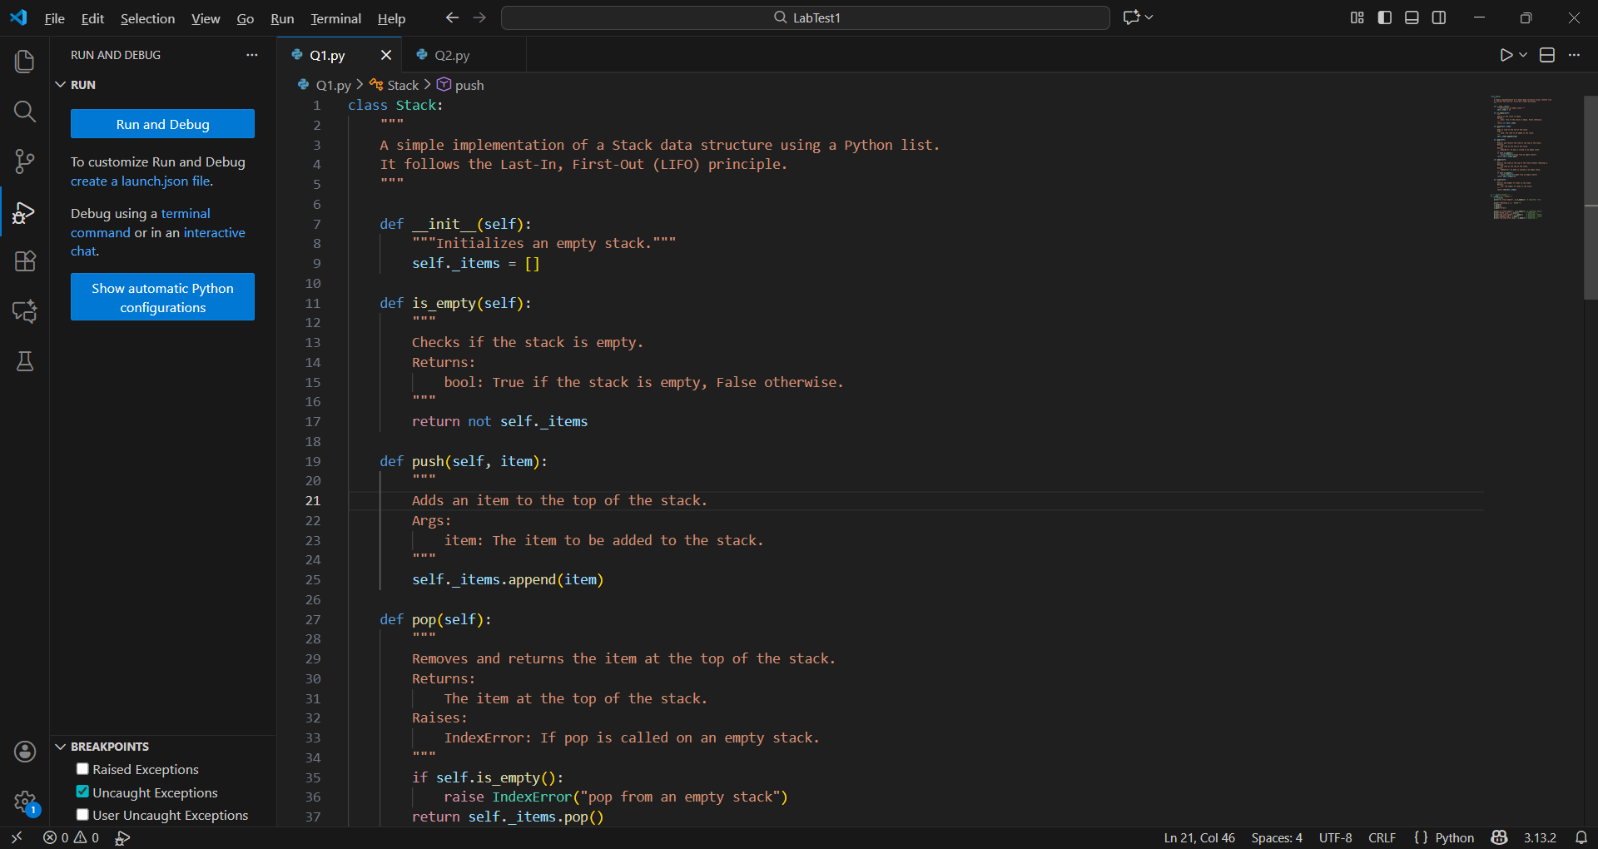
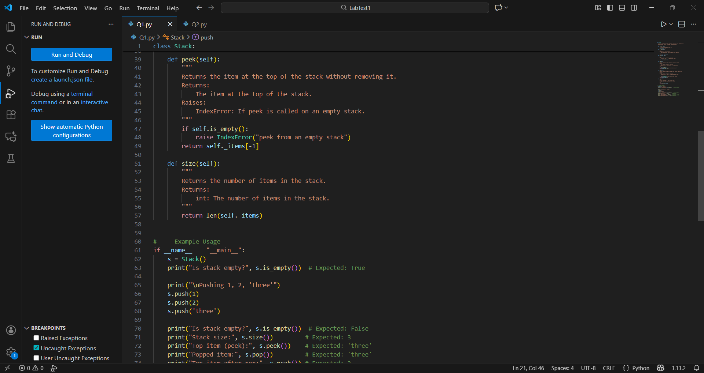

PRACTICAL OUTPUT:-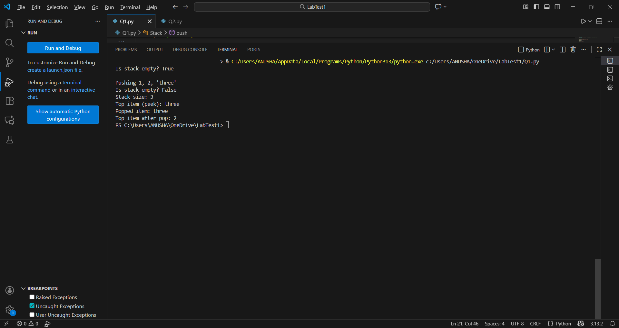
Q2 Refactor a poorly commented Python function using an AI assistant for automatic documentation. Evaluate clarity and completeness versus manual comments.
Poorly Commented Function
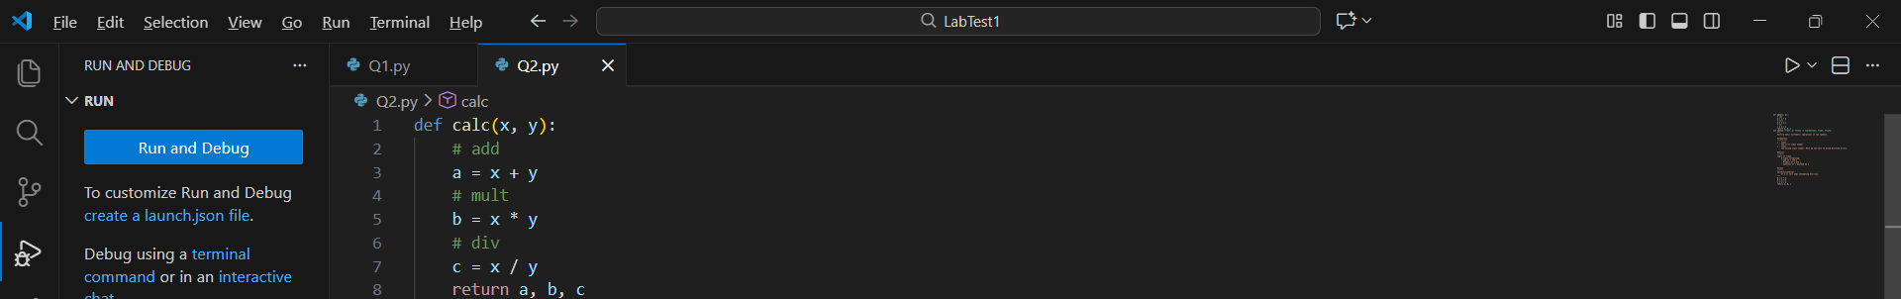

AI-Generated Documentation (Refactored)
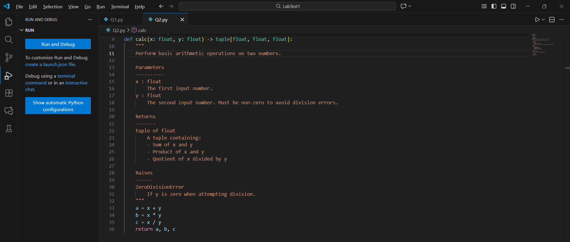
Evaluation: AI vs Manual Comments
