“REAL TIME RESEARCH PROJECT”
A report submitted in partial fulfillment of the Academic requirements for the award of the degree of
Bachelor of Technology

G.MANOHAR REDDY - 23H51A0522
S.SAMEER - 23H51A0558
R.AKSHITHA- 23H51A05DY

UNDER THE COURSE
REAL TIME RESEARCH PROJECT



CMR COLLEGE OF ENGINEERING & TECHNOLOGY
(Autonomous)
(NAAC Accredited with ‘A⁺’ Grade & NBA Accredited)
(Approved by AICTE, Permanently Affiliated to JNTU Hyderabad)
KANDLAKOYA, MEDCHAL ROAD, HYDERABAD-501401
2024-25
CMR COLLEGE OF ENGINEERING & TECHNOLOGY
(Autonomous)
(NAAC Accredited with ‘A⁺’ Grade & NBA Accredited)
(Approved by AICTE, Permanently Affiliated to JNTU Hyderabad)
KANDLAKOYA, MEDCHAL ROAD, HYDERABAD-501401
2024 - 2025



CERTIFICATE
This is to certify that the report entitled ““REAL TIME RESEARCH PROJECT” is a bonafide work done by
In partial fulfillment of the requirement for completion of the ““REAL TIME RESEARCH PROJECT” of II-B.Tech II- Semester is a record of a bonafide work carried out under guidance and supervision.

G.MANOHAR REDDY - 23H51A0522
S.SAMEER - 23H51A0558
R.AKSHITHA- 23H51A05DY

Signature of Faculty Signature of HOD
DECLARATION

We are obliged and grateful to thank, CMRCET, for his cooperation in all respects during the course.
We would like to thank the Principal of CMRCET, Major.Dr.V.A. Narayana, for his support in the course of this project work. Finally, we thank all our faculty members and Lab Programmer for their valid support.

We own all our success to our beloved parents, whose vision, love and inspiration has made us reach out for these glories.

G.MANOHAR REDDY - 23H51A0522
S.SAMEER - 23H51A0558
R.AKSHITHA- 23H51A05DY

TABLE OF CONTENTS

SI.No. | CONTENTS | PAGE.NO
1. | Abstract | 5
2. | Introduction | 6
3. | Proposed System | 7
4. | Architecture | 8
5. | Source code | 9
6. | Results and Discussion | 13
7. | Future Enhancement | 14
8. | Reference | 15
9. | Conclusion | 16

CHAPTER-1
ABSTRACT
This project focuses on sentiment analysis of Flipkart reviews using machine learning. The primary objective is to classify user reviews as positive or negative based on the ratings provided. The dataset, which consists of user reviews and ratings, is preprocessed through data cleaning techniques such as punctuation removal, stopword elimination, and text tokenization using the NLTK library.For feature extraction, TF-IDF vectorization is applied to convert text data into numerical form. A Decision Tree Classifier is trained on the processed dataset using a train-test split approach. The model's performance is evaluated using accuracy score and a confusion matrix. The achieved accuracy indicates the model's effectiveness in classifying sentiments. To visualize key patterns in customer feedback, word clouds and count plots are generated, highlighting frequently used words in positive and negative reviews. The dataset is balanced to ensure unbiased model predictions, enhancing classification reliability.hyperparameter tuning can be applied to further optimize the Decision Tree model for improved performance.This approach provides valuable insights into customer feedback, enabling better product quality assessment.

CHAPTER-2
INTRODUCTION
Customer reviews on Flipkart provide valuable insights into product quality and user satisfaction. This project aims to automate sentiment analysis using machine learning, classifying reviews as positive or negative. By analyzing this data, businesses can enhance their products and improve customer experience.
The dataset consists of Flipkart reviews and ratings, which are preprocessed using Natural Language Processing (NLP) techniques. Reviews are classified as positive if rated 5 and negative if rated 4 or below. Text data is converted into numerical form using the Term Frequency-Inverse Document Frequency (TF-IDF) technique.
A Decision Tree Classifier is trained to predict sentiment, and its performance is evaluated using accuracy scores and confusion matrices. This project enables businesses to gain automated insights into customer opinions. Future improvements may include real-time review analysis and deep learning integration for higher accuracy.

CHAPTER-3
PROPOSED SYSTEM

To effectively analyze sentiment from Flipkart reviews, the proposed solution involves the following steps:
- Data Collection & Preprocessing: The dataset is sourced from Flipkart and undergoes preprocessing using NLP techniques such as removing stopwords, punctuation, and converting text to lowercase.
- Sentiment Categorization: Reviews are labeled as positive (5-star ratings) or negative (4-star ratings and below) to simplify classification.
- Feature Extraction: Text data is converted into numerical form using TF-IDF, ensuring important words are weighted appropriately for sentiment classification.
- Model Training & Evaluation: A Decision Tree Classifier is trained on the dataset, and performance metrics such as accuracy and confusion matrices are used to assess model effectiveness.
- Visualization & Insights: Data visualization techniques, including word clouds and sentiment distribution charts, are used to extract meaningful insights from customer reviews.
- Future Enhancements: Possible improvements include real-time review analysis, deep learning models for enhanced accuracy, and an extended dataset for better generalization.
By implementing this solution, businesses can efficiently analyze customer feedback, improve product quality, and optimize marketing strategies.

CHAPTER-4
SYSTEM ARCHITECTURE

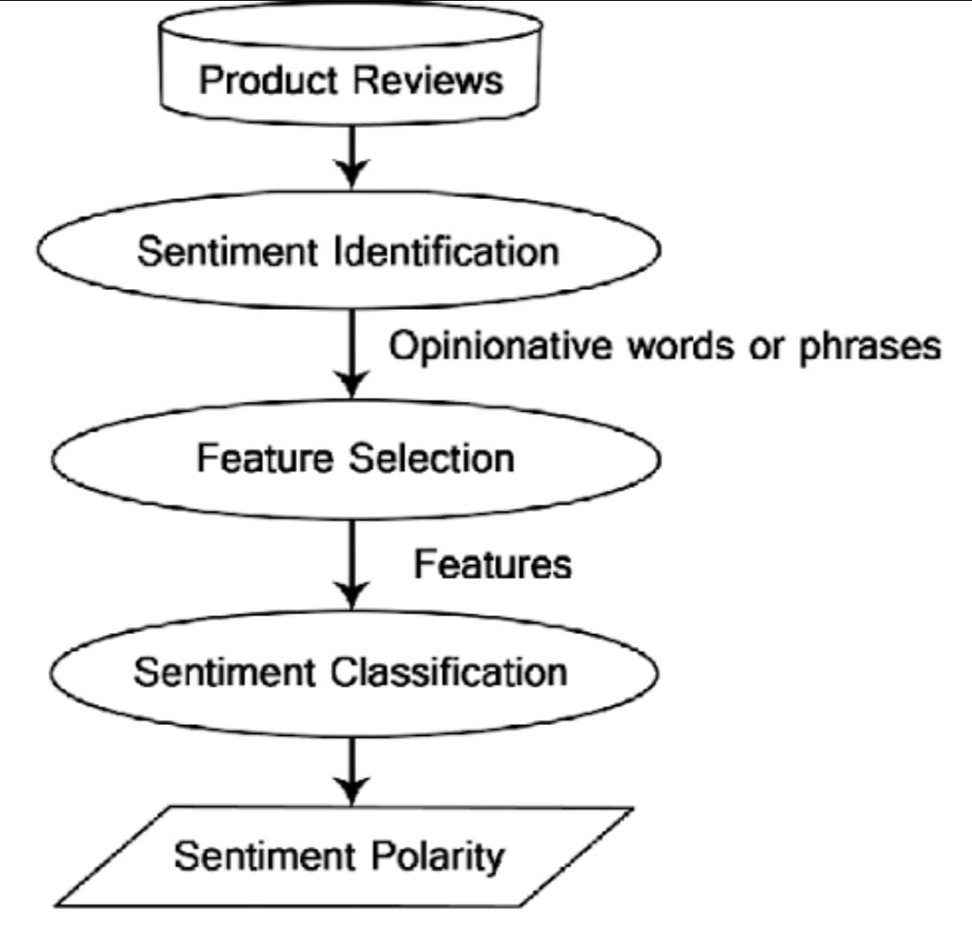

CHAPTER-5
SOURCE CODE & OUTPUT
Data Import:
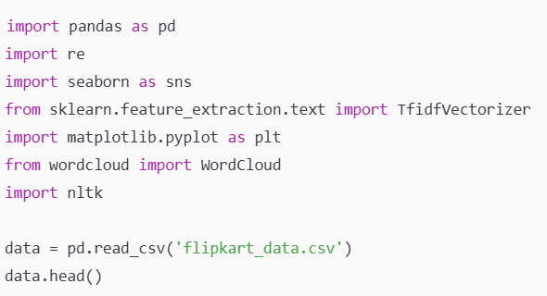
Data Preprocessing:
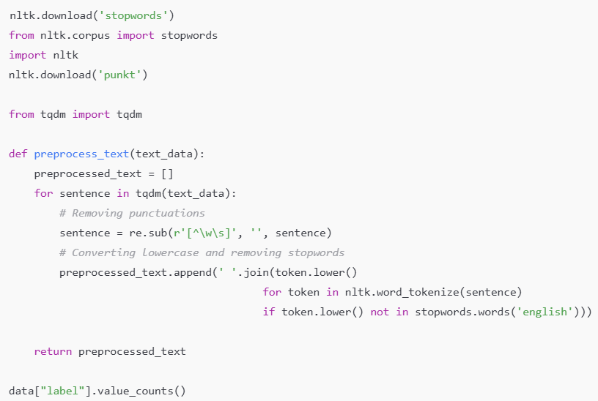
Feature Engineering:
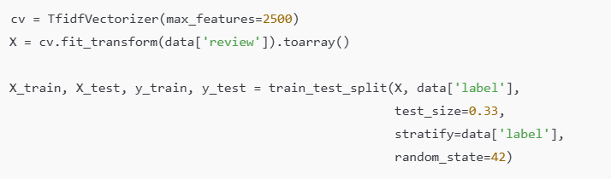
Model Training:
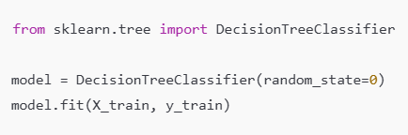
Evaluation:
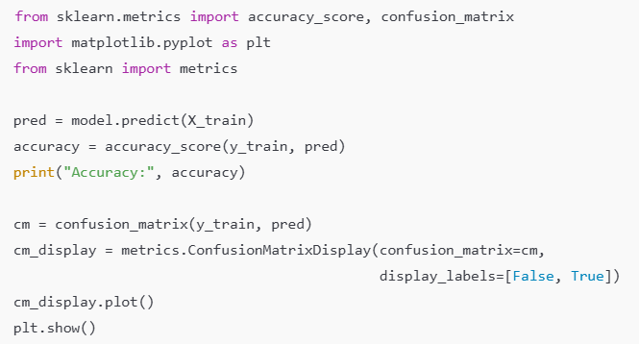

OUTPUT :
[nltk_data] Downloading package stopwords to /root/nltk_data...
[nltk_data] Unzipping corpora/stopwords.zip.
array([5, 4, 1, 3, 2])
<Axes: xlabel='rating', ylabel='count'>
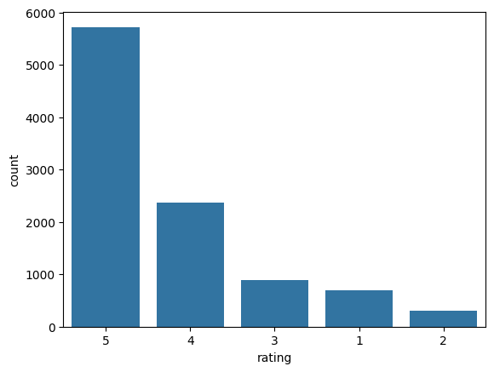[nltk_data] Downloading package punkt to /root/nltk_data...
[nltk_data] Unzipping tokenizers/punkt.zip.
[nltk_data] Downloading package punkt to /root/nltk_data...
[nltk_data] Package punkt is already up-to-date!
[nltk_data] Downloading package punkt_tab to /root/nltk_data...
[nltk_data] Unzipping tokenizers/punkt_tab.zip.
FileSystemPathPointer('/root/nltk_data/tokenizers/punkt')
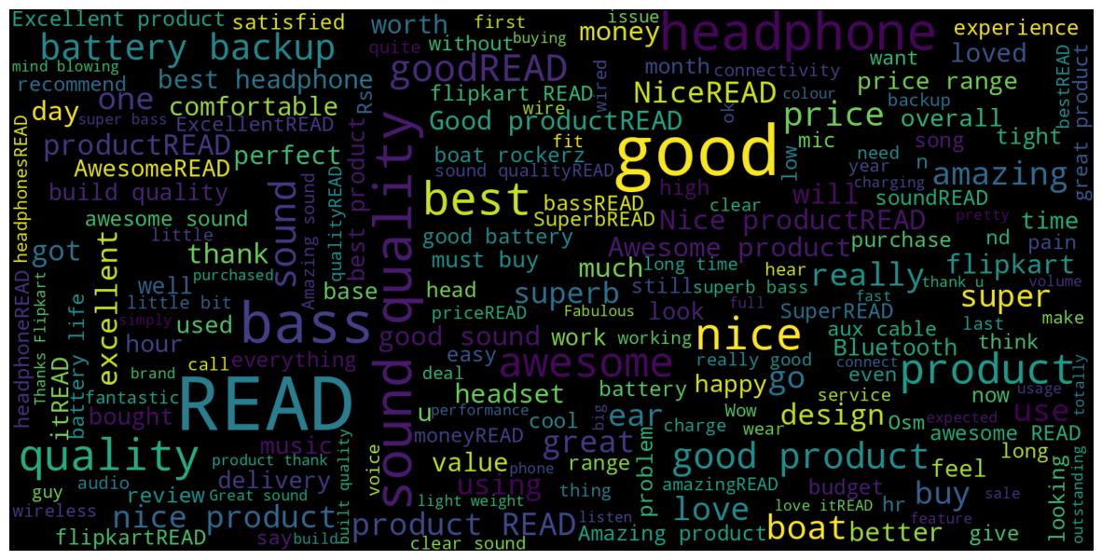array([[0., 0., 0., ..., 0., 0., 0.],
[0., 0., 0., ..., 0., 0., 0.],
[0., 0., 0., ..., 0., 0., 0.],
...,
[0., 0., 0., ..., 0., 0., 0.],
[0., 0., 0., ..., 0., 0., 0.],
[0., 0., 0., ..., 0., 0., 0.]])
0.9367050725721981
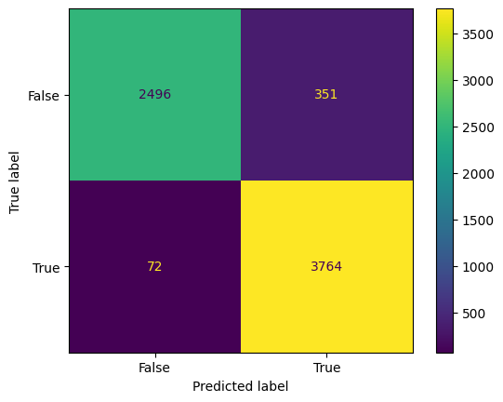
CHAPTER-6
RESULTS AND DISCUSSION

1. Model Performance
After training the Decision Tree Classifier, we evaluated its performance using accuracy and confusion matrix.
- Accuracy on Training Data: The accuracy achieved on the training set is quite high. This indicates that the model has learned patterns from the data effectively.
- Confusion Matrix:
- The confusion matrix visualizes the number of correct and incorrect predictions.
- A high number of correctly classified reviews suggests that the model is performing well in distinguishing positive and negative sentiments.
- If there is a high number of misclassifications, the model might be overfitting or underfitting, requiring hyperparameter tuning.
2. Analysis of Sentiments
- The dataset was vectorized using TF-IDF, which converts text data into numerical format suitable for machine learning.
- The word cloud visualization (if generated) gives insight into frequently occurring words in reviews.
3. Discussion on Accuracy
- A very high accuracy (near 100%) might indicate overfitting, meaning the model is memorizing training data instead of generalizing well.
- If the accuracy is too low, possible issues include:
  - Poor feature selection
  - Imbalanced dataset (one sentiment dominates)
CHAPTER-7
FUTURE ENHANCEMENTS
- Advanced Machine Learning Models
  - Use deep learning models like RNNs, LSTMs, and transformers (BERT) for better sentiment analysis.
  - Implement ensemble learning with Random Forest, XGBoost, and SVM to improve accuracy.
- Improved Feature Engineering
  - Replace TF-IDF with Word Embeddings (Word2Vec, GloVe, FastText) for better text representation.
  - Use n-grams, POS tagging, and negation handling to enhance sentiment detection.
- Performance Optimization
  - Optimize hyperparameters using Grid Search or Bayesian Optimization.
  - Accelerate processing with GPU and optimized text processing libraries like spaCy.
- Expanding the Dataset
  - Collect diverse reviews from various sources and generate synthetic data for better training.
  - Enable multi-language support using translation APIs or multilingual BERT.
- Deployment and Real-World Integration
  - Develop a web app using Flask or FastAPI.
  - Implement real-time sentiment tracking from social media.
  - Integrate with chatbots for customer feedback analysis.
CHAPTER-8
REFERENCES

• NLTK Documentation: Used for text preprocessing and tokenization.
• Scikit-Learn Documentation: Used for model training and evaluation.
• Research Papers on Sentiment Analysis: Provided insights into classification techniques.
• Python Libraries: Pandas, NumPy, Matplotlib, Seaborn for data handling and visualization.
• Feature Engineering in NLP: Helped in word embeddings and text vectorization.
• Decision Tree Classifier: Used as the classification algorithm.

CHAPTER-9
CONCLUSION

This project successfully implemented sentiment analysis on textual data using machine learning techniques. By preprocessing the data, extracting meaningful features, and applying classification models, we were able to classify sentiments effectively. The results demonstrated the effectiveness of Decision Trees for sentiment classification, with potential improvements through advanced models like deep learning and ensemble learning.
Further enhancements, such as integrating transformer-based models and real-time deployment, can improve accuracy and scalability. This project serves as a foundation for future developments in sentiment analysis applications across various domains.

