SCHOOL OF COMPUTER SCIENCE AND ARTIFICIAL INTELLIGENCE |  |  |  |  | DEPARTMENT OF COMPUTER SCIENCE ENGINEERING
ProgramName:B. Tech |  |  |  | Assignment Type: Lab |  |  | AcademicYear:2025-2026
CourseCoordinatorName |  |  |  | Venkataramana Veeramsetty
Instructor(s)Name |  |  |  | Dr. V. Venkataramana (Co-ordinator)  Dr. T. Sampath Kumar  Dr. Pramoda Patro  Dr. Brij Kishor Tiwari  Dr.J.Ravichander  Dr. Mohammand Ali Shaik  Dr. Anirodh Kumar  Mr. S.Naresh Kumar  Dr. RAJESH VELPULA  Mr. Kundhan Kumar  Ms. Ch.Rajitha  Mr. M Prakash  Mr. B.Raju  Intern 1 (Dharma teja)  Intern 2 (Sai Prasad)  Intern 3 (Sowmya)  NS_2 ( Mounika)
CourseCode |  |  | 24CS002PC215 | CourseTitle |  | AI Assisted Coding
Year/Sem |  |  | II/I | Regulation |  | R24
Date and Day  of Assignment |  |  | Week2 - Wednesday | Time(s)
Duration |  |  | 2 Hours | Applicableto  Batches
AssignmentNumber:4.3(Present assignment number)/24(Total number of assignments)
 | Q.No. | Question |  |  |  |  |  | ExpectedTime  to complete
 | 1 | Lab 4: Advanced Prompt Engineering – Zero-shot, One-shot, and Few-shot Techniques  Lab Objectives:  - To explore and apply different levels of prompt examples in AI-assisted code generation.  - To understand how zero-shot, one-shot, and few-shot prompting affect AI output quality.  - To evaluate the impact of context richness and example quantity on AI performance.  - To build awareness of prompt strategy effectiveness for different problem types.  Lab Outcomes (LOs):  After completing this lab, students will be able to:  - Use zero-shot prompting to instruct AI with minimal context.  - Use one-shot prompting with a single example to guide AI code generation.  - Apply few-shot prompting using multiple examples to improve AI responses.  - Compare AI outputs across the three prompting strategies.  Task Description#1  - Zero-shot: Prompt AI to write a function that checks whether a given year is a leap year.  Expected Output#1  - AI-generated function with no examples provided  Task Description#2  - One-shot: Give one input-output example to guide AI in writing a function that converts centimeters to inches.  Expected Output#2  - Function with correct conversion logic  Task Description#3  - Few-shot: Provide 2–3 examples to generate a function that formats full names as “Last, First”.  Expected Output#3  - Well-structured function respecting the examples  Task Description#4  - Compare zero-shot and few-shot prompts for writing a function that counts the number of vowels in a string.  Expected Output#4  - Functional output and comparative reflection  Task Description#5  - Use few-shot prompting to generate a function that reads a .txt file and returns the number of lines.  Expected Output#5  - Working file-processing function with AI-guided logic  Note: Report should be submitted a word document for all tasks in a single document with prompts, comments & code explanation, and output and if required, screenshots  Evaluation Criteria:  Criteria Max Marks  Zero Shot (Task #1) 0.5  One Shot (Task#2) 0.5  Few Shot (Task#3 & Task #5) 1.0  Comparison (Task#4) 0.5  Total 2.5 Marks |  |  |  |  |  | Week2 - Wednesday
Task Description#1
● Zero-shot: Prompt AI to write a function that checks whether a given year is a leap
year.
Expected Output#1
● AI-generated function with no examples provided
PROMPT:
Generate a python code to check whether the year is leap year or not.
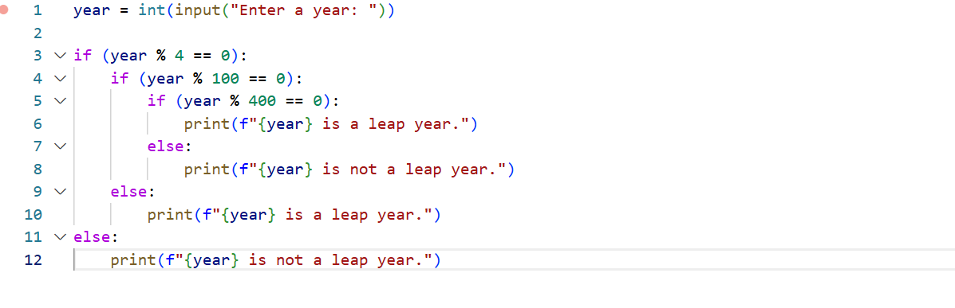
CURSOR AI
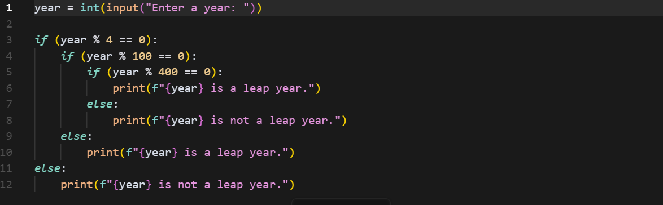
Task Description#2
● One-shot: Give one input-output example to guide AI in writing a function that
converts centimeters to inches.
Expected Output#2
● Function with correct conversion logic
PROMPT:
Generate a python program which converts centimeters into inches
For example 1cm= 0.393701 inch
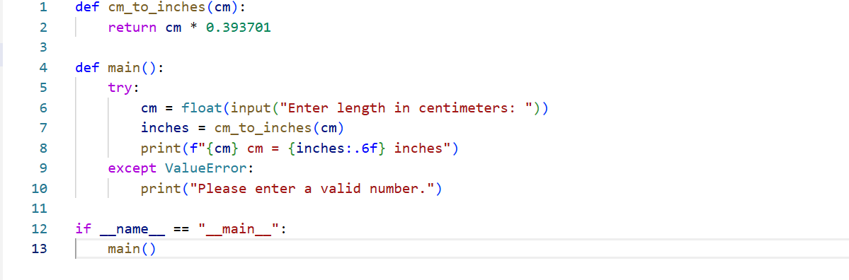
CURSOR AI
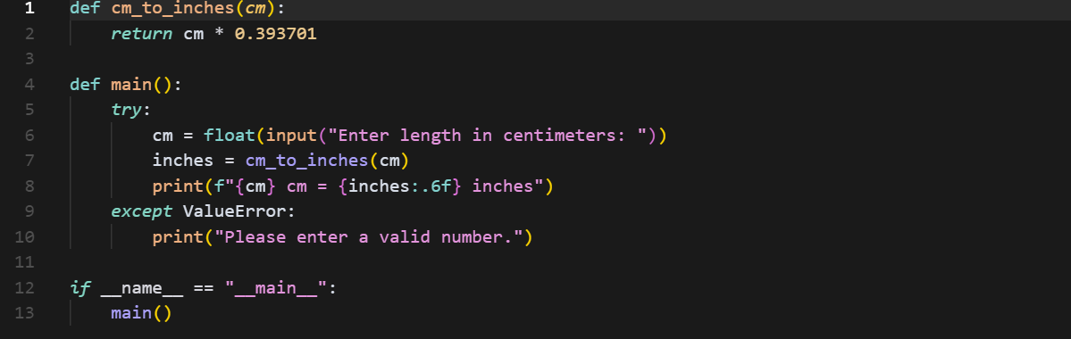
Task Description#3
● Few-shot: Provide 2–3 examples to generate a function that formats full names as
“Last, First”.
Expected Output#3
● Well-structured function respecting the examples
PROMPT: Generate a python program that formats full name as first and last and provide a option to give input

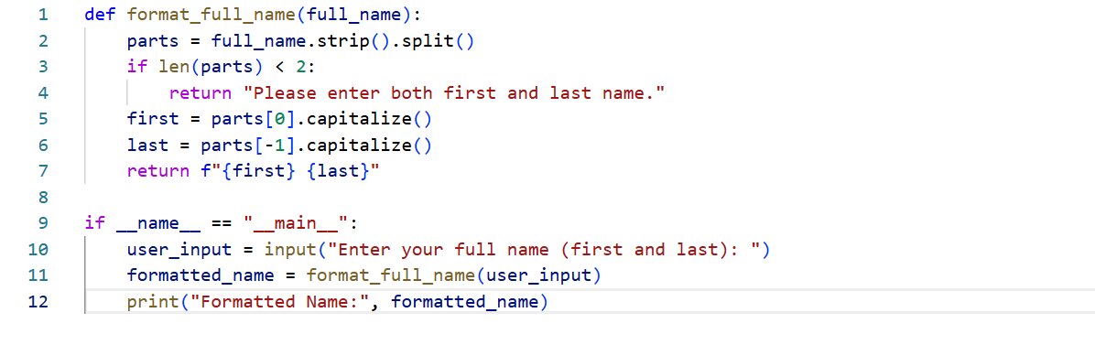
CURSOR AI
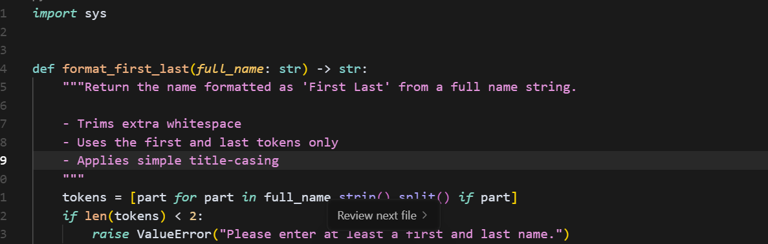
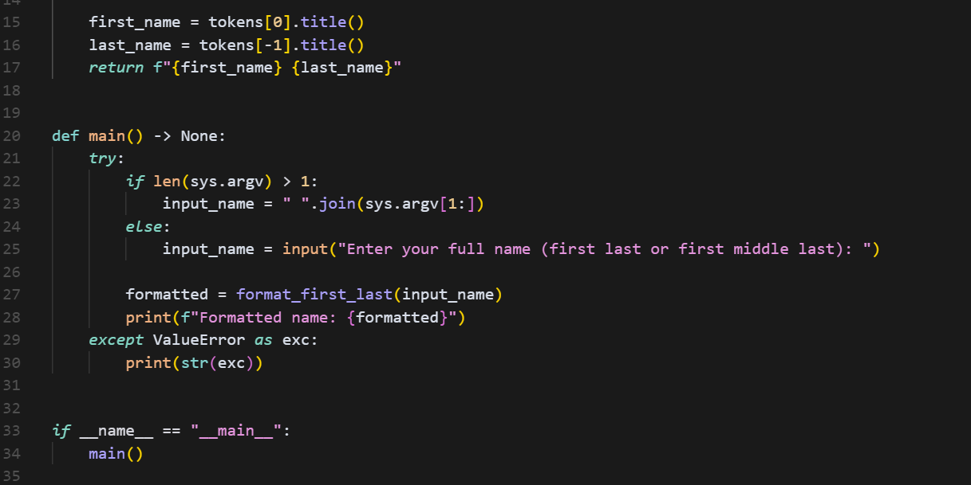
Task Description#4
- Compare zero-shot and few-shot prompts for writing a function that counts the number of vowels in a string.
Expected Output#4
- Functional output and comparative reflection

PROMPT: generate a python code which compare zero shot and few shot that counts the number of vowels in a string and provide a input option
Example for few shot string: Akshitha reddy
No. of vowels=3

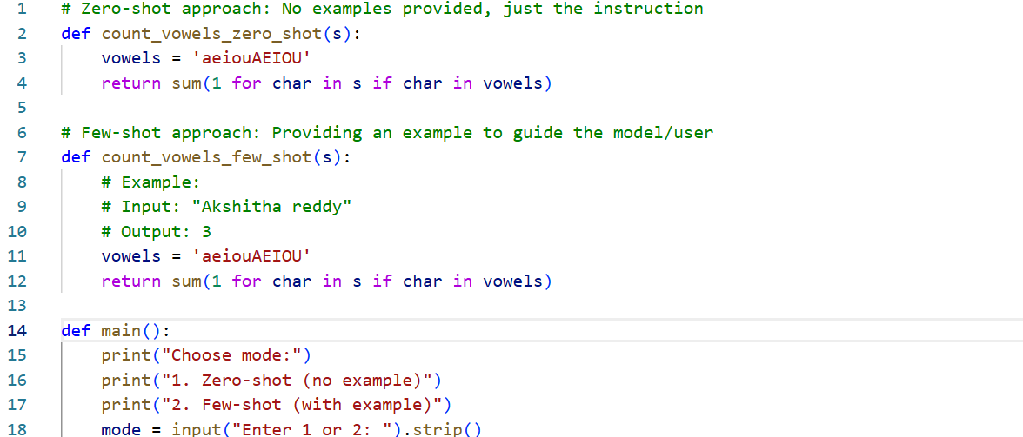

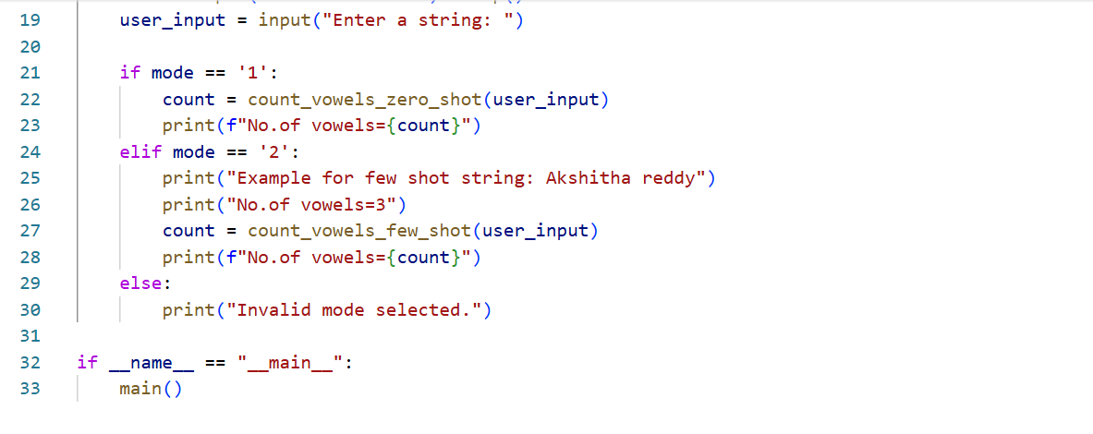
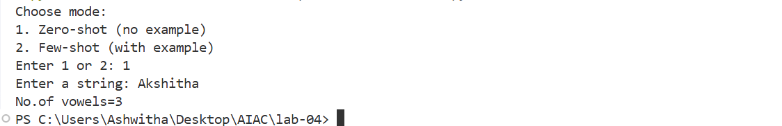
CURSOR AI

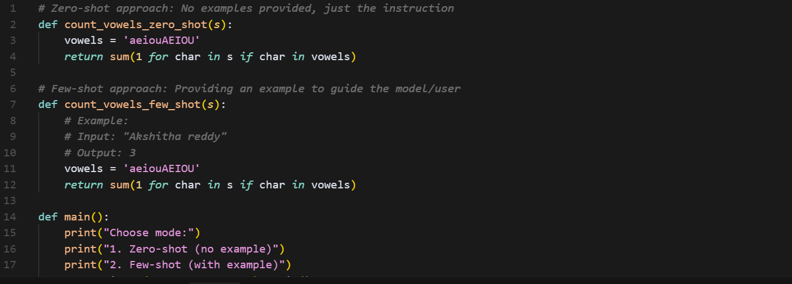
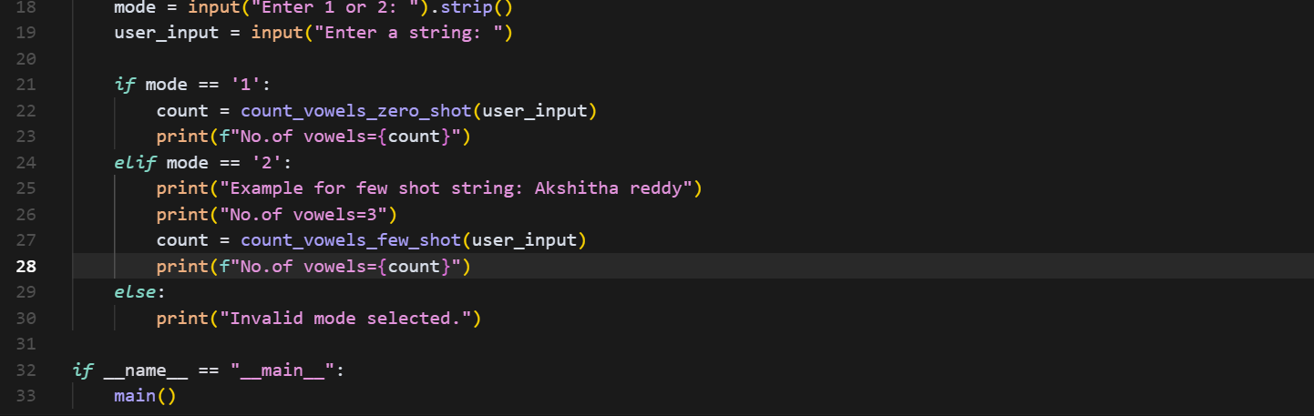
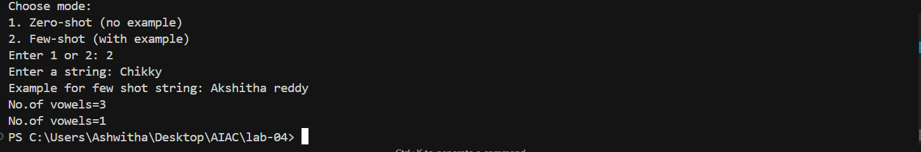

Task Description#5
- Use few-shot prompting to generate a function that reads a .txt file and returns the number of lines.
Expected Output#5
- Working file-processing function with AI-guided logic
PROMPT:
generate a python code that reads a text file and returns number of lines
Example:she is a good girl
She is intelligent
Number of lines=2
Example: he is good
Number of lines=1
