Activity 14 — Cloud Courier
Akshitha Sainath Sanagarapu | Student ID: 003027780
CSC 4360 / MAD 4360 — Mobile App Development
Firebase Cloud Messaging | November 9, 2026

Test setup
Device: Pixel 10 Android emulator, Android 17 (API 37). Notifications: authorized. FCM token: Ready; token intentionally omitted. Valid payload: action=update_ui, asset=promo. Invalid T4 payload: action=update_ui, asset=unknown.

Test results
Test | Expected | Observed | Evidence
T1 Foreground | onMessage; promo accepted | onMessage; promo accepted; UI updated | T1_Foreground.png
T2 Background tap | onMessageOpenedApp; promo accepted | onMessageOpenedApp; promo accepted | T2_BackgroundTap.png
T3 Cold start | getInitialMessage; promo accepted | getInitialMessage; 1 receipt; promo accepted | T3_ColdStart.png
T4 Invalid foreground | onMessage; reject unknown; preserve UI | onMessage; rejected; promo unchanged | T4_InvalidPayload.png
All four tests passed on the emulator. flutter analyze: no issues. flutter test: 6/6 passed.

Graduate reflection (three responses)

1. Setup and payload
I built Cloud Courier using the Firebase project from an earlier activity, but kept messaging in a separate FCMService. I chose two data fields: action=update_ui tells the app what to do, and asset=default or promo chooses the announcement. I validate both fields before updating the screen. This is safer than using an incoming value directly as an asset path.

2. Lifecycle and evidence
I tested on a Pixel 10 Android emulator. T1 used onMessage in the foreground. T2 used onMessageOpenedApp after tapping a notification in the background. T3 used getInitialMessage when a notification launched the stopped app. The separate onBackgroundMessage handler is for background work; it cannot directly change a visible widget. These results show what worked on this device with notification-plus-data messages, not guaranteed delivery on every device. A device token identifies an installation, not permission to access private information.

3. Validation and improvement
For T4, I sent asset=unknown while the app was open. The diagnostic rejected the value, and the existing promo announcement stayed unchanged. I chose an allowlist over blindly building an asset path because an unknown value could cause a broken image or an incorrect update. The app also checks widget lifetime and cancels listeners when disposed. A next improvement would be saving notification history; Success would mean messages remained visible after restarting the app. I used ChatGPT to help organize and review the code and documentation, and verified the behavior through emulator tests.
Evidence limitation: These observations cover one Android emulator and notification-plus-data messages; results may differ with other operating systems, permissions, or network conditions.
Repository: https://github.com/AkshithaSanagarapu/MAD4360-Activity14-FCM

Screenshot evidence
Screenshots are also included as separate PNG files in the evidence folder. Each image shows the result observed on the Android emulator.

T1 — Foreground valid message
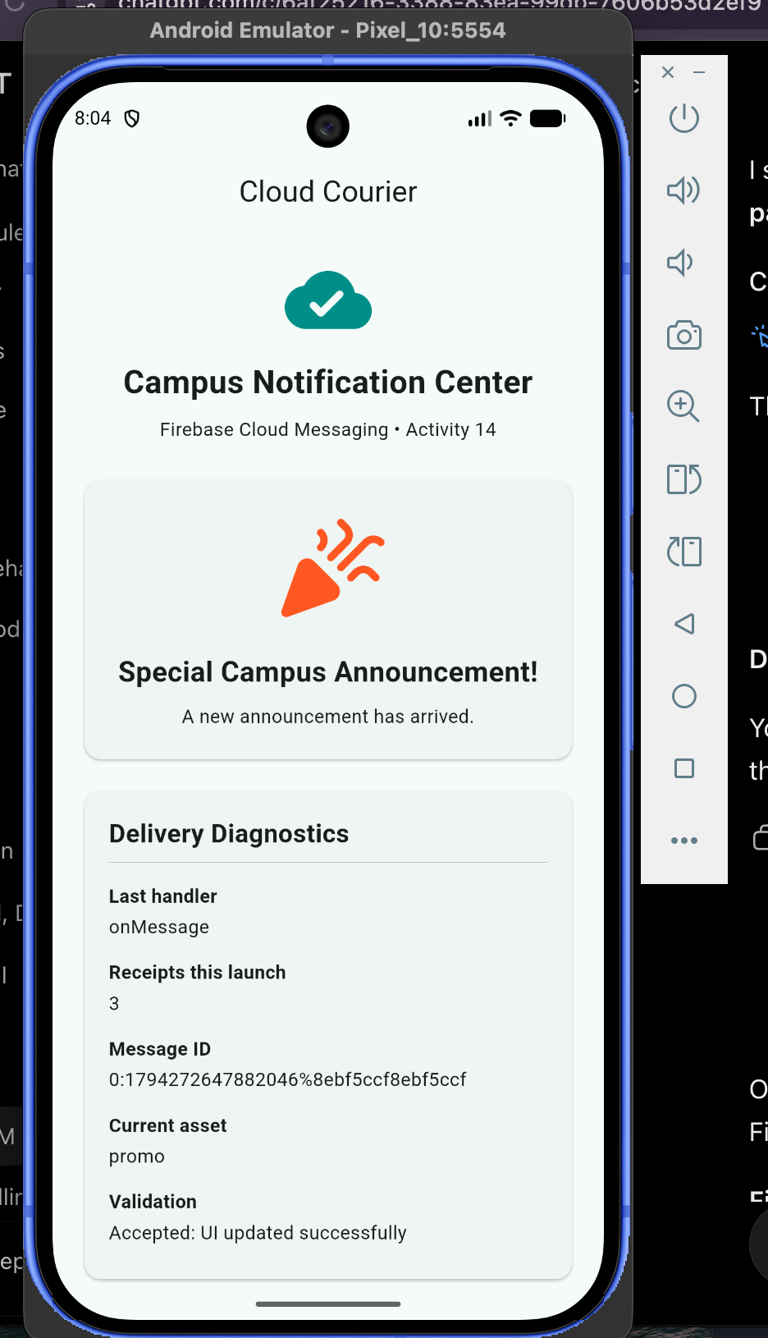
Evidence file: evidence/T1_Foreground.png

T2 — Background notification tap
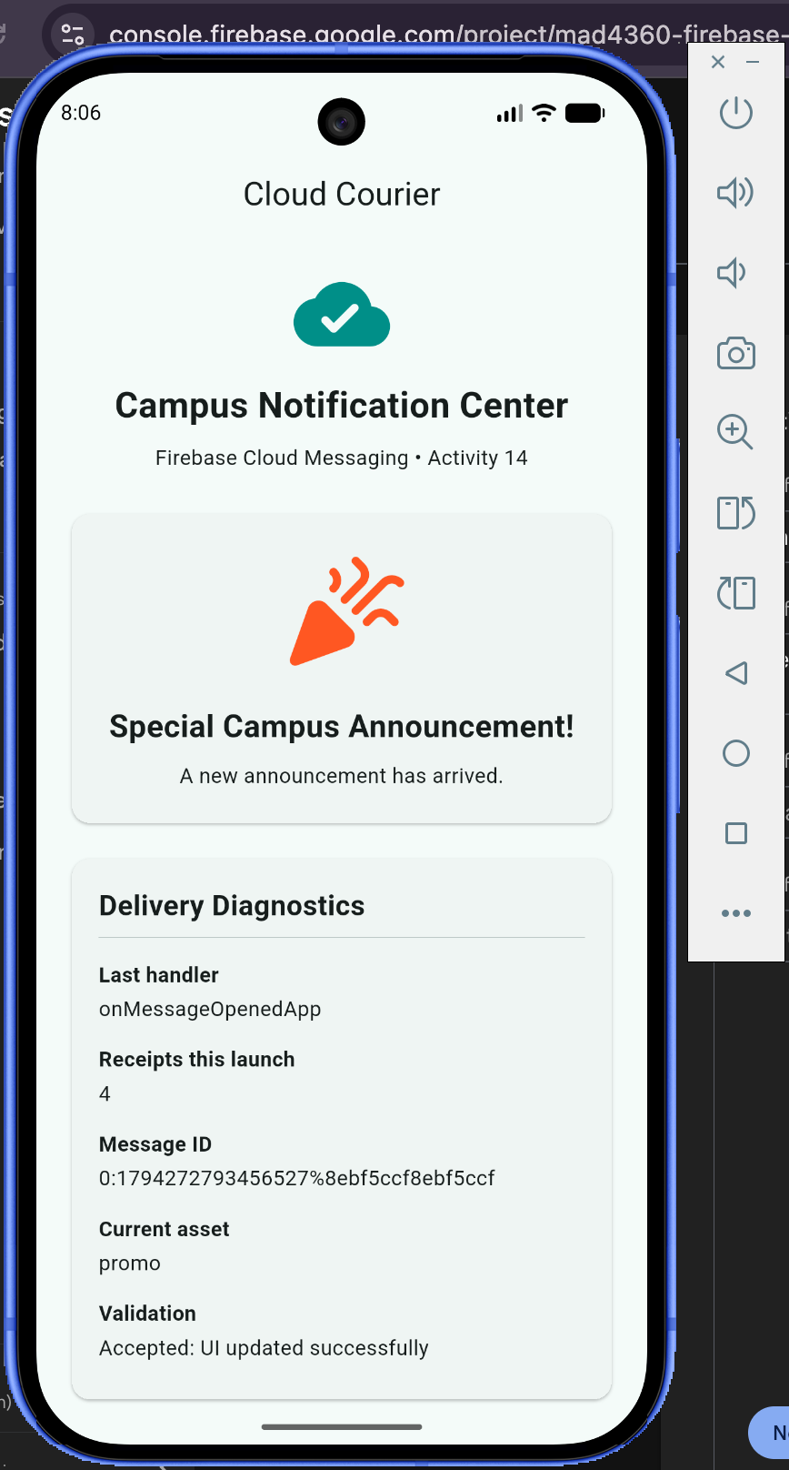
Evidence file: evidence/T2_BackgroundTap.png

T3 — Cold-start notification tap
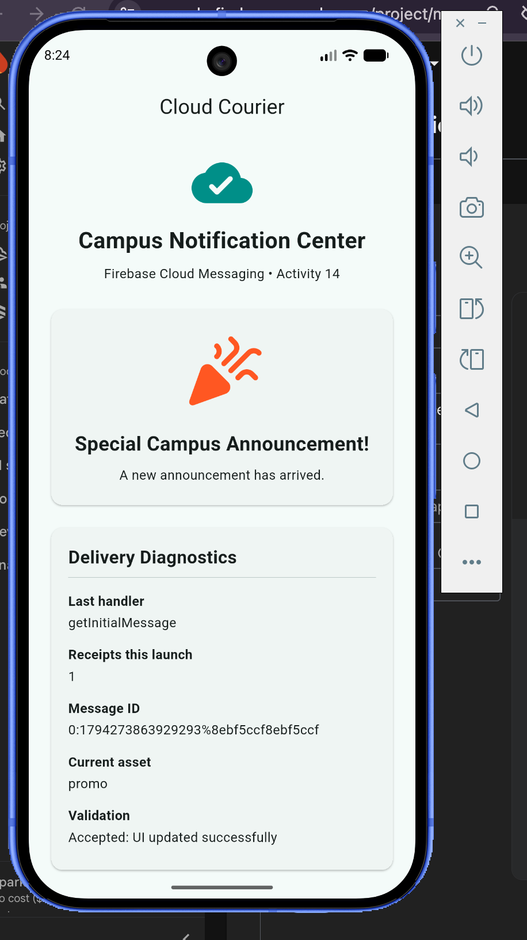
Evidence file: evidence/T3_ColdStart.png

T4 — Foreground invalid message
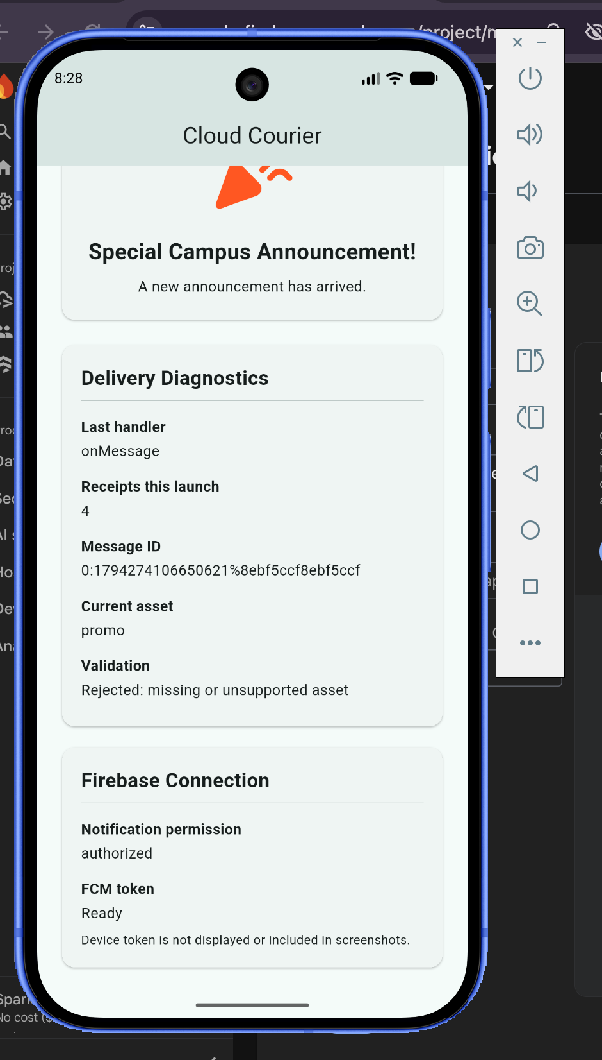
Evidence file: evidence/T4_InvalidPayload.png

