Activity 15 – API-to-Cloud Trivia Showdown
Akshitha Sainath Sanagarapu | Student ID: 003027780
CSC 4360 – Mobile App Development | November 11, 2026

Project overview
I built a Flutter trivia app that requests five easy multiple-choice questions from the Open Trivia Database. The code handles loading and errors, decodes the API response, shuffles the choices, gives answer feedback, tracks the score, and offers a replay option. The final score action is a classroom simulation, not a real cloud upload.

How the API and UI work
The app sends a GET request and checks both the HTTP status and the API response code. These checks matter because an HTTP request can succeed while the API still returns unusable data. Once the response is valid, the app converts the JSON into question objects and cleans encoded text before showing it. Loading, questions, and errors are shown as separate states. Only the first answer counts toward the score.

Graduate question 1 – Restart and offline experience
In my trivia app, I used the Open Trivia Database API to fetch five questions. Once the questions are loaded, I can answer them without making another API request. If the internet disconnects during the round, I can still continue with the questions that are already loaded. For restarting, I added a Play Again button that starts a fresh round by fetching new questions. If the internet is unavailable during that request, the app displays an error with an option to retry.
For offline support in the future, I would consider saving the current questions and score locally so users could continue after closing the app. I would clearly distinguish saved questions from newly fetched questions and check that the saved data is complete before allowing the user to resume. Compared with keeping an unlimited cache of old questions, this would make it easier to tell whether a round is current. A useful test would be to close the app after answering two questions, reopen it without internet, and check whether the saved progress is restored correctly. Local saving is a design idea for future work, not part of this version.

Graduate question 2 – Local scores versus a leaderboard
In my app, I display the score as I answer each question. I tested both correct and incorrect answers: the score increased for correct answers and stayed the same for incorrect answers. After completing five questions, my final score was 2/5. I also clicked Simulate Score Sync and saw “Simulation complete.” That action demonstrates the submission flow, but it does not upload anything to a cloud database.
If I added score history later, I would save completed scores on the device and label the screen “My Score History (this device).” I would keep it separate from a shared leaderboard, because local records are not visible to other users. Local history would be easier to build and work offline, but it would not sync between devices. A real leaderboard would require a backend that accepts and confirms scores. I would test the difference by checking two devices: a score stored only on one should not appear on the other or be described as cloud synced. I kept this version focused on the required trivia round and the clearly labeled sync simulation.

Score sync and limitations
The final action prepares a score payload and simulates an asynchronous submission. It does not make a POST request or store a score remotely. The interface should make that distinction clear. I included the app source code and kept the simulated sync clearly separate from a real backend write. Screenshots will be added after I run the app.

Observed testing evidence
I ran the Flutter app in Chrome and completed a five-question round. The screenshots below show the questions loading, the answer colors, score updates, and the final result of 2 out of 5. The score-sync button changed to “Simulation complete,” and the screen explicitly says that no real cloud write happened. I did not separately capture the loading spinner, network error state, or replay after pressing the button.

Screenshot 01 – Question loaded
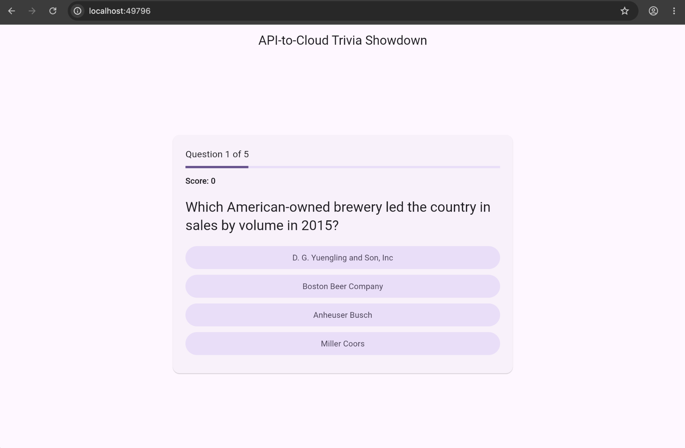

Screenshot 02 – Incorrect answer feedback
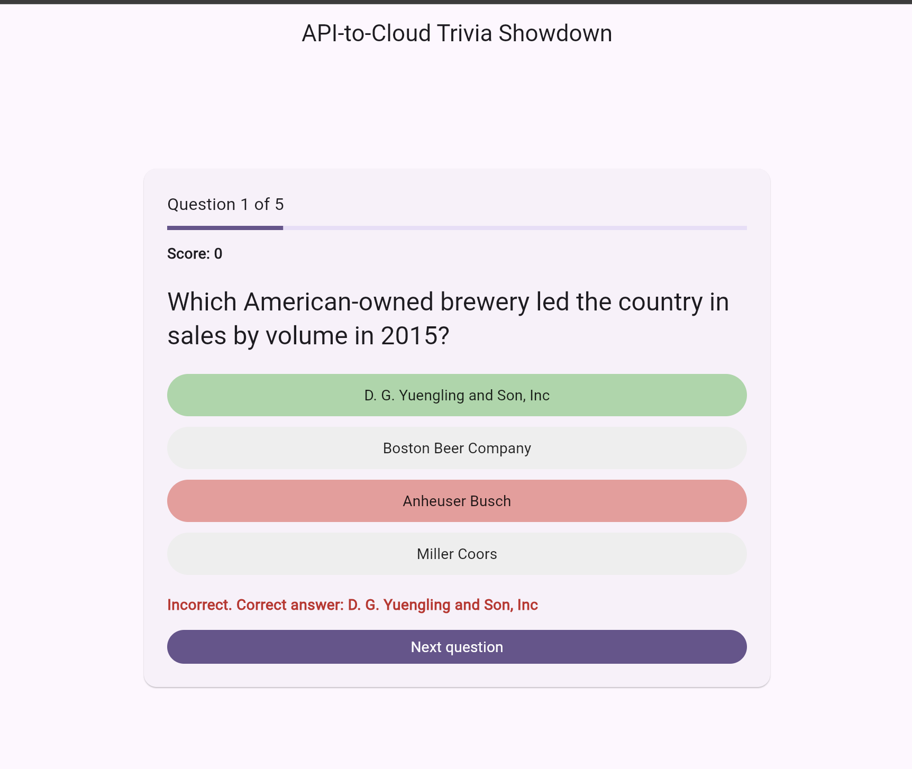

Screenshot 03 – Question progression
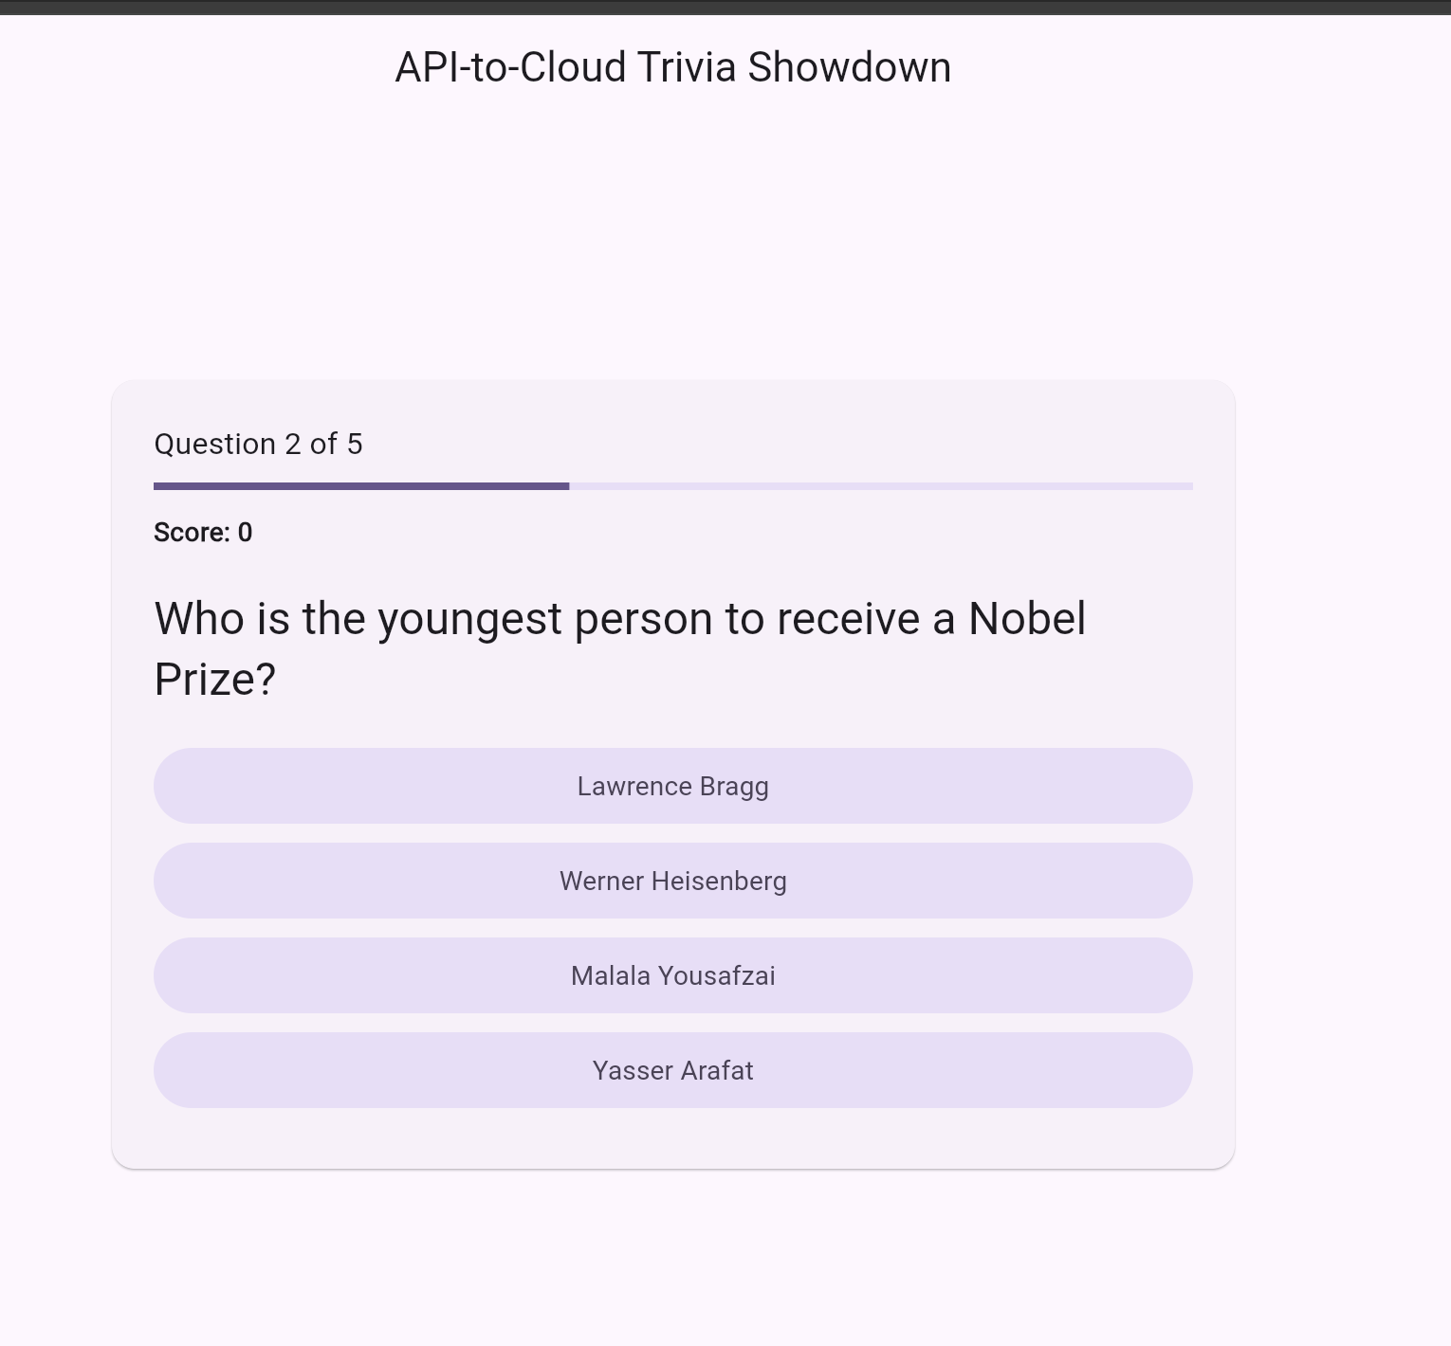

Screenshot 04 – Correct answer and score update
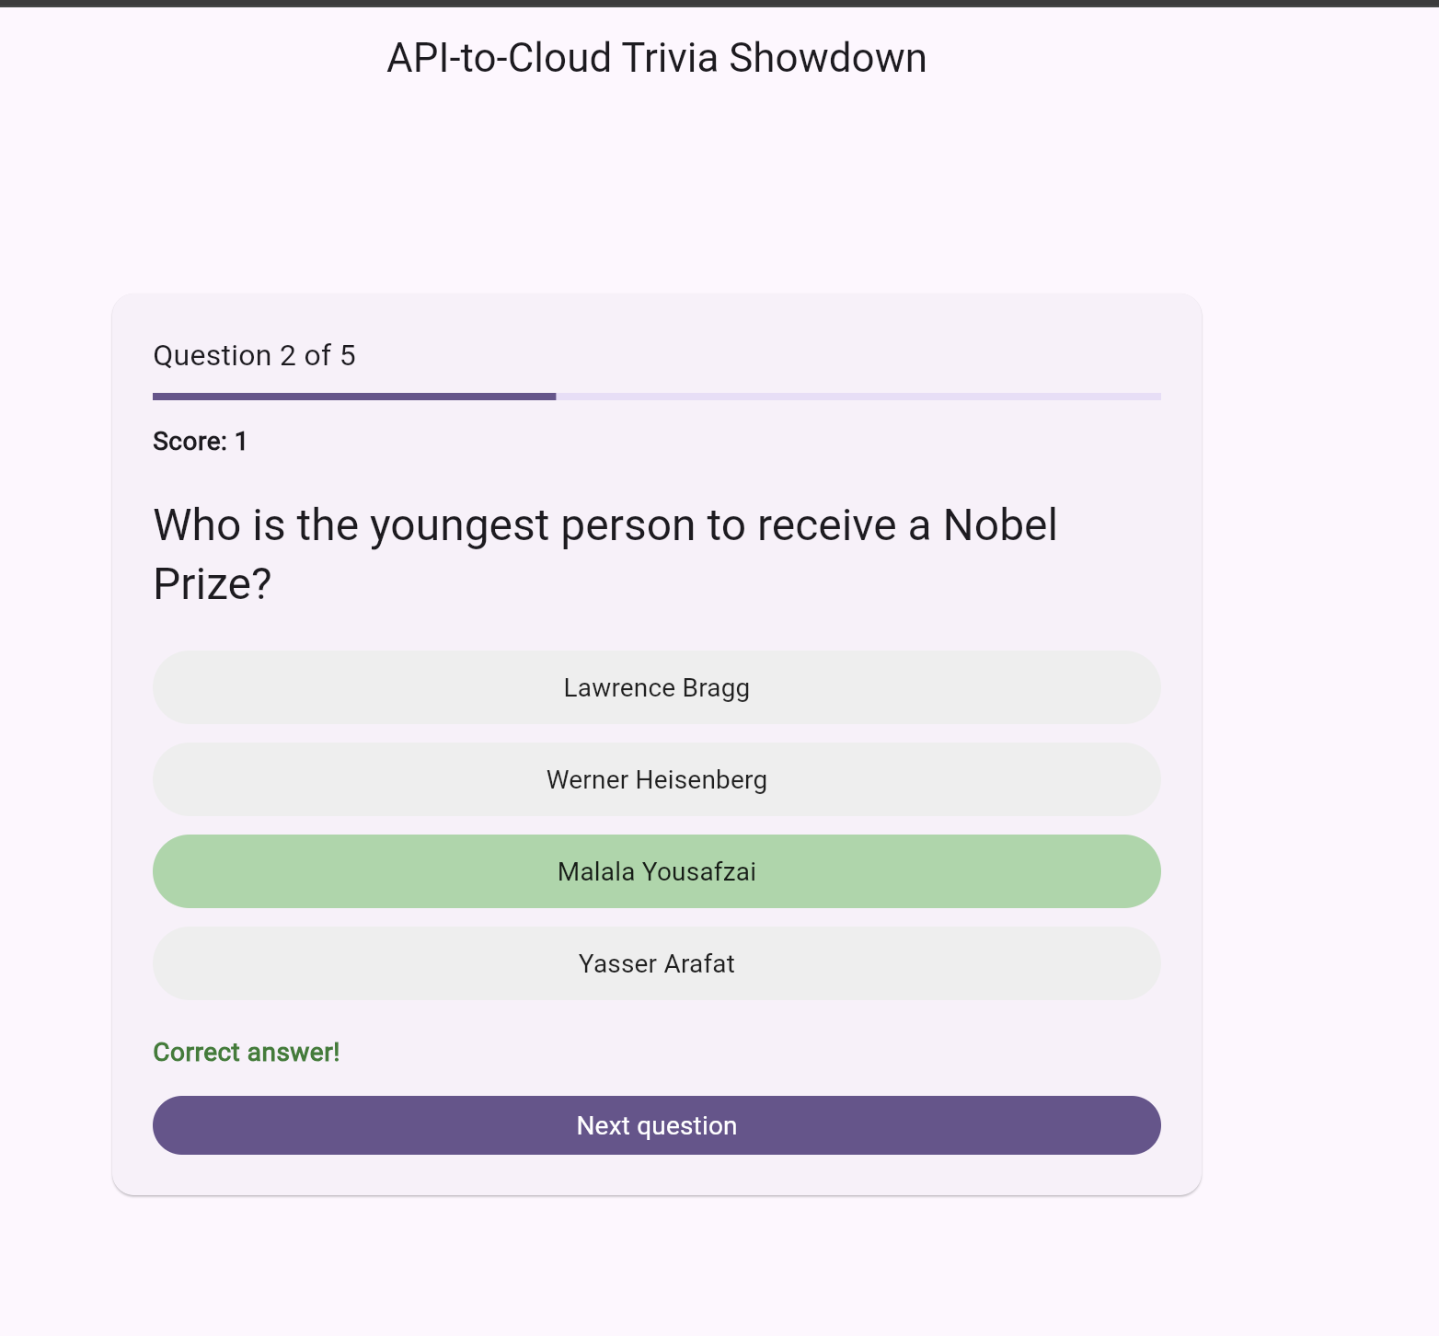

Screenshot 05 – Score reaches 2
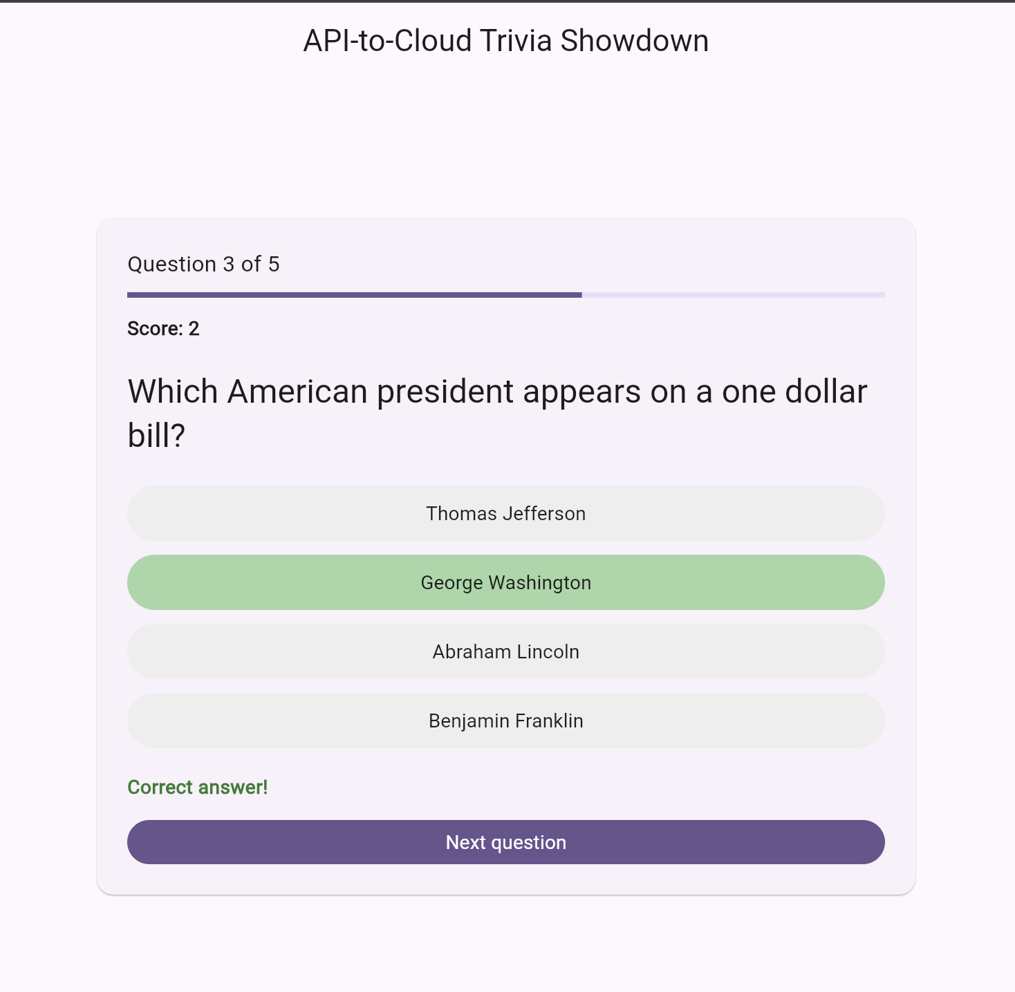

Screenshot 06 – Completed round: 2/5
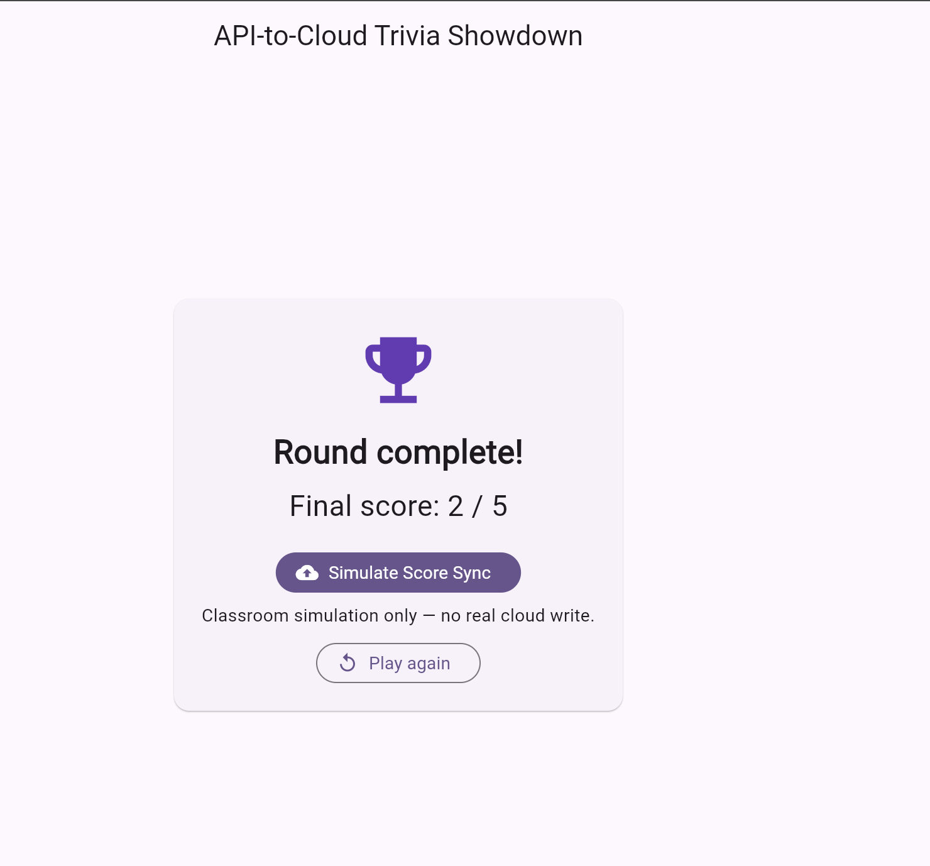

Screenshot 07 – Score-sync simulation complete
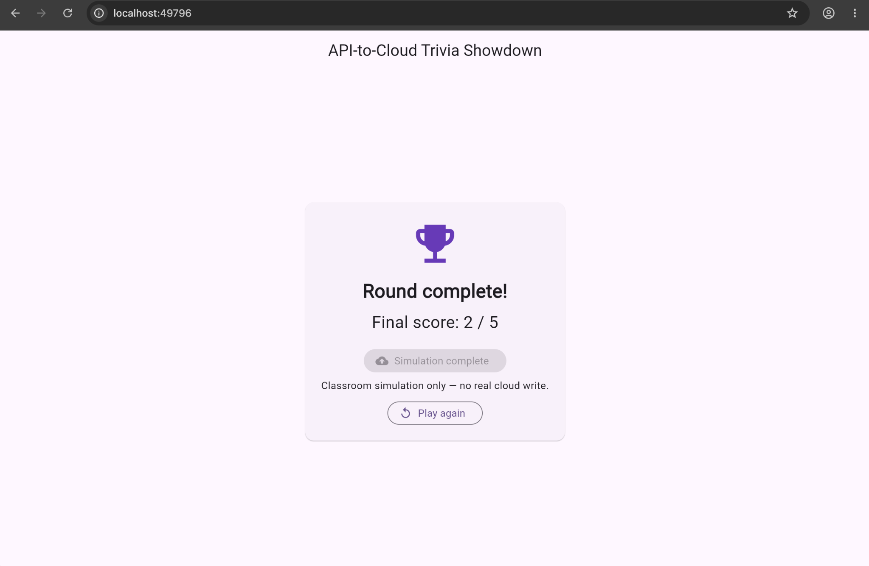

AI Assistance
I used ChatGPT for testing guidance, troubleshooting, and bug-fixing support while working on this Flutter activity.

