PROJECT 1
Student Performance and Dropout-Risk Prediction System
Part 1 -- Data Pipeline Implementation: Project Report
Course: Data Engineering and MLOps
Mode: Individual Project
Submitted by: Akshitha
Submission date: 7 September 2026

1. Introduction & Background
Academic institutions generate a continuous stream of data about their students -- attendance registers, internal assessment marks, assignment submissions, and, increasingly, learning-management-system (LMS) activity logs. In practice this data lives in separate systems that are rarely joined together, so early signs that a student is struggling (falling attendance, missed assignments, declining marks, low LMS engagement) are often visible only in hindsight, after a student has already fallen behind.
This project builds a data-engineering pipeline that unifies these sources into a single, clean, queryable academic-analytics warehouse, and exposes it through an interactive dashboard so that patterns -- attendance vs. marks, subject-wise pass/fail rates, department- and semester-level performance, and a high-risk student list -- are visible immediately rather than after the fact. Part 1 of the assignment (this report) covers the data engineering half of the system end-to-end: acquisition, ingestion, validation/cleaning, storage, transformation, and visualization. Part 2, to be announced separately, will extend this same pipeline with a trained machine-learning model, MLflow experiment tracking, FastAPI serving, Docker containerization, and drift monitoring.

1.1 Justification
A rule-based or ML-based early-warning system is only as good as the data pipeline feeding it. Building a disciplined, layered pipeline (source -> raw -> cleaned -> analytical) with explicit validation rules and an auditable rejected-record log is what makes the eventual Part 2 model trustworthy: every feature the model will consume in Part 2 (attendance percentage, average internal marks, assignment completion rate, previous-semester performance) is already defined, computed, and documented here in Part 1.

2. Project Objectives & Scope

2.1 Objectives (from the assignment brief)
- Create a unified student data pipeline from multiple academic sources.
- Clean, validate, transform, and store student records in a structured database.
- Develop dashboards for performance, attendance, and risk analysis.
- Extend the pipeline into an MLOps workflow for dropout/performance-risk prediction (Part 2).

2.2 Part 1 scope (this report)
Part 1 is explicitly limited to data engineering -- no ML model is trained or deployed at this stage. Delivered in Part 1:
- Dataset acquisition and documentation (Section 3).
- A four-layer data architecture: source -> raw -> cleaned -> analytical (Section 4).
- Ingestion scripts with extraction logging (Section 5.1).
- Validation and cleaning with a rejected-record log (Section 5.2).
- Feature engineering and a SQLite analytical data mart (Section 6).
- A 5-view Streamlit dashboard, including a transparent rule-based risk flag (Section 7).
- Full documentation: architecture diagram, data dictionary, validation rules, schema, README.

2.3 Role of ML in this system (and why Part 1 has none)
The eventual role of machine learning (Part 2) is to replace the simple, transparent, rule-based risk_score computed in this pipeline (Section 7.3) with a trained classifier -- starting with Logistic Regression as an interpretable baseline, then Random Forest and XGBoost for improved accuracy -- predicting one of dropout risk, failure risk, or a final-score category, tracked with MLflow and served via FastAPI. Part 1 deliberately stops short of this so that the data foundation can be evaluated on its own merits first.

3. Data Sources
Per the assignment's dataset rule (“use only free, legally accessible, public, institutional, or instructor-approved datasets”), this project combines one real public dataset with simulated supplementary sources. Full access instructions are in docs/data_sources.md; summarized below.
Source | Type | Rows | Role
UCI Student Performance dataset (student-mat.csv, student-por.csv) | Real, public (CC BY 4.0) | 395 + 649 = 1,044 | Primary historical dataset
College ERP roster export | Simulated (seeded) | 1,044 (+dup noise) | student_id / department / semester enrichment
ERP attendance export | Simulated (seeded, linked to real 'absences') | 4,176 (-noise) | Monthly attendance -> attendance %
LMS activity export | Simulated (seeded, linked to studytime/internet) | 12,528 | Weekly engagement -> LMS engagement score
Assignment submissions export | Simulated (seeded, linked to studytime/failures) | 6,264 | Per-assignment marks -> completion rate

The UCI dataset (P. Cortez & A. Silva, 2008; UCI ML Repository, dataset id 320) was retrieved via a public GitHub mirror of the identical, unmodified CSV files, since the UCI archive host itself was not reachable from the network used to build this pipeline; values were spot-checked against the documented UCI schema (33 columns, 0-20 grade scale) after download. No real student names, government IDs, or other personally identifiable information appear anywhere in this project -- every student is identified only by a synthetic student_id, per the brief's explicit prohibition on private/confidential data.

3.1 Why simulate attendance, LMS and assignment data?
The brief lists ERP and LMS exports as optional institutional sources. As an individual student project without access to a real college ERP/LMS feed -- and forbidden from uploading real institutional records -- these three sources were generated synthetically with deliberate, documented statistical relationships to the real UCI attributes (e.g., simulated attendance is derived from each student's real absences value; LMS engagement scales with real studytime and internet-access fields), so the resulting pipeline and dashboard behave like a genuine multi-source academic dataset rather than being populated with arbitrary random noise. This design choice, and its limitations, are disclosed in full in docs/data_dictionary.md.

4. System / Data Architecture
The pipeline follows the layered architecture suggested by the brief (CSV/ERP/LMS -> Python ingestion -> orchestration -> validation & cleaning -> warehouse -> analytics tables -> dashboard), implemented exactly as shown below.
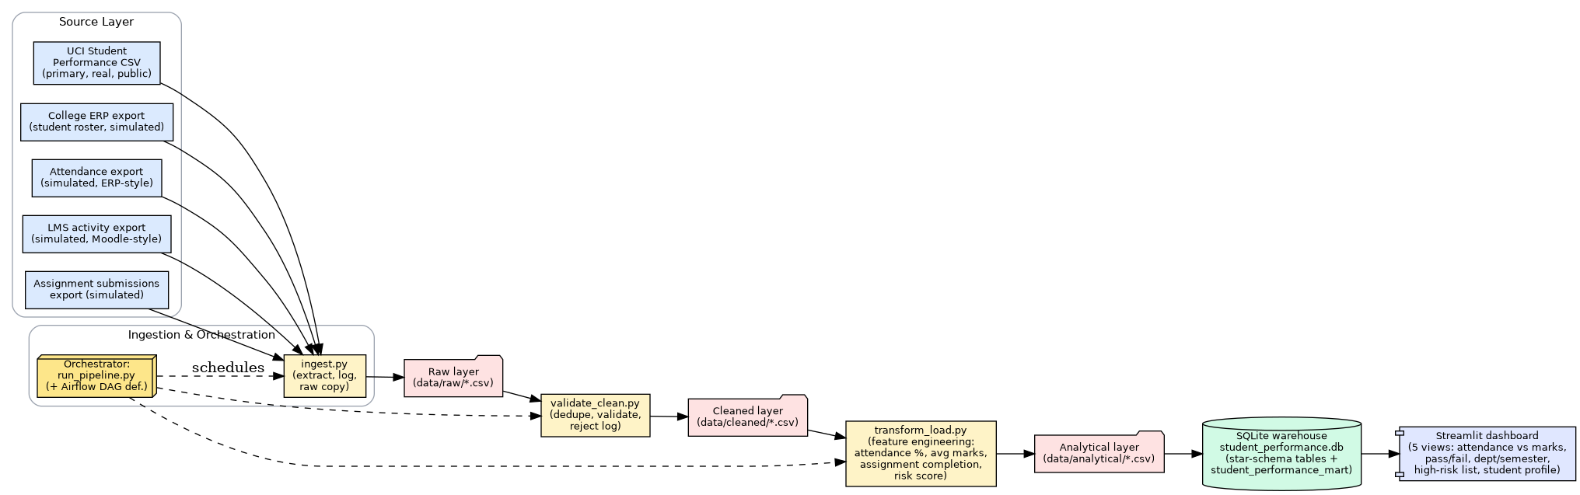
Figure 1. End-to-end pipeline architecture (source -> raw -> cleaned -> analytical -> dashboard).

4.1 Layers
Layer | Location | Produced by
Source | data/source_files/ | External (UCI download + generate_synthetic_sources.py)
Raw | data/raw/ | scripts/ingest.py
Cleaned | data/cleaned/ | scripts/validate_clean.py
Analytical | data/analytical/ + db/student_performance.db | scripts/transform_load.py

5. ETL / Data Engineering Implementation

5.1 Ingestion (scripts/ingest.py)
Extracts each of the five source files into the raw layer, and for every source logs the extraction timestamp, source name, target raw file, status, and row count to logs/extraction_log.csv:
Source | Raw file | Status | Rows
college_erp_roster | raw_student_roster.csv | SUCCESS | 1,059
uci_academic_records | raw_academic_records.csv | SUCCESS | 1,054
erp_attendance_export | raw_attendance.csv | SUCCESS | 4,093
lms_activity_export | raw_lms_activity.csv | SUCCESS | 12,528
assignment_submissions_export | raw_assignments.csv | SUCCESS | 6,264

To make the downstream validation stage demonstrate genuine data-quality work, ingestion deliberately injects a small, seeded amount of realistic noise while copying into the raw layer (duplicate roster/academic rows, a few out-of-range grades, a handful of missing attendance rows) -- fully documented in ingest.py's docstring and docs/validation_rules.md. The original UCI source files are never altered.

5.2 Validation & Cleaning (scripts/validate_clean.py)
Implements: identifier standardization, duplicate removal, invalid-mark rejection, referential-integrity checks, and missing-record handling. Every dropped/corrected row is logged with a reason code:
Rejection reason | Count
duplicate_student_id (roster) | 15
duplicate_student_subject (academic) | 10
G3_out_of_range (0-20 scale) | 10
Total rejected | 35

Full rule descriptions are in docs/validation_rules.md; the raw rejected rows themselves are in logs/rejected_records.csv.

5.3 Orchestration
scripts/run_pipeline.py runs ingestion -> validation/cleaning -> transformation/load as a single, re-runnable command, logging each stage's status and timing to logs/pipeline_run_log.txt. dags/student_pipeline_dag.py defines the identical three-stage task graph as a real Apache Airflow DAG (PythonOperator tasks, ingest_task >> validate_task >> transform_load_task), satisfying the brief's “Airflow DAG, or an approved equivalent ETL workflow” requirement; run_pipeline.py is what is used for the live demo to avoid depending on a freshly-installed Airflow scheduler being available on demand.

5.4 Missing-Data Handling
Guiding principle: a NULL produced anywhere in this pipeline is never automatically replaced by zero or a guessed value. The cause is identified first, and the treatment depends on that cause and on how the feature will be used -- distinguishing a genuine measurement from a data-quality gap.
Situation | Where | Handling
Partial gap -- a student has some but not all expected attendance months | validate_clean.py | Not fabricated: attendance % computed from months present; gap logged to attendance_completeness_gaps.csv
Full gap -- a source has no record at all for a student that semester | transform_load.py (mart) | Flagged FIRST (attendance_data_available / lms_data_available / assignment_data_available = False), THEN a documented fallback (cohort median, or 0 for assignments) is applied
Missing assignment marks (not submitted) | source data | Kept NULL, never coerced to 0 -- a meaningful absence, directly lowers assignment_completion_rate

The mart carries this as an explicit, auditable column (data_quality_flag: "complete" or "imputed:<source>"), rather than an invisible substitution. In the current seeded run, 15 of 1,034 student-subject records are flagged imputed:attendance -- a genuine case produced by simulating a full-semester ERP sync failure for a small subset of students (see ingest.py).
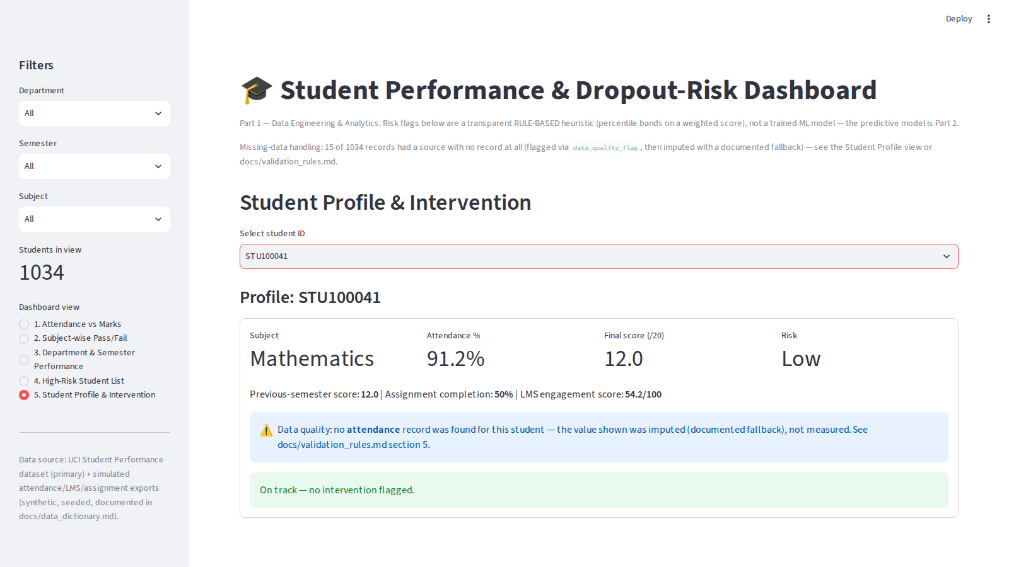
Figure 5. Student Profile view surfacing a flagged, imputed record (student STU100041 had no attendance source record for this semester).

6. Database Schema & Data Dictionary
All cleaned and analytical tables are loaded into a single-file SQLite warehouse (db/student_performance.db) -- an approved open-source database per the brief. The design is a light star schema: one dimension table (dim_student_roster), four fact tables at their natural grain, three per-student aggregates, one analytical data mart, and one department/semester rollup. Full DDL is in docs/schema.sql; the complete column-level data dictionary (with real vs. synthetic vs. derived provenance for every field) is in docs/data_dictionary.md. Key tables:
Table | Grain | Rows
dim_student_roster | 1 per student | 1,044
fact_academic_records | 1 per student x subject | 1,034
fact_attendance_monthly | 1 per student x semester x month | 4,093
fact_lms_activity_weekly | 1 per student x week | 12,528
fact_assignments | 1 per student x subject x assignment | 6,264
student_performance_mart (data mart) | 1 per student x subject | 1,034
department_semester_performance | 1 per department x semester | 32

7. Feature Engineering & Risk Scoring
scripts/transform_load.py computes every feature the brief requires, all landing in student_performance_mart:
Required feature | Definition
Attendance percentage | classes_attended / classes_held x 100, aggregated per student per semester
Average internal marks | (G1 + G2) / 2 (period-1 and period-2 UCI grades)
Assignment completion rate | assignments_submitted / assignments_total, per student per subject
Previous-semester performance | G2 (the UCI dataset's second-period grade)

7.1 A supplementary engagement signal
lms_engagement_score (0-100) blends weekly logins (50%), average quiz score (40%) and forum posts (10%) into a single number, giving the dashboard an LMS-derived signal beyond the four required features.

7.2 Rule-based risk score (Part 1 only -- not an ML model)
risk_score = 0.4 x (100 - attendance_pct) + 0.4 x ((20 - current_score) / 20 x 100) + 0.2 x (100 x (1 - assignment_completion_rate))
Students are then bucketed into Low / Medium / High risk_category by PERCENTILE band within the current cohort (top 10% -> High, next 20% -> Medium, remaining 70% -> Low), rather than a fixed score cutoff, so the thresholds stay meaningful regardless of dataset size. This is intentionally a transparent, auditable heuristic -- Part 2 will replace it with a trained, evaluated classifier.
Risk category | Students (of 1,034) | Share
Low | 722 | 69.8%
Medium | 207 | 20.0%
High | 105 | 10.2%

Cohort-level result: overall pass rate 77.9% (G3 >= 10) and average attendance 88.6% across all 1,034 student-subject records after cleaning.

8. Dashboard & Visualization
dashboard/app.py is a Streamlit application reading directly from the SQLite warehouse, with sidebar filters (department, semester, subject) that apply across all five required views.
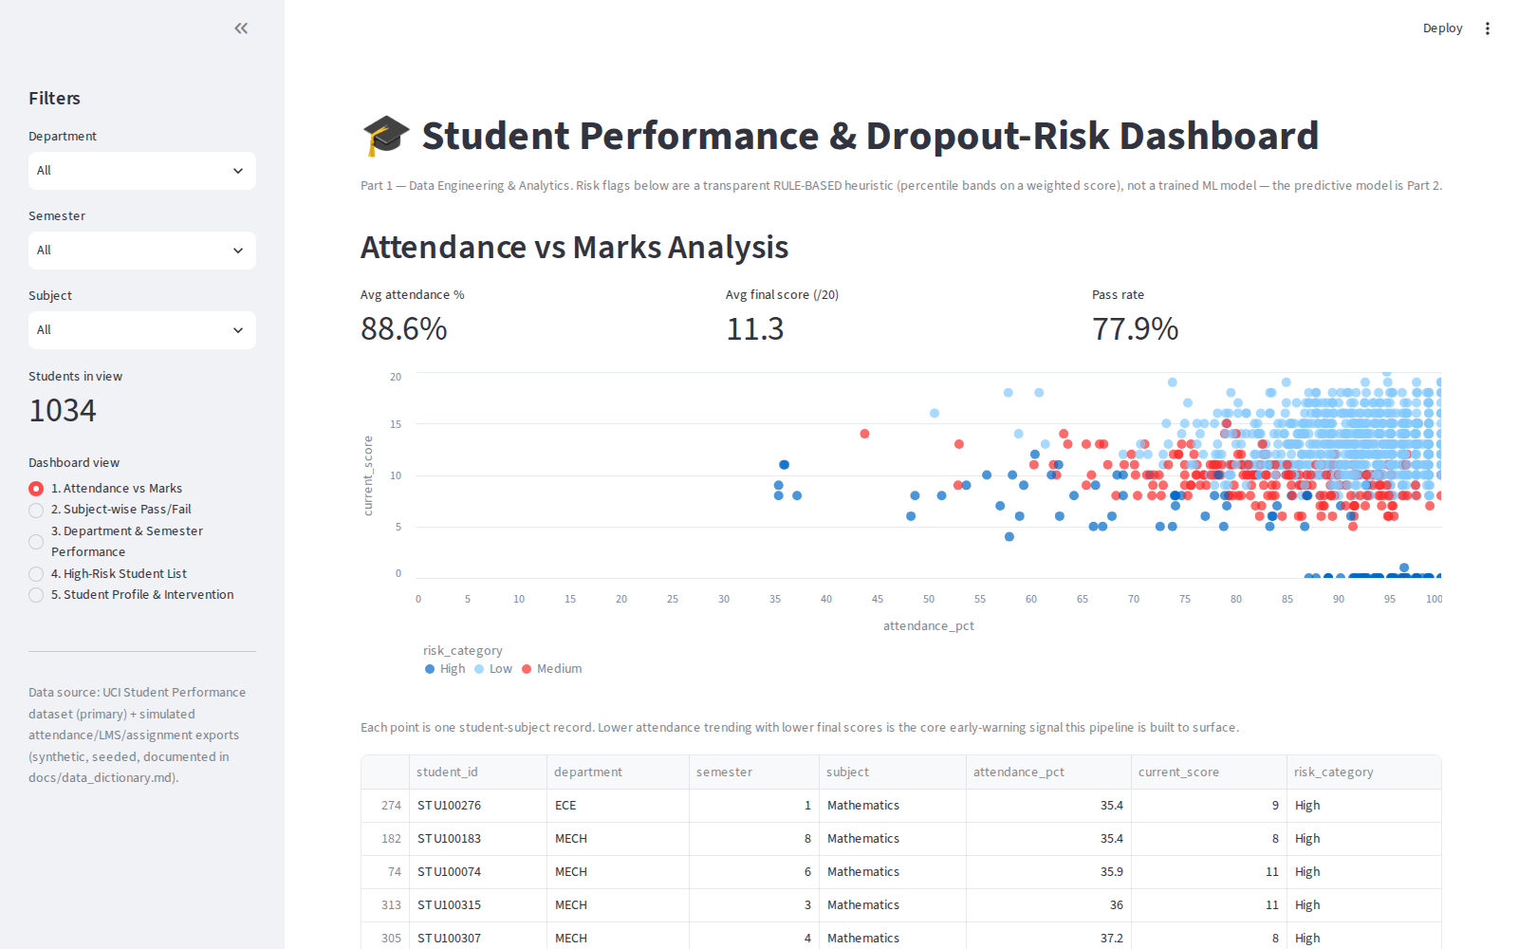
Figure 2. View 1 -- Attendance vs. Marks Analysis (scatter, coloured by risk category).

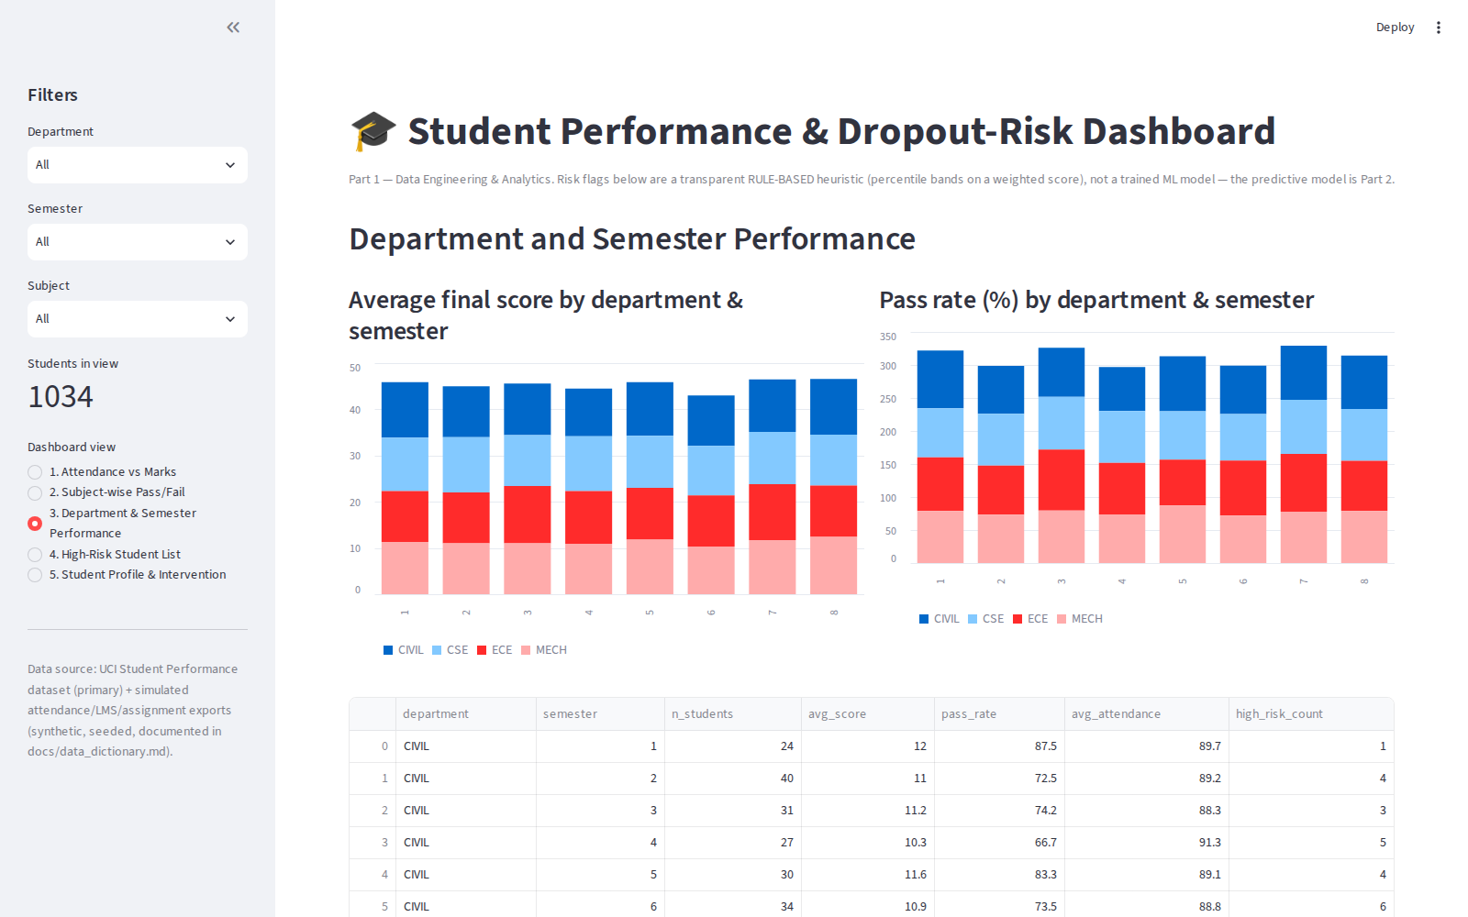
Figure 3. View 3 -- Department and Semester Performance (average score and pass rate).
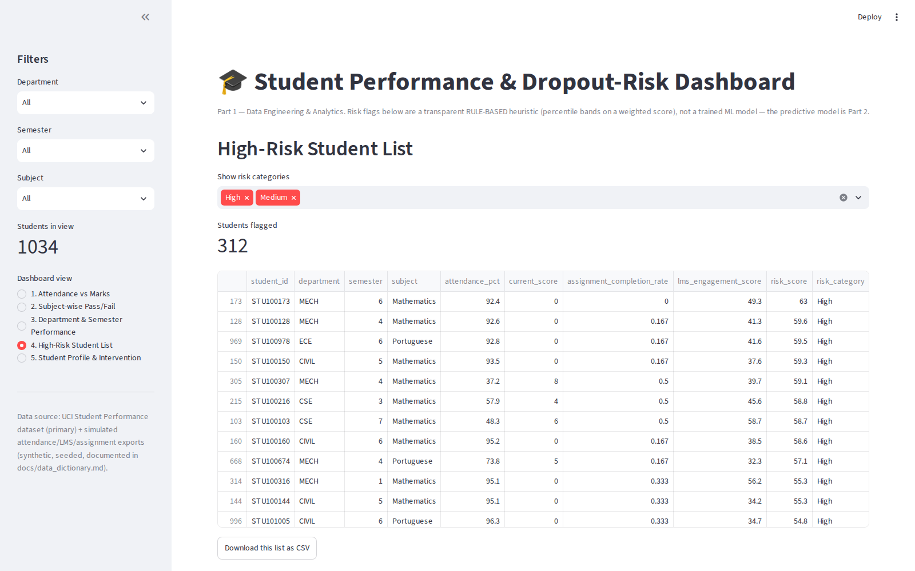
Figure 4. View 4 -- High-Risk Student List (filterable, downloadable as CSV).
The remaining two required views -- Subject-wise Pass/Fail Distribution and Student Profile & Intervention (with a rule-based, plain-language intervention suggestion per student) -- are included in the live application and in screenshots/02_subject_pass_fail.png and screenshots/05_student_profile.png.

9. Execution Evidence
A full pipeline run (python scripts/run_pipeline.py) completes all three stages successfully in well under one second on this dataset size, producing the following log artefacts (all included in this submission):
- logs/extraction_log.csv -- per-source extraction status and row counts (Section 5.1).
- logs/rejected_records.csv -- 35 rejected rows with reason codes (Section 5.2).
- logs/attendance_completeness_gaps.csv -- students with missing monthly attendance records.
- logs/pipeline_run_log.txt -- timestamped STAGE START / STAGE OK lines for the full run.
- db/student_performance.db -- the populated 10-table SQLite warehouse.
- screenshots/ -- five dashboard-view screenshots captured from a live run of the application.
Additional terminal-output screenshots from the live review demo should be added to screenshots/ alongside these before final submission.

10. Conclusion & Part 2 Roadmap
This Part 1 submission delivers a complete, working, documented data pipeline: a real public dataset combined with realistic supplementary sources, ingested with logging, validated and cleaned with a full audit trail, transformed into an engineered feature set and loaded into a queryable SQLite warehouse, and surfaced through a 5-view interactive dashboard -- with no shortcuts taken on the parts of the brief that are explicitly graded (rejected-record logging, data dictionary, architecture diagram, orchestration).
Part 2 will build directly on this foundation: the four engineered features already computed here (attendance percentage, average internal marks, assignment completion rate, previous-semester performance) become the model's input features; the rule-based risk_category becomes the baseline to beat; and student_performance_mart becomes the training table for a Logistic Regression baseline followed by Random Forest and XGBoost, tracked in MLflow, served via FastAPI, containerized with Docker, and monitored for input drift -- exactly as specified in Section 8 of the assignment brief.

