Assignment-2

1.Write a java program for Matrix Addition.

Program: import java.util.Scanner;

public class MatrixAddition{

public static void main(String args[]){

Scanner sc=new Scanner(System.in);

int n=sc.nextInt();

int a[][]=new int[n][n];

int b[][]=new int[n][n];

int i,j;

for(i=0;i<n;i++){

for(j=0;j<n;j++){

a[i][j]=sc.nextInt();

}

}

for(i=0;i<n;i++){

for(j=0;j<n;j++){

b[i][j]=sc.nextInt();

}

}

int c[][]=new int[3][3];

for(i=0;i<3;i++){

for(j=0;j<3;j++){

c[i][j]=a[i][j]+b[i][j];

System.out.print(c[i][j]+" ");

}

System.out.println();

}

}}

Output:

Input: n=3 a={{1,3,4},{2,4,3},{3,4,5}} b={{1,3,4},{2,4,3},{1,2,4}}

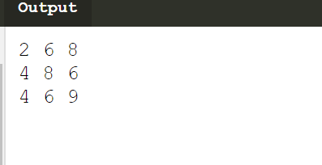

2.Write a java program for Matrix Multiplication.

Program: import java.util.Scanner;

public class MatrixAddition{

public static void main(String args[]){

Scanner sc=new Scanner(System.in);

int n=sc.nextInt();

int a[][]=new int[n][n];

int b[][]=new int[n][n];

int i,j;

for(i=0;i<n;i++){

for(j=0;j<n;j++){

a[i][j]=sc.nextInt();

}}

for(i=0;i<n;i++){

for(j=0;j<n;j++){

b[i][j]=sc.nextInt();

}}

int c[][]=new int[3][3];

for(i=0;i<n;i++){

for(j=0;j<n;j++){

c[i][j]=0;

for(int k=0;k<n;k++)

{

c[i][j]+=a[i][k]*b[k][j];

}

System.out.print(c[i][j]+" ");

}

System.out.println();

}

}}

Output:

Intput: n=3 a={{1,1,1},{2,2,2},{3,3,3}} b={{1,1,1},{2,2,2},{3,3,3}}

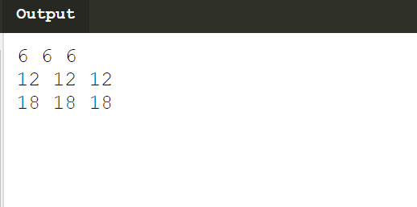

3.Write a java program to demonstrate method overloading.

Program: class DisplayOverloading

{

public void disp(char c)

{

System.out.println(c);

}

public void disp(char c, int num)

{

System.out.println(c + " "+num);

}}

class Sample

{

public static void main(String args[])

{

DisplayOverloading obj = new DisplayOverloading();

obj.disp('a');

obj.disp('a',10);

}}

Output:

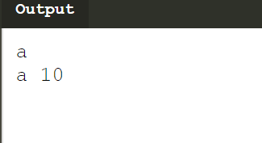

4. Write a java program to create a class Point with two data members x & y. Include

all constructors and display().

Program: public class Point {

public int x = 0;

public int y = 0;

public Point(int x, int y) {

this.x = x;

this.y = y;

}

public void display()

{System.out.print(x+&quot;,&quot;+y);

}

public static void main(String args[])

{

Point p = new Point(10,20);

p.display();

}

}

Output:

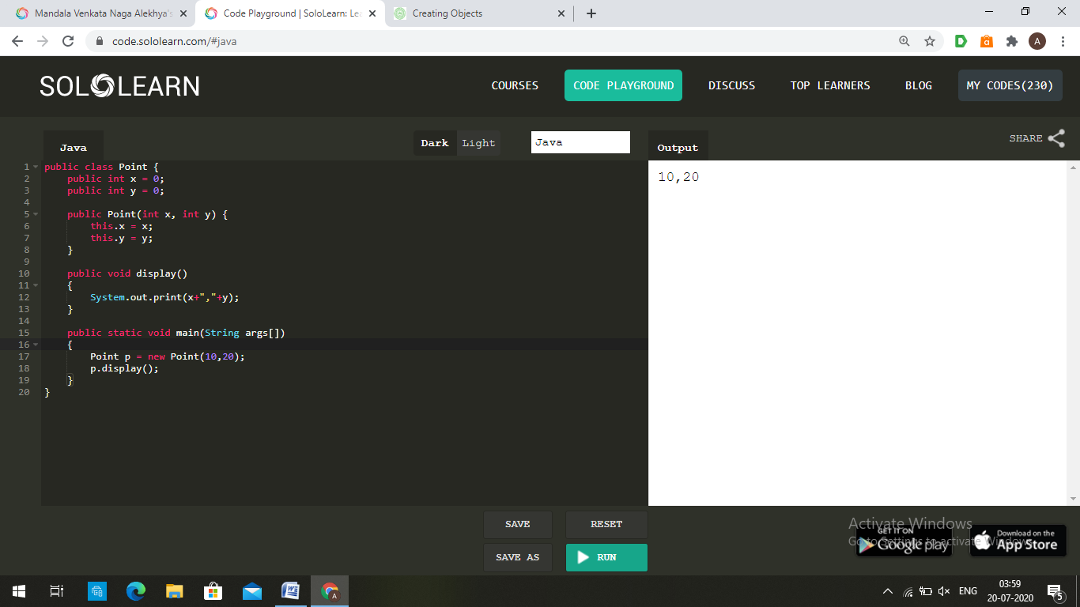

5. Write a java program using static method.

Program: class Calculate{

static int cube(int x){

return x*x*x;

}

public static void main(String args[]){

int r=Calculate.cube(3);

System.out.println(r);

}

}

Output:

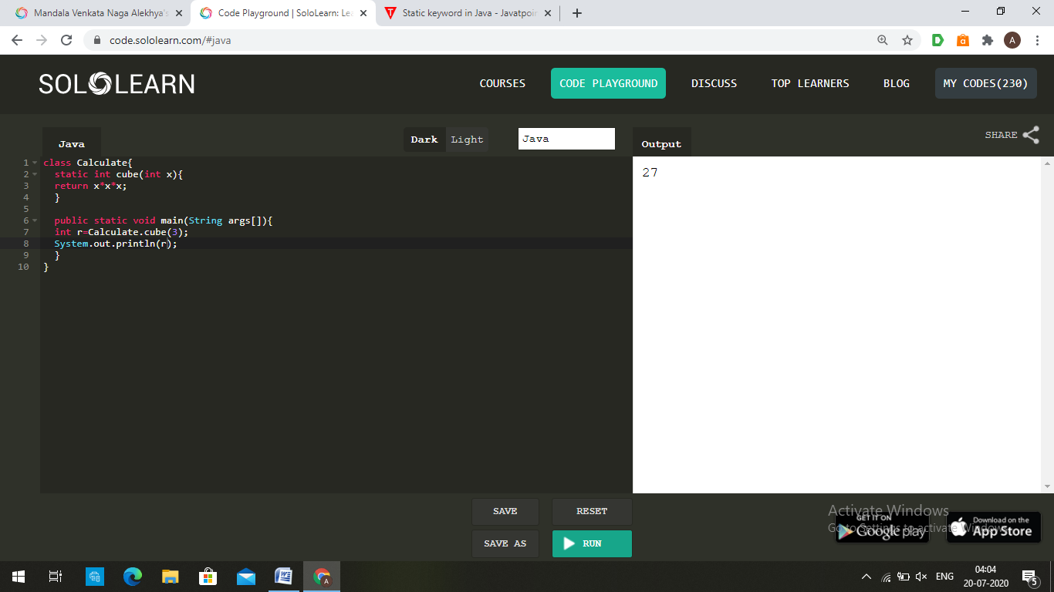

Theory

1.What is conditional statement?

Answer:A conditional statement is a statement that computer programming language used to

decide which code has to be run when the true condition is met or which code has not to

be run when the true condition is not met.

1. if statement

2. nested if statement

3. if-else statement

4. if-else-if statement

5. Switch Case Statement

2.Write the syntax of switch..case statement.

Answer:switch (variable/expression) {

case value1:

// statements of case1

break;

case value2:

// statements of case2

break;

.. .. ...

.. .. ...

default:

// default statements

}

3. Write the difference between break and continue statement.

Answer:

|  |  |
| --- | --- |
| **break**  1. It terminates the execution of  remaining iteration of the loop.  2. 'break' resumes the control of the program to the end of loop enclosing that 'break'.  3. It causes early termination of loop.  4. break' stops the continuation of loop.  5. 'break' can be used with 'switch', 'label'. | **continue**  1. It terminates only the current iteration of the loop.  2. 'continue' resumes the control of the program to the next iteration of that loop enclosing 'continue'.  3. It causes early execution of the next iteration.  4. 'continue' do not stops the continuation of loop, it only stops the current iteration.  5. 'continue' cannot be executed with 'switch' and 'labels'. |

4.What is looping statement?

Answer:A loop statement allows us to execute a statement or group of statements multiple times.

There are 3 types of loop statements.

1. while loop

2. for loop

3. do..while loop

5. Write the difference between while and do..while statement.

Answer:The while loop in java executes one or more statements after testing the loop

continuation condition at the start of each iteration. The do-while loop, however, tests

the loop continuation condition after the first iteration has completed. Therefore, the do-

while loop guarantees one execution of the loop logic whereas the while does not.

public class WhileAndDoWhileLoop {

public static void main(String args[]) {

int i=5;

System.out.println("Test while Loop:");

while(i < 5) {

System.out.println("Iteration: "+ ++i);

}

System.out.println("Test do-while Loop:");

i=5;

do {

System.out.println("Iteration: "+ ++i);

} while(i < 5);

}

}

In the above example, The while loop statement will not execute at all. However, one

iteration of the do-while loop will execute.

Test while Loop:

Test do-while Loop:

Iteration: 6

6. What is array? How it is created?

Answer:An array is a group of like-typed variables that are referred to by a common name.

The general form of a one-dimensional array declaration

type var-name[];

OR

type[] var-name;

An array declaration has two components: the type and the name. type declares the

element type of the array. The element type determines the data type of each element that

comprises the array.

int intArray[];

or

int[] intArray;

When an array is declared, only a reference of array is created. To actually create or give

memory to array, you create an array like this:The general form of new as it applies to

one-dimensional arrays appears as follows:

var-name = new type [size];

Example:

int[] intArray = new int[20];

7. What is class?

Answer:A class is a user defined blueprint or prototype from which objects are created. It

represents the set of properties or methods that are common to all objects of one type. In

general,

class declarations can include these components, in order:

1.Modifiers : A class can be public or has default access (Refer this for details).

2.Class name: The name should begin with a initial letter (capitalized by convention).

3.Superclass(if any): The name of the class’s parent (superclass), if any, preceded by the

keyword extends. A class can only extend (subclass) one parent.

4.Interfaces(if any): A comma-separated list of interfaces implemented by the class, if

any, preceded by the keyword implements. A class can implement

more than one interface.

5.Body: The class body surrounded by braces, { }.

8. What is constructor?

Answer: **Constructor** is a special method that is used to initialize a newly created object and is

called just after the memory is allocated for the object. It can be used to initialize the

objects to desired values or default values at the time of object creation.

9. What is the use of copy constructor?

Answer: A copy constructor in a Java class is a [constructor](https://www.baeldung.com/java-constructors) that**creates an object using**

**another object of the same Java class**.

That's helpful when we want to copy a complex object that has several fields, or when

we want to make a [deep copy](https://www.baeldung.com/java-deep-copy) of an existing object.

10. What is the use of this keyword?

Answer:this keyword in Java is a special keyword that can be used to represent the current

object or instance of any [class in Java](http://javarevisited.blogspot.com/2011/10/class-in-java-programming-general.html). “this” keyword can also call the constructor of

the same class in Java and used to call overloaded constructor.

11. What is method overloading?

Answer:Method Overloading is a feature that allows a class to have more than one method

having the same name, if their argument lists are different.

12. What is static variable?

Answer: **Static variable in Java** is variable which belongs to the class and initialized only once at

the start of the execution.These variables will be initialized first, before the

initialization of any instance variables.

* A single copy to be shared by all instances of the class
* A static variable can be accessed directly by the class name and doesn’t need any object

13. What is access modifier?

Answer: Access modifiers are reserved keywords that provide a different level public,

of access to classes, methods, fields, etc. Reserved keywords for access

modifiers are protected, and private

14. Write the difference between instance and static methods.

|  |  |
| --- | --- |
| Instance method | Static method |
| 1.Instance method are methods which  require an object of its class to be  created before it can be called. | 1.Static methods are the methods in Java  that can be called without creating an  object of class. |
| 2.Instance method is not with static  keyword. | 2.Static method is declared with static  keyword. |
| 3.instance methods exist as multiple  copies depending on the number of  instances created for that class. | 3.Static method means which will exist  as a single copy for a class. |

Answer:

15. What is object? How it is created?

Answer: An object is an instances of a class. Each object has its own state, behavior, and

identity. Objects can communicate with other objects by calling functions. an object is

created from a class. In Java, the new keyword is used to create new objects.

There are three steps when creating an object from a class −

**Declaration** − A variable declaration with a variable name with an object

type.

* + - **Instantiation** − The 'new' keyword is used to create the object.
    - **Initialization** − The 'new' keyword is followed by a call to a constructor.

This call initializes the new object.

Syntax:

**Classname objectname**= new Classname();