ASSIGNMENT – 9.2
K. Akshitha
2303A52026
Batch – 38
Task Description -1 (Documentation – Function Summary Generation)
Task:
Use AI to generate concise functional summaries for each Python
function in a given script.
Instructions:
• Provide a Python script to the AI.
• Ask the AI to write a short summary describing the purpose of
each function.
• Ensure summaries are brief and technically accurate.
• Do not include code implementation details.
Expected Output -1:
A Python script where each function contains a clear and concise
summary explaining its purpose.
PROMPT:
Add the summary as a docstring inside each function and return the updated script without explaining the code.
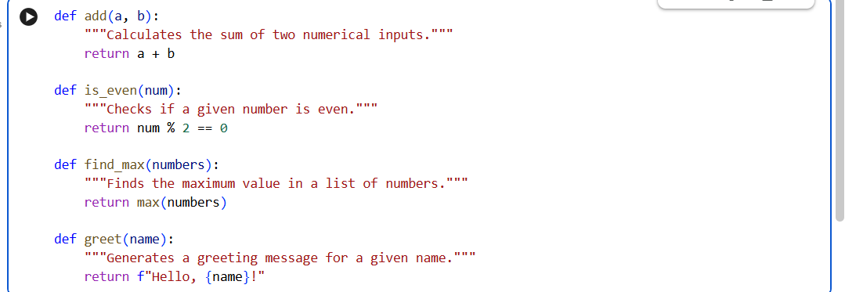
EXPLANATION:
AI generated short docstrings that explain the purpose of each function in the script. The summaries describe what the function does, not the internal logic or steps. Simple technical language is used so the meaning is clear and easy to understand. This makes the code more readable and helps others quickly understand the functions.
Task Description -2 (Documentation – Logical Explanation for Conditions and Loops)
Task:
Use AI to document the logic behind conditional statements and loops in a Python program.
Instructions:
• Provide a Python program without comments.
• Instruct AI to explain only decision-making logic and loop behavior.
• Skip basic syntax explanations.
Expected Output -2:
Python code with clear explanations describing the logic of conditions and loops
PROMPT:
Read the Python program and add comments explaining the logic of conditional statements and loops.
Return the updated code with comments, without explaining basic syntax.
OUTPUT:
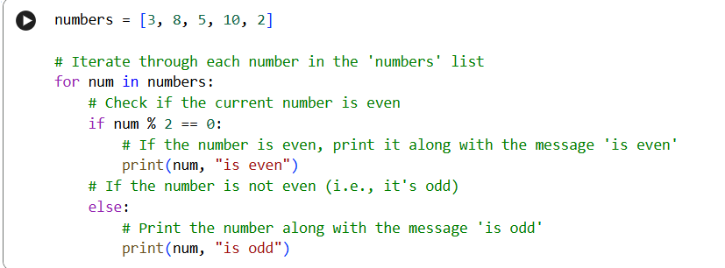
EXPLANATION:
Read the Python program and add comments explaining the logic of conditional statements and loops.
Return the updated code with comments, without explaining basic syntax.
Task Description -3 (Documentation – File-Level Overview)
Task:
Use AI to generate a high-level overview describing the functionality of
an entire Python file.
Instructions:
• Provide the complete Python file to AI.
• Ask AI to write a brief overview summarizing the file’s purpose
and functionality.
• Place the overview at the top of the file.
Expected Output -3:
A Python file with a clear and concise file-level overview at the
beginning.
PROMPT:
Read the Python file and write a brief overview summarizing its purpose and functionality.
Add the overview as a comment at the top and return the updated file.
OUTPUT:
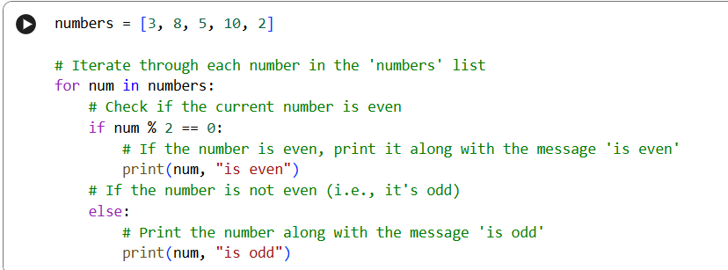
EXPLANATION:
AI generates a file-level summary that explains the overall purpose of the program. The overview is placed at the top of the file for documentation. This helps readers quickly understand what the Python file does.
Task Description -4 (Documentation – Refine Existing Documentation)
Task:
Use AI to improve clarity and consistency of existing documentation in
Python code.
Instructions:
• Provide Python code containing basic or unclear comments.
• Ask AI to rewrite the documentation to improve clarity and
consistency.
• Ensure technical meaning remains unchanged.
Expected Output -4:
Python code with refined and improved documentation that is clear and consistent.
PROMPT:
Read the Python code and rewrite the existing comments to improve clarity and consistency without changing their meaning. Return the updated code with refined documentation.
OUTPUT:
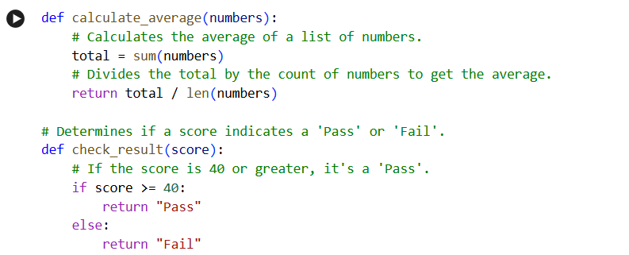
EXPLANATION:
AI rewrites unclear comments to make them more professional and consistent. The technical meaning remains the same, but the wording becomes clearer. This improves overall code readability and documentation quality.
Task Description -5 (Documentation – Prompt Detail Impact Study)
Task:
Study the impact of prompt detail on AI-generated documentation quality.
Instructions:
Create two prompts: one brief and one detailed.
• Use both prompts to document the same Python function.
• Compare the generated outputs.
Expected Output -5:
A comparison table highlighting differences in completeness, clarity, and
accuracy of documentation.
PROMPT 1:
Write a short docstring for the following Python function.
OUTPUT:
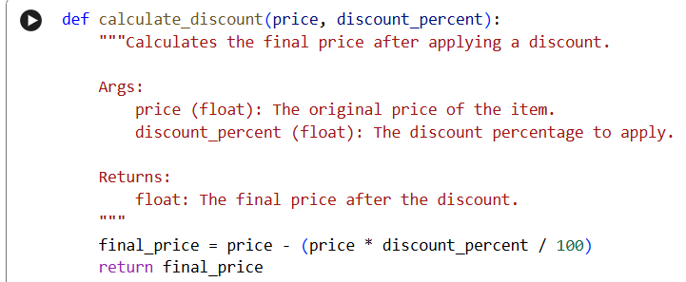
PROMPT 2:
Write a clear and concise docstring for the given Python function explaining its purpose. Include a brief description of the parameters and the return value.
OUTPUT:
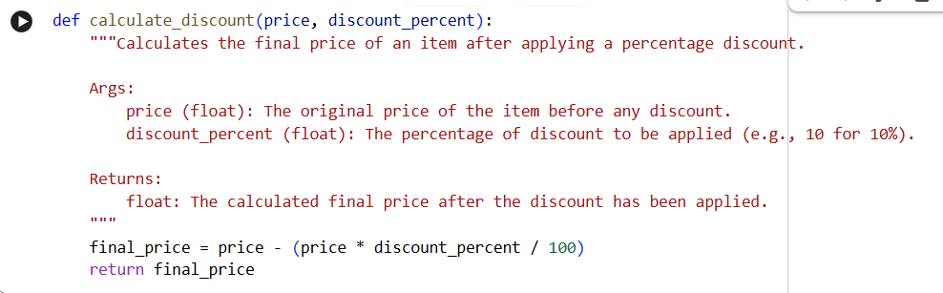
EXPLANATION:
The brief prompt produces minimal documentation with limited detail. The detailed prompt generates clearer, more structured, and complete documentation. This shows that more specific prompts improve the quality and usefulness of AI-generated documentation.
COMPARSION TABLE:
Aspect | Brief Prompt Output | Detailed Prompt Output
Completeness | Very short, only states purpose | Includes purpose, parameters, and return value
Clarity | Basic and minimal | Clear and well-structured
Accuracy | Correct but limited detail | Correct and more informative

