AI ASSISTANT CODING
ASSIGNMENT-4
K.Akshitha
2303A52026
Batch-38

Lab 4: Advanced Prompt Engineering – Zero-shot, One-shot, and Few-shot Techniques
Lab Objectives:
• To explore and apply different levels of prompt examples in AI-assisted code
generation.
• To understand how zero-shot, one-shot, and few-shot prompting affect AI output
quality.
• To evaluate the impact of context richness and example quantity on AI performance.
• To build awareness of prompt strategy effectiveness for different problem types.
Lab Outcomes (LOs):
After completing this lab, students will be able to:
• Use zero-shot prompting to instruct AI with minimal context.
• Use one-shot prompting with a single example to guide AI code generation.
• Apply few-shot prompting using multiple examples to improve AI responses.
• Compare AI outputs across the three prompting strategies.

Task Description-1
• Zero-shot: Prompt AI with only the instruction. Write a Python function to determine
whether a given number is prime
Expected Output-1
• A basic Python function to check if a number is prime, demonstrating correct logical
conditions without relying on examples or additional context

Prompt:
Write a Python function to determine whether a given number is prime INCLUDE THE CASE OF NUMBERS LESS THAN 1 , IT SHOULD RETURN 'PROVIDE A VALID NUMBER THE CODE SHOULD BE USER DEFINED

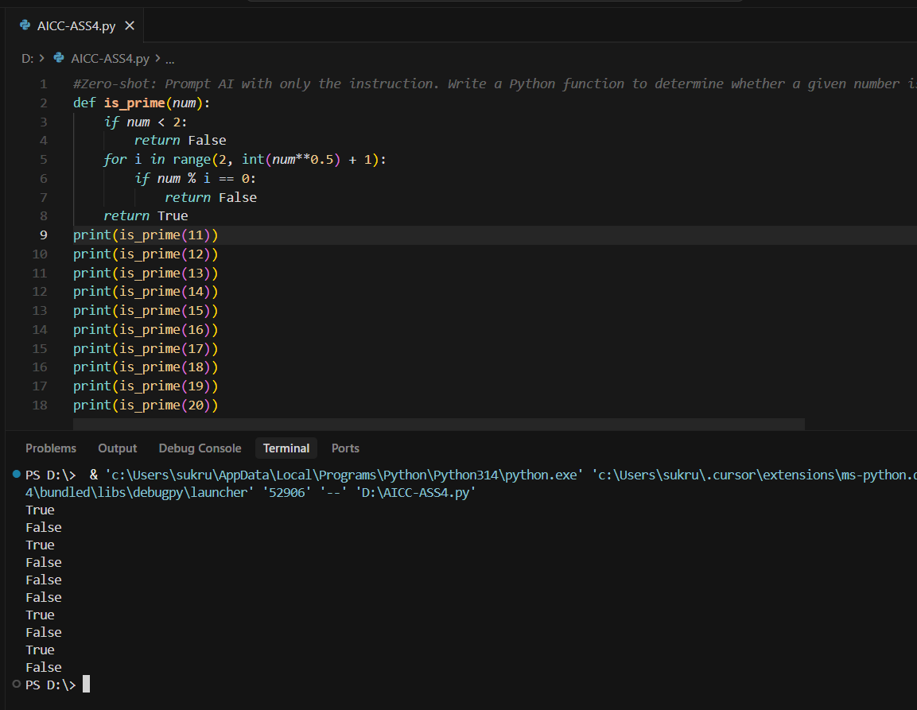

Explanation:

Task Description-2
• One-shot: Provide one example: Input: [1, 2, 3, 4], Output: 10 to help AI generate a
function that calculates the sum of elements in a list.
Expected Output-2
• A correct conversion function guided by the single example.

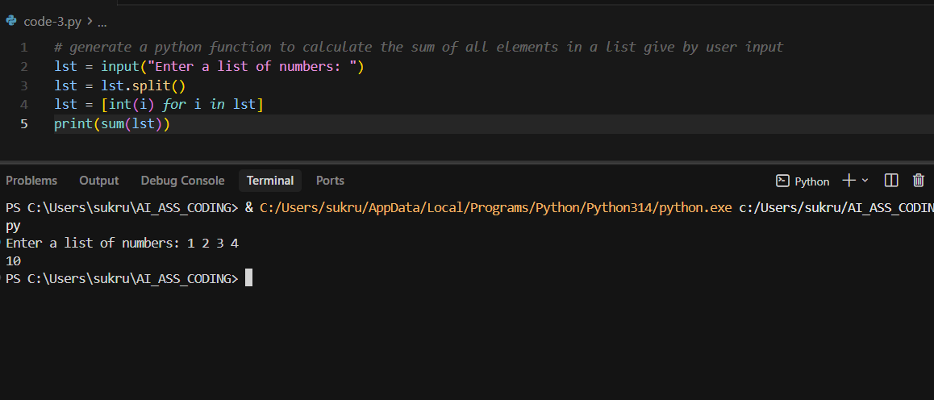
Explanation:
This program defines a function that finds the sum of all elements in a list. The function takes a list as input and uses the built-in sum () function to add all the values. When the list [1, 2, 3, 4] is passed to the function, it returns 10, which is printed as the output.
Task Description-3
• Few-shot: Give 2–3 examples to create a function that extracts digits from an
alphanumeric string.
Expected Output-3
• Accurate function that returns only the digits from alphanumeric string.
Prompt:
#Give 2–3 examples to create a function that extracts digits from an alphanumeric string.and Expected Output-3 Accurate function that returns only the digits from alphanumeric string.

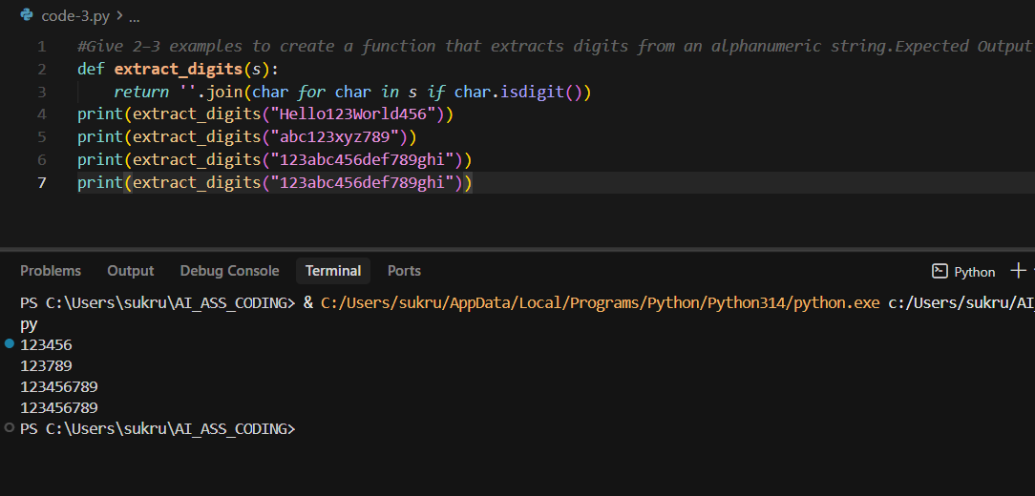

Task Description-4
• Compare zero-shot vs few-shot prompting for generating a function that counts the
number of vowels in a string.
Expected Output-4
• Output comparison + student explanation on how examples helped the model
Prompt:
Write a function that counts the number of vowels in a string
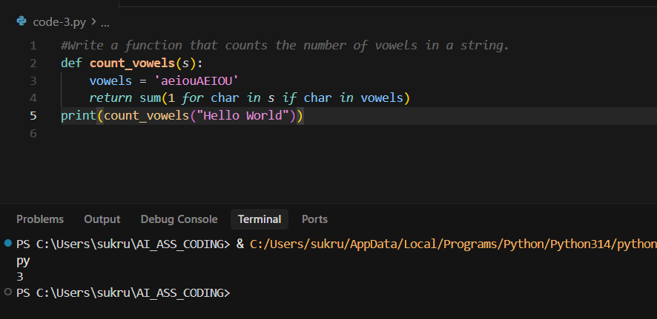

Prompt:
Write a function that counts the number of vowels in a string.
Examples:
Input: "hello" → Output: 2
Input: "AEIOU" → Output: 5
Input: "xyz" → Output: 0

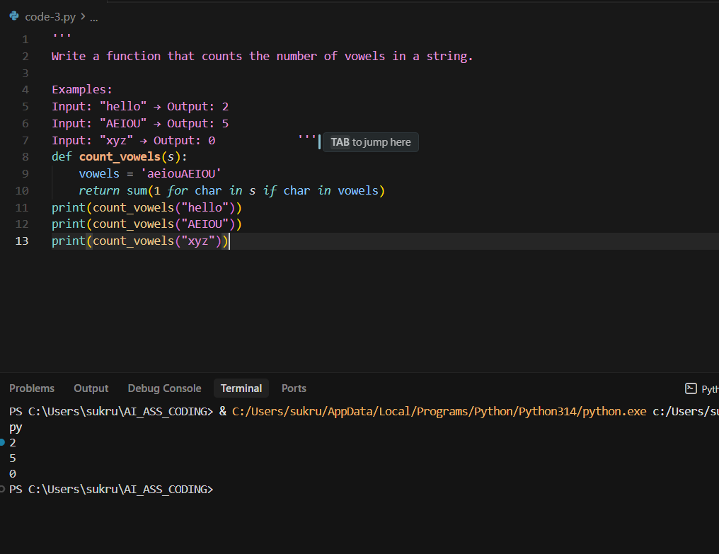

Task Description-5
• Use few-shot prompting with 3 sample inputs to generate a function that determines
the minimum of three numbers without using the built-in min() function.
Expected Output-5
• A function that handles all cases with correct logic based on example patterns.
Prompt:
Write a function that determines the minimum of three numbers without using the built-in min() function.
Examples:
Input: (3, 7, 5) → Output: 3
Input: (10, 2, 8) → Output: 2
Input: (4, 4, 6) → Output: 4

Requirements:
- Do not use min()
- Compare values using conditional statements
- Return the smallest number

