ASSIGNMENT – 10.3
K. Akshitha
2303A52026
Batch – 38

Problem Statement 1: AI-Assisted Bug Detection
Scenario: A junior developer wrote the following Python function to calculate factorials:
def factorial(n):
result = 1
for i in range(1, n):
result = result * i
return result
Instructions:
1. Run the code and test it with factorial(5).
2. Use an AI assistant to:
o Identify the logical bug in the code.
o Explain why the bug occurs (e.g., off-by-one error).
o Provide a corrected version.
3. Compare the AI’s corrected code with your own manual fix.
4. Write a brief comparison: Did AI miss any edge cases (e.g., negative numbers, zero)?
Expected Output:
Corrected function should return 120 for factorial(5).
PROMPT:
Identify the bug in this Python factorial function, explain why it happens, and provide a corrected version. Also handle edge cases like 0 and negative numbers.
OUTPUT:
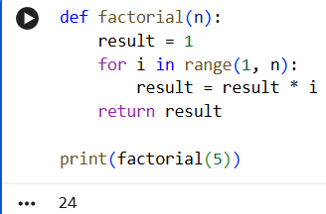

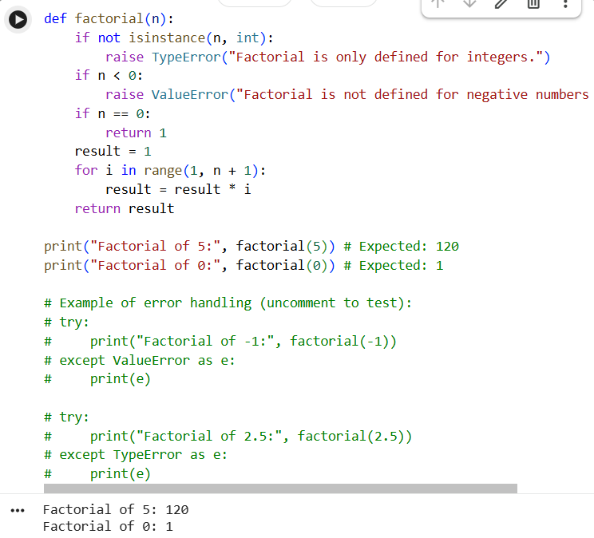

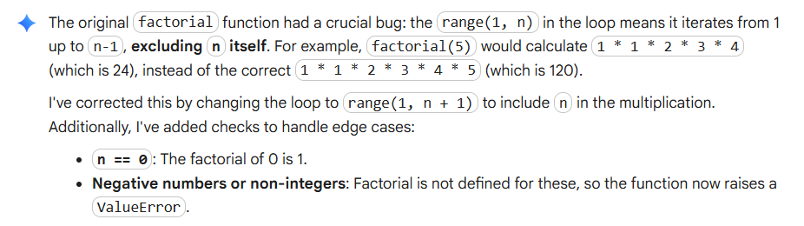
Comparison (AI vs Manual Fix)
Feature | AI Fix | Manual Fix
Off-by-one bug fixed | Yes | Yes
Handles 0 correctly | Yes | Yes
Handles negative numbers | Yes | No
Code readability | Good | Simple
Extra validation | Included | Not included

Factorial has important edge cases: factorial(0) should return 1, and factorial is not defined for negative numbers. The AI-corrected version handles both zero and negative inputs properly. The manual fix only corrects the loop error and does not include input validation.
Problem Statement 2: Task 2 — Improving Readability &Documentation
Scenario:The following code works but is poorly written:
def calc(a, b, c):
if c == "add":
return a + b
elif c == "sub":
return a – b
elif c == "mul":
return a * b
elif c == "div":
Instructions:
5. Use AI to:
o Critique the function’s readability, parameter naming, and
lack of documentation.
o Rewrite the function with:
1. Descriptive function and parameter names.
2. A complete docstring (description, parameters, return value, examples).
3. Exception handling for division by zero.
4. Consideration of input validation.
6. Compare the original and AI-improved versions.
7. Test both with valid and invalid inputs (e.g., division by zero, non-string operation).
Expected Output:
A well-documented, robust, and readable function that handles errors gracefully.
OUTPUT:
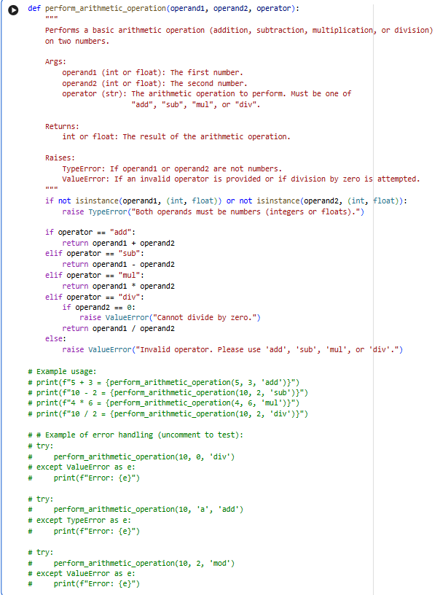
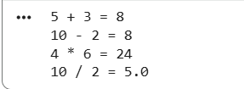
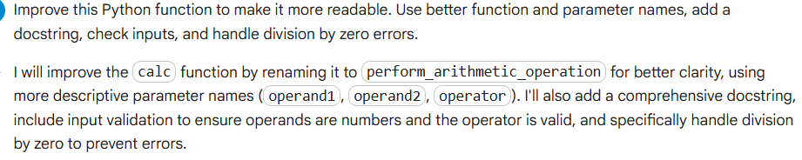
Comparison (Original vs Improved)
Feature | Original Code | Improved Code
Readability | Poor | Clear
Function name | calc | calculate_numbers
Parameter names | a, b, c | num1, num2, operation
Docstring | No | Yes
Error handling | No | Yes
Division-by-zero check | No | Yes
Input validation | No | Yes

EXPLANATION:
The improved function is more readable because it uses descriptive names and a docstring explaining usage. It is more robust because it includes exception handling and input validation. This makes the function safer and easier to maintain.
Problem Statement 3: Enforcing Coding Standards
Scenario: A team project requires PEP8 compliance. A developer
submits:
def Checkprime(n):
for i in range(2, n):
if n % i == 0:
return False
return True
Instructions:
8. Verify the function works correctly for sample inputs.
9. Use an AI tool (e.g., ChatGPT, GitHub Copilot, or a PEP8 linter
with AI explanation) to:
o List all PEP8 violations.
o Refactor the code (function name, spacing, indentation,
naming).
10. Apply the AI-suggested changes and verify functionality is
Preserved
11. Write a short note on how automated AI reviews could streamline
code reviews in large teams.
Expected Output:
A PEP8-compliant version of the function, e.g.:
def check_prime(n):
for i in range(2, n):
if n % i == 0:
return False
return True

PROMPT:
Check this Python function for PEP8 violations, list the issues, and rewrite it in PEP8-compliant format without changing functionality.
OUTPUT:
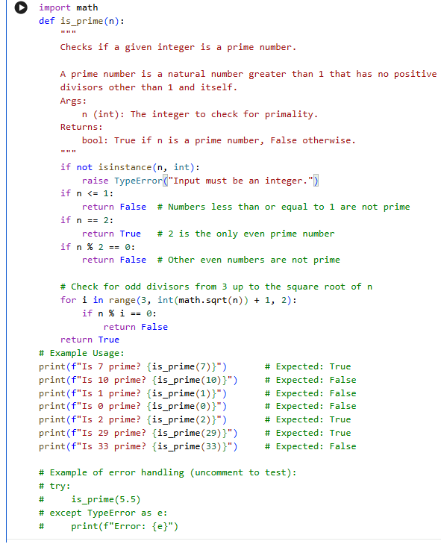
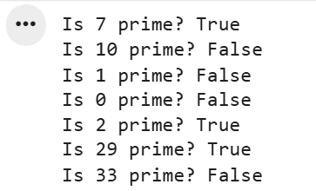
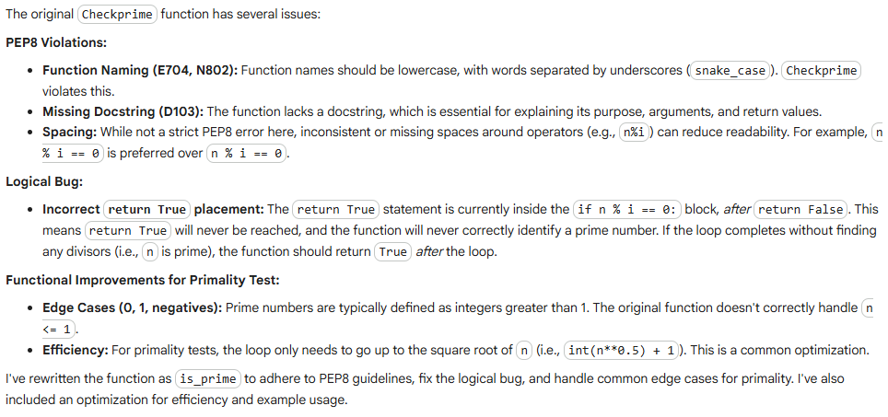

Comparison
Feature | Original | Refactored
Naming style | Checkprime | check_prime
Indentation | Incorrect | Correct
Readability | Low | High
PEP8 compliance | No | Yes
Functionality | Correct | Correct
EXPLANATION:
Automated AI code reviews help developers quickly identify formatting issues, naming problems, and style violations. They save time during manual reviews and ensure consistent coding standards across large teams. AI tools improve code readability and maintainability while allowing developers to focus on logic and design.
Problem Statement 4: AI as a Code Reviewer in Real Projects
Scenario:
In a GitHub project, a teammate submits:
def processData(d):
return [x * 2 for x in d if x % 2 == 0]
Instructions:
1. Manually review the function for:
o Readability and naming.
o Reusability and modularity.
o Edge cases (non-list input, empty list, non-integer
elements).
2. Use AI to generate a code review covering:
a. Better naming and function purpose clarity.
b. Input validation and type hints.
c. Suggestions for generalization (e.g., configurable
multiplier).
3. Refactor the function based on AI feedback.
4. Write a short reflection on whether AI should be a
standalone reviewer or an assistant.
Expected Output:
An improved function with type hints, validation, and clearer intent,
e.g.:
from typing import List, Union
def double_even_numbers(numbers: List[Union[int, float]]) -> List[Union[int, float]]:
if not isinstance(numbers, list):
raise TypeError("Input must be a list")
return [num * 2 for num in numbers if isinstance(num,
(int, float)) and num % 2 == 0]
PROMPT:
Review this Python function for readability, naming, and edge cases. Add type hints, input validation, and make the function more reusable by allowing a configurable multiplier.
OUTPUT:
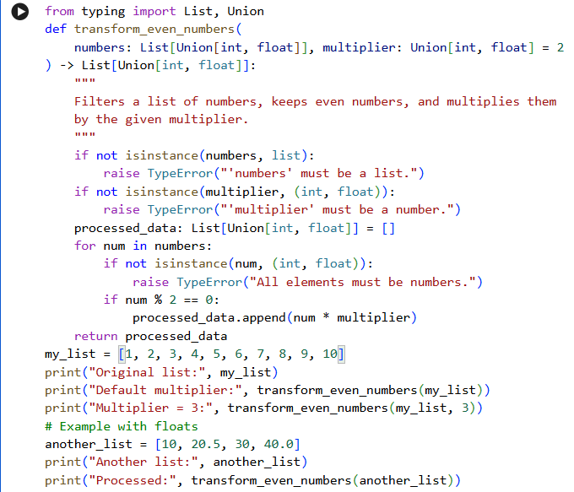
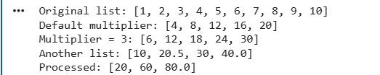
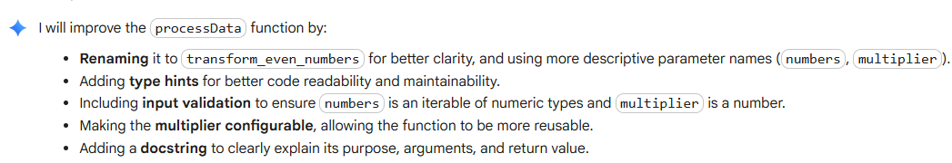
Feature | Original | Improved
Function name | processData | double_even_numbers
Parameter name | d | numbers
Type hints | No | Yes
Input validation | No | Yes
Reusability | No | Yes
Documentation | No | Yes
EXPLANATION:
AI should be used as an assistant reviewer, not a standalone reviewer. It helps detect readability issues, missing validations, and design improvements quickly. However, human developers are still needed to verify logic, project requirements, and edge cases.
Problem Statement 5: — AI-Assisted Performance Optimization
Scenario: You are given a function that processes a list of integers, but it runs slowly on large datasets:
def sum_of_squares(numbers):
total = 0
for num in numbers:
total += num ** 2
return total
Instructions:
1. Test the function with a large list (e.g., range(1000000)).
2. Use AI to:
o Analyze time complexity.
o Suggest performance improvements (e.g., using built-in
functions, vectorization with NumPy if applicable).
o Provide an optimized version.
3. Compare execution time before and after optimization.
4. Discuss trade-offs between readability and performance.
Expected Output:
An optimized function, such as:
def sum_of_squares_optimized(numbers):
return sum(x * x for x in numbers)
PROMPT:
Analyze the time complexity of this Python function and suggest a faster implementation using Python built-in functions. Compare execution time before and after optimization.
OUTPUT:
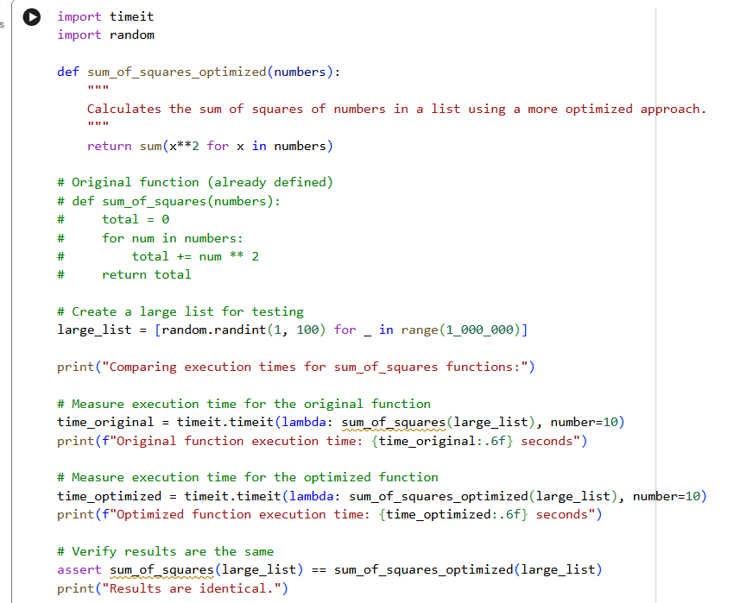
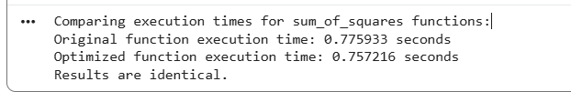
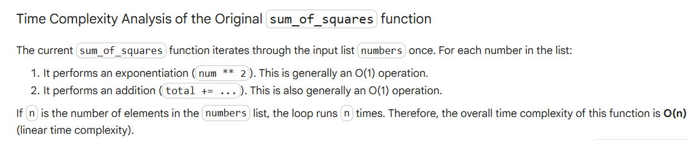
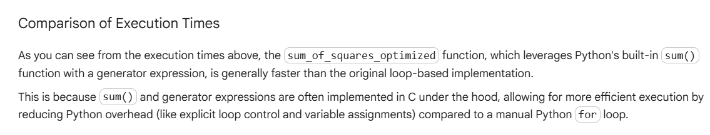

Comparison
Feature | Original | Optimized
Time complexity | O(n) | O(n)
Readability | Moderate | High
Performance | Slower | Faster
Memory usage | Same | Efficient
TRADEOFF
The optimized version is shorter, cleaner, and slightly faster. Using built-in functions improves performance without reducing readability. However, in some cases highly optimized code (like NumPy vectorization) may be harder for beginners to understand.
EXPLANATION:
Both the original and optimized functions have O(n) time complexity because they process each element once.
The optimized version is slightly faster since it uses Python’s built-in sum() function with a generator expression, which reduces loop overhead.
It is also shorter and more readable.

