ASSIGNMENT-20.2
K.Akshitha
2303A52026
Batch:38

Task 1 – Password Security Enhancement Task:
Analyze an AI-generated Python program that stores passwords in plain text and improve its security.

Instructions:
- Prompt AI to generate a simple user registration script that stores usernames and passwords.
- Check whether passwords are stored as plain text.
- Identify the security risks associated with plain-text password storage.
- Refactor the program to use secure password hashing (e.g., hashlib or bcrypt).
- Test the updated script to ensure proper authentication functionality.

Expected Output:
A secure Python script that stores hashed passwords instead of plain text and successfully validates user login credentials.

Prompt:
Generate a Python user registration and login script, then analyze it for password security issues and improve it using secure password hashing techniques like bcrypt.

Code & Output:
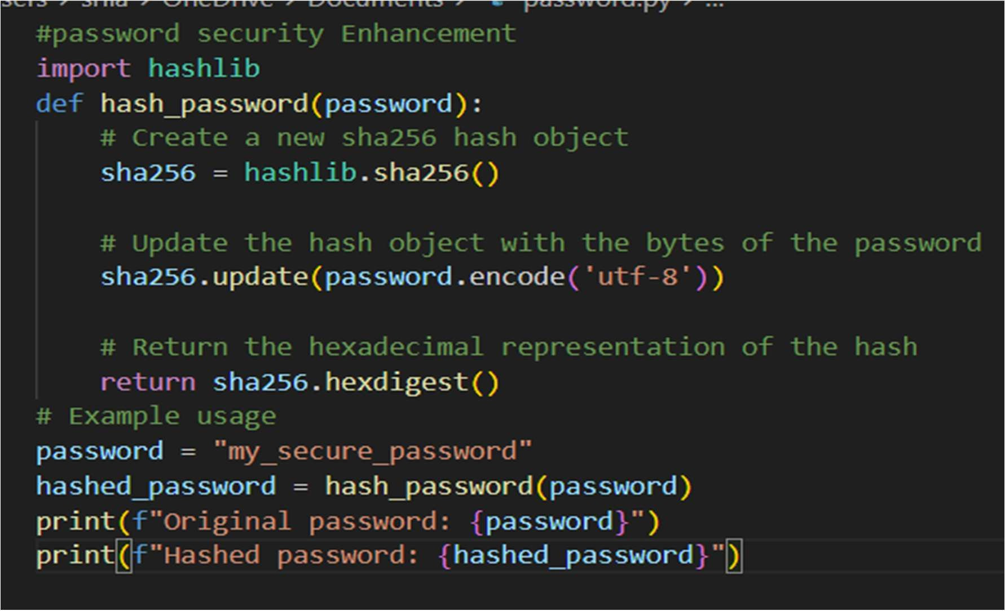

Explanation:
Initially, the AI-generated program stores user passwords in plain text, which is highly insecure. If the database is exposed, attackers can directly read all user passwords. To fix this, password hashing is applied so that actual passwords are never stored. A secure hashing algorithm like bcrypt ensures that even if data is leaked, passwords remain protected. The updated program also verifies user login by comparing hashed passwords instead of plain text.

Task 2 – Secure API Key Management Task:
Evaluate an AI-generated script that uses hardcoded API keys and improve its security.

Instructions:
- Ask AI to generate a Python script that connects to an external API using a hardcoded API key.
- Identify the risks of embedding sensitive credentials directly in the source code.
- Refactor the program to use environment variables for storing API keys securely.
- Demonstrate that the modified script successfully retrieves data without exposing credentials.

Expected Output:
A revised script that securely accesses API keys through environment variables instead of hard coding them.

Prompt:
Generate a Python script that uses an API key to fetch data from an external API, then identify security risks and refactor it to securely use environment variables instead of hardcoded credentials.

Code & Output:
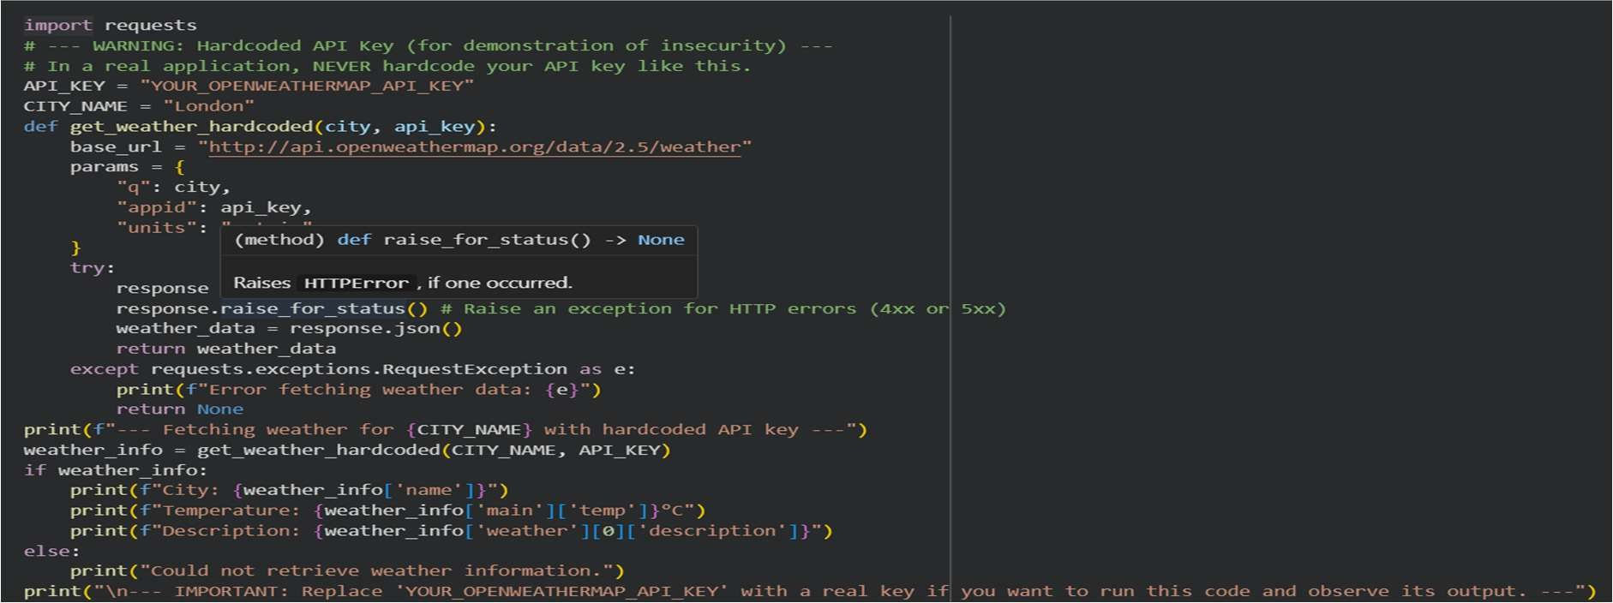

Explanation:
In the beginning, the API key was directly written in the code, which is risky because anyone who sees the code can misuse it. If the code is shared on platforms like GitHub, the key can easily get exposed. To fix this, environment variables are used to store the API key outside the code. This way, the key is hidden and not visible in the source file. The program then safely loads the API key when it runs, keeping it secure.

Task 3 – Weak Encryption Detection Task:
Examine an AI-generated program that uses weak encryption techniques and strengthen it.

Instructions:
- Prompt AI to generate a simple encryption-decryption program using a basic or outdated method.
- Identify weaknesses in the encryption approach (e.g., reversible encoding or outdated algorithms).
- Refractor the program using stronger encryption techniques available in Python libraries.
- Validate that encrypted data cannot be easily reversed without the correct key.

Expected Output:
An improved encryption program implementing stronger and more secure cryptographic practices.

Prompt:
Generate a Python encryption-decryption program using a basic method, analyze its weaknesses, and improve it using secure cryptographic techniques with proper key-based encryption.

Code & Output:
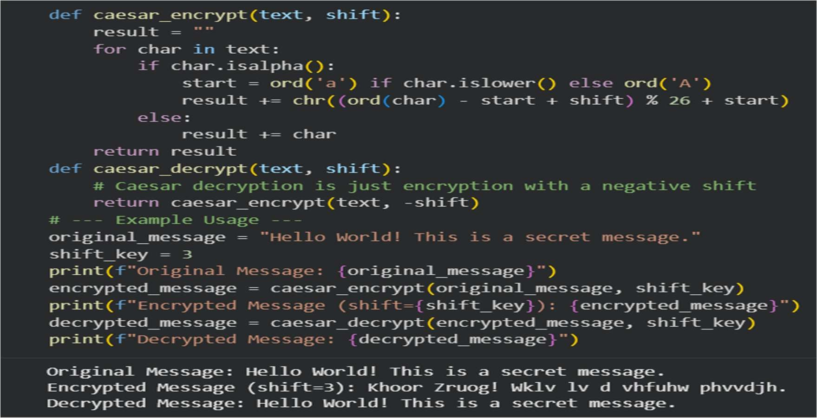

Explanation:
In the beginning, the program used Base64 encoding to protect data, but this is not secure because it can be easily decoded by anyone. It does not truly protect sensitive information. To make it safer, strong encryption like Fernet is used, which secures the data using a secret key. This means only someone with the correct key can read the data. The updated version keeps the information safe from unauthorized access.

Task 4 – Real-Time Application: Security Review of AI-Generated Web Service Scenario:
Students select an AI-generated web service snippet (e.g., REST API, file upload handler, or authentication module).

Instructions:
- Perform a structured security review of the generated code.
- Identify at least three potential vulnerabilities.
- Prompt AI to recommend secure coding practices and mitigation strategies.
- Implement the suggested improvements and test the secured version.
- Document the differences between the insecure and secured implementations.

Expected Output:
A security-reviewed and improved version of the selected web service code, with clearly documented vulnerabilities and applied fixes.

Prompt:
Review the following AI-generated web service code for security vulnerabilities, identify at least three issues, and provide a secure, improved version with proper mitigation techniques.

Code & Output:
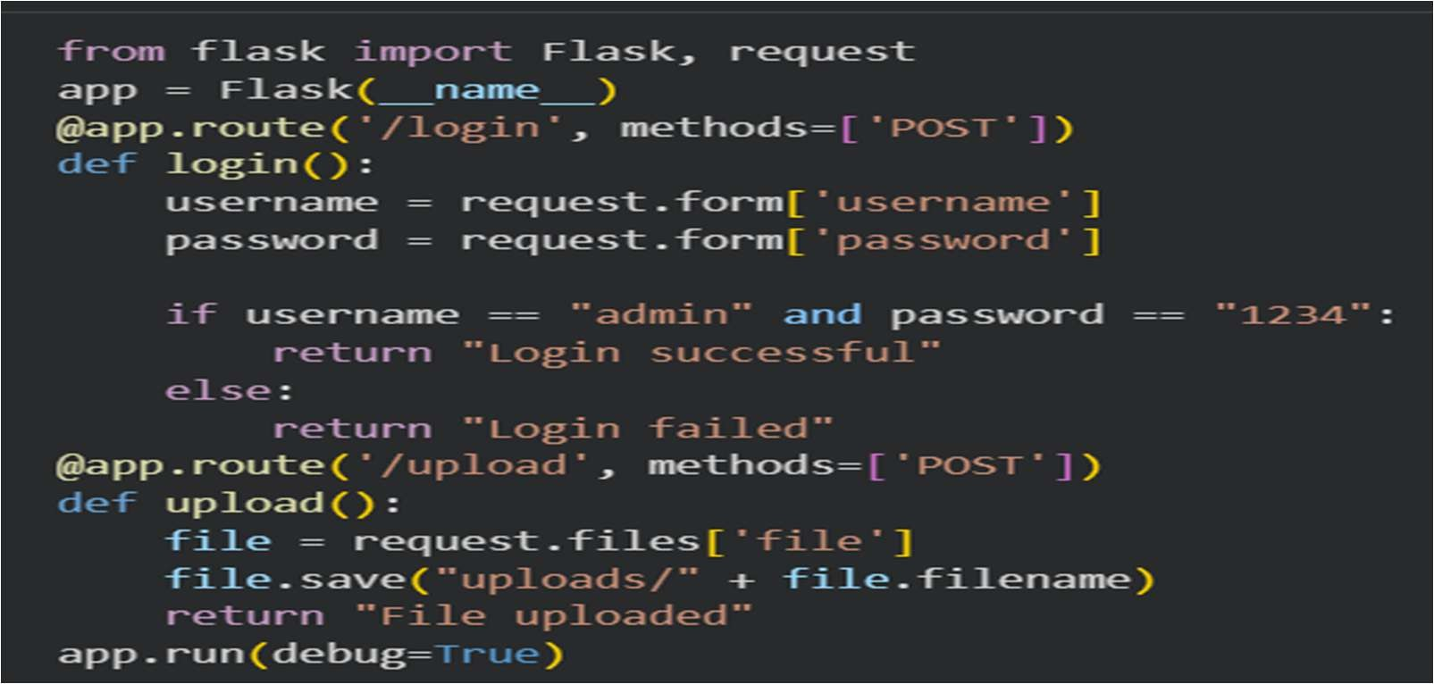

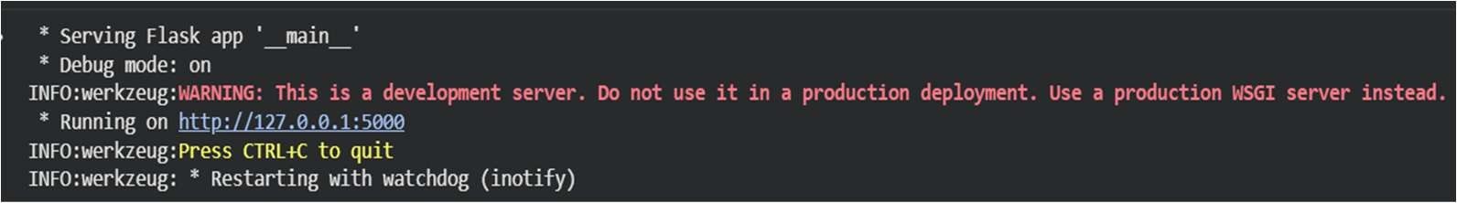
Explanation:
This task is about checking AI-generated web service code to find common security problems like poor input validation, missing authentication, and unsafe file handling. After identifying these issues, improvements are made using secure practices such as cleaning user input, adding proper login checks, and handling errors safely. The updated version makes the interaction between users and the server more secure. Testing is done to ensure all problems are fixed. Finally, the differences between the insecure and secure versions are clearly

Task 5 – Exception Handling Improvement Task:
Analyze an AI-generated Python program that does not handle runtime errors and improve its reliability.

Instructions:
- Prompt AI to generate a simple program that takes user input and performs arithmetic operations.
- Identify possible runtime errors (e.g., invalid input, division by zero).
- Modify the program to include proper try-except blocks.
- Provide meaningful error messages for invalid inputs.
- Test the improved version with valid and invalid test cases.

Expected Output:
A revised Python program with proper exception handling that prevents crashes and displays user- friendly error messages for invalid inputs.

Prompt:
Generate a Python program that performs arithmetic operations using user input, then analyze possible runtime errors and improve it using proper exception handling with user-friendly messages.

Code & Output:

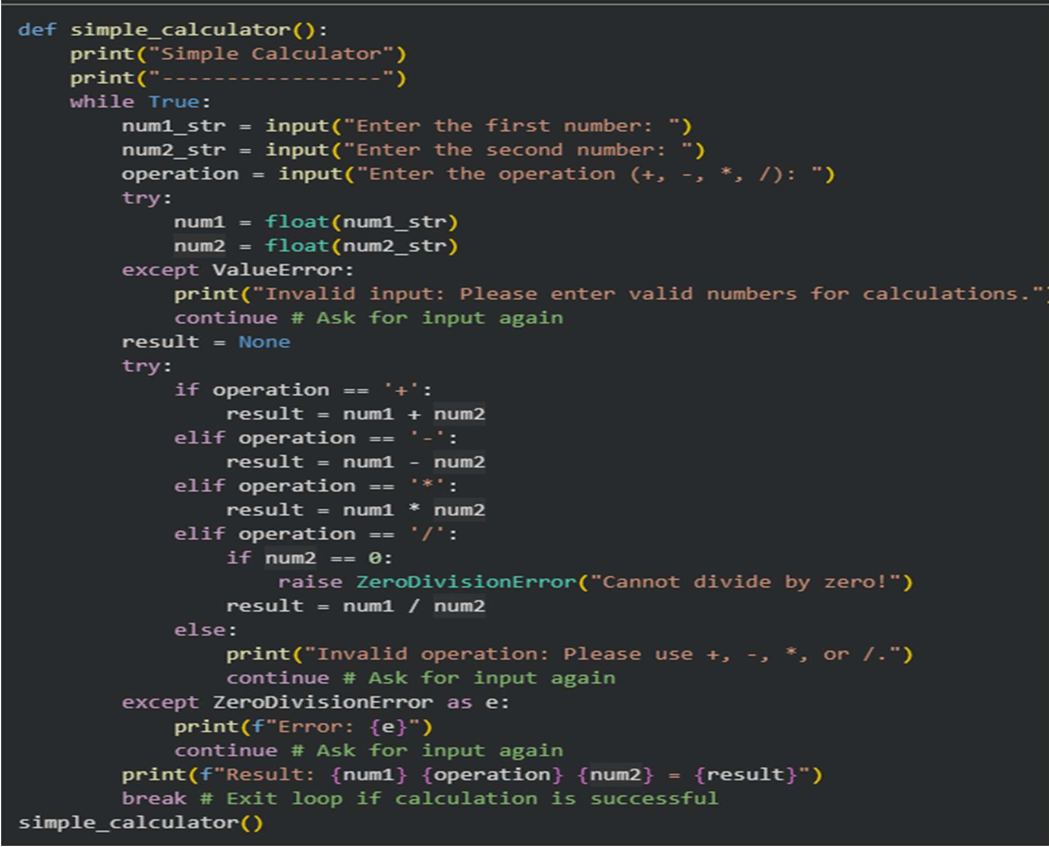
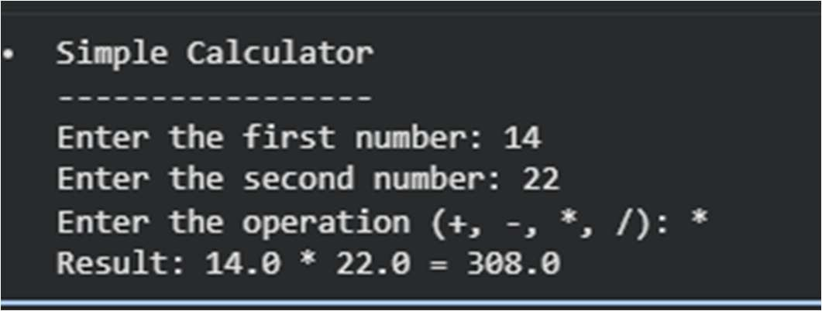
Explanation:
In the beginning, the program performed calculations without handling errors, which could cause crashes if users entered invalid input or tried to divide by zero. To fix this, try-except blocks are added to catch errors like Value-Error and ZeroDivisionError. This helps the program run smoothly even when mistakes happen. Instead of crashing, it shows clear and simple error messages to the user.
The updated version is more reliable and user-friendly.

