AI ASSISTED CODING
ASSIGNMENT-17
K.Akshitha
2303A52026
Batch:38
Lab 17 – AI for Data Processing: Data Cleaning and Preprocessing Scripts
Task Description – 1(Student Academic Data Cleaning)
• Task:
Use AI assistance to generate a Python script that cleans and prepares a student academic dataset for analysis.
Instructions:
• Handle missing values in marks, attendance, and department.
• Remove duplicate student records based on student ID.
• Standardize text fields such as department names.
• Encode categorical variables like gender and department.
Sample Code:
import pandas as pd
data = pd.read_csv("students.csv")
print(data.head())
Expected Output:
• A cleaned and encoded Pandas DataFrame suitable for academic
performance analysis.
Prompt:
Generate a Python script using Pandas to clean a student dataset by handling missing values, removing duplicate records based on student ID, standardizing department names, and encoding categorical variables like gender and department.
Code & Output:
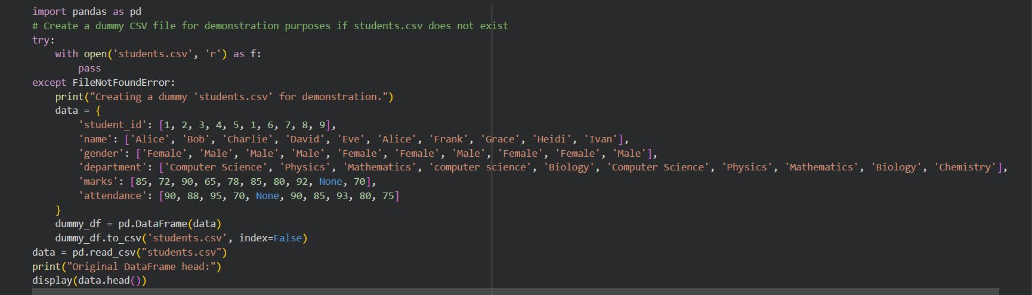
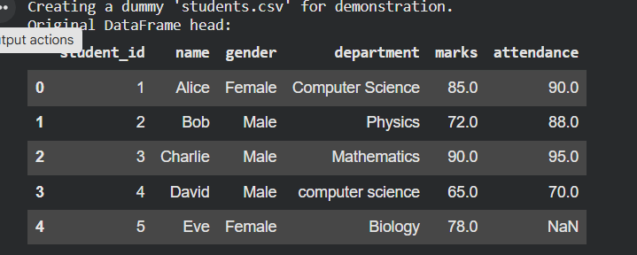
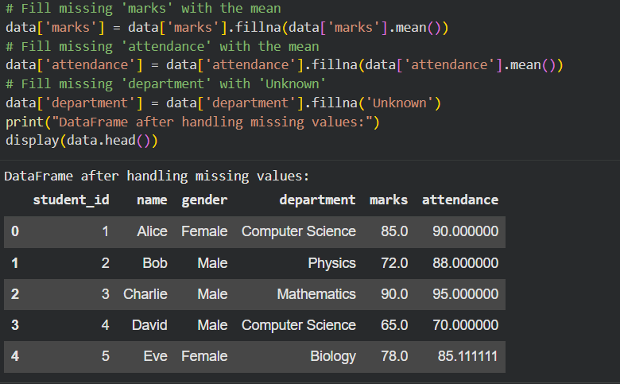
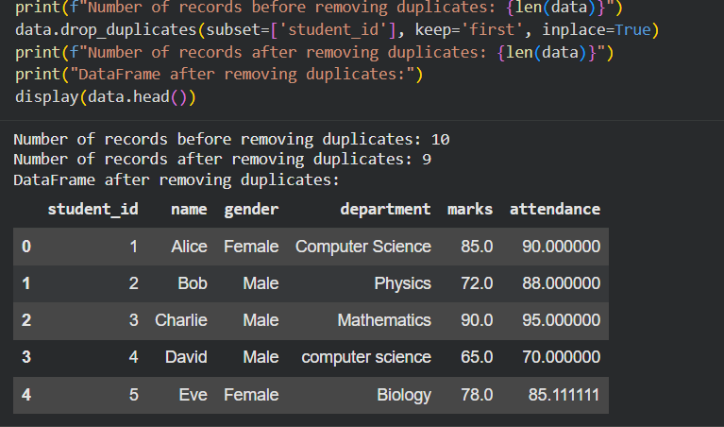
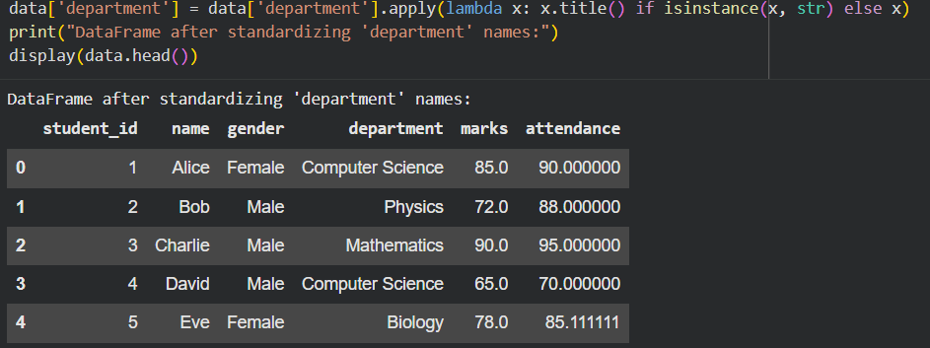
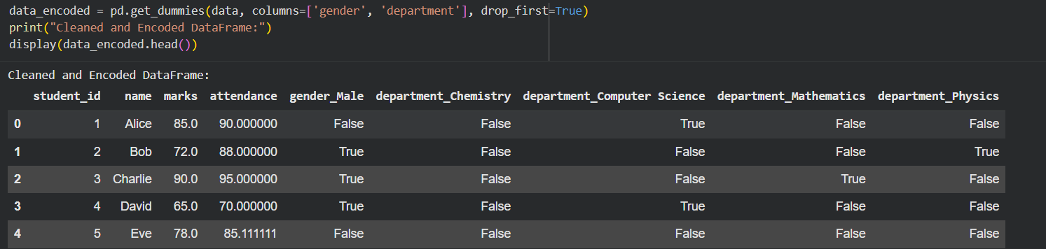
Explanation:
The script first loads the dataset and fills missing values in marks and attendance using the mean, while missing departments are replaced with the most frequent value. Duplicate student records are removed to ensure data consistency. Text fields like department names are standardized by converting them to lowercase and trimming spaces. Categorical variables such as gender are encoded into numeric form, and departments are transformed using one-hot encoding. The final output is a clean and structured dataset ready for analysis.
Task Description – 2 (Financial Transaction Data Preprocessing)
• Task:
Preprocess financial transaction data using AI-generated Python code.
Instructions:
• Convert transaction date columns to datetime format.
• Create derived features such as transaction month and year.
• Normalize the transaction amount column.
• Identify and handle extreme transaction values.
Sample Code:
import pandas as pd
from sklearn.preprocessing import MinMaxScaler
transactions = pd.read_csv("transactions.csv")
print(transactions.info())
Expected Output:
• A transformed dataset with normalized values and newly
generated time-based features.
Prompt:
Generate a Python script using Pandas and Scikit-learn to preprocess financial transaction data by converting date columns to datetime, creating month and year features, normalizing transaction amounts, and handling extreme values.
Code & Output:
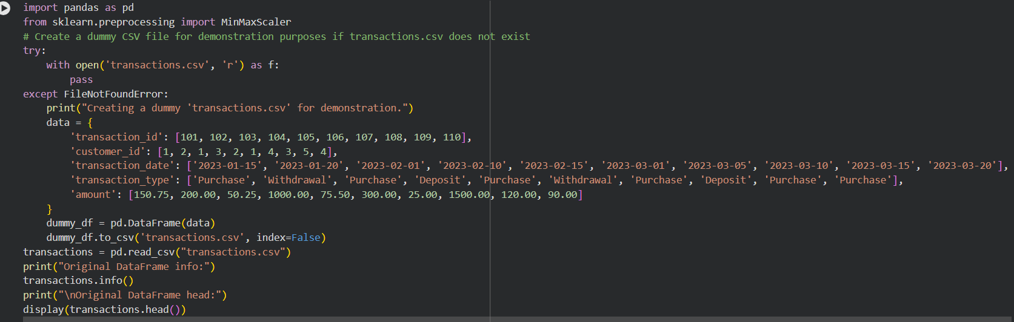
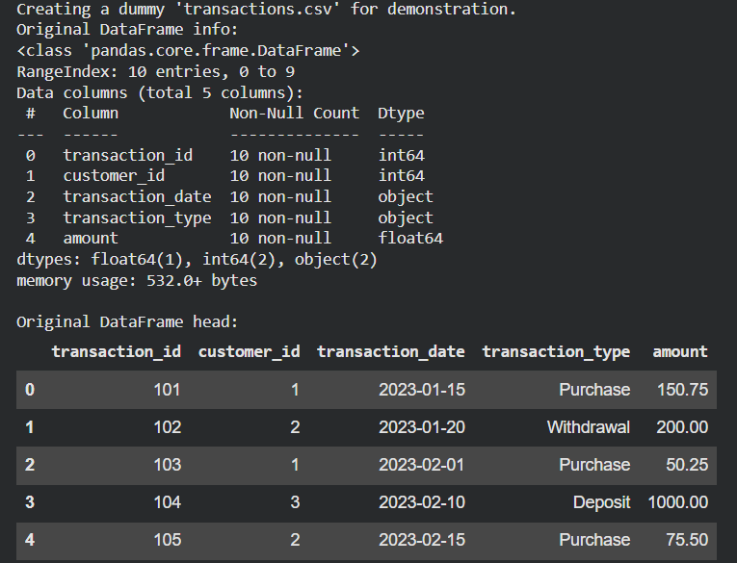
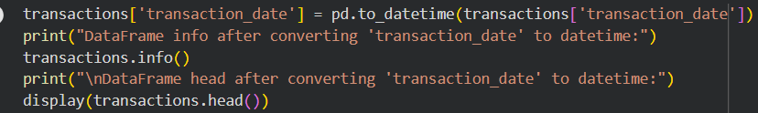
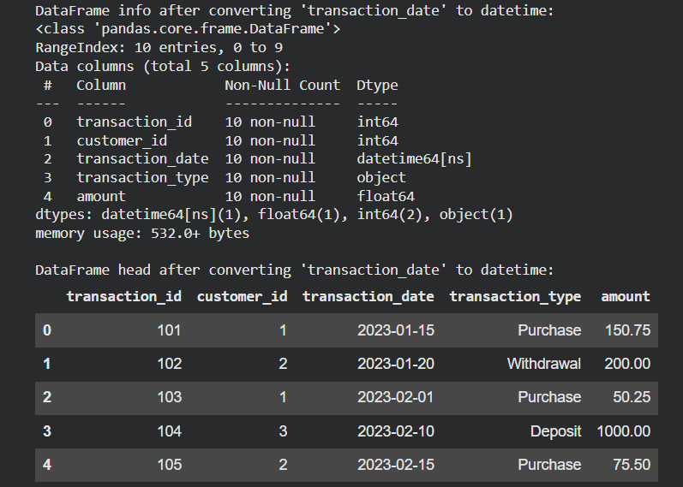
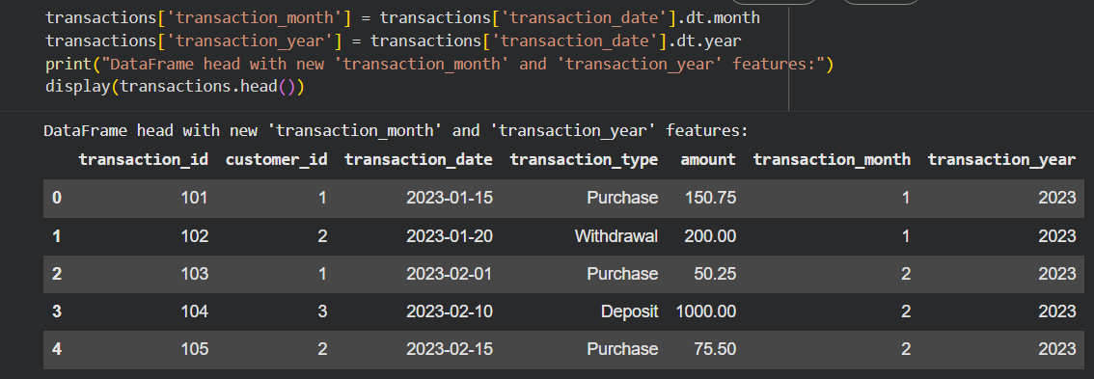
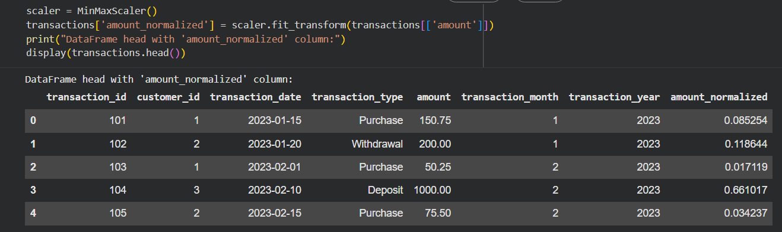
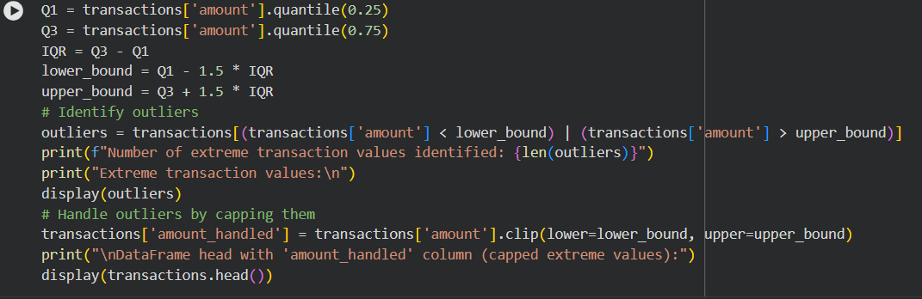
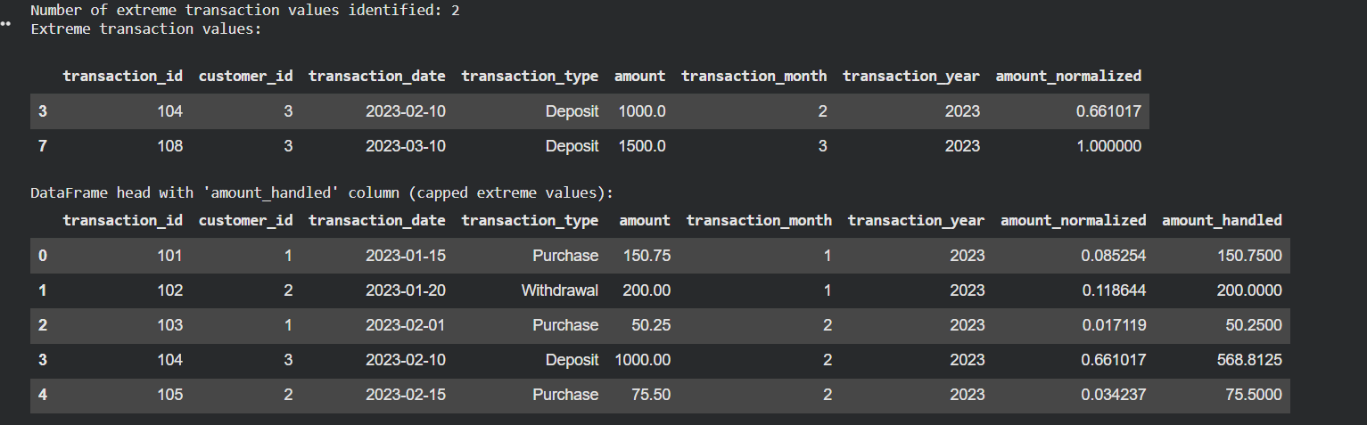
Explanation:
The script first loads the dataset and converts the transaction date column into datetime format for easier time-based analysis. It then extracts useful features like transaction month and year from the date. The transaction amount is normalized using MinMaxScaler to bring values into a standard range. Extreme values (outliers) are identified using statistical methods like IQR and handled by removal or capping. The final dataset becomes clean, consistent, and ready for financial analysis or machine learning.
Task 3 – (Environmental Sensor Data Preparation)
• Task:
Clean and preprocess environmental sensor data using AI-assisted scripts.
Instructions:
• Handle missing values in temperature, humidity, and air_quality_index.
• Scale numerical features using standard scaling.
• Encode categorical fields such as sensor_status.
• Split the dataset into training and testing subsets.
Sample Code:
import pandas as pd
from sklearn.model_selection import train_test_split
data = pd.read_csv("sensor_data.csv")
Expected Output:
• A fully preprocessed dataset ready for predictive modeling tasks.
Prompt:
Generate a Python script using Pandas and Scikit-learn to preprocess environmental sensor data by handling missing values, scaling numerical features, encoding categorical variables like sensor_status, and splitting the dataset into training and testing sets.
Code & Output:
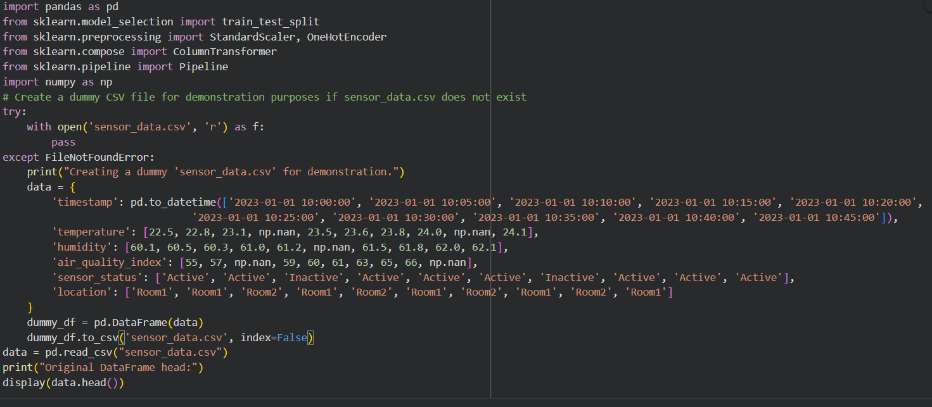
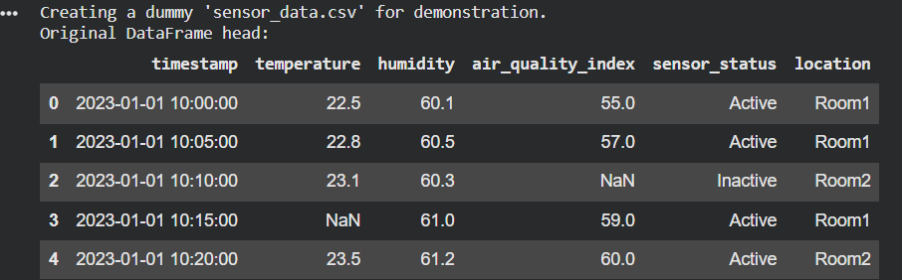
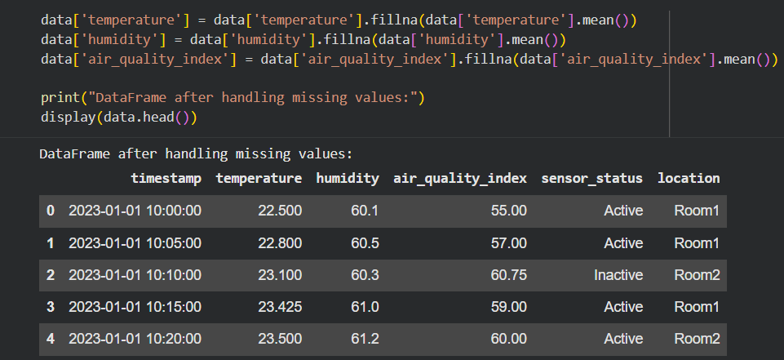
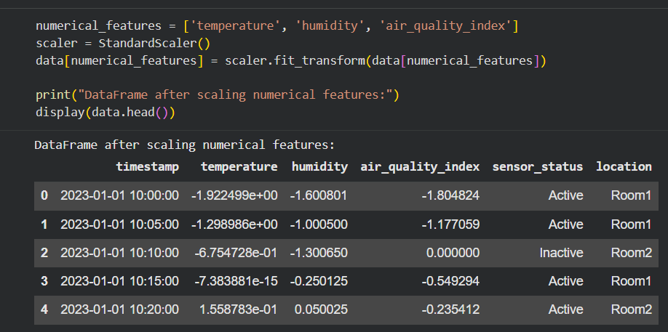
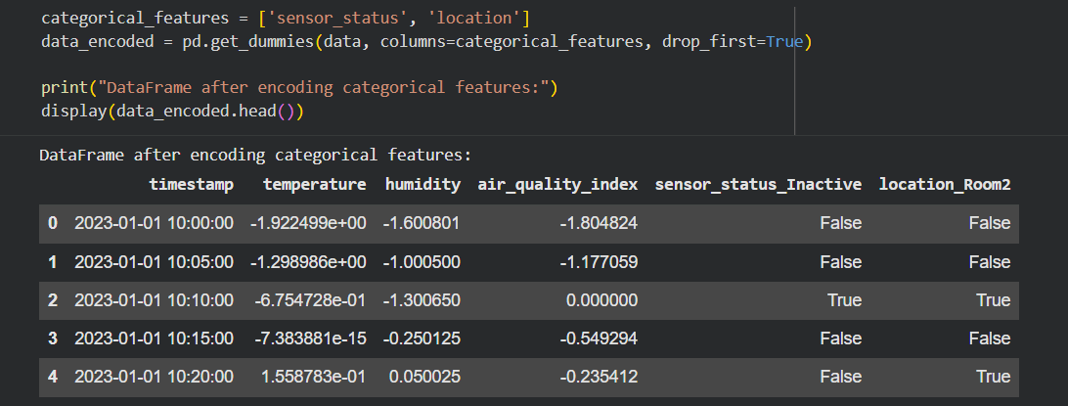
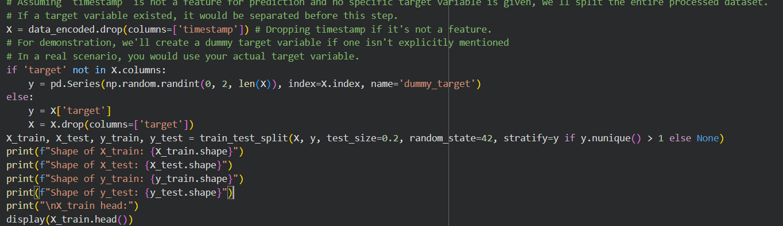
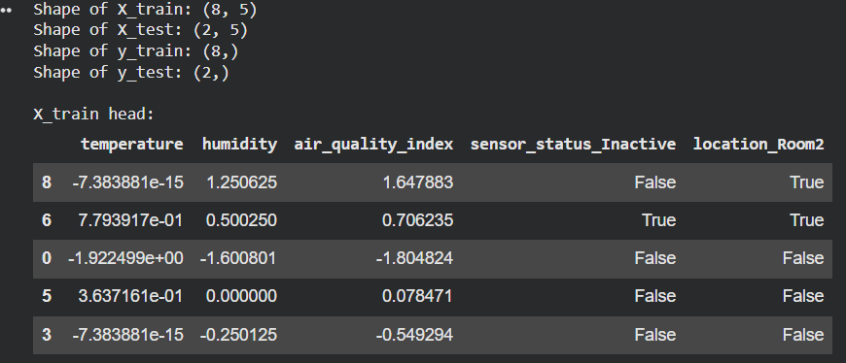
Explanation:
The script begins by loading the dataset and handling missing values in temperature, humidity, and air quality index using appropriate methods like mean or median. Numerical features are then scaled using standard scaling to ensure uniform data distribution. Categorical variables such as sensor_status are encoded into numerical form for model compatibility. Finally, the dataset is split into training and testing subsets using train_test_split. This prepares the data for efficient and accurate predictive modeling.
Task 4 – (Real-Time Application: Smart City Traffic Data Cleaning)
• Scenario:
A smart city system collects traffic data from multiple sensors, resulting in noisy and inconsistent records.
Requirements:
• Standardize road and location names.
• Fill missing traffic density values using appropriate statistical methods.
• Remove duplicate sensor readings.
• Normalize speed and vehicle count metrics.
• Generate a brief summary comparing dataset quality before and after cleaning
Sample Code:
import pandas as pd
traffic = pd.read_csv("traffic_data.csv")
print(traffic.describe())
Expected Output:
• A cleaned and normalized traffic dataset with an accompanying data-quality improvement summary.
Prompt:
Generate a Python script using Pandas to clean smart city traffic data by standardizing road/location names, handling missing traffic density, removing duplicates, normalizing speed and vehicle count, and summarizing data quality before and after cleaning.
Code & Output:
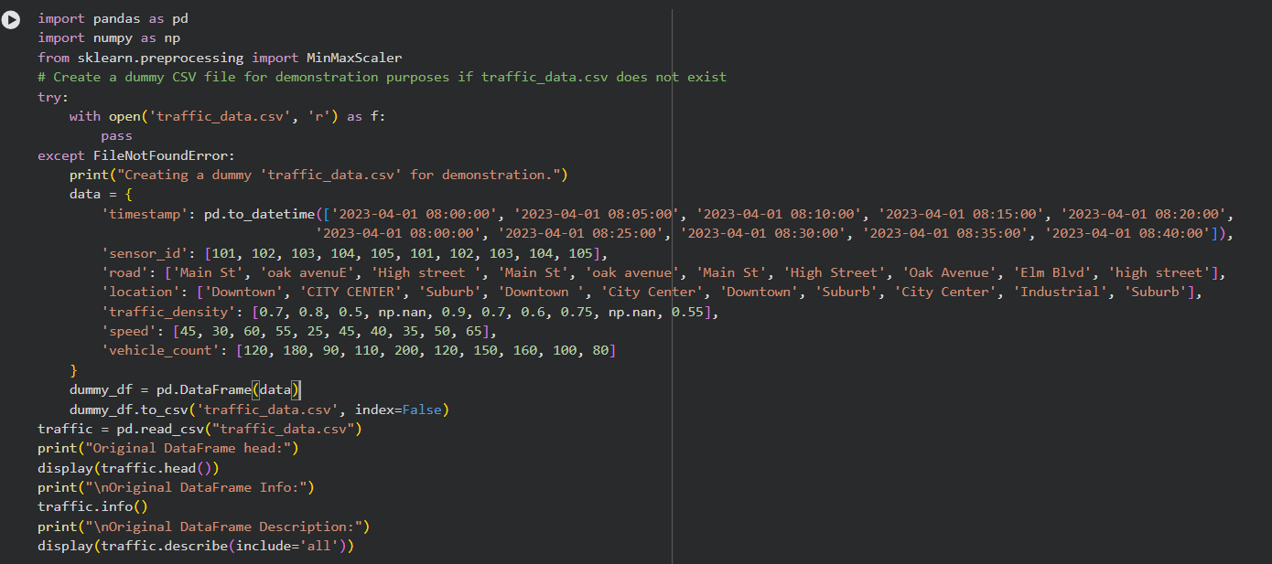
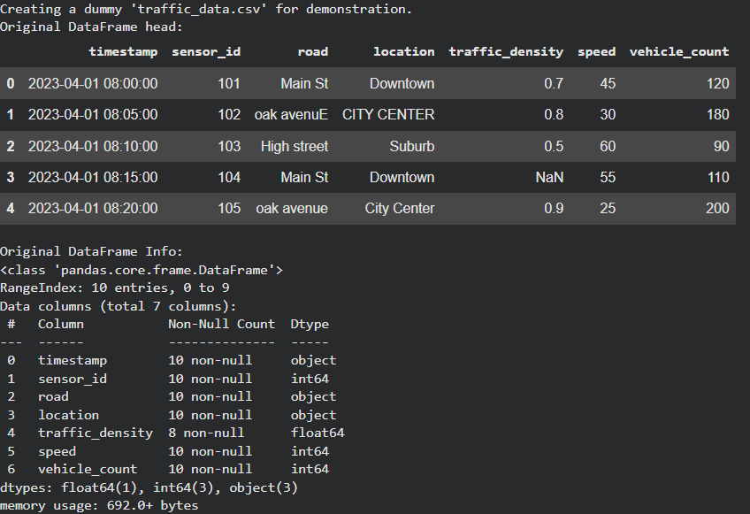
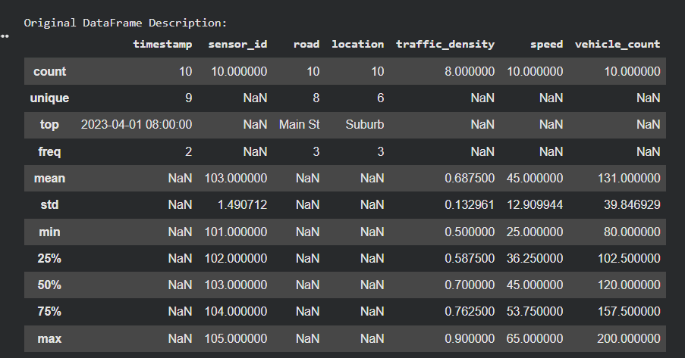
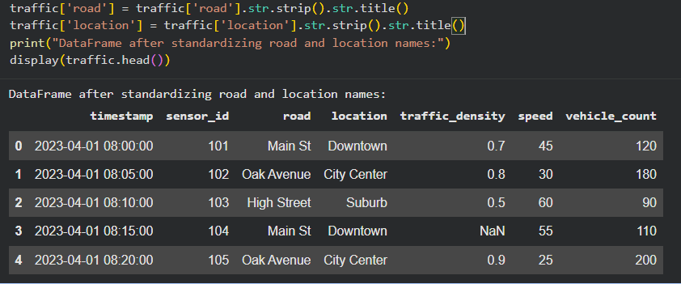
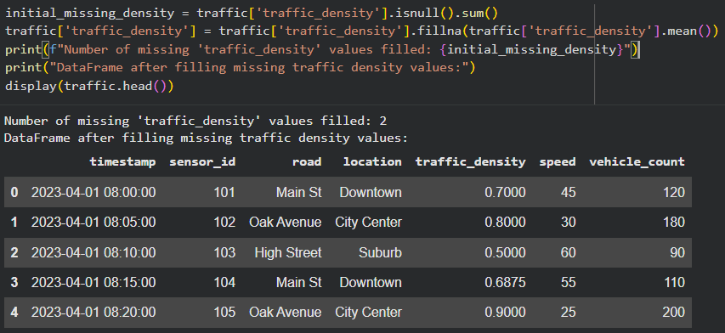
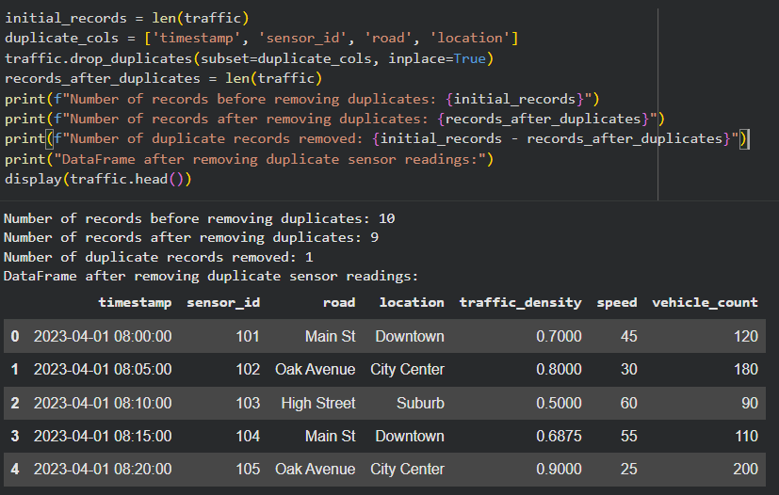
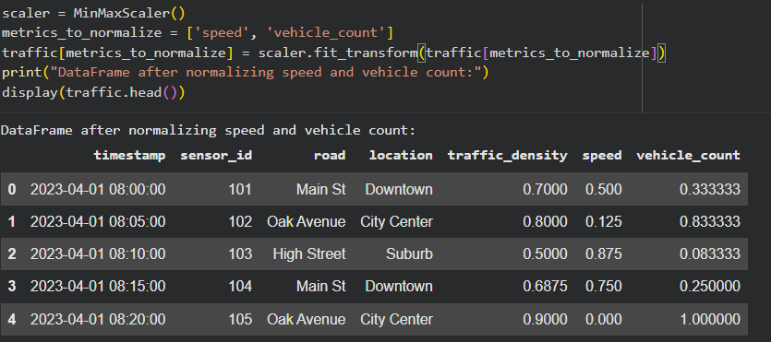
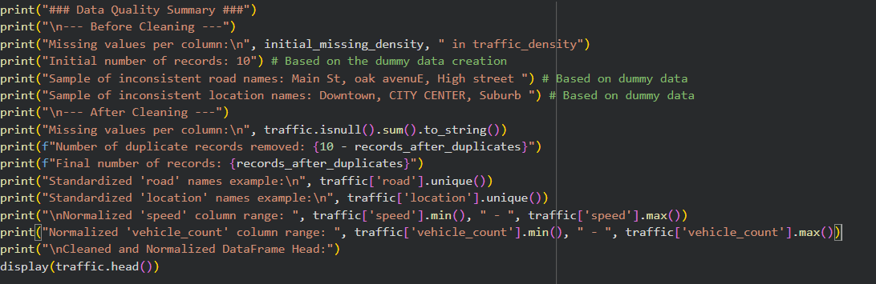
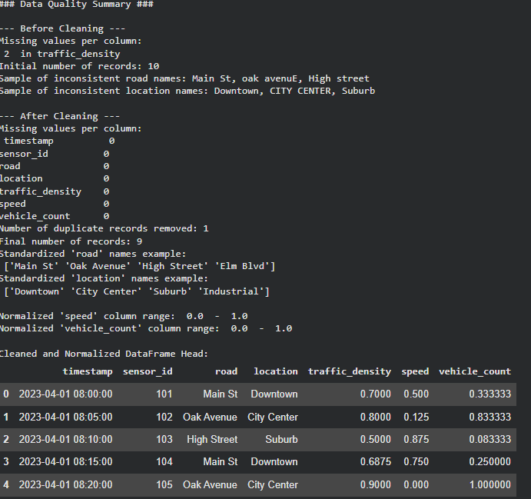
Explanation:
The script starts by loading the dataset and standardizing text fields like road and location names by converting them to lowercase and removing extra spaces. Missing traffic density values are filled using statistical measures such as mean or median. Duplicate sensor readings are removed to ensure data accuracy. Numerical features like speed and vehicle count are normalized for consistency across the dataset. Finally, a comparison summary is generated to highlight improvements in data quality before and after preprocessing.
Task 5 – (Social Media Text Data Cleaning and Feature Extraction)
• Task:
Use AI-assisted Python scripting to clean and preprocess social media text data for sentiment analysis.
Instructions:
• Remove duplicate posts and null text entries.
• Clean text by removing URLs, special characters, and extra spaces.
• Convert text to lowercase and perform basic tokenization.
• Remove stopwords and perform stemming or lemmatization.
• Generate basic text features such as word count and sentiment score.
Sample Code:
import pandas as pd
import re
posts = pd.read_csv("social_media_posts.csv")
print(posts.head())
Expected Output:
A cleaned text dataset with extracted features suitable for sentiment analysis models.
Prompt:
Generate a Python script using Pandas, regex, and NLP libraries to clean social media text data by removing duplicates and noise, preprocessing text, and extracting features like word count and sentiment score.
Code & Output:
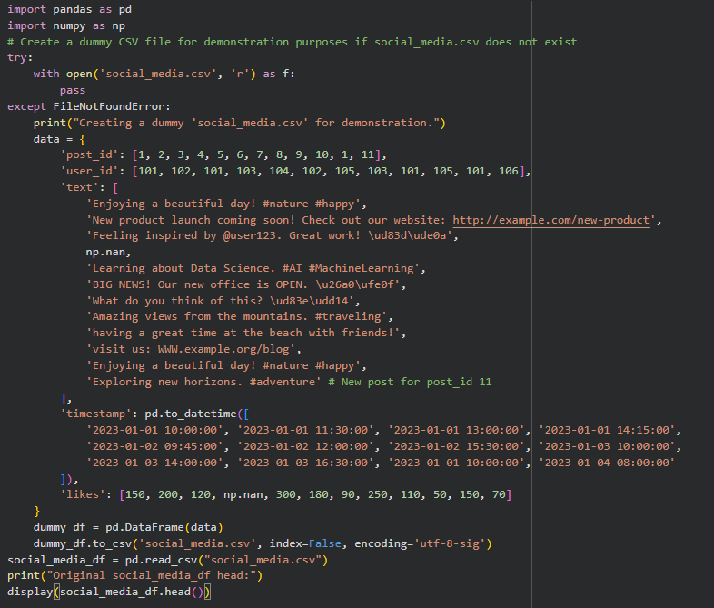
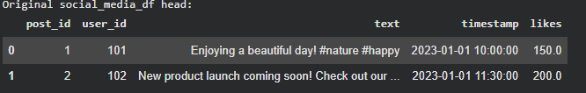
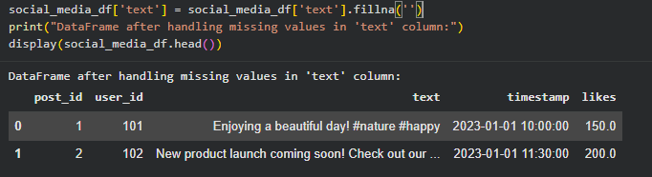
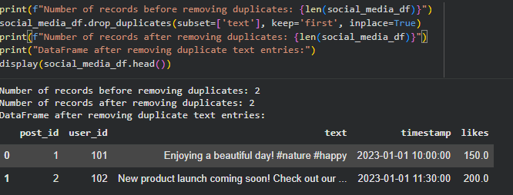
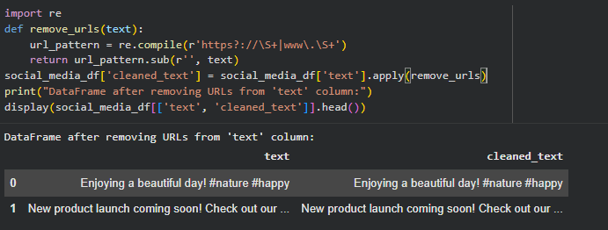
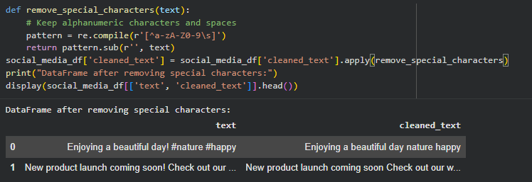
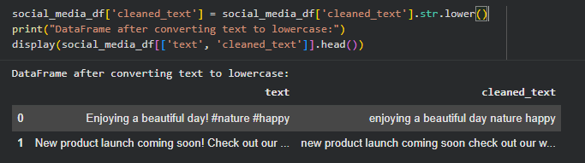
Explanation:
The script begins by loading the dataset and removing duplicate posts and null text entries to ensure data quality. It cleans the text by removing URLs, special characters, and extra spaces, then converts all text to lowercase for consistency. Tokenization is applied, followed by removal of stopwords and performing stemming or lemmatization to simplify words. Basic features such as word count and sentiment scores are generated for each post. The final dataset becomes structured and ready for sentiment analysis models.

