**BMS Institute of Technology & Management Yelahanka, Bangalore-560119**

**Internship Report (22MCA401)**

##### On

**“Analysis of Air Quality Data”**

##### Submitted towards the partial fulfillment of the requirement for the completion of 4th semester in

##### **MASTER OF COMPUTER APPLICATIONS**

By

**AKSHITHA M H**

**1BY23MC008**

Under the guidance of

**Dr. M. Sridevi**

**Assistant Professor & Head**

**Department of MCA**

**BMSIT&M, Bengaluru – 560064**

**And**

**Mr. Rajesh**

**Team Head**

**Anspro Technologies**



**Department of Master of Computer Applications**

### 2025

**BMS INSTITUTE OF TECHNOLOGY & MANAGEMENT**

**YELAHANKA, BANGALORE-560119**

**DEPARTMENT OF MASTER OF COMPUTER APPLICATIONS**



**2025**

**INTERNSHIP CERTIFICATE**

This is to certify that **AKSHITHA M H** bearing USN **1BY23MC008** has satisfactorily completed the Internship 22MCA401 with title “**Analysis of Air Quality Data**” as prescribed by VTU for IV Semester of Master of Computer Applications.

Signature of the Candidate

|  |  |
| --- | --- |
| Marks Obtained | |
| Presentation — Max Marks 25 |  |
| Report- Max Marks 25 |  |
| **Total** Marks – **50** |  |

Signature of the Guide Signature of the HOD

**Internship Certificate**

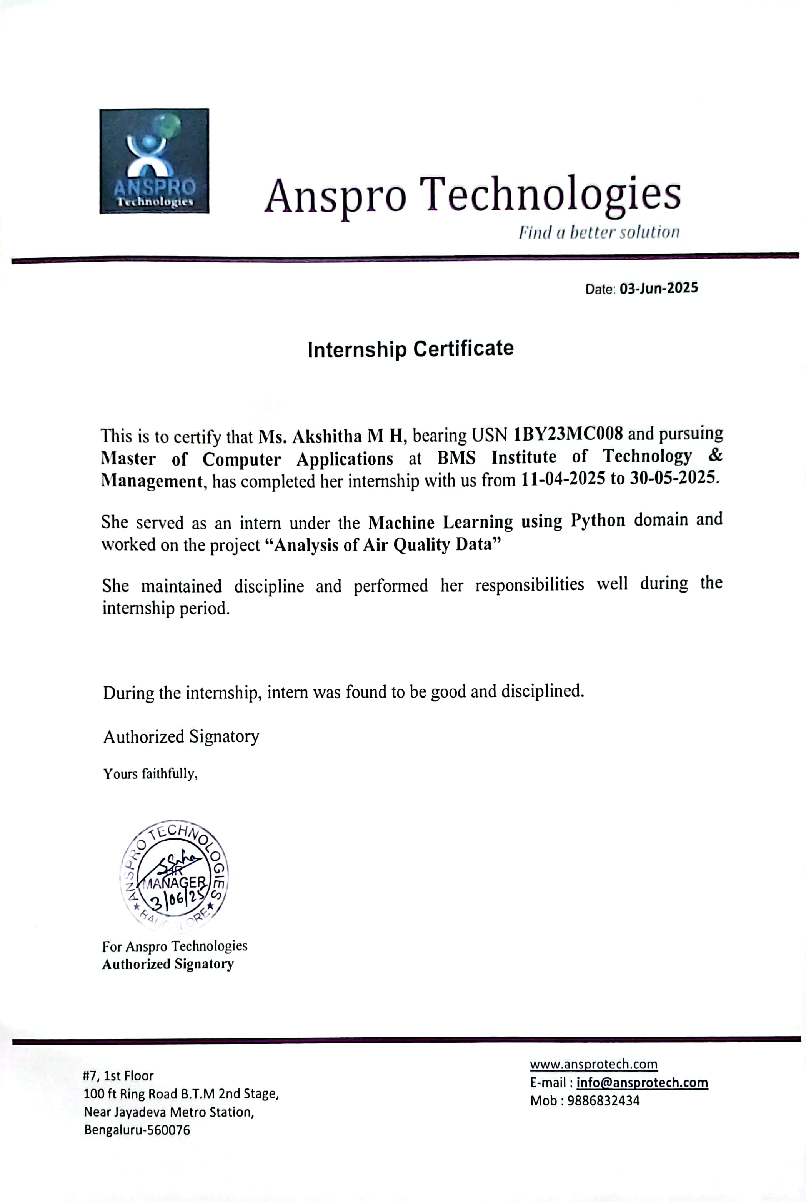

## DECLARATION

I, **Akshitha M H** student of 4th MCA, **BMS Institute of Technology and Management,**

**Yelahanka, Bangalore – 560119,** bearing USN 1BY23MC008**,** hereby declare that the internship

entitled “**Analysis of Air Quality Data”** at **Anspro Technologies** guided by **Mr. Rajesh, Team Head at Anspro Technologies** for the academic year 2024-25. I also declare that the matter embodied in this internship is a genuine work done by me and has not been submitted in fulfillment of any curriculum described by the university.

**AKSHITHA M H**

**1BY23MC008**

**ACKNOWLEDGEMENT**

The Internship work would not have been complete without remarking and thanking people who guided me, helped me and encouraged me throughout the internship period. I convey my truthful gratitude to BMSIT&M Management for providing a good infrastructure and educational support in lighting our career. I would like to show my sincere gratitude to our Principal, Dr. SANJAY H A for his kind support in completing this internship work. I take this opportunity to thank our Head of Department Dr M. Sridevi, Assistant Professor and internship work coordinator Dr. Shivakumara T, Assistant Professor their support and encouragement, and valuable inputs throughout the completion of this internship work. Last but not the least, I thank my parents, family and friends who stood with me as a moral support and encouraging me in accomplishing this internship work.

Akshitha M H

1BY23MC008

**BMS INSTITUTE OF TECHNOLOGY & MANAGEMENT**

**YELAHANKA, BANGALORE-560119**

**DEPARTMENT OF MASTER OF COMPUTER APPLICATIONS**

**VISION**

To emerge as a leading department in computer applications, producing skilled professionals equipped to deliver sustainable solutions.

**MISSION**

Facilitate effective learning environment through quality education, industry interaction with orientation towards research, critical thinking and entrepreneurial skills.

**PROGRAMME EDUCATIONAL OBJECTIVES**

**Graduates will be able to:**

**PEO-1:** Develop innovative IT applications to meet industrial and societal needs.

**PEO-2:** Adapt themselves to evolving domain requirements.

**PEO-3:** Exhibit leadership skills and progress in their chosen career path.

**PROGRAMME OUTCOMES**

**PO1:** Apply knowledge of mathematics, programming logic and coding fundamentals for solution architecture and problem solving.

**PO2:** Identify, review, formulate and Analyse problems for primarily focusing on customer requirements using critical thinking frameworks.

**PO3:** Design, develop and investigate problems with an innovative approach for solutions incorporating ESG/SDG goals.

**PO4:** Select, adapt and apply modern computational tools such as development of

algorithms with an understanding of the limitations including human biases.

**PO5:** Function and communicate effectively as an individual or a team leader in diverse and multidisciplinary groups using methodologies such as agile.

**PO6:** Use the principles of project management such as scheduling, work breakdown structure and be conversant with the principles of Finance for profitable project management.

**PO7:** Commit to professional ethics in managing software projects with financial aspects. Learn to use new technologies for cyber security and insulate customers from malware.

**PO8:** Change management skills and the ability to learn, keep up with contemporary

technologies and ways of working.

**INTERNSHIP (22MCA401)**

**COURSE OUTCOMES**

**The students will be able to:**

**CO1:** Analyse the real-time industry/research work environment with emphasis on organizational structure/job process/different departments and functions / tools /technology.

**CO2:** Develop applications using modern tools and technologies.

**CO3:** Demonstrate self-learning capabilities with an effective report and detailed presentation.

**CO-PO MAPPING:**

|  |  |  |  |  |  |  |  |  |
| --- | --- | --- | --- | --- | --- | --- | --- | --- |
| **CO/PO** | **PO1** | **PO2** | **PO3** | **PO4** | **PO5** | **PO6** | **PO7** | **PO8** |
| **CO1** | **3** | **3** | **3** | **3** |  |  |  |  |
| **CO2** |  |  | **3** | **3** | **2** |  |  |  |
| **CO3** |  |  |  |  | **3** |  | **3** | **3** |

**Rubrics for Internship Presentation Assessment**

|  |  |  |  |  |  |  |
| --- | --- | --- | --- | --- | --- | --- |
|  | **Excellent (5)** | **V. Good (4)** | **Good (3)** | **Satisfactory (2)** | **Poor (1)** | **Final Score** |
| **Knowledge on industry experience /Research work** | Demonstrates in depth knowledge about Industry Research processes; answered all  Questions with elaboration. | Adequate knowledge on most of the industry/Research processes. Answered all Questions but failed to elaborate. | Knowledge to a limited extent on major processes.  Able to  answer most of the questions though not elaborate. | Superficial knowledge of topic; only able to answer basic questions | Does not  have any knowledge; Unable to answer questions. |  |
| **Organization of the presentation** | Presented in logical sequence; introduction and background given in proper context; key  points and conclusions are clear and well presented with citations and references. | Most information presented in logical sequence; clear introduction; adequate background; some irrelevant information.Some references areoverlooked. | Organized in a presentable manner though lacks details of some of the topics. Or  very less references and citations. | Problems with sequencing, lacks clear transitions; incomplete or overly detailed introduction, emphasis given to less important information | Little or no organization, difficult to follow; missing or in effective introduction; confusing background; key points  unclear. |  |
| **Usage of Modern tools and technologies** | Effectively  Utilized appropriate tools and technologies  for implementation | Involved  sufficiently in developing  applications by utilizing  modern tools  and  technologies. | Developed  applications, though not very effectively.  Fair enough. | Sufficient for understanding but not  clearly elaborated about usage of tools and technologies | Too brief or  insufficient for understanding or too detailed. |  |
| **Presentation Skills** | Clear articulation  About tools /technology steady  delivery rate,  good posture  and eye  contact, confident and appropriately dressed. | Clear articulation  About tools /technology but not very polished.  Able to recover from minor mistakes.  appropriately dressed. | Good  articulation about tools /technology  and not very  polished. Not  able to realize  minor mistakes**.**  presentable attire. | Refers to slides to  make points, occasional eye  contact,  incorrect  pronunciation  s, and Voicefluctuation. | No clarity in sentence, Inaudible or too loud, no eye contact, delivery rate is too slow or too fast**,** not in formal attire. |  |
| **Question and Answers** | Student confidently answered all the questions appropriately. Has deep knowledge on concepts learnt | Student confidently answered all the questions. Has good knowledge on concepts learnt | Student answered only few questions. Has good knowledge on concepts learnt | Student has minimal knowledge on concepts learnt and answered very few questions | Student has inadequate knowledge on conepts learnt, doesn’t answered any questions |  |
| **Total Score** |  | | | | | |

**Rubrics for Internship Report Assessment**

|  |  |  |  |  |  |  |
| --- | --- | --- | --- | --- | --- | --- |
|  | **Excellent (5)** | **V. Good (4)** | **Good (3)** | **Satisfactory (2)** | **Poor (1)** | **Final Score** |
| **Purpose and Objective of Internship** | The purpose and objective of the Internship report is made clear, and the report addresses the objective(s) in a focused and logical manner. | The purpose and objective of the Internship report is made clear, and the report addresses the objective(s). | Documented well but with slight ambiguity in analysing the problems | Purpose and objectives are stated ambiguously | The report  does not clearly address the objective(s) of Internship. |  |
| **Documenting the Tools/Technology used, Grammar & Spelling** | Complete  information is provided about tools/technology, very few spelling errors, correct  punctuation,  grammatically  correct,  complete  sentences. | Information is  Provided about tools/technology, Occasional lapses in spelling, punctuation, grammar, but  not enough to  seriously distract  the reader. | Average  technical details on tools/ Technology usage, Grammatical  mistakes  not  corrected. | Less  technical details, sentences are not framed properly and with a few  spelling  mistakes | No details  about tools/ technology, Numerous spelling errors, non-existent or  incorrect  punctuation,  and/or severe  Errors in Grammar that  interfere with  understanding. |  |
| **Report Format** | All required  elements of the  report are present and completed efficiently. | All required  elements of the  report are present and completed to a satisfactory standard. | All  required  elements are present but some of  them are  not given  completely. | All required  elements are  provided but in a  haphazard way. | Key elements  of the report  are not  provided. Overall  presentation of the document is not to a professional  standard. |  |
| **Furnishing Proofs for Concepts/Tools learnt/Problems solved** | All the proofs are neatly documented to convey his/her work | All the proofs are documented to convey his/her work. Still there is scope to document in a better way | Some of the proofs are neatly documented to convey his/her work | Some of the proofs are neatly documented to convey his/her work. Still there is scope to document in a better way | Proofs are incomplete and fails to convey the acquired knowledge |  |
| **Plagiarism Check** | Uniqueness and Above | 90% | Uniqueness to 89% | 85% | Uniqueness 80% to 85% |  |
| **Total Score** |  | | | | | |

**Rubrics for Internship Presentation Assessment (out of 25 marks) =**

**Rubrics for Internship Report Assessment (out of 25 marks) =**

**Total Marks (Out of 50 marks) =**

**Signature of Faculty in Charge**

**Contents**

|  |  |  |
| --- | --- | --- |
| **SL No** | **Topics** | **Page No** |
| 1 | Introduction | 2 |
| 2 | Company Profile | 3 |
| 3 | Weekly Progress <<Total 6 Weeks>> | 5 |
| 4 | Tools and Technologies used | 7 |
| 5 | Outcome of Internship | 9 |
| 6 | Conclusion | 10 |

1. **INTRODUCTION**

**Air pollution** has emerged as one of the most serious environmental issues affecting both developed

developing nations. Regardless of a country's economic status, the quality of air is deteriorating due to increased human activity, especially in urban regions. This problem is particularly severe in developing countries where rapid industrialization, unplanned urban growth, and an ever-increasing number of vehicles contribute significantly to the release of harmful gaseous pollutants into the atmosphere.

These pollutants, which include carbon dioxide (CO₂), nitrogen oxides (NOₓ), ammonia (NH₃), smoke, benzene, alcohol fumes, and liquefied petroleum gas (LPG), pose serious health risks. The health consequences range from relatively mild symptoms like eye, nose, and throat irritation, to life-threatening conditions such as bronchitis, pneumonia, aggravated asthma, heart diseases, and even lung cancer. According to international studies, air pollution is responsible for approximately 50,000 to 100,000 premature deaths each year in the United States alone. In the European Union, this number rises to around 300,000, and globally, over 3 million people die prematurely each year due to exposure to polluted air.

To combat this growing problem, **IoT-based Air Pollution Monitoring Systems** are being developed and deployed. These systems leverage the power of the Internet of Things (IoT) to continuously monitor the air quality in real time and provide vital data through a web server. When the pollution levels rise above a predefined threshold — indicating the presence of harmful gases — the system immediately triggers an alert to notify users of the potential danger.

One of the core components of this system is the **MQ2 gas sensor**, which is widely used in domestic settings due to its ability to detect a variety of gases such as LPG, smoke, alcohol, propane, hydrogen, methane, and carbon monoxide. In addition to monitoring gas levels, the system also tracks environmental conditions like **temperature and humidity**, giving a more comprehensive picture of air quality.

These systems can be installed in a variety of locations, but they are especially useful in **industrial environments and households**, where the emission of toxic gases is more likely. By sending alerts when the air quality deteriorates, these systems serve as an early warning mechanism, enabling people to take precautionary measures to protect their health and safety.

**2.COMPANY PROFILE**

**2.1 Background**

Anspro Technologies operates as a software development company in Bangalore that delivers specialized services for e-learning platforms together with secure identity technologies and smart card solutions. The company creates customized software products which at present consist of school administration software and biometric attendance systems for clients. The application development services at Anspro include Android and Java solutions which serve companies from different business sectors.

**2.2 Mission**

The mission of Anspro Technologies involves utilizing advanced technology to produce future-oriented software solutions which bring affordable security and scalability while boosting productivity in businesses. The company plans to achieve leadership status in smart identity solutions as well as software development by integrating advanced technologies including biometrics and RFID and mobile applications. The organization strives to achieve total automation through its mission of raising operational efficiency in educational establishments together with corporate entities and industrial facilities.

**2.3 Services and Programs**

Anspro Technologies offer comprehensive services in Business & M-Commerce, Publishing Apps, Media-Intensive Applications, Hospitality Apps, Retail Apps, and Education Apps. Our organization excels at delivering Location-Based Apps joined with GPS and Maps Integration and a variety of Media Integration features and secure Large Data Management systems that embrace Streaming and Indexing solutions. Our company offers training through combination of internships and webinars alongside hands-on workshops which teach the newest technological developments for building skills. Through practical learning we teach people specialized knowledge of development software along with artificial intelligence technologies and cloud computing and cybersecurity skills and additional IT fields. The organization exists to develop businesses and individuals through its leading-edge solutions and its ongoing programs for technological skills acquisition and innovation development.

**2.4 Organizational Structure**

The organization functions using a defined framework to successfully implement its programs. The strategic direction comes from the Executive Leadership Team while the Program Managers lead program execution and the organization reaches industry collaborations through these teams. Subject matter specialists along with mentors direct pupils throughout their studies by offering practical assistance and industrial knowledge.

**3. WEEKLY PROGRESS**

**Week 1: Orientation and Basic Concepts**

* Attended internship orientation session and understood the goals of the internship.
* Met with the assigned mentor and discussed expectations for the project.
* Selected the project topic: *“Analysis of Air Quality Data”*.
* Learned basic environmental science concepts related to air pollution:
  + Major air pollutants (CO₂, NOx, SO₂, PM2.5, PM10, etc.).
  + Sources and effects of air pollution on health and environment.
* Explored the importance of real-time air quality monitoring in urban areas.
* Studied introductory concepts in IoT (Internet of Things) and its role in smart environmental monitoring.

**Result of Graph 1:** 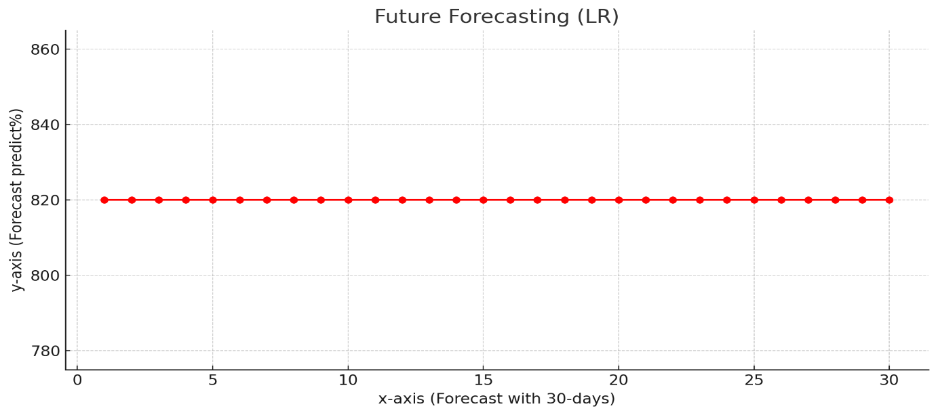

Figure 3.1 future dust-label predictions

In the above figure 3.1, I have arrived at the moment of truth. I will print out the future dust-label (next 30 days) predictions of the dust-label using the linear regression model of the x_forecast data. Here x-axis is ‘Forecast with 30-days’ and y-axis is ‘Forecast prediction%’.

**Week 2: Introduction to Sensors and Hardware Setup**

* Gained hands-on knowledge of common air quality sensors: MQ2 (for smoke, CO, LPG), DHT11 (temperature & humidity).
* Studied how these sensors work and how they can be integrated into IoT systems.
* Understood the working of NodeMCU (ESP8266) microcontroller used for data transmission.
* Practiced writing simple Arduino code to read data from sensors and display it on the serial monitor.
* Assembled the sensor components on a breadboard for testing.
* Began collecting test data and checking sensor accuracy in indoor conditions.

**Result of Graph 2:**

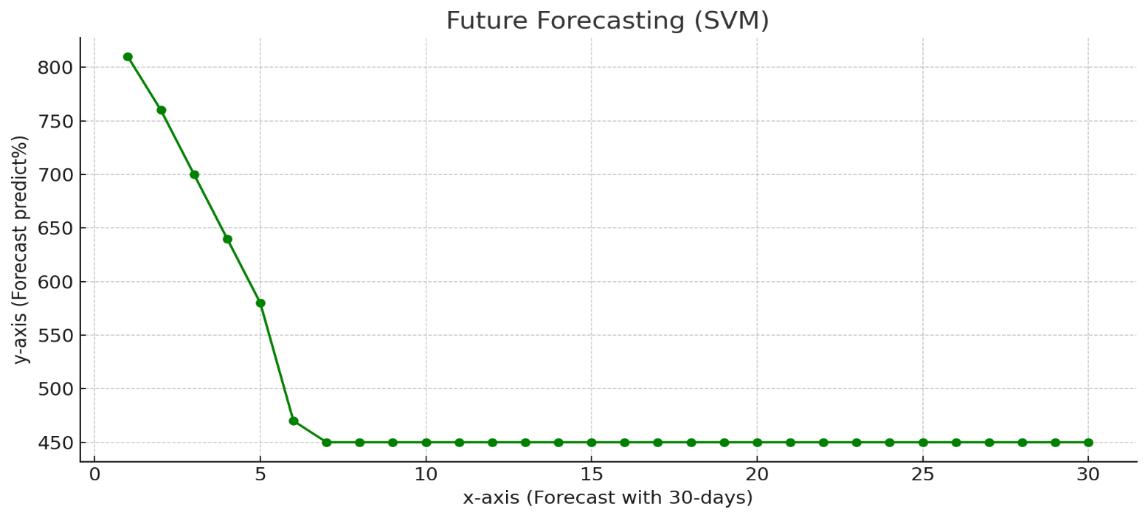

Figure 3.2 future dust-label predictions

In the above figure3.2, I have arrived at the moment of truth. I will print out the future dust-label (next 30 days) predictions of the dust-label using the support vector machine of the x_forecast data. Here x-axis is ‘Forecast with 30-days’ and y-axis is ‘Forecast prediction%’

**Week 3: IoT Integration and Data Logging**

* Learned how to connect the NodeMCU to Wi-Fi for real-time data transmission.
* Explored and selected a cloud platform (ThingSpeak) for IoT data logging.
* Successfully configured the system to upload sensor data to the cloud at regular intervals.
* Created a basic dashboard to visualize air quality parameters.
* Ensured consistent data flow and fixed minor connection issues during testing.

**Result of Graph 3:**

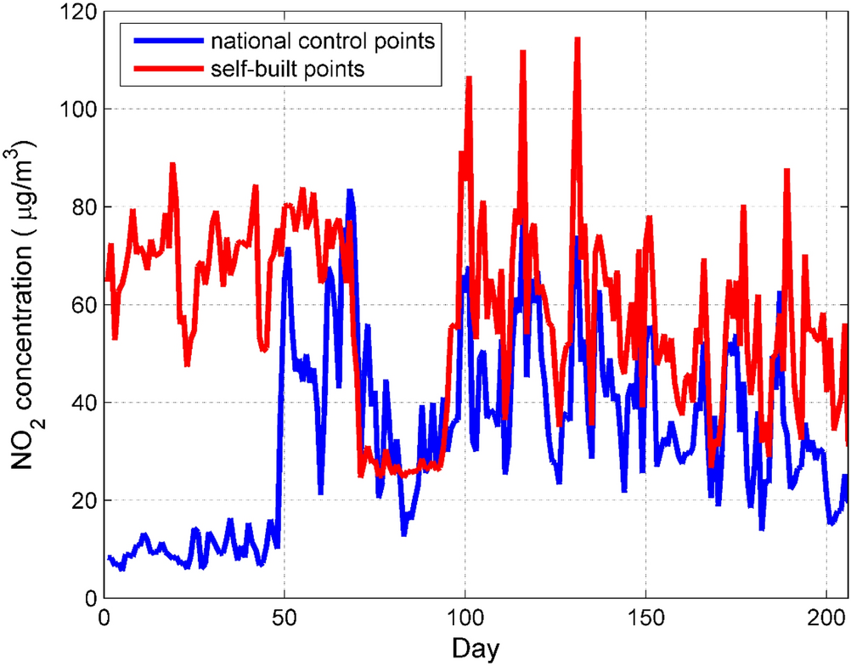

Figure 3.3 NO₂ concentration trends over 200 days

In the above figure 3.3, I have arrived at the moment of truth. I will print out the NO₂ concentration levels over 200 days using data from national control points (blue) and self-built points (red). The x-axis represents ‘Day’, while the y-axis indicates the ‘NO₂ concentration (µg/m³)’, showing that self-built points consistently record higher pollution levels.

**Week 4: Real-Time Data Collection and Initial Analysis**

* Deployed the setup in different areas (e.g., indoors, near kitchen, and outdoors) for data collection.
* Collected and organized data sets over several days, noting environmental conditions.
* Conducted basic analysis using Excel: averages, max/min values for gas concentrations, temperature, and humidity.
* Identified notable patterns and variations in pollution levels during different time frames.

**Result of Graph 4:**

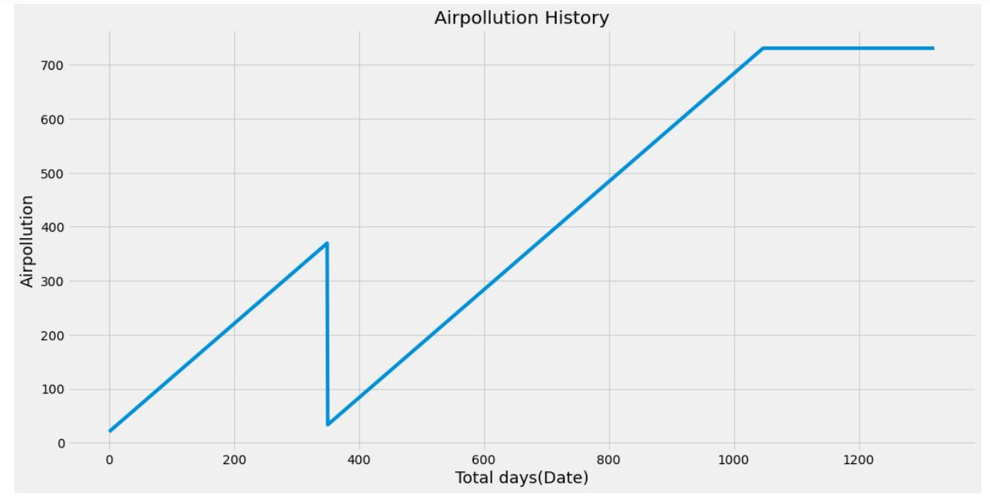

Figure 3.4 The historical trend of air pollution levels

In the above figure 3.4 of graph to visualize the original data of Air-pollution history. Here x-axis is ‘Total days (Date)’ and y-axis is ‘Air-pollution label’.

**Week 5: Advanced Analysis and Visualization**

* Performed deeper analysis using Excel and Python tools (Pandas, Matplotlib).
* Created visual charts and graphs to present trends in pollutant levels.
* Compared daily and weekly pollution variations.
* Investigated correlations between human activities (e.g., traffic hours, cooking times) and spikes in pollutants.
* Discussed findings with mentor and drafted early conclusions.

**Week 6: Final Report and Presentation**

* Compiled all work done into a structured report: Introduction, Methodology, System Design, Data Analysis, Results, and Conclusion.
* Designed a presentation summarizing key aspects of the internship and outcomes of the project.
* Delivered final presentation to the mentor/internship guide and received feedback.
* Reflected on the internship experience:
  + Gained practical exposure to IoT-based systems.
  + Improved technical skills in sensors, data collection, and analysis.
  + Understood the real-world significance of monitoring and analyzing air quality.

**Result of Graph 5:**

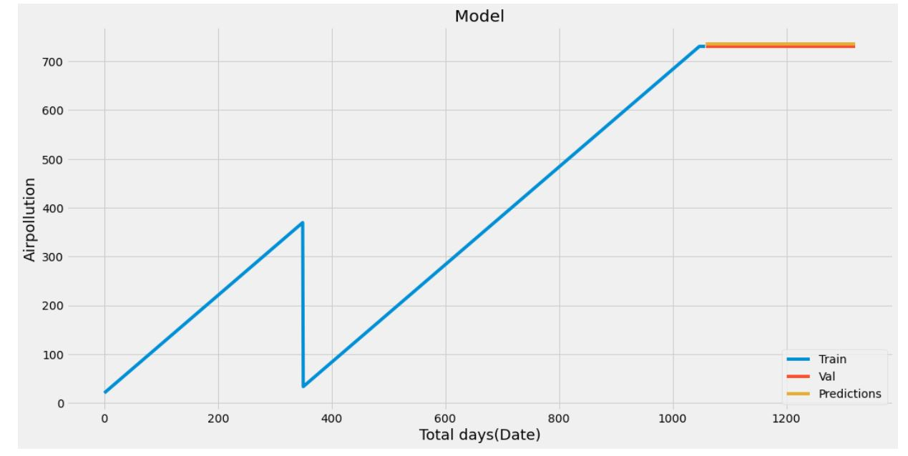

Figure 3.5 Air pollution trends over time

In the above figure 3.5 , I have arrived at the moment of truth. I will print out the future Air-pollution (next 60 days) predictions of the air-pollution using the LSTM model of the x_forecast data. Graph showing the training (train), actual (valid) and predicted (predictions) of air-pollution label. Here x-axis is ‘Total days (Date)’ and y-axis is ‘Air-pollution label’.

**4. TOOLS AND TECHNOLOGIES USED**

**4.1. Hardware Tools**

* **Arduino Uno** – Microcontroller board for interfacing sensors and controlling the system.
* **NodeMCU (ESP8266)** – Wi-Fi-enabled microcontroller for IoT communication and data transfer to cloud/server.
* **Laptop/PC** – System for code uploading, monitoring, and running server applications (Minimum: Intel i3, 4GB RAM).
* **Breadboard & Connecting Wires** – For circuit building and prototyping.
* **Power Supply** – To power the sensors and microcontroller setup.

**4.2. Sensors**

* **MQ-2 Gas Sensor** – Detects gases like CO₂, smoke, LPG, alcohol, NH₃, benzene, and other harmful pollutants.
* **DHT11 Temperature & Humidity Sensor** – Monitors environmental temperature and humidity.
* **Sharp GP2Y1010AU0F Dust Sensor** – Detects fine dust particles, including smoke, to assess particulate matter levels.

**4.3. Software Tools**

* **Arduino IDE (version 1.8.10)** – For programming and uploading code to Arduino/NodeMCU.
* **NetBeans IDE** – Used for web-based application development (Java-based).
* **MySQL** – For storing sensor data in a database.
* **Navicat** – A GUI tool for managing MySQL databases and queries.

**4.4. Programming & Development Technologies**

* **Embedded C** – For writing Arduino and sensor interaction code.
* **Java** – For web application development and data visualization.
* **HTML/CSS/JavaScript** *(implicitly required)* – For building the user interface of the air monitoring dashboard (if web-based).
* **Wi-Fi Communication (IoT Protocol)** – Using ESP8266 for real-time data transfer.
* **Cloud/Server Interface** – For displaying real-time air quality data remotely.

**4.5. Operating System**

* **Windows XP or Higher**, **Linux**, or **Unix** – Compatible platforms for running the development tools and software stack.

**5. OUTCOME OF INTERNSHIP**

The internship on **“Analysis of Air Quality Data using IoT”** provided a comprehensive learning experience in both theoretical and practical aspects of environmental monitoring. Through this project, the following outcomes were achieved:

* 1. **Understanding of Air Pollution and Its Impacts:**
  + Gained insights into various pollutants (CO₂, NOx, NH₃, smoke, dust, etc.) and their impact on human health and the environment.
  + Understood the significance of monitoring air quality in both industrial and domestic environments.

**5.2 Hands-on Experience with IoT and Embedded Systems:**

* + Acquired practical skills in using microcontrollers like **Arduino Uno** and **NodeMCU (ESP8266)**.
  + Learned to interface various sensors such as **MQ-2**, **DHT11**, and **Dust Sensor** for data collection.

**5.3 Sensor Data Handling and Real-Time Monitoring:**

* + Successfully implemented a real-time monitoring system that collects and displays data on a web server using the **ESP8266 Wi-Fi module**.
  + Ensured accurate tracking of environmental parameters like gas concentration, temperature, and humidity.
  1. **Software Development and Integration:**
  + Developed an application using tools like **Arduino IDE**, **NetBeans**, and **MySQL** to store and manage sensor data.
  + Learned how to use **Navicat** for database interaction and visualizing recorded data.

**5.5 System Design and Deployment:**

* + Designed a low-cost, scalable, and efficient system that can be deployed in homes, offices, or industrial premises.
  + Tested the system under real-world conditions and verified the accuracy and reliability of sensor data.

**5.6 Improved Analytical and Problem-Solving Skills:**

* + Analyzed air quality data using collected readings to identify pollution trends.
  + Learned to troubleshoot hardware and software issues during implementation.
  1. **Project Documentation and Reporting:**
  + Documented every phase of the project from planning, implementation to analysis.
  + Prepared a detailed internship report covering objectives, system design, implementation, results, and conclusions.

**6. CONCLUSION**

The proposed system utilizes **Arduino microcontroller** and **IoT (Internet of Things) technology** to monitor environmental air quality effectively and in real time. This system is designed to address the growing concern of air pollution by continuously measuring harmful gas concentrations in the atmosphere and providing timely alerts when pollution exceeds safe limits.

By integrating **IoT technology**, the system enables remote monitoring and data accessibility through the internet, allowing users to view real-time pollution data on a web-based interface from anywhere. This enhances awareness and facilitates quicker decision-making for mitigating pollution-related risks.

At the core of the system is the **MQ2 gas sensor**, a highly sensitive sensor capable of detecting a wide range of harmful gases such as **CO₂, smoke, alcohol, LPG, methane, ammonia (NH₃), and NOx compounds**. The sensor sends analog signals to the **Arduino Uno**, which acts as the central controller. The Arduino processes the sensor data, compares it against predefined threshold levels, and then either displays the air quality status or triggers an alert if pollution levels are unsafe.

Additionally, sensors for **temperature and humidity** are integrated to provide more comprehensive environmental data, as these parameters often influence pollutant behavior and dispersion.

The system architecture is simple, cost-effective, and scalable, making it suitable for deployment in **homes, industrial zones, schools, hospitals, and public areas**. Through the use of **ESP8266 Wi-Fi module**, the system transmits collected data to a web server, ensuring global access and storage for analysis and historical trends.

In conclusion, this IoT-based air pollution monitoring system not only promotes environmental awareness but also provides an efficient and practical solution for tracking air quality, ultimately aiming to reduce health hazards and improve quality of life.