Skill Week-4

Task 1: To Split Input into Tokens, Identify Delimiters, Handle Whitespace, Create Token Structures, Validate Token Streams, Debug Parsing Output and Design Parser Logic, Generate Parse Trees, Validate Syntax, Detect Errors, Handle Empty Commands, Produce Execution Structures.
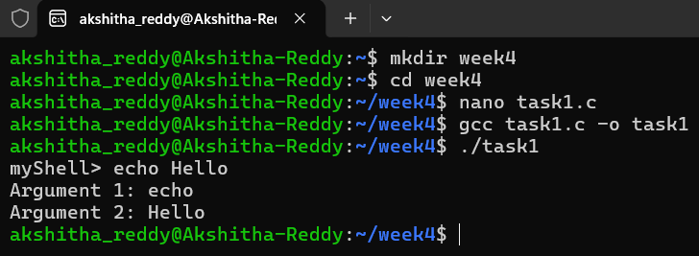
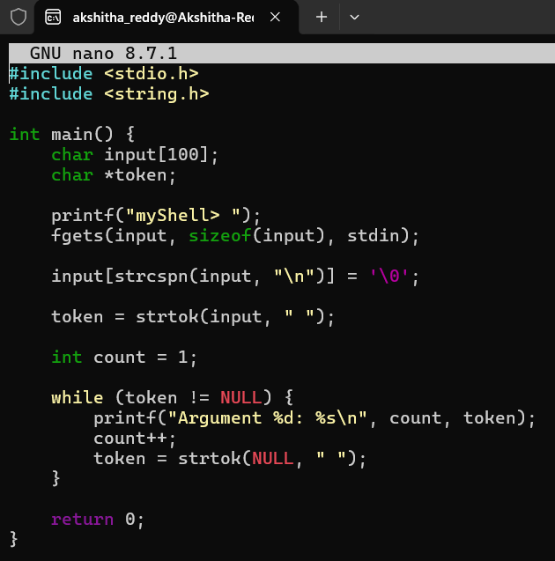

Task 2: To Apply Single Quotes, Preserve Literal Content, Ignore Variable Expansion, Store Quoted Strings, Validate Parsing Results, Test Edge Cases.
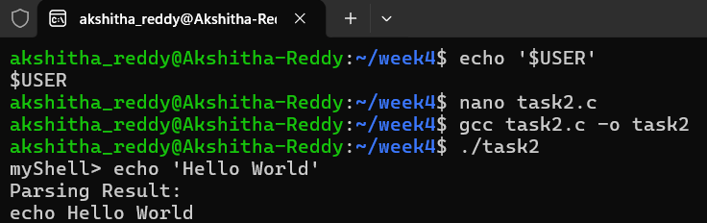
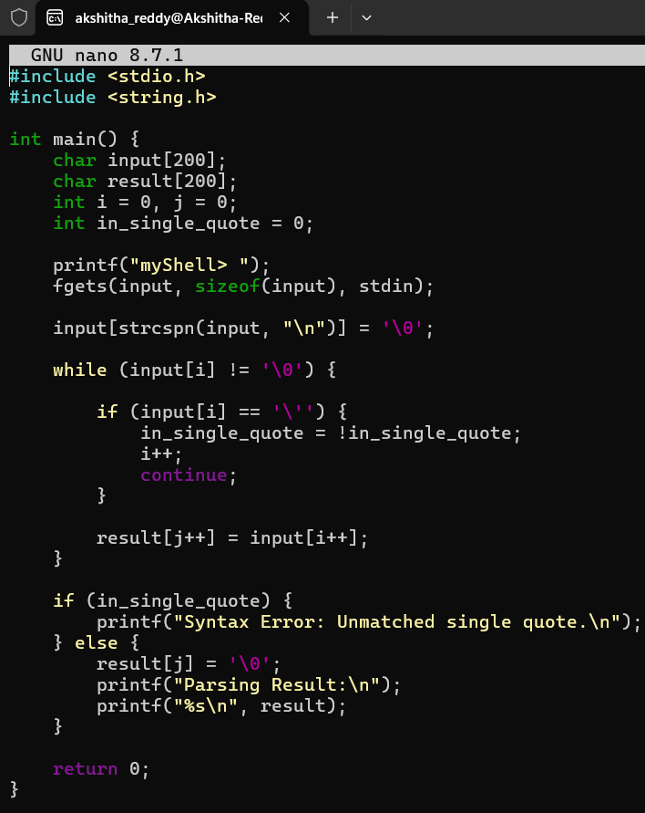

Task 3:To Apply Double Quotes, Preserve Spaces, Allow Variable Expansion, Parse Nested Tokens, Validate Outputs, Test Quoted Commands.

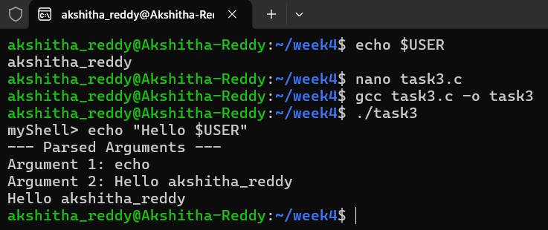
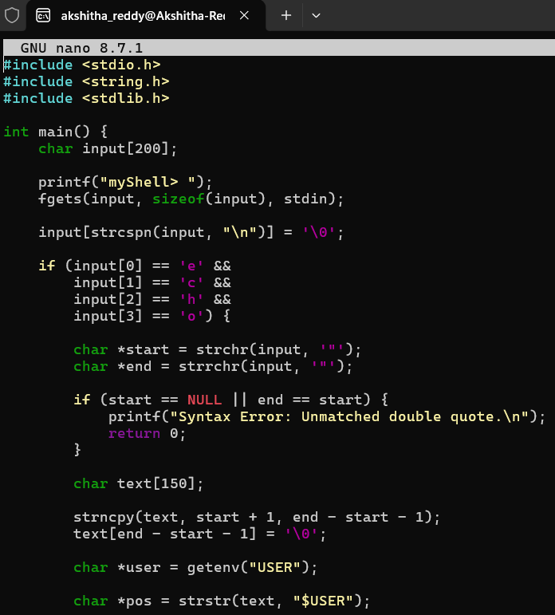
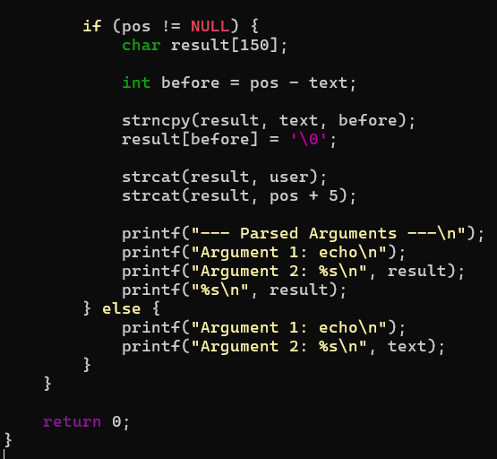

Task 4: To Create Process Escape Sequences, Handle Escaped Spaces, Escape Special Symbols, Preserve Characters, Validate Parser Output, Test Complex Inputs.
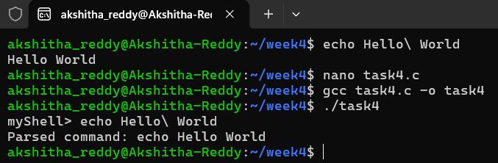
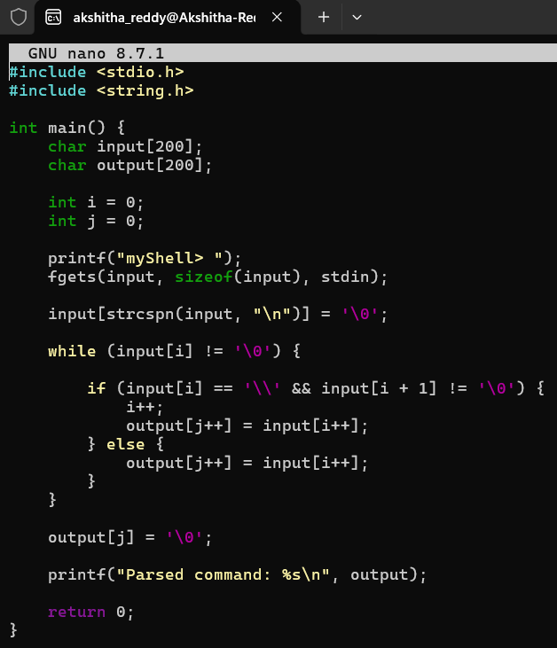

Task 5: To Create Child Processes, Execute Programs, Handle Execution Errors, Pass Arguments, Manage Parent Process, Test Command Launching.
