Practical Week-10
Task 1: Investigate inode structures using commands such as ls -i, stat, and find. Create hard links and symbolic links and explain their impact on inode allocation.
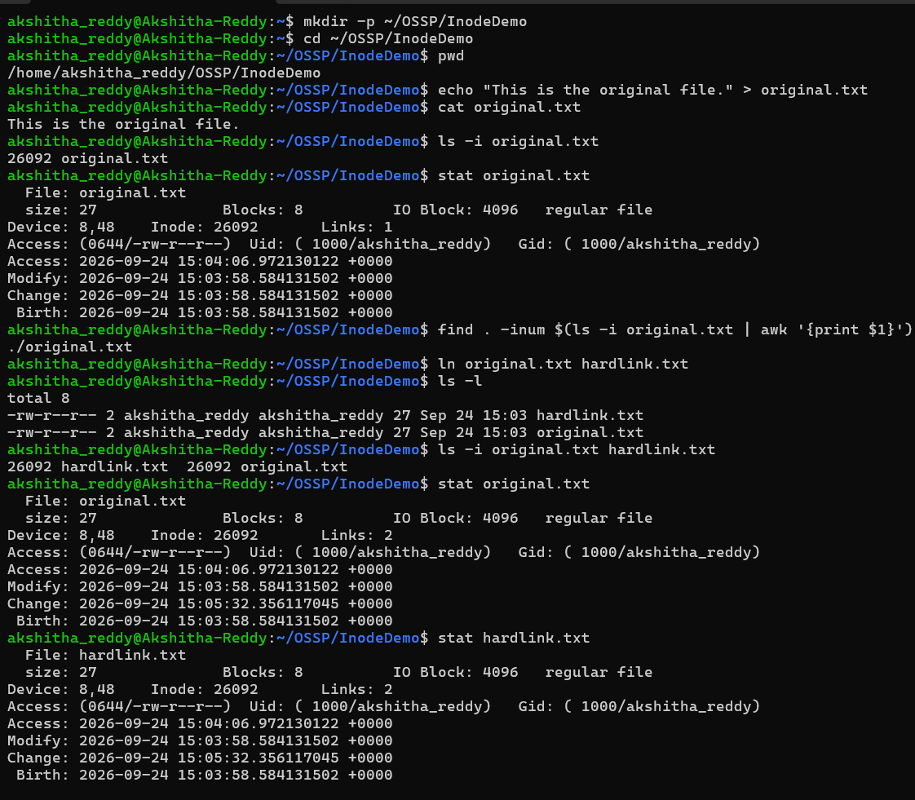
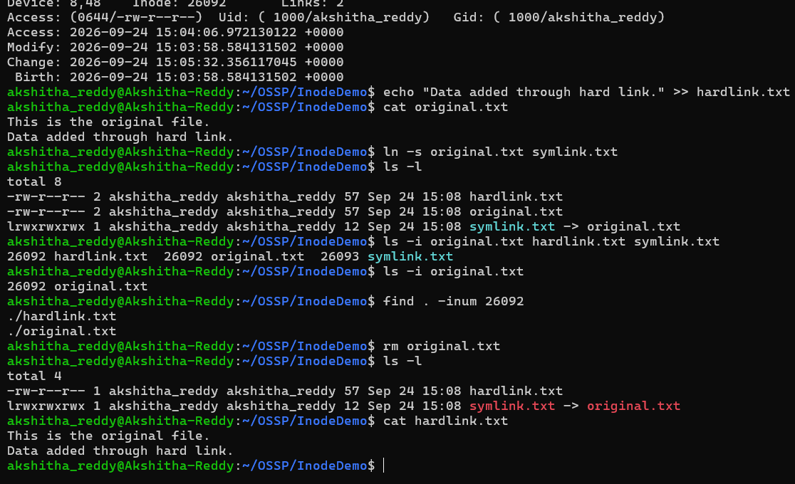

Task 2: Design a program using mmap() to perform file reading and writing. Compare memory-mapped I/O with traditional read/write operations in terms of efficiency and implementation complexity.
