Practical Week-7
Task 1: Write a program that prints the addresses of code, global, static, heap, and stack variables. Analyze the Linux process address space layout and explain each memory segment.
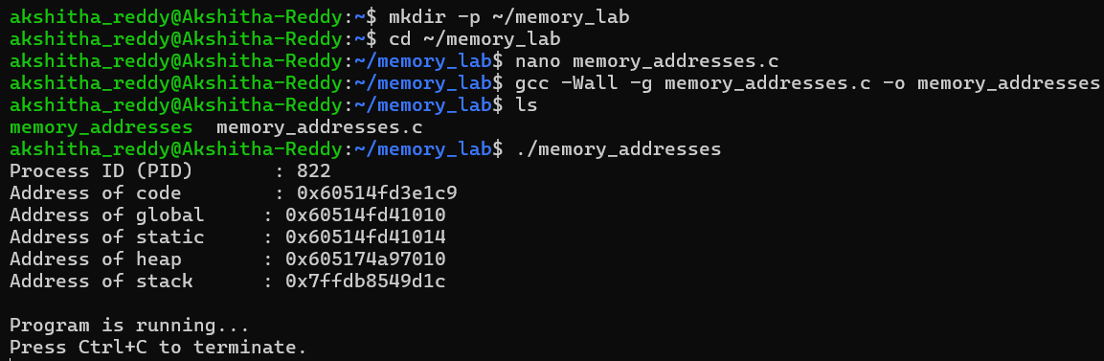
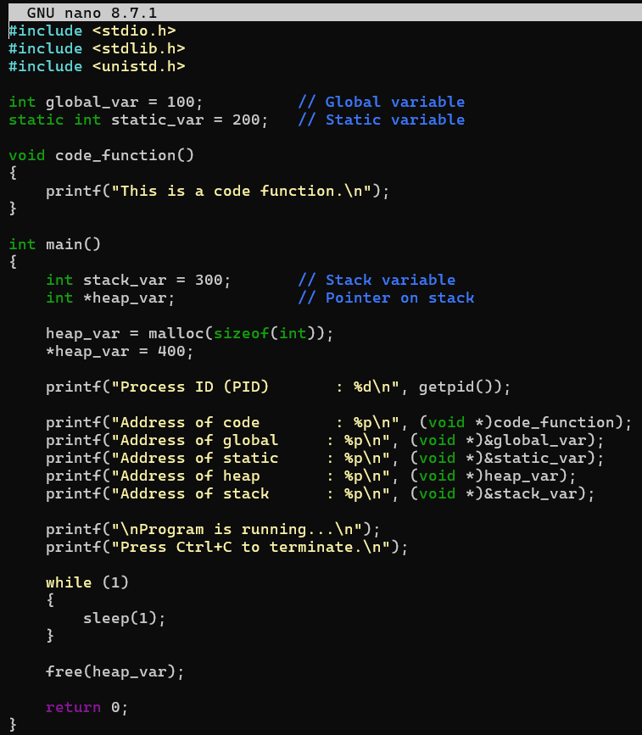

Task 2: Make use of the /proc/<PID>/maps file and memory analysis tools to study the memory organization of a running process.
