Skill Week-6
Session-11
Task 1: To Store Commands, Maintain History Buffer, Handle Capacity Limits, Retrieve Entries, Display History, Validate Consistency
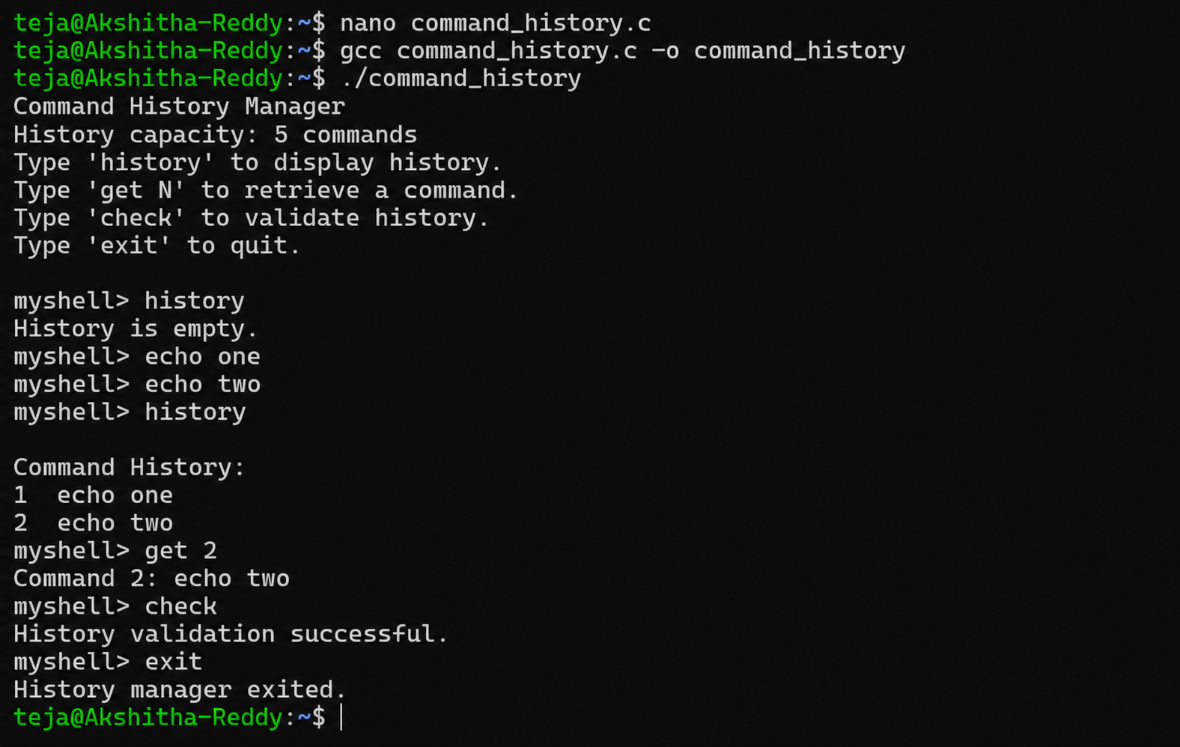
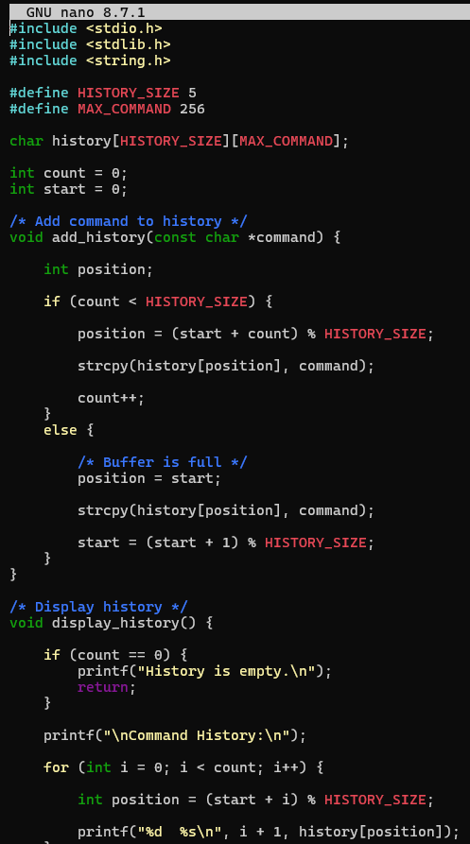
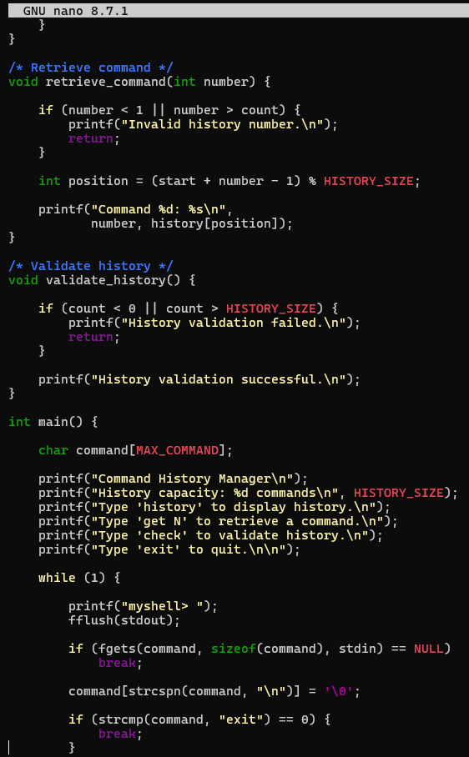
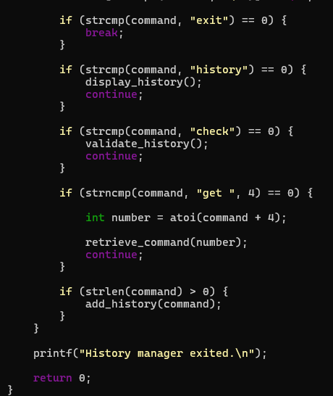

Task 2: To Create Pipeline Structures, Store Commands, Maintain Execution Order, Connect Processes, Validate Pipeline Layout, Test Configurations
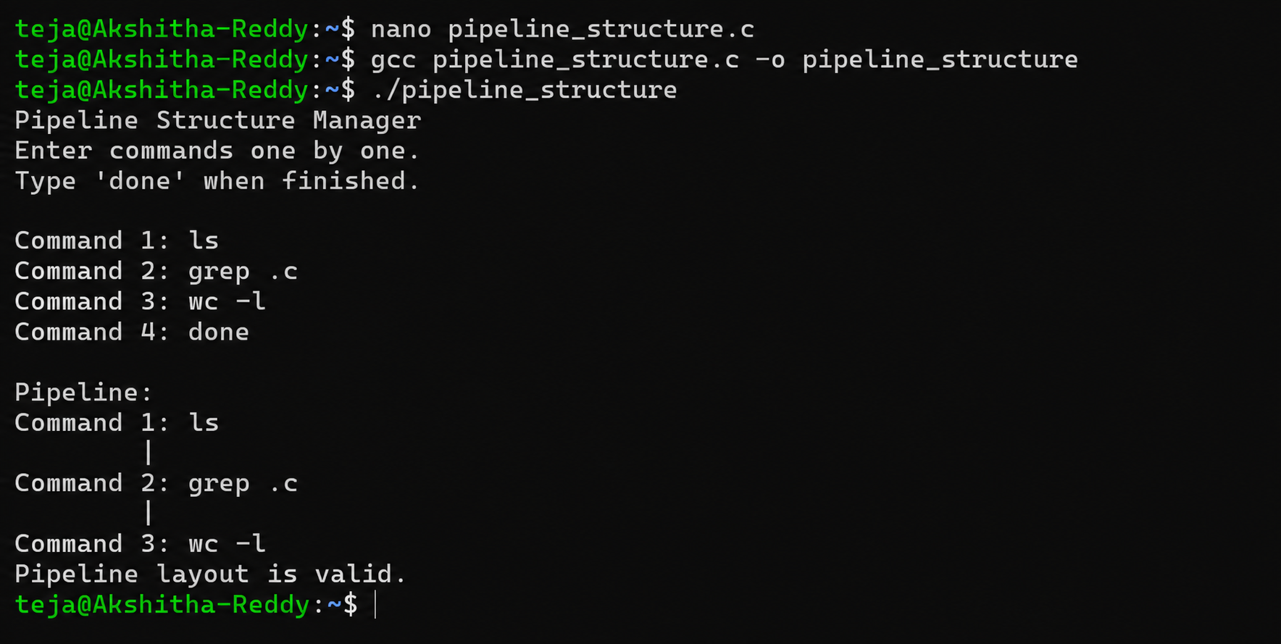
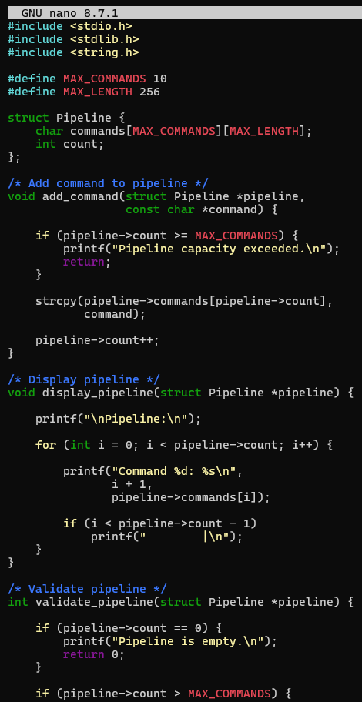
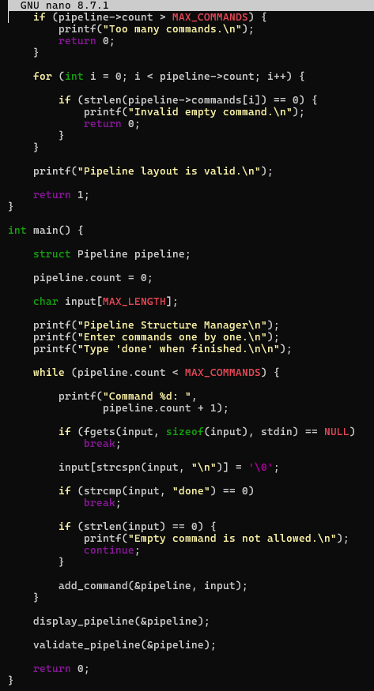

Session-12
Task 1: To Create Pipes, Redirect Streams, Execute Connected Commands, Close Descriptors, Synchronize Processes, Test Data Flow
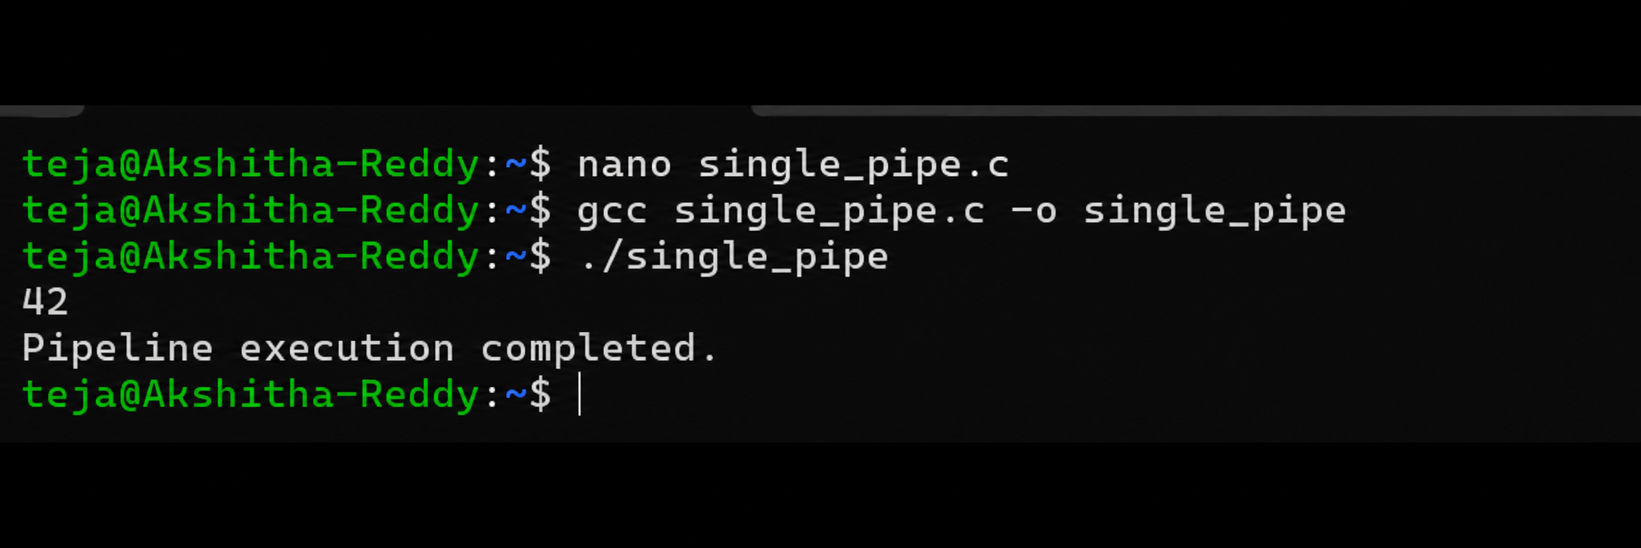
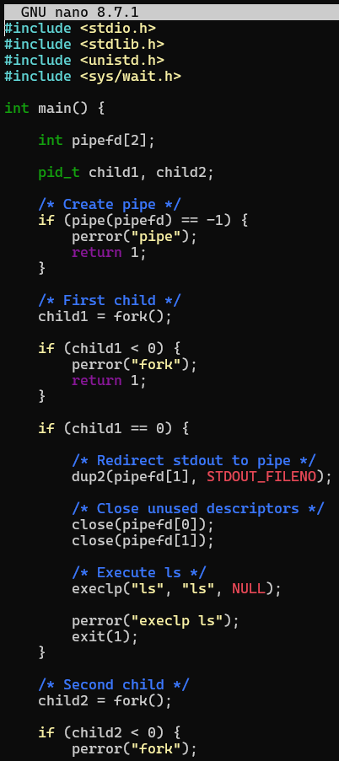
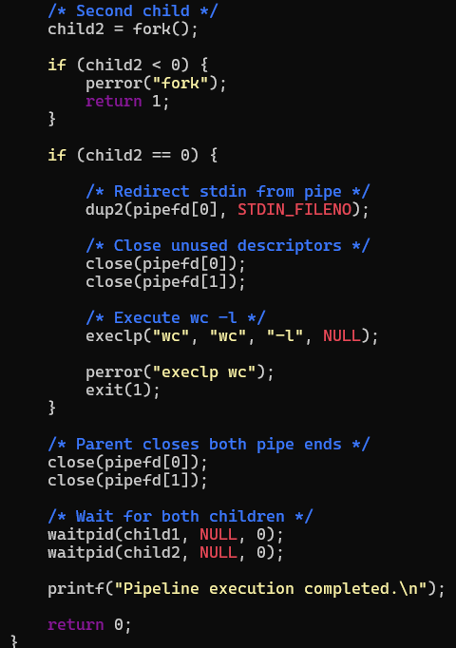

Task 2: To Support Multiple Pipes, Manage Descriptor Arrays, Launch Multiple Processes, Coordinate Execution, Cleanup Resources, Test Long Pipelines
