Skill Week-4
Session-7
Task 1: Process Synchronization and Child Process Monitoring Using waitpid()
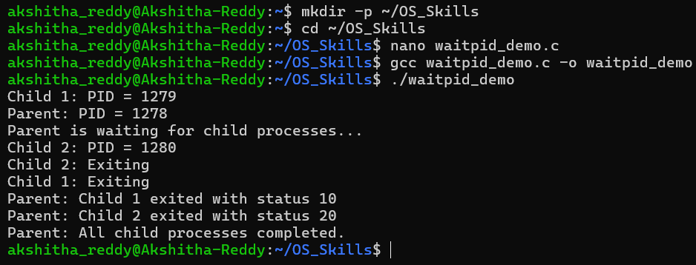
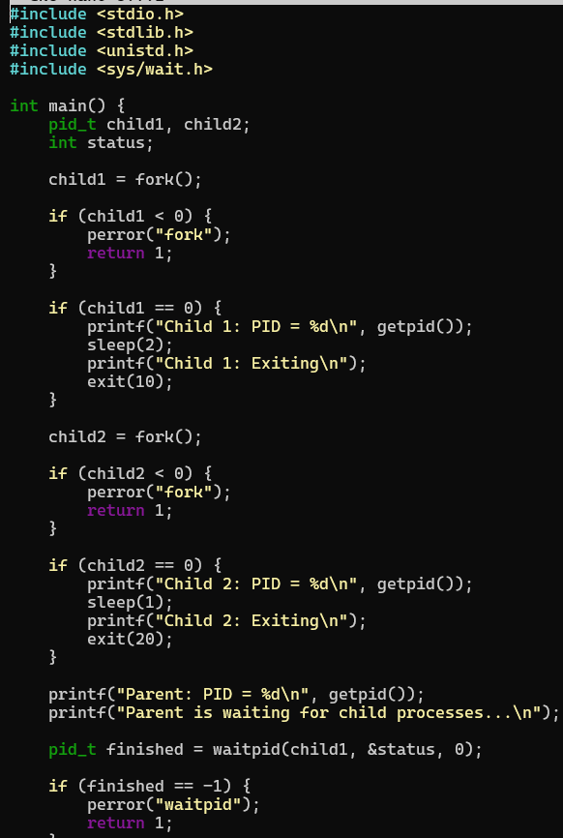
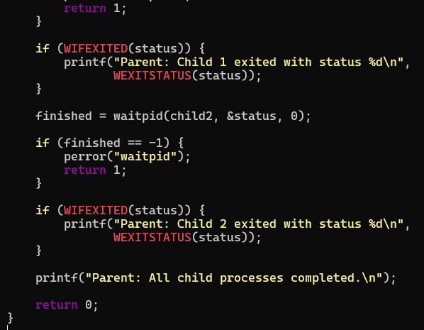

Task 2: To Retrieve PATH Variable, Parse Search Directories, Locate Executables, Verify Permissions, Handle Missing Commands, Test Command Resolution
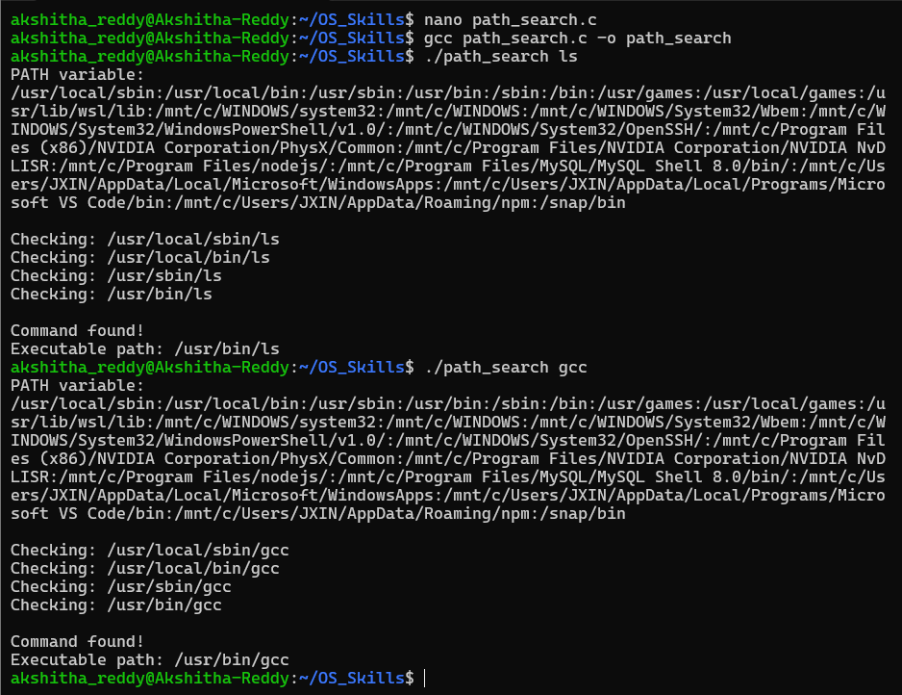
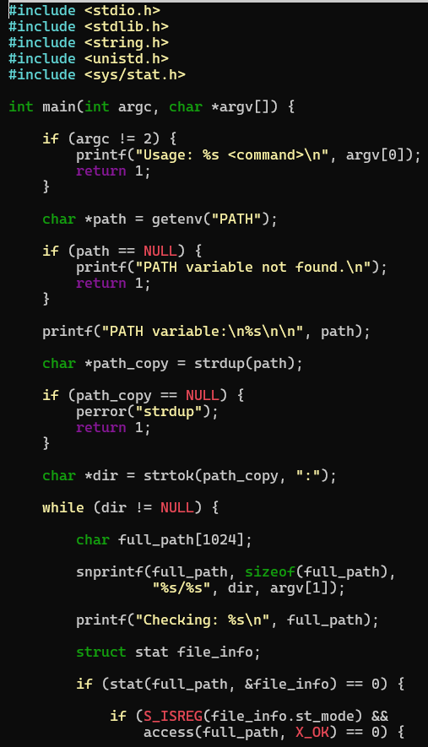
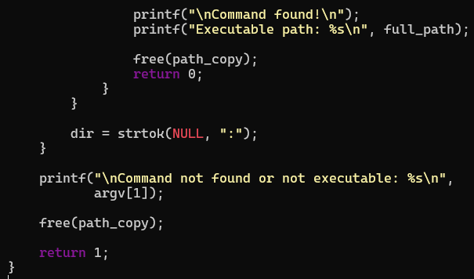

Session-8
Task 1: To Detect Variable References, Expand Values, Handle Undefined Variables, Update Tokens, Support Nested Variables, Test Expansion Logic
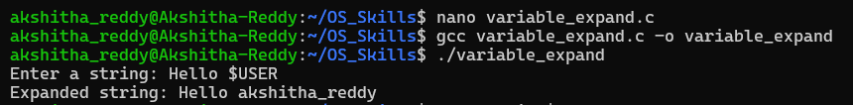
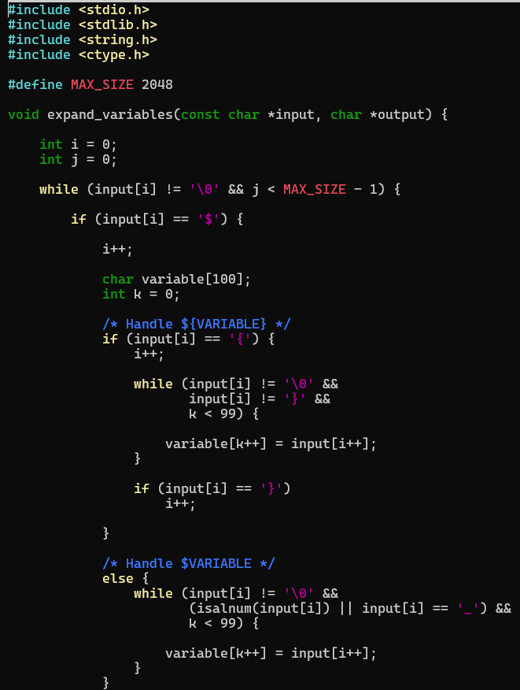
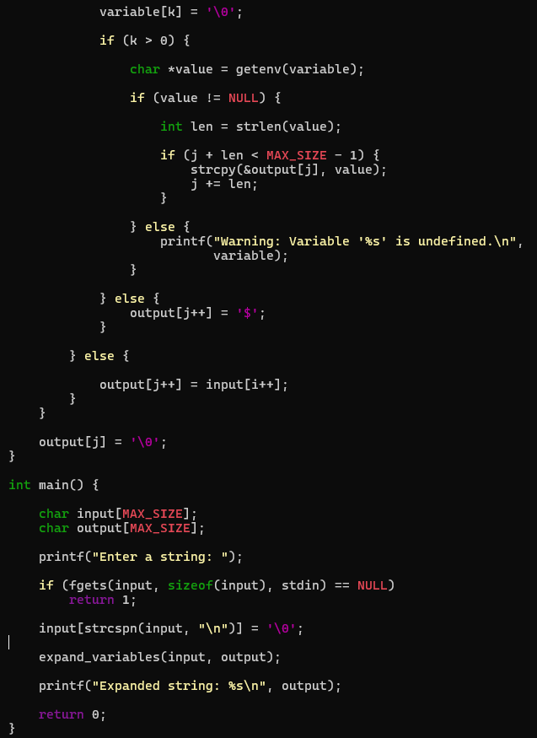

Task 2: To Identify Built-ins, Create Dispatch Table, Execute In- Process Commands, Handle Invalid Commands, Maintain State, Test Dispatch Logic
