Skill Week-7
Session-13
Task 1: To parse Input Redirection, Open Files, Redirect stdin, Handle Missing Files, Restore Streams, Test File Inputs
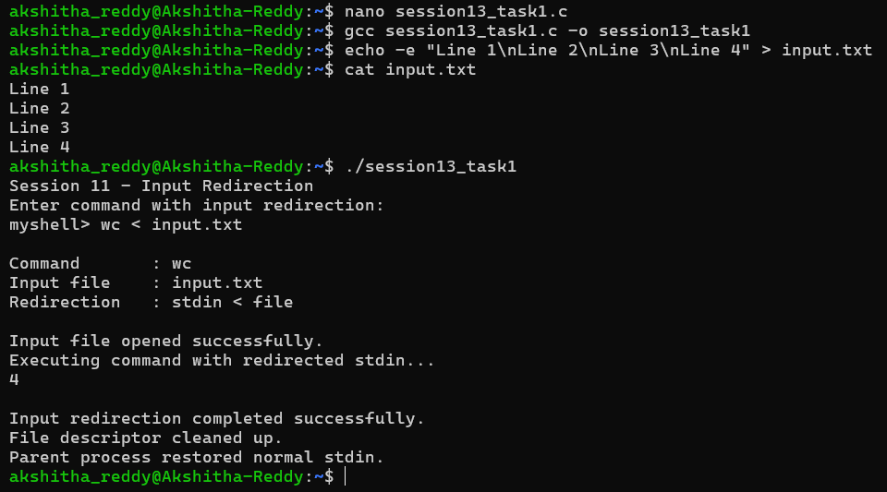
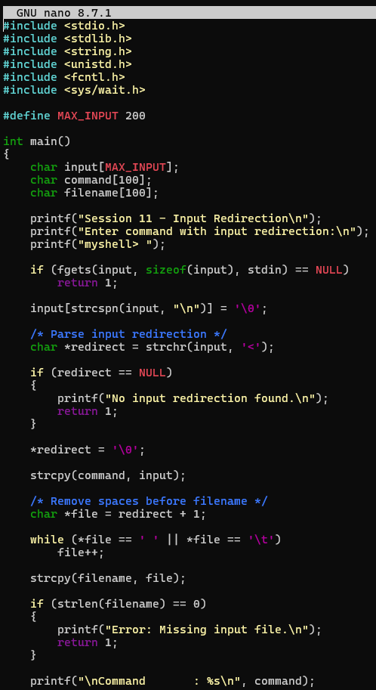
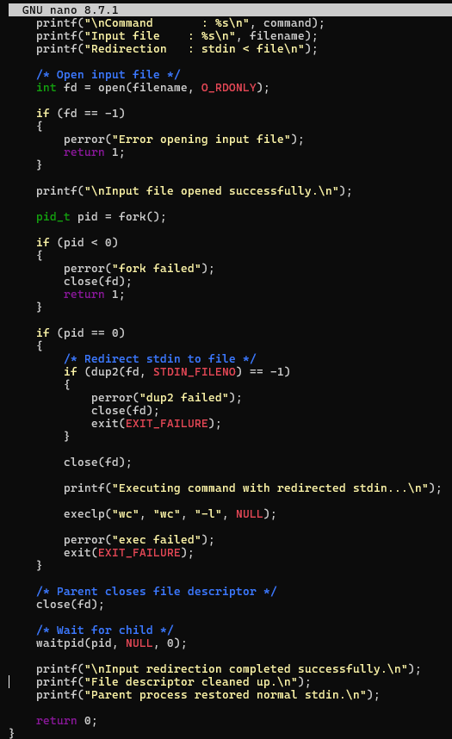

Task 2: To Parse Output Redirection, Create Output Files, Redirect stdout, Handle Permissions, Verify Output Data, Test Redirection
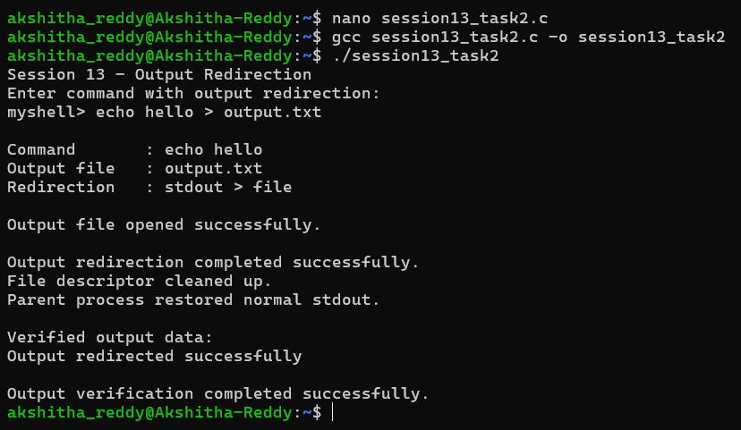
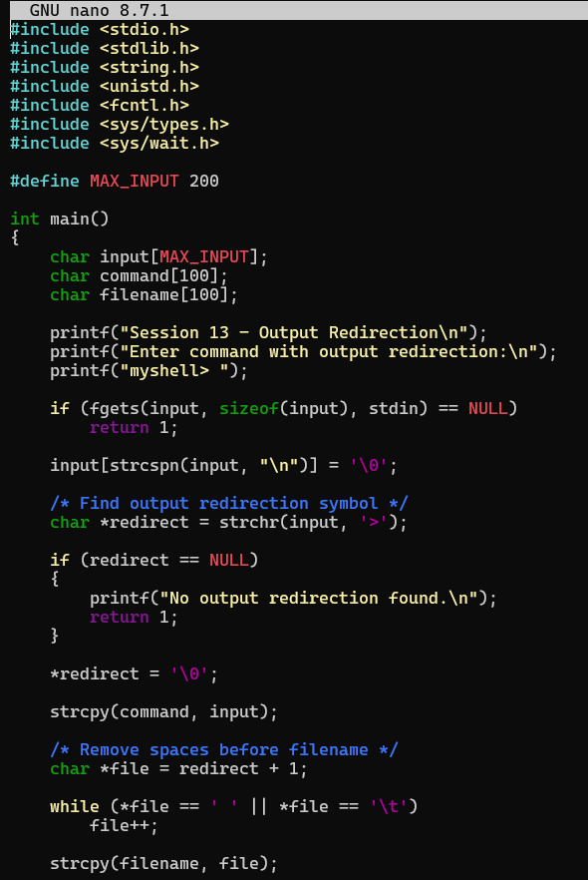
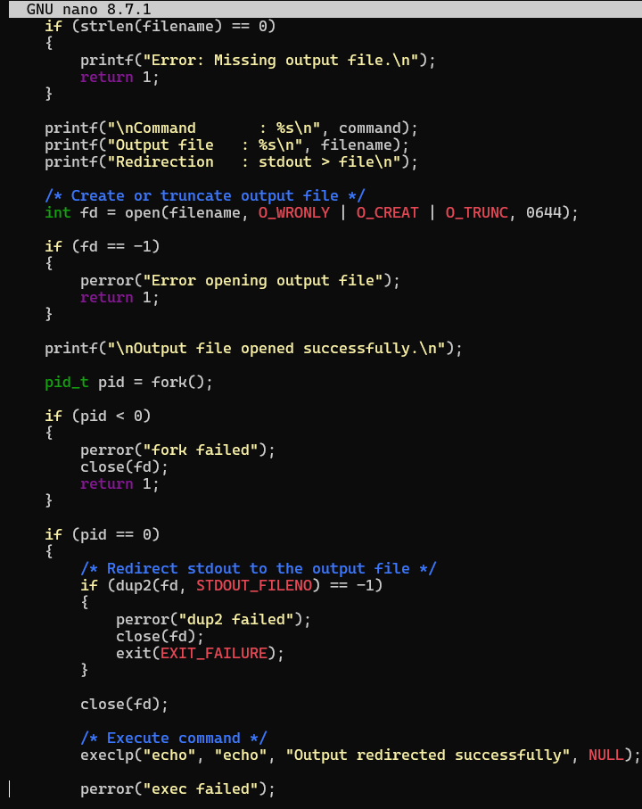
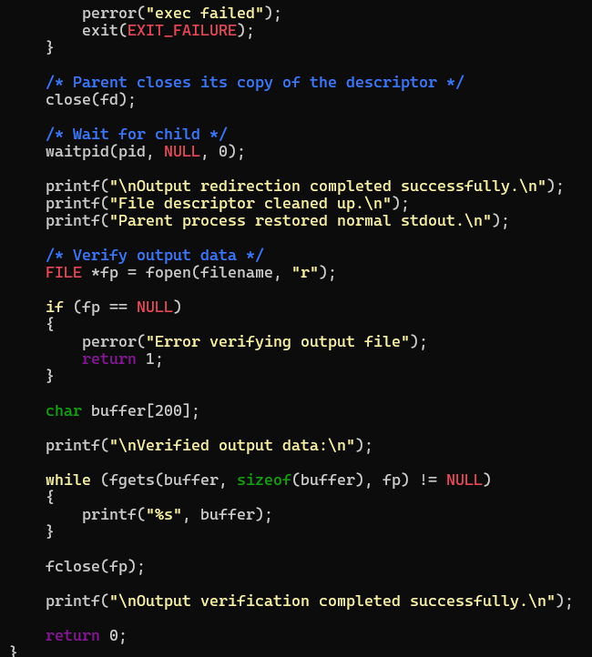

Session-14
Task 1: To Parse Append Operator, Open Files in Append Mode, Redirect Streams, Preserve Existing Data, Validate Appends, Test Scenarios
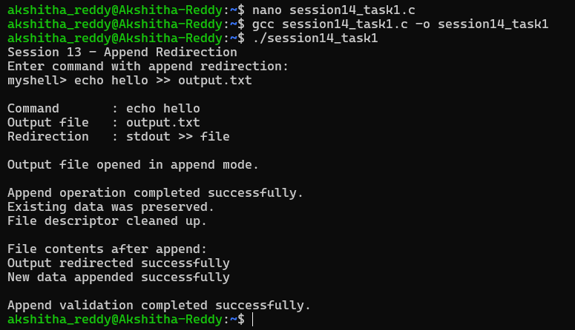
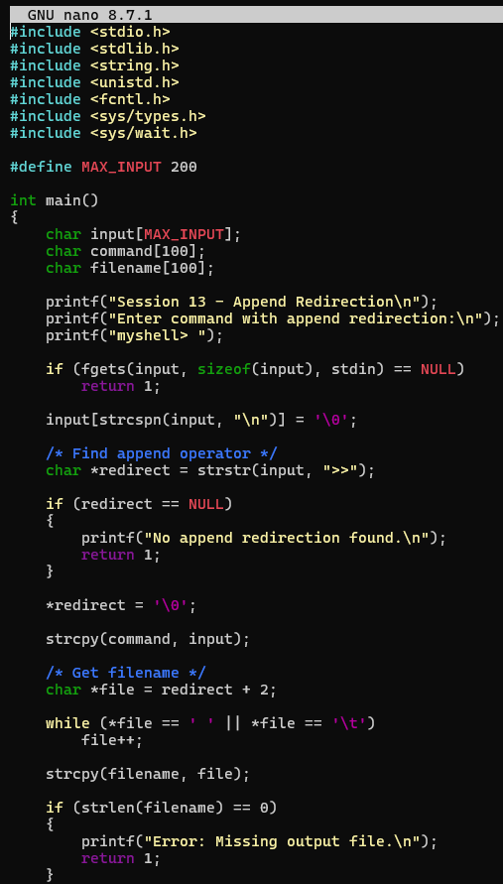
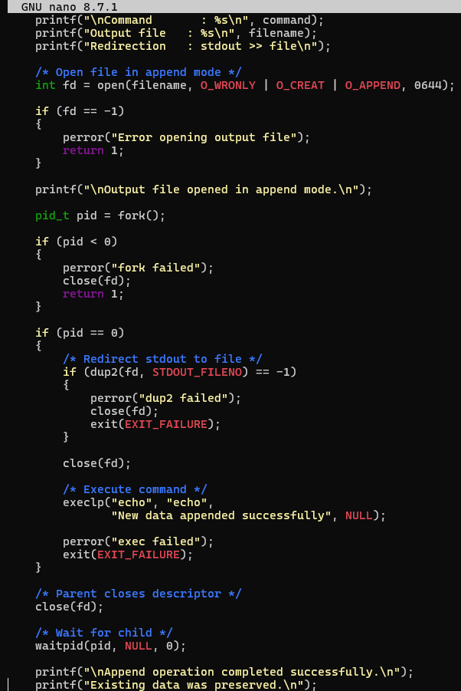
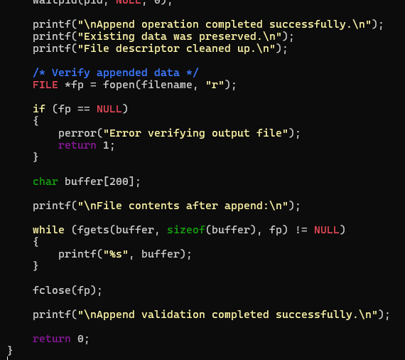

Task 2: TO parse stderr Redirection, Redirect Error Streams, Capture Error Output, Verify File Contents, Handle Failures, Test Error Cases
