“Smart Resource Allocation – Banker’s Algorithm”
A Project Report Submitted in the partial fulfillment of the requirements for the award of the degree of

BACHELOR OF TECHNOLOGY
In

DEPARTMENT OF COMPUTER SCIENCE ENGINEERING

By

SRIJA 2520090053

PRAVEENA 2520090057

AKSHITHA REDDY 2520090178

Under the Esteemed Guidance of

Raghupathi M
Assistant Professor
Department of Computer Science and Information Technology




K L (Deemed to be) University DEPARTMENT OF COMPUTER SCIENCE ENGINEERING
&

DEPARTMENT OF COMPUTER SCIENCE AND INFORMATION TECHNOLOGY

Declaration

The Project Report entitled “Smart Resource Allocation – Banker’s Algorithm” is a record of bonafide work of SRIJA - 2520090053, PRAVEENA - 2520090057, AKSHITHA REDDY - 2520090178, submitted in partial fulfillment for the award of B.Tech in Computer Science and Engineering (or) Computer Science and Information Technology to the K L (Deemed to be) University. The results embodied in this report have not been copied from any other department/University/Institute.

SRIJA-2520090053

PRAVEENA-2520090057

AKSHITHA REDDY-2520090178

K L (Deemed to be) University

DEPARTMENT OF COMPUTER SCIENCE ENGINEERING

CERTIFICATE

This is to certify that the mini project based report entitled “Smart Resource Allocation – Banker’s Algorithm” is a bonafide work done and submitted by SRIJA - 2520090053, PRAVEENA - 2520090057, AKSHITHA REDDY - 2520090178, in partial fulfillment of the requirements for the award of the degree of BACHELOR OF TECHNOLOGY in Department of Computer Science Engineering, K L (Deemed to be University), during the academic year 2026-2027.

Signature of the Guide

Signature of the Course Coordinator Signature of the HOD

ACKNOWLEDGEMENT
The success of this project would not have been possible without the timely help and guidance rendered by many people. We wish to express our sincere thanks to all those who have assisted us in one way or the other in the completion of our project.

Our greatest appreciation goes to our Course Coordinator Dr. K. Anusha, and our guide Raghupathi M, Assistant Professor, Department of Computer Science and Information Technology, whose tremendous support, encouragement and guidance for this project cannot be expressed in words.

We express our gratitude to Dr. Khaja Shareef (CSIT), Head of the Department of Computer Science Engineering, for providing us with adequate facilities, ways and means by which we were able to complete this project-based lab.

We thank all the members of the teaching and non-teaching staff who have assisted us directly or indirectly in the successful completion of this project. Finally, we sincerely thank our parents, friends and classmates for their kind help and cooperation during our work.

SRIJA-2520090053

PRAVEENA-2520090057

AKSHITHA REDDY-2520090178

Abstract

The Smart Resource Allocation – Banker’s Algorithm project is an operating systems project designed to allocate system resources to processes in a way that avoids deadlock. In a multiprogramming environment, several processes compete for a limited number of resources such as memory, printers and other I/O devices. If resources are granted carelessly, processes may end up waiting for each other indefinitely, which results in a deadlock that halts the affected processes and reduces system performance. To address this problem, our project implements the Banker’s Algorithm, a classical deadlock-avoidance technique that grants a resource request only if the system remains in a safe state afterwards.
The system is developed using Python and the Tkinter graphical user interface (GUI). The user enters the number of processes and resource types, the total instances of each resource, and the Allocation and Maximum matrices. The program computes the Need matrix (Need = Maximum − Allocation) and the Available vector, and then applies the Safety Algorithm to determine whether the system is in a safe state. If a safe state exists, the program displays a safe sequence of process execution. When a process makes a new resource request, the Resource-Request Algorithm checks that the request does not exceed the process’s declared need or the currently available resources, tentatively allocates the resources, and runs the Safety Algorithm again. The request is granted only if the resulting state is safe; otherwise the allocation is rolled back and the process must wait.
The project also provides a graphical interface through which users can enter data, check system safety, submit resource requests, and observe the updated matrices, the safe sequence and the status messages. Important events, including safety checks, granted requests and denied requests, are recorded in a timestamped event log for future reference and analysis. A sample data set of five processes and three resource types is provided so that the working of the algorithm can be verified quickly.
This project demonstrates important operating system concepts, including resource allocation, deadlock and its necessary conditions, safe and unsafe states, deadlock avoidance, and the sharing of limited resources among concurrent processes. It also shows how a theoretical algorithm can be turned into a practical, user-friendly application. The proposed system is intended for educational and demonstration purposes and provides a foundation for developing more advanced resource-management tools. Overall, the Smart Resource Allocation – Banker’s Algorithm system aims to improve system reliability, avoid deadlock, and provide a simple way to understand and implement safe resource allocation.

Index

S. No. | Chapter | Topics / Subtopics | Page No.
 | Acknowledgement |  | i
 | Abstract |  | ii
1 | Introduction |  | 7
 |  | 1.1 Background of the Project
 |  | 1.2 Problem Statement
 |  | 1.3 Objectives of the Project
2 | OS Concepts and Background Study |  | 8
 |  | 2.1 Operating System Concepts Related to the Project
3 | Technologies Used |  | 9
4 | System Architecture and Design |  | 10–11
 |  | 4.1 GUI Dashboard
 |  | 4.2 Banker’s Algorithm Engine
 |  | 4.3 Sample Data Module
 |  | 4.4 Working Methodology
 |  | 4.5 Implementation Modules
5 | Testing and Validation |  | 12–13
 |  | 5.1 Screenshots of Test Execution
6 | Results |  | 14–15
7 | Limitations |  | 16
8 | Future Enhancements |  | 17
9 | Team Contributions |  | 18
10 | Conclusion |  | 19

CHAPTER -1 INTRODUCTION
1.1 Background of the Project
In a multiprogramming operating system, many processes run concurrently and share a finite set of resources. A process requests resources, uses them and then releases them. When processes hold some resources while waiting for others, the system can reach a deadlock in which no process can proceed. An operating system can prevent, avoid, detect or ignore deadlocks. This project focuses on deadlock avoidance using the Banker’s Algorithm, proposed by Edsger W. Dijkstra.
The algorithm works like a banker who lends money only when it is certain that every customer can eventually be satisfied. Each process declares its maximum resource requirement in advance, and the system grants a request only if, after granting it, there is at least one order in which all processes can complete (a safe sequence). The GUI provides a convenient way to enter data, run the algorithm and observe the results.
1.2 Problem Statement
To develop a system that allocates resources to multiple processes dynamically and safely using the Banker’s Algorithm, so that every resource request is granted only when the system remains in a safe state and deadlock is avoided.
1.3 Objectives of the Project
- Accept the number of processes, the resource types, and the Allocation, Maximum and Available data.
- Calculate the Need matrix automatically.
- Determine whether the system is in a safe state using the Safety Algorithm.
- Display the safe sequence of processes.
- Process new resource requests using the Resource-Request Algorithm and grant only safe requests.
- Provide a graphical interface for data entry and result display.
- Maintain timestamped event logs.
- Demonstrate operating-system concepts of resource allocation and deadlock avoidance.

CHAPTER -2 OS CONCEPTS AND BACKGROUND STUDY
2.1 Operating System Concepts Related to the Project
- Deadlock: A situation in which a set of processes is blocked because each process holds a resource and waits for a resource held by another process.
- Necessary conditions for deadlock: Mutual exclusion, hold and wait, no preemption, and circular wait must all hold at the same time.
- Deadlock avoidance: The system uses advance information about the maximum resource needs of processes to ensure that it never enters an unsafe state.
- Safe state: A state in which there is at least one safe sequence in which every process can obtain its maximum need and finish.
- Unsafe state: A state with no safe sequence. An unsafe state may lead to deadlock, although not every unsafe state is a deadlock.
- Data structures: Available (free instances of each resource), Max (maximum demand of each process), Allocation (resources currently held) and Need = Max − Allocation.
- Safety Algorithm: Uses the Work and Finish vectors to search for a safe sequence.
- Resource-Request Algorithm: Checks a request against Need and Available, tentatively allocates it, and grants it only if the resulting state is safe.

CHAPTER -3 TECHNOLOGIES USED
- Programming language: Python 3
- GUI framework: Tkinter
- Data structures: Lists and two-dimensional matrices (Allocation, Max, Need)
- Operating system: Windows / Ubuntu Linux
- Interpreter: CPython
- Development environment: Visual Studio Code
- Version control: Git and GitHub

CHAPTER -4 SYSTEM ARCHITECTURE AND DESIGN
The system consists of three main components.
4.1 GUI Dashboard
The Python Tkinter dashboard provides input tables for the Allocation, Maximum and Available data, together with Check Safety, Request Resources, Load Sample Data and Reset controls. It displays the computed Need matrix, the safe sequence, the updated Available vector and the event history.
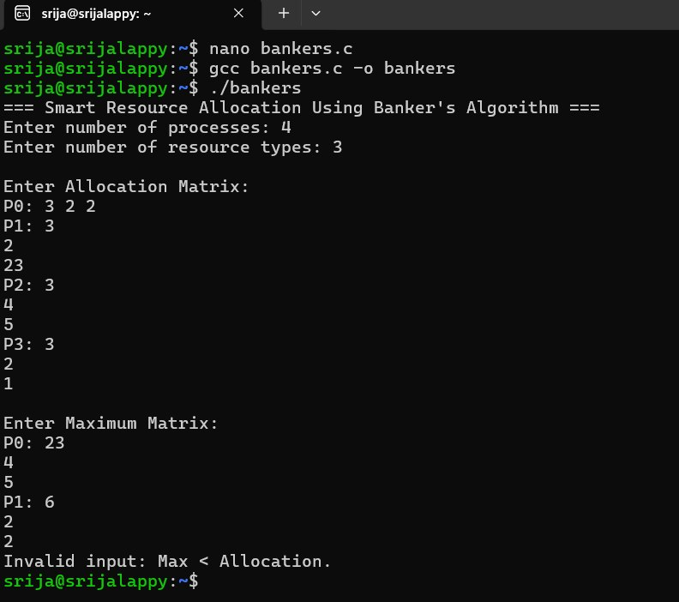
Figure 4.1: GUI Dashboard
4.2 Banker’s Algorithm Engine
The core module implements the Banker’s Algorithm. It calculates Need = Max − Allocation and then runs the Safety Algorithm: it initialises Work = Available and Finish[i] = false for every process, finds an unfinished process whose Need is less than or equal to Work, adds that process’s Allocation to Work, marks it finished, and repeats. If all processes finish, the state is safe and the order in which they were selected is the safe sequence. New requests are handled by the Resource-Request Algorithm described in Section 4.4.
4.3 Sample Data Module
The sample data module loads a standard example of five processes (P0–P4) and three resource types (A, B, C), so that the system can be tested quickly without typing all values. Every safety check and every resource request is also written to a timestamped event log.
4.4 Working Methodology
- The user opens the GUI dashboard.
- The user enters (or loads) the number of processes, the resource types, the Allocation and Maximum matrices and the Available vector.
- The program calculates the Need matrix: Need = Max − Allocation.
- The Safety Algorithm initialises Work = Available and Finish = false for all processes.
- It repeatedly finds an unfinished process whose Need ≤ Work, adds that process’s Allocation to Work and marks it finished.
- If all processes can finish, the system is safe and the safe sequence is displayed; otherwise the system is reported as unsafe.
- For a new request Request(i), the Resource-Request Algorithm checks Request(i) ≤ Need(i) (otherwise it reports an error) and Request(i) ≤ Available (otherwise the process must wait).
- It tentatively sets Available = Available − Request(i), Allocation(i) = Allocation(i) + Request(i) and Need(i) = Need(i) − Request(i), then runs the Safety Algorithm again. The request is granted if the state is safe; otherwise it is rolled back and denied.
- The GUI displays the updated matrices and the result, and records the event in the log file.
4.5 Implementation Modules
- Banker’s Algorithm engine
- Safety Algorithm
- Resource-Request Algorithm
- Python GUI dashboard
- Event logging

CHAPTER -5 TESTING AND VALIDATION
The following tests are planned or performed to evaluate the system.
Test | Expected result
Safe state check | The system is reported safe and a valid safe sequence is displayed
Unsafe state check | The system is reported unsafe and no safe sequence exists
Valid resource request | The request is granted and Available, Allocation and Need are updated
Invalid request | A request exceeding Need is rejected; a request exceeding Available makes the process wait
Unsafe request | The request is denied and the state is rolled back because granting it would lead to an unsafe state
Log verification | Safety checks, granted and denied requests appear in the log file

5.1 Screenshots of Test Execution
Figure 5.1: Safe state check: the system is safe and a safe sequence is displayed
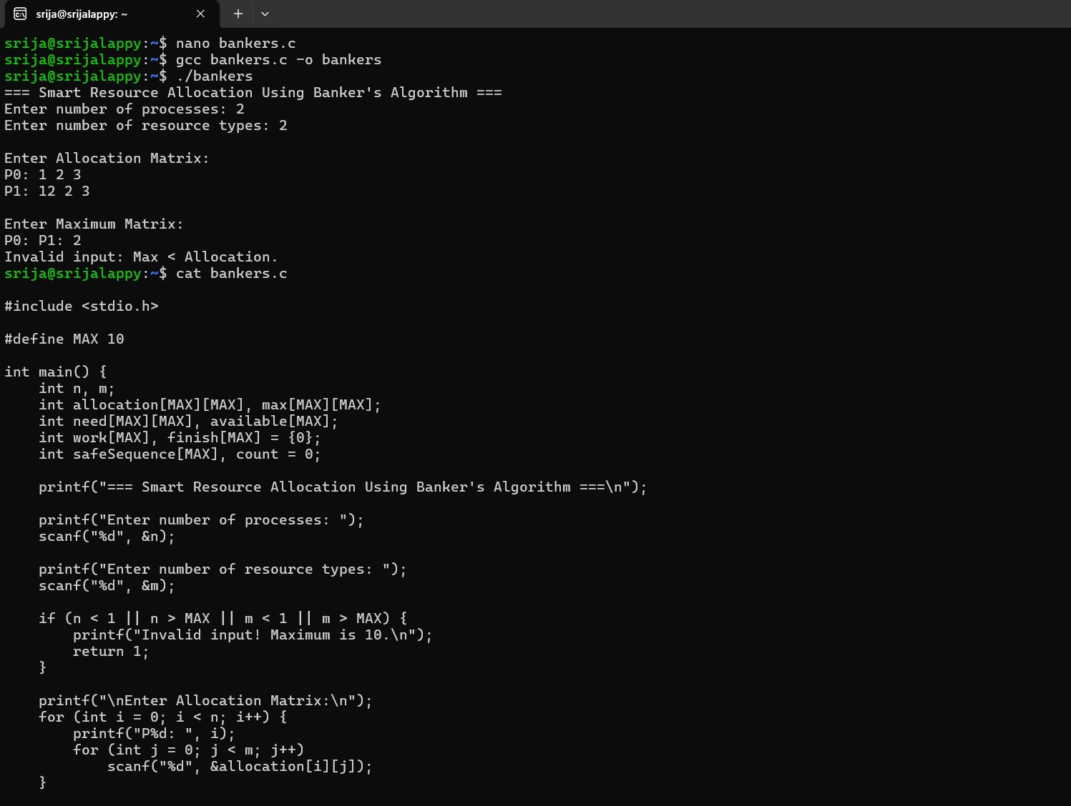
Figure 5.2: Unsafe state check: the system is reported unsafe
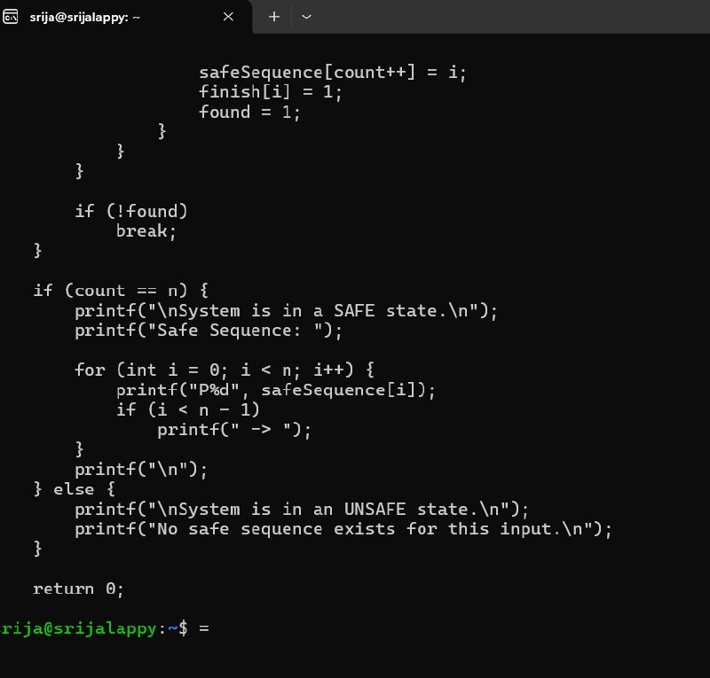
Figure 5.3: Valid resource request: the request is granted and the matrices are updated

CHAPTER -6 RESULTS
The prototype correctly calculates the Need matrix, determines whether the system is in a safe state and displays the safe sequence. Table 6.1 shows the sample data used for testing: five processes (P0–P4) and three resource types A, B and C with 10, 5 and 7 instances respectively. The initial Available vector is (3, 3, 2).
Process | Allocation (A B C) | Max (A B C) | Need (A B C)
P0 | 0 1 0 | 7 5 3 | 7 4 3
P1 | 2 0 0 | 3 2 2 | 1 2 2
P2 | 3 0 2 | 9 0 2 | 6 0 0
P3 | 2 1 1 | 2 2 2 | 0 1 1
P4 | 0 0 2 | 4 3 3 | 4 3 1
Table 6.1: Sample data (Total resources: A = 10, B = 5, C = 7)
For this data the system is in a safe state, and the Safety Algorithm produces the safe sequence <P1, P3, P0, P2, P4>. When P1 requests (1, 0, 2), the request is within its Need (1, 2, 2) and the Available vector (3, 3, 2); the resulting state is still safe, so the request is granted and Available becomes (2, 3, 0). A later request by P4 for (3, 3, 0) exceeds the Available vector, so P4 must wait. A request by P0 for (0, 2, 0) is within both limits, but granting it would leave no safe sequence, so it is denied and the allocation is rolled back. The GUI displays these results together with the updated matrices, and the event log records every check and request with a timestamp.
6.1: G
CHAPTER-7 LIMITATIONS
- Every process must declare its maximum resource requirement in advance.
- The number of processes and resources is assumed to be fixed; processes cannot join or leave dynamically.
- Resources are simulated data entries; the project does not manage real hardware or operating-system resources.
- The safety check must be repeated for every request, which adds computation and makes the approach less suitable for very large production systems.

CHAPTER -8 FUTURE ENHANCEMENTS
- Add a step-by-step animated visualization of the safe sequence.
- Support dynamic addition and removal of processes and resources.
- Add resource-release functionality and automatic request simulation.
- Add deadlock detection and recovery for comparison with deadlock avoidance.
- Add export of logs and results to CSV or PDF.
- Add configuration files, stronger input validation and additional automated tests.

CHAPTER -9 TEAM CONTRIBUTIONS
- SRIJA (2520090053): Banker’s Algorithm engine, including Need calculation, the Safety Algorithm and the Resource-Request Algorithm.
- PRAVEENA (2520090057): GUI development using Tkinter, input validation and event logging.
- AKSHITHA REDDY (2520090178): Test cases, testing and validation, documentation and presentation.

CHAPTER -10 CONCLUSION
The Smart Resource Allocation – Banker’s Algorithm system demonstrates how deadlock can be avoided by allocating resources only when the system remains in a safe state. By combining a Python implementation of the Safety and Resource-Request algorithms with a Tkinter GUI, the project provides a practical demonstration of resource allocation, safe-state analysis and deadlock avoidance.

