AI-Based Ground Vibration Detection: Human / Vehicle Activity Classification
A Project Based Learning Report Submitted in partial fulfilment of the requirements for the award of the degree

of

Bachelor of Technology
in The Department of Electronics and Communication Engineering
Analog Electronic Circuit Design – 25EC1302E
Signal Processing – 25EC2104E
Machine Learning – 25SC2107E

Submitted by
2510040058: G.Akshith
2510040061: K.Ahladh
2510040085: P.Cyril Raj
2510040109: K.Sravya
2510040120: B.Gowri

Under the guidance of
A. Bhuvaneshwari (AECD), Ashwini Kumar Varma (Signal Processing), Gangamohan Paidi (Machine Learning)

Department of Electronics and Communication Engineering
Koneru Lakshmaiah Education Foundation, Aziz Nagar
Aziz Nagar – 500075
OCT - 2026.
Abstract

Cameras and other optical monitoring systems stop working reliably in darkness, fog, dust, dense foliage or when there is no line of sight. Ground vibration does not depend on visibility, and different activities leave different vibration signatures: footsteps arrive as slow, repeated impacts, while a light vehicle produces a continuous low-frequency hum with harmonics. This project designs a low-cost sensor node that detects ground vibration, conditions and processes the signal, and uses machine learning to classify the activity as No activity, Human footsteps, Light vehicle or Other vibration, and then raises an alert.
The project is a single pipeline that integrates three courses. In Analog Electronic Circuit Design (AECD), a piezoelectric transducer is protected, AC coupled, amplified with a non-inverting op-amp stage, shaped by an active low-pass filter that also acts as the anti-aliasing filter, buffered and biased at mid-supply so that it fits the 0 to 3.3 V range of the ESP32 ADC. In Signal Processing (SP), the signal is sampled at 2 kHz, cleaned with a 101-tap Hamming-window FIR band-pass filter (5 to 400 Hz), split into one-second windows, and converted into a six-element feature vector using RMS, peak amplitude, FFT dominant frequency and three band energies. In Machine Learning (ML), a Decision Tree and a Random Forest are trained on the feature vectors and evaluated with accuracy, precision, recall, F1-score and a confusion matrix. The result is shown on an OLED and signalled by an LED or buzzer.
The SP and ML stages have been implemented and tested in Python on a synthetic dataset of 960 labelled windows (240 per class, 720 for training and 240 for testing). The Decision Tree reached a test accuracy of 0.68 and the Random Forest 0.75, and five-fold cross-validation gave 0.81 and 0.86 respectively. A shuffled-label check gave about 0.23, close to the 0.25 expected by chance, which confirms that the models learn real structure in the features. Because the data are synthetic, these results confirm that the pipeline works end to end but do not predict field accuracy. The analog front end is specified with calculated component values for simulation in Multisim and breadboard testing, and the remaining work is to record a real labelled dataset with the built hardware and repeat the evaluation.

Keywords: ground vibration, piezoelectric sensor, active filter, anti-aliasing, FIR filter, FFT, feature extraction, Random Forest, edge classification.

List of Figures

Fig. 1. System block diagram of the ground vibration detection node
Fig. 2. Analog front end (AECD) with the component values used for design
Fig. 3. Multisim simulation of the analog front end with the multimeter and oscilloscope readings
Fig. 4. Example one-second vibration windows for the four classes
Fig. 5. FFT magnitude spectra of the four classes
Fig. 6. Frequency response of the FIR and IIR band-pass filters
Fig. 7. Confusion matrices of the Decision Tree and Random Forest
Fig. 8. Random Forest feature importance

List of Tables

TABLE I. Course topics used in each stage of the pipeline
TABLE II. Analog front-end design values
TABLE III. Components and tools
TABLE IV. Mean feature values per class (synthetic dataset)
TABLE V. Classification metrics on the 240-window test set
TABLE VI. Planned hardware experiments and pass criteria

Table of Contents

1. Introduction
2. Methodology
a. System overview
b. AECD stage: sensing and signal conditioning
c. Signal Processing stage: sampling, filtering and features
d. Machine Learning stage: classification
e. Alert output and system integration
f. Components, tools and build plan
3. Experiments
a. Synthetic dataset
b. Feature extraction and classifier training
c. Planned hardware experiments
4. Results
5. Conclusion and Future Work
References

AI-Based Ground Vibration Detection: Human / Vehicle Activity Classification

Introduction
Monitoring a boundary, a construction site, a remote facility or the area around machinery is a common safety and security need. Most low-cost monitoring relies on cameras, but a camera needs light and an unobstructed view. It struggles at night, in fog or dust, behind foliage and around corners. Every footstep and every moving vehicle, however, shakes the ground, and that vibration travels through the soil regardless of whether anything can be seen. A sensor placed on or in the ground can therefore notice activity that a camera would miss.

The vibration signatures of different activities are not the same. A person walking produces a train of short, sharp impacts about two per second, each ringing down within a fraction of a second at low frequency. A light vehicle produces a continuous low-frequency rumble made of a fundamental and its harmonics. A knock, a dropped object or a tool produces a short, higher-frequency burst, and a quiet site produces only low-level noise. Because these patterns differ in energy, in frequency content and in how they vary with time, a program can learn to tell them apart if the signal is first turned into suitable numbers.

This project builds a low-cost sensor node that does exactly that. A piezoelectric transducer converts ground vibration into a very small voltage. An analog circuit amplifies and filters this voltage so that it is large enough and clean enough to be sampled. A microcontroller samples the signal, and digital signal processing removes unwanted content and extracts features such as RMS, peak amplitude, dominant frequency and band energy. A machine learning classifier then decides whether the window contains no activity, human footsteps, a light vehicle or some other vibration, and the decision is displayed on an OLED and signalled by an LED or buzzer.

The work is deliberately an integrated project across three subjects, and each subject owns one clearly separate stage. Analog Electronic Circuit Design (course code 25EC1302E) provides the physical front end: amplification, buffering, active filtering, power supply decoupling and grounding. Signal Processing (25EC2104E) provides sampling, anti-aliasing, digital filter design, the FFT and feature extraction. Machine Learning (25SC2107E) provides dataset preparation, training and evaluation of the classifier. The output of one subject becomes the input of the next: electronics, then signal, then features, then intelligence.
Design motivation. A useful ground-vibration detector must do more than sense motion; it must preserve enough information for a later decision while rejecting electrical noise, accidental knocks and slow baseline drift. This makes the project an instrumentation problem as well as a classification problem. The quality of the final prediction is limited by the weakest stage in the chain: a clipped analog signal cannot be repaired by an FFT, and a poorly labelled dataset cannot be rescued by a more complex classifier.

The design therefore follows a measurement-first principle. Each block has a measurable output and a corresponding check: the sensor and amplifier are checked with an oscilloscope, the filter is checked through a frequency sweep, the ADC stream is checked for timing and saturation, the features are checked with plots and summary statistics, and the classifier is checked with held-out data. This staged approach makes faults easier to isolate and prevents a high classification score from hiding an analog or sampling error.

The intended deployment is a small, low-power edge node rather than a general surveillance system. The node is expected to provide an indication that activity is present and a broad activity category; it is not intended to identify a person, determine a vehicle registration number or replace a trained security response. This distinction is important because ground coupling changes with soil, pavement, sensor placement and weather. The classification output should therefore be interpreted as a decision aid whose confidence must be established through field measurements.

Problem Statement
To design, simulate and prototype a low-cost ground vibration sensor node that detects activity independently of visibility and classifies it into four classes (No activity, Human footsteps, Light vehicle, Other vibration) using machine learning, and raises a local alert.

Objectives
- Design an analog front end that amplifies the weak piezo signal, limits its bandwidth, acts as an anti-aliasing filter, and keeps the output within the 0 to 3.3 V input range of the microcontroller ADC.
- Sample the conditioned signal and apply a digital FIR/IIR filter, windowing, FFT and RMS to extract a feature vector for every one-second window.
- Train and compare a Decision Tree and a Random Forest, and evaluate them with accuracy, precision, recall, F1-score and a confusion matrix.
- Display the predicted class on an OLED and signal activity with an LED or buzzer, and, if feasible, run the lightweight model on the microcontroller.
- Validate the design in simulation (Multisim, Python and an ESP32 simulator) before and alongside breadboard construction and testing with an oscilloscope, DMM and function generator.

Scope and Course Mapping
The project stays within the topics of the three courses. Table I shows which topics are used in which stage.
- Course topics used in each stage of the pipeline
Stage | Course | Topics used
Power and grounding | AECD (Module 1, 6) | Linear supply, decoupling capacitors, single-point grounding, supply noise coupling
Amplification and buffering | AECD (Module 2) | Op-amp amplifiers, buffer, loading effect, AC coupling, impedance matching
Analog filtering | AECD (Module 2) | Passive RC filters, active filters (used as band-limiting and anti-aliasing)
Sampling and quantisation | SP (Module 4) | Nyquist criterion, aliasing, anti-aliasing filter, SQNR = 6.02N + 1.76 dB
Digital filtering | SP (Module 2, 5) | Convolution, frequency response, FIR windowing (Hamming), IIR Butterworth
Frequency analysis | SP (Module 3) | DTFT/FFT, frequency response, dominant frequency
Classification | ML | Windowing, feature vectors, Decision Tree, Random Forest, evaluation metrics

Organisation of the Report
Section 2 explains the methodology stage by stage. Section 3 describes the experiments carried out so far and those planned on hardware. Section 4 presents the results, and Section 5 concludes the report and lists future work.

METHODOLOGY

System Overview
The complete system is a chain of seven steps: sense, condition, digitise, clean and analyse, extract features, classify and alert. Figure 1 shows the chain and how it is divided among the three subjects.
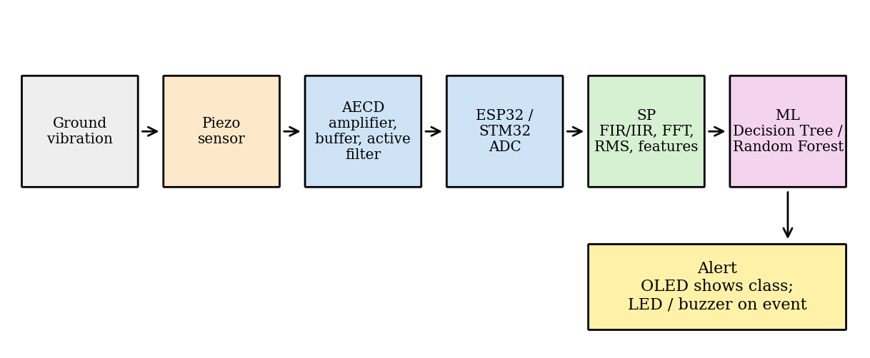
- System block diagram of the ground vibration detection node.
Beginner view. Think of the node as an ear, a pair of hands and a brain. The piezo sensor is the ear: it feels the ground shake. The analog circuit is the pair of hands that holds the signal steady, makes it louder and removes the parts we do not want. The microcontroller and the classifier are the brain: it looks at the signal for one second, measures a few simple things about it, and decides what caused it.

AECD Stage: Sensing and Signal Conditioning
Sensor. A piezoelectric transducer (a disc or a film) generates a charge when it is bent or pressed. When it is fixed firmly to the ground surface, a footstep or a passing vehicle bends it slightly and produces a voltage of the order of millivolts. A piezo behaves like a very high-impedance source, so the circuit that follows must have a very high input resistance, otherwise the signal is lost by the loading effect. A 1 MΩ resistor is placed across the piezo to give the charge a path and to define its DC level, and two 1N4148 diodes connected back to back to the supply rails clamp large spikes (for example a heavy stamp next to the sensor) so that they cannot damage the amplifier or the ADC.

Power supply. The ESP32 board is powered from the 5 V USB supply, and the op-amp stage runs from the same 5 V rail. Following the AECD power-supply topics, a 100 nF ceramic capacitor and a 10 µF electrolytic capacitor are connected across the op-amp supply pins, as close to the pins as possible, to stop supply noise from coupling into the signal. All grounds (sensor, op-amp, ESP32) meet at a single point to avoid ground loops and ripple-induced hum.

Biasing and AC coupling. The piezo output swings both positive and negative, but the ESP32 ADC can only read 0 to 3.3 V. The op-amp is therefore biased at mid-supply. A divider of two 10 kΩ resistors from the supply creates a bias of about 1.65 V when the 3.3 V logic rail is used as reference, and the piezo signal is AC coupled into the amplifier through a 10 µF capacitor. Together with the 5 kΩ equivalent resistance of the divider, this capacitor forms a high-pass filter with a corner frequency of 1/(2π × 5 kΩ × 10 µF) ≈ 3.2 Hz, which blocks the DC level and very slow drift while passing footstep energy.

Amplifier. A non-inverting amplifier built around an LM358 (or TL072) op-amp provides a gain of 1 + Rf/Rg = 1 + 47 kΩ / 2.2 kΩ ≈ 22. The non-inverting configuration is chosen because its input resistance is very high, which suits the piezo. If the piezo signal is smaller than expected on the bench, Rg is reduced to raise the gain; if the output clips on large impacts, Rf is reduced. Note that the AECD course uses the LM741, but the LM741 needs a dual supply of at least ±5 V. The LM358 or TL072 are used here because they work from a single 5 V supply; the supply voltage must be checked against the datasheet before building.

Active low-pass filter and anti-aliasing. The signal then passes through a second-order Sallen-Key active low-pass filter with R = 10 kΩ and C = 39 nF. Its cut-off frequency is fc = 1/(2π R C) ≈ 408 Hz. Footsteps and light vehicles are low-frequency events (tens to a few hundred hertz), so everything above about 400 Hz is unwanted. This filter has a second role: it is the anti-aliasing filter that removes frequencies above half the sampling rate before the ADC, as required by the sampling theorem in the Signal Processing course. A second-order filter falls at 40 dB per decade, so the attenuation at the 1 kHz Nyquist frequency is only about 16 dB; the digital FIR filter and the choice of an adequately high sampling rate cover the remainder, and a higher-order stage can be added if aliasing shows up on the bench.

Buffer. A unity-gain buffer follows the filter. It presents a low output impedance to the ADC sampling capacitor so the ADC reading is not distorted, which is the loading-effect argument for buffer amplifiers taught in AECD. Table II collects all the design values and Figure 2 shows the chain.
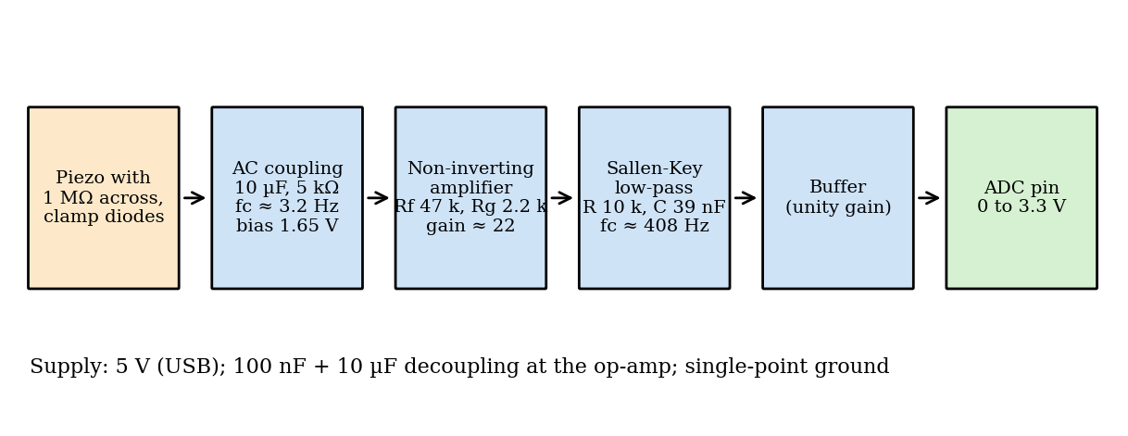
- Analog front end (AECD) with the component values used for design.
- Analog front-end design values
Block | Value / part | Purpose
Piezo load | 1 MΩ across piezo; 2 × 1N4148 clamp | Path for charge, protection from spikes
AC coupling | 10 µF into 5 kΩ (two 10 kΩ), fc ≈ 3.2 Hz | Block DC and slow drift
Bias | 1.65 V (mid-supply) | Keep signal inside 0 to 3.3 V
Amplifier | Non-inverting, Rf = 47 kΩ, Rg = 2.2 kΩ, gain ≈ 22 | Raise millivolt signal to volt level
Low-pass / anti-alias | Sallen-Key, R = 10 kΩ, C = 39 nF, fc ≈ 408 Hz | Limit bandwidth before ADC
Buffer | Unity-gain op-amp stage | Drive ADC without loading
Supply decoupling | 100 nF + 10 µF at op-amp pins | Reduce supply noise

Simulation. The front end was built and simulated in Multisim with a 50 mV peak, 20 Hz sine source in place of the piezo. Figure 3 shows the schematic together with the oscilloscope and multimeter readings: the multimeter at the bias node reads 1.644 V, close to the 1.65 V mid-supply design value, and at the oscilloscope cursor channel A (input) reads -44.286 mV while channel B (output) reads 1.199 V.
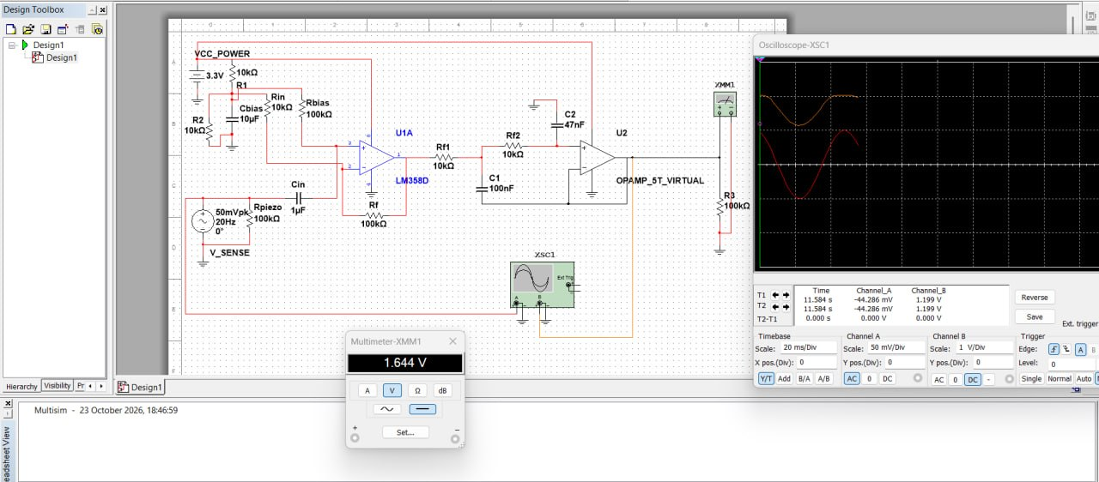
- Multisim simulation of the analog front end with the multimeter (bias voltage) and oscilloscope (input and output) readings.

Circuit-design rationale. The front end is arranged so that gain is applied after the high-impedance sensor has been protected and biased. The piezo is not treated as an ideal voltage source: its capacitance, cable length and mounting pressure can change the amplitude seen by the amplifier. The 1 MΩ load provides a defined discharge path, while the input protection limits unusually large transients. During breadboard testing, the sensor cable should be kept short and mechanically fixed because cable movement can generate a signal that resembles a real vibration event.

The mid-supply bias is a reference for the alternating signal, not an additional vibration component. Before connecting the ESP32, the bias should be measured with the sensor disconnected and again with the sensor connected. A noticeable change would indicate loading, an incorrect resistor connection or a noisy supply reference. The AC-coupling capacitor also has a practical polarity requirement when an electrolytic part is used; the positive terminal must remain at the higher DC potential established by the bias node. A film capacitor may be used where its size and availability permit.

Gain and headroom. With a nominal gain of about 22, a 50 mV peak input would ideally produce a much larger output swing than the ADC can accept. The Multisim reading is consequently useful as a design check, but it also shows why the gain must be calibrated with real sensor amplitudes rather than assumed from the function-generator test. The output should be centred around the bias voltage and should remain comfortably away from both supply rails. If clipping is observed, the first corrective action is to reduce gain or add a gain-select jumper, not to rely on software to reconstruct the clipped waveform.

Component tolerance and op-amp limitations also matter. A resistor tolerance of five percent changes both the gain and the filter corner, and the actual op-amp has finite input offset, input bias current, output-swing limits and finite gain-bandwidth product. The LM358 is convenient for single-supply operation but is not rail-to-rail at the positive output. These non-idealities will be recorded during testing by measuring the bias, quiescent output and response at several frequencies. The measured values can then be used to update the digital scaling and the feature-generation code.

A practical grounding sequence is to connect the sensor return, analog ground, controller ground and oscilloscope ground at one planned point, then add the supply decoupling before troubleshooting signal quality. If a large 50 Hz component appears, the team should first inspect grounding, cable routing and breadboard contact resistance. A digital notch filter should not be the first response because it could remove a genuine vehicle component near the same frequency. This follows the general rule that a physical interference source should be reduced physically before it is hidden computationally.
The analog acceptance test is passed only when the circuit behaves consistently for repeated measurements. Three repeated readings of the bias and gain should be within the selected tolerance band, and the waveform should recover after a large tap without ringing for an excessive time. Recording both the input and output traces creates a calibration record for each hardware revision and allows later differences in classifier performance to be related to circuit changes.

Signal Processing Stage: Sampling, Filtering and Features
Sampling. The ADC of the ESP32 (or STM32) samples the conditioned signal at fs = 2000 Hz. By the Nyquist criterion fs > 2 fmax, this allows content up to 1000 Hz to be represented without aliasing, comfortably above the 400 Hz that the analog filter passes. The ADC has 12-bit resolution, so the theoretical signal-to-quantisation-noise ratio is SQNR = 6.02 N + 1.76 = 6.02 × 12 + 1.76 ≈ 74 dB. In practice the real ESP32 ADC is noisier than this ideal figure, so the achievable value is lower and should be measured.

Windowing of the stream. The sample stream is divided into windows of 1 second (2000 samples). One second contains about two footsteps, enough to see the step rhythm, and gives a frequency resolution of fs/N = 1 Hz in the FFT.

Digital filter. Each window is filtered by a 101-tap FIR band-pass filter designed with the Hamming window method (scipy.signal.firwin) with pass-band 5 to 400 Hz at fs = 2000 Hz. An FIR filter was chosen because it always stays stable and has linear phase, which keeps the shape of the footstep bursts undistorted. The attenuation at 700 Hz is about 75 dB. For comparison, a 4th-order Butterworth IIR band-pass was also designed with the bilinear transform; it meets the same pass-band with far fewer coefficients but has non-linear phase. Figure 6 compares the two. A 50 Hz notch is not used, because the first harmonic of a vehicle can fall close to 50 Hz and a notch would remove useful energy; mains hum is instead reduced by the grounding and decoupling in the analog stage.

Features. For every filtered window six numbers are computed: the RMS value (energy of the window), the peak amplitude (largest absolute sample), the dominant frequency (the frequency of the largest FFT bin, ignoring the DC bin) and the share of spectral energy in three bands: 5 to 50 Hz, 50 to 150 Hz and 150 to 400 Hz. A Hanning window is applied before the FFT to reduce spectral leakage. These six numbers form the feature vector passed to the ML stage. They are chosen because each class differs from the others in at least one of them: footsteps have large peaks and energy concentrated below 50 Hz; a vehicle has the largest RMS and energy in the 50 to 150 Hz band; other vibrations are short bursts with energy above 150 Hz; and no activity has very small RMS and peak.

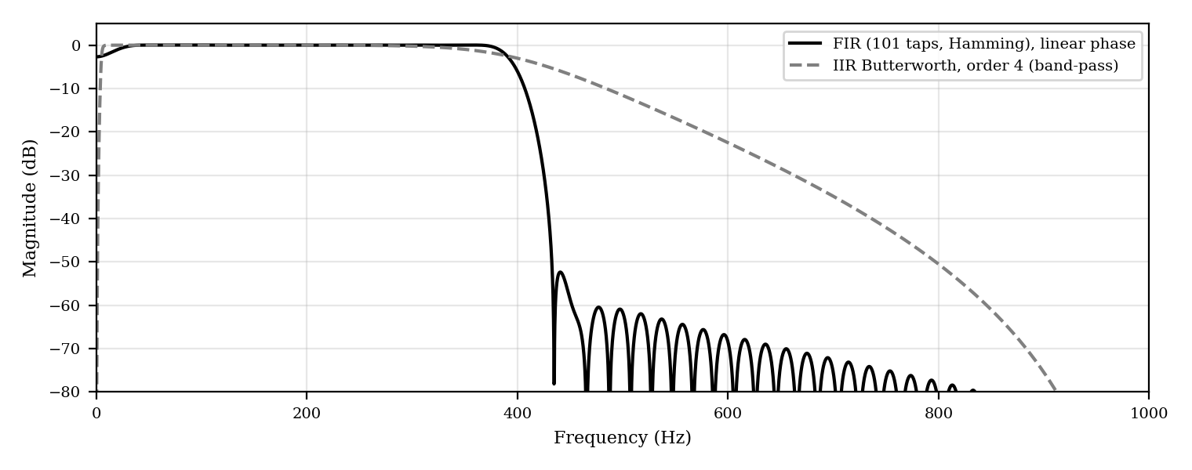
- Frequency response of the FIR and IIR band-pass filters.
Digital-processing details. For a window x[n] containing N samples, the RMS feature is computed as RMS = sqrt((1/N) sum x[n]^2), after removal of the DC reference. The peak feature is max |x[n]|. The FFT is evaluated on a Hanning-windowed version of the filtered signal, and the dominant frequency is selected from the non-zero bin with the largest magnitude. Band energies are calculated by summing squared FFT magnitudes inside each band and dividing by the total energy, so that the three energy features are comparable across windows with different amplitudes.

The order of operations is important. The bias is removed before the RMS and FFT, the band-pass filter is applied before feature extraction, and the Hanning window is applied only for the spectral calculation. Applying the Hanning window to the signal used for the RMS would reduce the measured energy and make the feature definition inconsistent. The same function and the same coefficient array should be used during dataset generation, offline evaluation and embedded inference wherever possible.

A 101-tap FIR filter introduces a group delay of approximately (101 - 1)/2 = 50 samples, or 25 ms at 2 kHz. This delay is small compared with the one-second decision window, but it must be considered if the alert is time-stamped or if overlapping windows are later added. The filter state should also be carried from one window to the next in a streaming implementation; resetting the state at every boundary can create an artificial transient at the start of each window.

The one-second window is a compromise. Longer windows improve frequency stability but delay the alert and can mix two different events. Shorter windows respond faster but may contain too few footsteps to reveal their rhythm. A future version can compare one-second non-overlapping windows with half-second windows and 50 percent overlap. That comparison should be made using the same train-test protocol and should report both classification quality and detection latency.

Embedded implementation. The feature extraction requires a buffer for 2000 samples, temporary storage for filter state and a small FFT workspace. The final classifier needs only the six features and its stored tree parameters, so inference is much lighter than training. Training remains on the laptop; the ESP32 receives the selected model parameters or generated decision rules. Before deployment, the team should compare Python features with features calculated on the microcontroller for the same stored test waveform. The maximum absolute difference should be recorded and kept small relative to the class separation observed in Table IV.

The IIR alternative is retained as a possible optimization, not as an automatic replacement. Its smaller memory requirement is attractive for an embedded node, but its state variables must be initialized and maintained carefully, and numerical differences can become significant near the cut-off frequencies. The FIR is therefore the reference implementation. Any IIR version should be accepted only after its features and classification predictions have been compared window by window against the FIR pipeline.

Machine Learning Stage: Classification
Dataset. The model needs labelled examples. For the hardware prototype, recordings will be collected for each class: quiet (no activity), a person walking near the sensor, a bicycle or car passing, and tapping or knocking for the other class. Each recording is cut into one-second windows and every window is converted into the six-element feature vector. To help the model generalise, recordings are made at different distances and surfaces and with different people and vehicles.

Models. A Decision Tree (maximum depth 4) and a Random Forest (100 trees) from scikit-learn are trained. A Decision Tree is easy to understand and small enough to be written as a set of if-else rules on a microcontroller. A Random Forest averages many trees and is usually more robust to noise. Both are lightweight compared with neural networks, which suits a low-cost node.

Evaluation. The data are split 75 % / 25 % into training and test sets. Performance is measured with accuracy, per-class precision, recall and F1-score, and a confusion matrix that shows which classes are confused with each other. Five-fold stratified cross-validation is also reported so the result does not depend on one lucky split.

Feature scaling and leakage control. Tree-based models do not require standardisation for their split decisions, but the feature ranges should still be inspected because a very large numerical range can make plots and debugging misleading. More importantly, windows from the same continuous recording should not be split randomly between training and testing if they are strongly correlated. The hardware dataset should be divided by recording session, person, vehicle or location where possible, so that the test set measures generalisation to a new situation rather than memorisation of a waveform fragment.

The four labels represent different operating conditions rather than equally clean laboratory signals. No activity includes the electronic and environmental noise floor. Other vibration is intentionally broad and may include taps, dropped objects, construction activity or machinery that is not a vehicle. This class is useful for safe operation, but its internal variation can make it difficult to model. During field collection, each Other vibration example should be annotated with a short description so that later analysis can reveal whether several physically different phenomena should become separate classes.

The confusion matrix is more informative than accuracy alone. A false Human-footsteps decision may cause an unnecessary local alert, whereas a false No-activity decision may miss a real event. The preferred operating point therefore depends on the application. For a safety-oriented boundary monitor, the team may choose a conservative rule that raises a review alert when the model is uncertain or when two classes receive similar scores. A confidence threshold and an Unknown or Review state can be added without changing the four-class training labels.

The Random Forest is expected to be more robust than a single tree, but it is less transparent and consumes more memory. A sensible deployment strategy is to use the Random Forest as the reference model during development, then measure whether a shallower tree, a small forest or a manually simplified rule set achieves an acceptable trade-off. Model size, inference time, test accuracy, false-alert rate and energy consumption should all be recorded before selecting the final embedded model.

Repeated validation is especially important because the synthetic classes are deliberately well structured. The shuffled-label test checks that the feature matrix does not produce above-chance results when the relationship to the target is destroyed, but it does not test robustness to a new soil surface or a different sensor mounting. Field validation should include a separate day and location, and the final report should state the number of sessions, windows and unique participants rather than reporting only the total number of windows.

Alert Output and System Integration
The predicted class is shown on an OLED display. If the class is anything other than No activity, an LED is switched on, and a buzzer sounds for Human footsteps and Light vehicle. To avoid false alarms from a single noisy window, the alert can be set to trigger only when the same class is predicted in two consecutive windows. The final integration follows the AECD system integration module: a complete block diagram, power distribution from one supply, decoupling capacitors placed at each IC, single-point grounding, and signal tracing with the oscilloscope at each stage (sensor, after the amplifier, after the filter, at the ADC pin) to find where a problem starts.

Alert logic. The output stage should be implemented as a small state machine rather than a direct connection from one prediction to the buzzer. A window is first classified, then a persistence counter is updated. The counter increases when the same non-quiet class repeats, resets or decays when the class changes, and activates the alert only after the selected confirmation count is reached. A cooldown period prevents the buzzer from remaining continuously active during a long vehicle passage, while the OLED can continue to show the latest class and the confidence or confirmation state.

Reliability and fail-safe behaviour. If the ADC stream stops, the sample timing moves outside its tolerance or the feature calculation produces an invalid value, the node should show a fault indication instead of silently reporting No activity. The same principle applies during startup: the alert output should remain disabled until the bias, sampling timer and model are initialised. A watchdog timer can recover from a firmware lock-up, but the reset event should be logged so that repeated failures are visible during testing.

Packaging and installation affect the signal almost as much as the circuit. The sensor should be mounted with repeatable pressure and orientation, protected from direct water entry and separated from the controller if cable movement creates triboelectric noise. The enclosure should provide strain relief for the cable and a clear service point for the battery or USB connection. Installation notes should record surface type, mounting method, approximate sensor-to-path distance and weather conditions for every field recording.

The project also has a responsible-use boundary. The system classifies physical activity patterns and should not be described as a person-identification device. Data collection should avoid unnecessary recording of private conversations or unrelated personal information, and the team should document who performed each action and where the sensor was placed. These controls improve both ethical practice and technical reproducibility because they turn an informal demonstration into a traceable experiment.

Components, Tools and Build Plan
- Components and tools
Block | Choice
Sensor | Piezoelectric vibration transducer
Analog front end | LM358 or TL072 op-amp, resistors, capacitors, 1N4148 diodes, active filter
Controller | ESP32 or STM32 with ADC
Output | OLED display, LED, buzzer
Simulation and test | Multisim, Wokwi (ESP32 simulator), breadboard, oscilloscope, DMM, function generator
Development | Python with NumPy, SciPy and scikit-learn
Dataset | Self-collected, labelled vibration data (synthetic data used until hardware is ready)

The build is done in the following order, and each step is tested before the next one starts.
- Step 1: Simulate the analog front end in Multisim, then build it on a breadboard and check the output on the oscilloscope using the function generator as a test source.
- Step 2: Capture raw samples with the microcontroller, send them to the laptop and plot the waveforms.
- Step 3: Analyse in Python: apply the digital filter, FFT and RMS and see how footsteps and vehicles differ.
- Step 4: Build the labelled dataset with many windows per class under varied conditions.
- Step 5: Train and evaluate the classifier and study the confusion matrix.
- Step 6: Integrate the real-time demo with OLED and buzzer alert.
- Step 7 (optional): Run the trained model on the microcontroller.

EXPERIMENTS

Synthetic Dataset
Hardware recordings are not yet available, so the SP and ML stages were developed and tested on synthetic data produced by a Python generator with a fixed random seed (so that results can be reproduced). The generator creates 240 one-second windows for each of the four classes at fs = 2000 Hz (960 windows in total). Every window starts with low-level Gaussian noise that models the electronic noise floor, and then adds a class-specific pattern:
- No activity: noise only.
- Human footsteps: decaying sine bursts (decay constant 50 ms) at 18 to 32 Hz repeated at 1.6 to 2.4 steps per second with random start offset and amplitude.
- Light vehicle: a continuous harmonic hum with a fundamental of 25 to 35 Hz plus its second and third harmonics with random phase and amplitude.
- Other vibration: one to three short decaying bursts (20 ms) at 120 to 220 Hz at random times.

Figure 4 shows one example window of each class and Figure 5 shows their spectra. The patterns follow the physical description in the Introduction but are idealised; real recordings will be noisier and less regular.
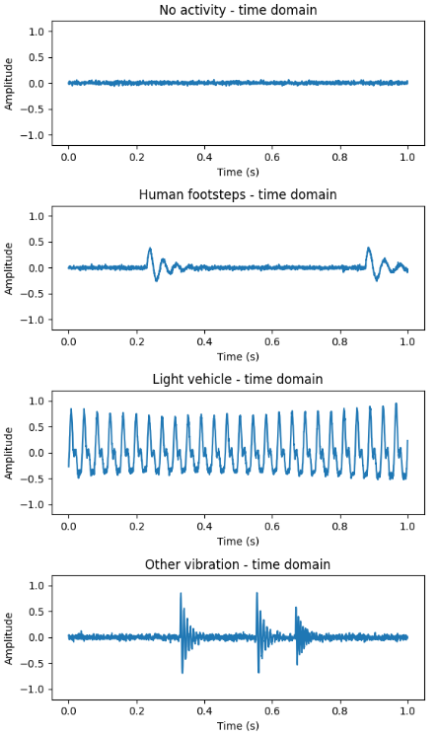
- Example one-second vibration windows for the four classes.
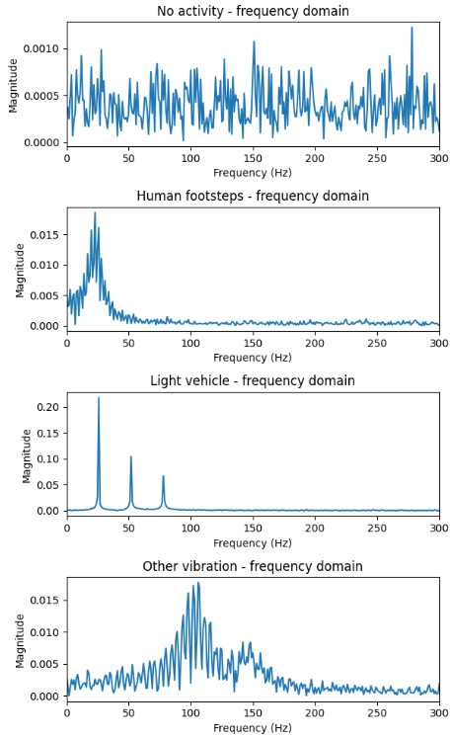

- FFT magnitude spectra of the four classes.

Synthetic signal construction. The generator is useful because it permits controlled changes to one property at a time. A simplified footstep signal can be represented as a sum of damped sinusoids, s_f(t) = A exp(-(t-t_k)/tau) sin(2 pi f (t-t_k)) for t >= t_k, where t_k is the start time of the kth step. The vehicle signal is represented by a fundamental and harmonics with independent phases, while the Other vibration signal uses short higher-frequency bursts. Gaussian noise is added after the class signal so that the signal-to-noise ratio can be varied in later experiments.

The fixed seed makes the current result reproducible, but reproducibility does not mean that the generator is realistic. The synthetic data use clean class-specific assumptions: footsteps occupy a narrow low-frequency region, vehicles are continuous and harmonic, and Other vibration is relatively high-frequency. A useful sensitivity study is therefore to increase the noise level, vary the step rate, add missing or overlapping events and introduce a low-frequency background hum. The expected result is a gradual reduction in accuracy rather than an abrupt failure; such a curve would show how much margin the feature set has.

The class counts were kept equal to make the initial comparison easy to interpret. In a deployed system, No activity may dominate the recording time, while a real vehicle or footstep event may be rare. The final dataset should report both balanced metrics and an application-weighted metric based on the expected event rate. Oversampling a rare class or using class weights may improve recall, but those choices must be applied only to the training data so that the test distribution remains an honest representation of the intended use.

Feature Extraction and Classifier Training
Each of the 960 windows was passed through the FIR band-pass filter and converted to the six features described in Section 2. The feature table contained 240 windows per class and no duplicate feature rows. It was split 75 / 25, giving 720 training windows and a test set of 240 windows (60 footsteps, 40 no activity, 80 other vibration and 60 light vehicle). A Decision Tree (maximum depth 4) and a Random Forest (100 trees) were trained on the training set, and then evaluated on the test set and with five-fold cross-validation on all 960 windows. All random seeds were fixed to 42.

Training procedure. The complete preprocessing pipeline is treated as part of the model definition: filtering coefficients, frequency bands, feature order, label encoding and random seeds are saved together with the trained classifier. This prevents a common deployment error in which the laptop uses one feature order while the microcontroller uses another. A small metadata file or printed configuration block should record fs, window length, filter type, number of taps, band edges and model hyperparameters for every experiment.

The five-fold cross-validation values are useful for estimating variability, but the folds are not independent if adjacent windows originate from the same synthetic process or future recording. For the real dataset, grouped cross-validation by recording session is preferred. The final hold-out set should be kept untouched until model selection is complete. Only then should the team report the final confusion matrix and compare it with the cross-validation estimate.

In addition to the metrics already listed, the implementation should measure detection latency and false alerts per hour during a continuous recording. These quantities connect the model to the actual user experience. A classifier that is accurate on isolated one-second windows but produces frequent alerts during a quiet ten-minute recording may not be acceptable without persistence logic or a better definition of the No activity class.

Planned Hardware Experiments
The following experiments will be carried out when the analog circuit and microcontroller are built. Each has a pass criterion so that it is clear whether the step worked.
- Planned hardware experiments and pass criteria
Experiment | How it is done | Pass criterion
Power rails | Measure the supply and bias with the DMM | 5 V ± 5 %; bias about 1.65 V
Amplifier gain | Apply a 20 Hz, 50 mV peak-to-peak sine from the function generator; measure output on the oscilloscope | Gain about 22 without clipping
Filter cut-off | Sweep the function generator from 10 Hz to 1 kHz at constant amplitude | Output falls to 70 % near 400 Hz
ADC range | Tap the sensor hard and soft and print raw ADC values | Values stay between 0 and 4095 without saturation
Sampling rate | Toggle a pin in the sampling loop and measure it on the oscilloscope | 2000 samples per second ± 1 %
Aliasing check | Feed a 1.5 kHz tone and observe the FFT | No false peak below 400 Hz
Data collection | Record each class at several distances and surfaces | At least 100 windows per class
Live demo | Run the classifier on live data with OLED and buzzer | Correct class shown for planned actions

Hardware-test protocol. The experiments in Table VI should be performed in a controlled order, beginning with the power rails and ending with live classification. First, record the supply, bias and quiescent output with no sensor excitation. Next, use the function generator to check gain and cut-off while observing both the waveform and the DC operating point. Only after these checks pass should the piezo be connected. Raw ADC samples should be saved with a timestamp and a short test label rather than only being viewed in a serial plot.

For each labelled action, the operator should record the action start time, approximate distance from the sensor, surface, direction of motion, speed and any nearby disturbance. A short silent interval before and after the action is valuable because it supplies No activity windows under the same environmental conditions. Multiple people should perform the walking trials, and vehicles should be tested at more than one speed where safe. The purpose is not to create a large number of nearly identical windows, but to sample the variation that the classifier will meet after deployment.

The aliasing check deserves special care. A tone above the Nyquist frequency can fold into the sampled band, so the test should compare the observed FFT with the expected aliased frequency and should be repeated with the analog filter enabled and bypassed only in simulation. This experiment validates the complete sampling chain rather than merely checking that the digital filter removes a high-frequency component after it has already been aliased.

A data-quality checklist should be applied before training on hardware recordings. It should flag saturated ADC windows, disconnected-sensor windows, missing samples, incorrect sample rates, excessive clipping and windows whose label is uncertain. Flagged data should be retained in a separate review folder rather than silently deleted. The number of accepted and rejected windows per class should be included in the experiment log so that the reported dataset size is auditable.

The final live demonstration should include both expected and negative cases: a quiet period, a deliberate footstep sequence, a passing light vehicle if available, an Other vibration event and a sudden electrical disturbance. The OLED message, LED state, buzzer state and serial log should agree. A demonstration is considered successful only when the node continues sampling after the alert, returns to No activity after the event, and does not remain latched because of a single corrupted window.

RESULTS
Table IV gives the mean value of each feature for each class. The classes are clearly separated by the features: No activity has the smallest RMS and peak; Human footsteps have a low dominant frequency (about 24 Hz), a large peak and almost all of their energy (95 %) in the 5 to 50 Hz band; the Light vehicle has the largest RMS (about 0.45) and energy shared between the 5 to 50 Hz and 50 to 150 Hz bands; and Other vibration has a high dominant frequency (about 167 Hz) with most of its energy above 50 Hz.
- Mean feature values per class (synthetic dataset)
Class | RMS | Dominant freq (Hz) | Peak | E 5-50 Hz | E 50-150 Hz | E 150-400 Hz
No activity | 0.012 | 211.2 | 0.042 | 0.089 | 0.270 | 0.628
Human footsteps | 0.123 | 23.8 | 0.665 | 0.949 | 0.015 | 0.009
Light vehicle | 0.445 | 31.4 | 0.879 | 0.577 | 0.422 | 0.000
Other vibration | 0.073 | 166.9 | 0.721 | 0.019 | 0.379 | 0.600

The two classifiers were then evaluated on the 240 held-out windows. The Decision Tree reached a test accuracy of 0.675 and the Random Forest 0.754 (Table V). The Random Forest was better for every class. Its F1-scores were 0.94 for Light vehicle, 0.77 for Other vibration, 0.76 for Human footsteps and 0.41 for No activity, against 0.83, 0.68, 0.70 and 0.41 for the Decision Tree. Light vehicle was the easiest class (Random Forest precision 0.98, recall 0.90), while No activity was the hardest for both models (precision 0.44, recall 0.38). Training accuracy was 0.914 for the Decision Tree and 0.928 for the Random Forest, so the train-test gaps of 0.239 and 0.174 show some overfitting, which is smaller for the Random Forest. Five-fold cross-validation over all 960 windows gave 0.809 ± 0.052 for the Decision Tree (folds 0.825, 0.850, 0.830, 0.706, 0.833) and 0.864 ± 0.065 for the Random Forest (folds 0.850, 0.920, 0.915, 0.744, 0.889). As a sanity check, training the Random Forest on shuffled labels gave an accuracy of 0.226, close to the 0.25 expected by chance for four classes.

- Classification metrics on the 240-window test set
Model | Accuracy | Precision (macro avg) | Recall (macro avg) | F1 (macro avg) | 5-fold CV accuracy
Decision Tree (depth 4) | 0.68 | 0.67 | 0.65 | 0.65 | 0.809 ± 0.052
Random Forest (100 trees) | 0.75 | 0.73 | 0.72 | 0.72 | 0.864 ± 0.065

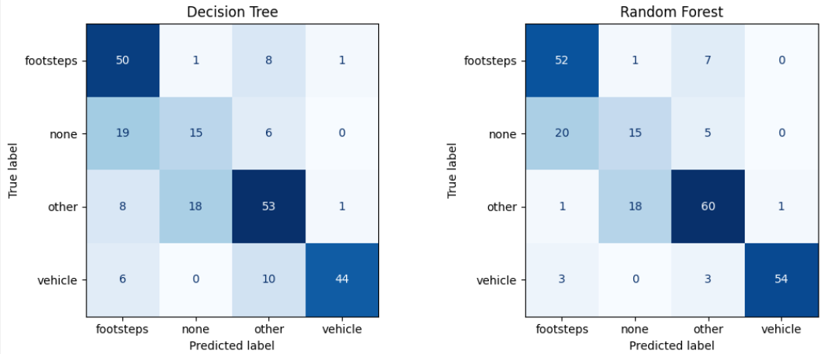
- Confusion matrices of the Decision Tree and Random Forest on the test set (None = No activity, Foot = Human footsteps, Veh = Light vehicle, Other = Other vibration).

Figure 8 shows which features the Random Forest relied on. The importance is spread over several features, led by the 5 to 50 Hz band energy and RMS, which agrees with the physical reasoning that energy level and frequency band are what separate footsteps, vehicles and other events.
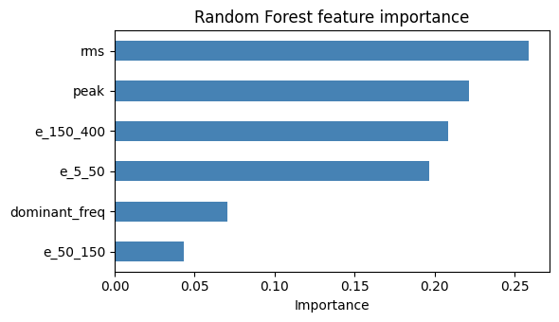
- Random Forest feature importance.

Interpretation and limits. The results show that the filter, FFT, feature and classifier code work together correctly and that the chosen features carry real information, since the accuracy is far above the 0.25 chance level and the shuffled-label check fell to chance. They also show where the features are weak: No activity is often confused with the other classes, and the gap between training and test accuracy shows that the models partly fit the training windows too closely. The Random Forest generalises better than the single Decision Tree. These figures come from synthetic data and do not show how well the node will perform in the field. Real soil, different surfaces, distance from the sensor, wind, nearby machinery and the variety of people and vehicles will add overlap between the classes, and the accuracy is expected to be lower on real data. The hardware experiments in Table VI and a real labelled dataset are needed before any accuracy claim is made about the physical prototype.

Additional interpretation of the current results. The mean feature values show why a small feature vector is sufficient for the synthetic experiment. RMS and peak separate quiet windows from active windows, while the band-energy ratios distinguish low-frequency periodic activity from short higher-frequency bursts. Dominant frequency is especially useful for the Other vibration class, but it is less reliable when a window contains several comparable spectral peaks. This suggests that a future feature set could include spectral centroid, spectral spread or a time-domain crest factor, provided that each added feature is tested with the same grouped validation procedure.

The poor No activity F1-score is not necessarily a contradiction of the system concept. The class contains low-level random content, so its dominant FFT bin can occur at almost any frequency even when the absolute energy is small. A dedicated energy gate before the four-class model may improve this case: if RMS and peak are below a calibrated noise threshold, the node can directly report No activity; otherwise it can invoke the activity classifier. The threshold must be learned from quiet recordings collected across the intended installation conditions and must be revisited when the sensor or analog gain changes.

The training-test gaps indicate that the current model has learned some details of the generated windows in addition to the broad class structure. More data alone may not solve this if the additional examples come from the same generator. Regularisation, grouped validation, noise augmentation and a wider range of class parameters are more informative next steps. The Random Forest result is encouraging, but its 0.75 held-out accuracy should be read as a baseline for the pipeline rather than as evidence of field-ready performance.
The most important engineering deliverable after the present report is a traceable comparison between three signal representations: the original sensor waveform, the filtered waveform and the six-feature vector. Saving these three levels for the same event makes it possible to explain a wrong prediction. If the waveform is clipped, the problem is analog; if the filtered waveform is distorted, the problem is sampling or filtering; if the features look reasonable but the class is wrong, the problem is model coverage or label definition. This diagnostic chain will guide the next iteration more effectively than changing the classifier blindly.

CONCLUSION and FUTURE WORK
This report presented an AI-based ground vibration detection node that classifies activity as No activity, Human footsteps, Light vehicle or Other vibration. The design links three subjects into one pipeline: an AECD front end (piezo protection, AC coupling and bias, non-inverting amplifier with gain of about 22, 408 Hz Sallen-Key low-pass that doubles as anti-aliasing filter, and a buffer), a Signal Processing stage (2 kHz sampling, 101-tap Hamming FIR band-pass, one-second windows, FFT, RMS and band-energy features) and a Machine Learning stage (Decision Tree and Random Forest). The SP and ML stages were implemented in Python and gave a test accuracy of 0.68 (Decision Tree) and 0.75 (Random Forest) on 240 synthetic test windows, and a five-fold cross-validation accuracy of 0.81 and 0.86, which confirms that the pipeline works end to end.

The main limitation is that all numerical results come from synthetic data, and the analog circuit values are design calculations that still have to be verified in Multisim and on a breadboard. The future work is therefore: (1) simulate and build the analog front end and confirm gain, cut-off and bias with the oscilloscope; (2) record a real labelled dataset at different distances, surfaces, people and vehicles; (3) retrain and re-evaluate the classifiers and report the real confusion matrix; (4) run the lightweight model on the ESP32 for real-time inference with the OLED and buzzer alert; and (5) extend the system to several sensor nodes reporting to a central dashboard.

Implementation roadmap. The next milestone is a stable single-channel hardware acquisition test with the analog output visible on the oscilloscope and the 2 kHz sample timing verified. The second milestone is a small, carefully labelled field dataset collected across surfaces and distances. The third is an offline evaluation using grouped splits and an untouched hold-out session. The final milestone is embedded inference with the OLED, LED and buzzer, followed by a continuous recording that measures latency and false alerts per hour.

The main technical risks are sensor mounting variability, analog clipping, supply noise, sample-timing drift, class overlap and insufficient negative examples. Each risk has a corresponding mitigation: a repeatable mounting fixture, selectable gain, local decoupling and single-point grounding, timer-based sampling, grouped field collection and long quiet recordings. Maintaining this risk list throughout the build will keep the project connected to measurable actions rather than only to software accuracy.

A multi-node extension is possible after the single-node pipeline is stable. Several nodes could compare arrival time and energy to reject a local tap or estimate the direction of a moving vehicle. That extension would require synchronised clocks, a communication protocol and a new evaluation plan, so it should remain future work rather than be added before the basic sensor node is validated. The current design deliberately keeps the first prototype small enough to debug completely.

In summary, the project demonstrates a coherent path from transducer physics to an edge-machine-learning decision. Its strongest contribution at this stage is the integration of AECD, Signal Processing and Machine Learning into a testable pipeline with explicit pass criteria. Its next contribution must be experimental: replacing idealised signals with measured ground vibration, quantifying the effect of installation conditions, and reporting the resulting limitations honestly.

References
- J. G. Proakis and D. G. Manolakis, Digital Signal Processing: Principles, Algorithms, and Applications, 4th ed., Pearson, 2007.
- A. V. Oppenheim and R. W. Schafer, Discrete-Time Signal Processing, 3rd ed., Pearson, 2010.
- R. G. Lyons, Understanding Digital Signal Processing, 3rd ed., Pearson, 2011.
- A. S. Sedra, K. C. Smith, T. Chan Carusone and V. Gaudet, Microelectronic Circuits, 9th ed., Oxford University Press, 2025.
- R. A. Gayakwad, Op-Amps and Linear Integrated Circuits, 4th ed., Pearson Education.
- F. Pedregosa et al., “Scikit-learn: Machine Learning in Python,” Journal of Machine Learning Research, vol. 12, pp. 2825-2830, 2011.
- P. Virtanen et al., “SciPy 1.0: fundamental algorithms for scientific computing in Python,” Nature Methods, vol. 17, pp. 261-272, 2020.
- C. R. Harris et al., “Array programming with NumPy,” Nature, vol. 585, pp. 357-362, 2020.
- L. Breiman, “Random Forests,” Machine Learning, vol. 45, pp. 5-32, 2001.
- Espressif Systems, ESP32 Series Datasheet and Technical Reference Manual.
- Texas Instruments, LM358 and TL072 operational amplifier datasheets.

