Front End Engineering-I Project
Team Details:
AKSH BANSAL(2310990270)
AKSHAT KUMAR(2310990271) AKSHIT KALRA(2310990273)
Faculty Coordinator::
DR.NIHARIKA THAKUR
Chitkara University Institute of Engineering and Technology, Chitkara University, Punjab

•Introduction •NOTE LOG
•Brief Overview- The Note Log Project is a versatile digital platform designed to help individuals and organizations efficiently manage, organize, and retrieve their notesand information.

SERIAL NUMBER | TOPIC | SLIDE NUMBER
1 | INTRODUCTION | 2
2 | PROBLEM STATEMENT | 4
3 | TECHNICAL DETAILS | 5
4 | KEY FEATURES | 6
5 | CODES | 7
6 | CONCLUSION | 8
7 | REFERENCES | 9

Problem Statement
In today's fast-paced digital age, individuals and organizations face a multitude of challenges related to managing and organizing information. As the volume of data and the demands on our time continue to increase, the need for a comprehensive note log solution becomes increasingly evident. The following problems highlight the critical reasons why such a system is essential:
1.Information Overload:
- Individuals are inundated with an overwhelming amount of information daily, including emails, web articles, documents, and personal notes.
- Without an efficient system, important information can be lost or forgotten, leading to missed opportunities and increased stress.
2.Fragmented Note-Taking:
- People often use various tools and methods for note-taking, including physical notebooks, digital notepads, sticky notes, and different apps.
- This fragmentation makes it difficult to consolidate and access notes efficiently, leading to time wastage and frustration.
3.Disorganization:
•Lack of a centralized and organized system for notes leads to chaotic information storage.
•It becomes challenging to categorize, search for, or retrieve specific notes when needed, hindering productivity.

Technical Details
- HTML: HTML provides a structured way to organize content on the web.Itallows us to
.
define different elements of a webpage , such as headings ,paragraphs ,lists.
- Css: It is a crucial component of web development that is used for styling and visually enhancing web pages.
Key Features
1.User-Friendly Interface:
1. An intuitive and user-friendly interface for easy note creation, editing, and organization.
2.Note Creation and Editing:
  - Support for creating notes with text, images, links, and multimedia content.
  - Formatting options for text, including bold, italic, bullet points, and headers.
3.Organization and Tagging:
  - Categorize notes with tags, labels, or folders for efficient organization.
  - Quick and advanced search functionality to find specific notes.
4.Cross-Platform Accessibility:
  - Access notes from various devices, including desktop, mobile, and tablet, with seamless synchronization.
  - Native apps for popular operating systems like iOS, Android, Windows, and macOS.
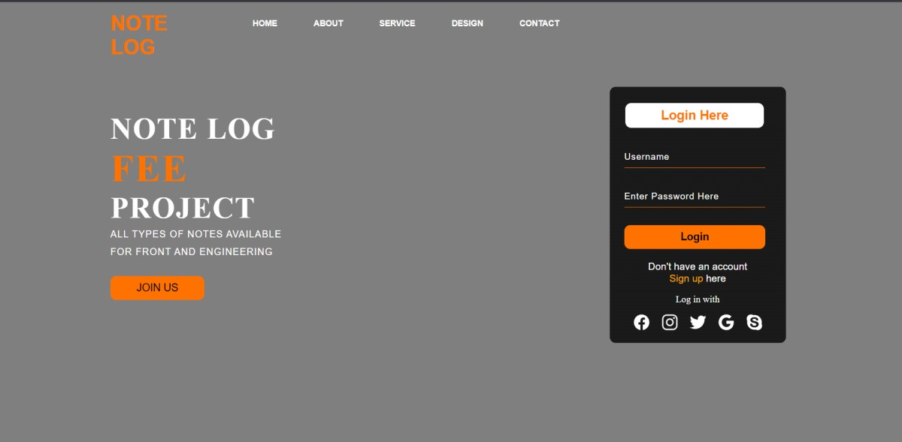
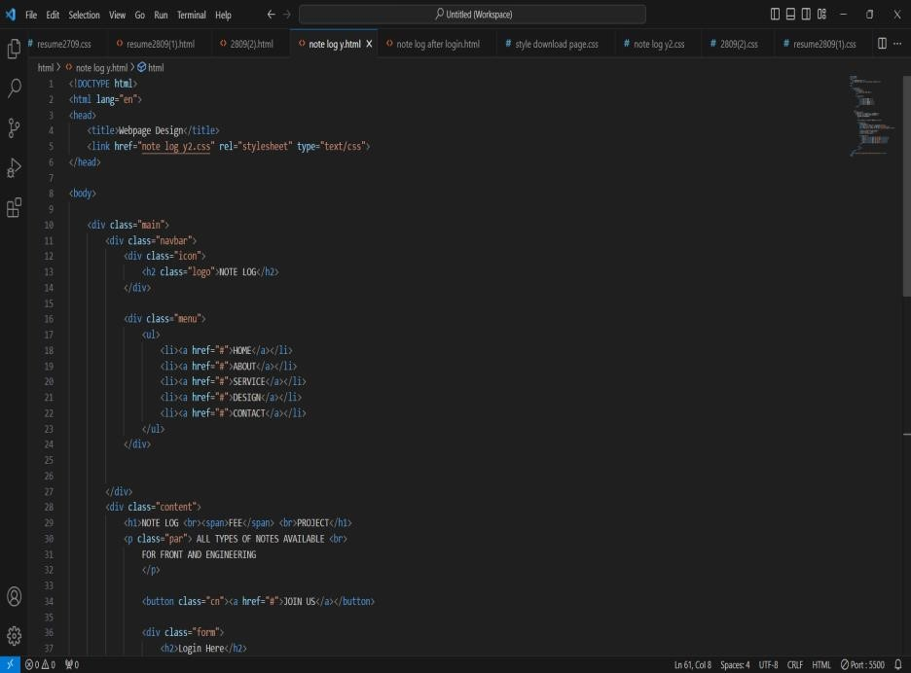
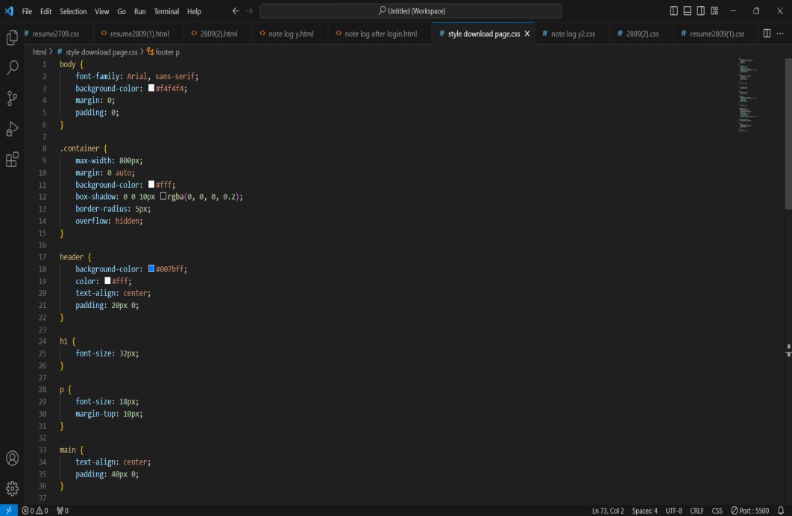

Project Highlights

References/Links used
• Various open source material from internet. •Some requirements are gathered through various books from library.
•Discussion among the group and with guide •Youtube


