cdn bootstrap :- https://cdnjs.cloudflare.com/ajax/libs/bootstrap/4.6.2/js/bootstrap.min.js
cdn bootstrap css:- https://cdnjs.cloudflare.com/ajax/libs/bootstrap/4.6.2/css/bootstrap.min.css
jQuery cdn :- https://cdnjs.cloudflare.com/ajax/libs/jquery/3.7.0/jquery.min.js
font-awesome js :- https://cdnjs.cloudflare.com/ajax/libs/font-awesome/6.4.0/js/all.min.js

font-awesome css :- https://cdnjs.cloudflare.com/ajax/libs/font-awesome/6.4.0/css/all.min.css

Lightbox for bootstrap:- https://ashleydw.github.io/lightbox/

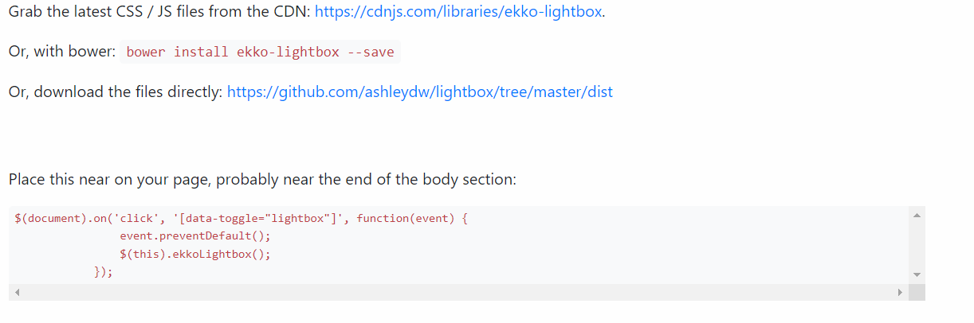
- Aos js:- https://cdnjs.cloudflare.com/ajax/libs/aos/2.3.4/aos.js

- Aos CSS:- https://cdnjs.cloudflare.com/ajax/libs/aos/2.3.4/aos.css

